Step 1: Compile and run the Group server program.

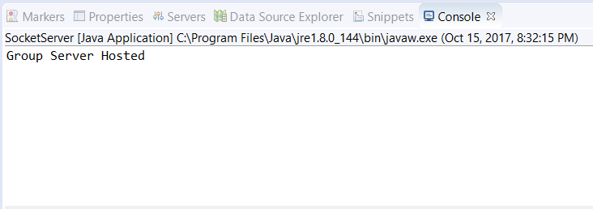

Step 2: Compile and run Persist.java and category.java in each server which will display “Success”.

Step 3: Compile and run the Categorized server program(Silver, Gold and Platinum).

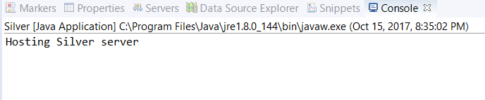

Step 4: Compile and run Persis.java and Points.java in client which will display “Success”.

Step 5: Compile and run the client program. Check if connection is successful at group server end.

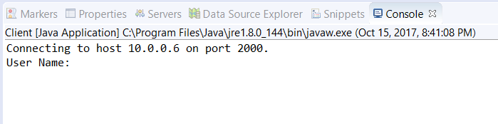

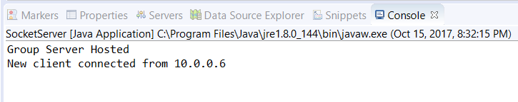

Step 6: Enter the Client user name and password which will be encrypted and sent  
for Client1: username is client1 and password as 1234  
for Client2: username is client2 and password as 1234  
for Client3: username is client3 and password as 1234

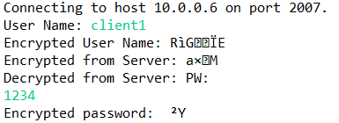

Group server will validate the credentials by decrypting the data sent and will encrypt the data it wishes to send

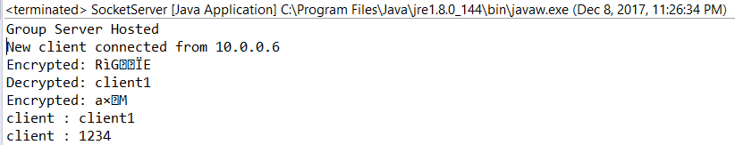  
  
Step 7: If you had entered correct login and password. It will display an encrypted data which when decrypted will ensure login successful and will display the current points of the client

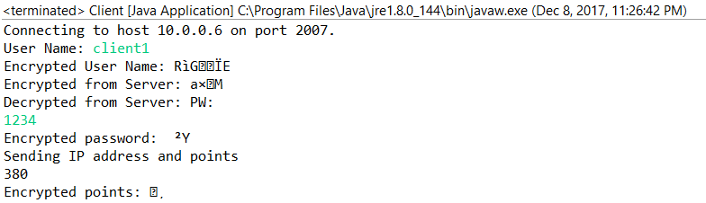

Meanwhile based upon the points group server will direct the client to appropriate category server after communicating with the category server. Also group server will send the IP address of the client in an encrypted format to Category server to initiate UDP connection between client and category server.

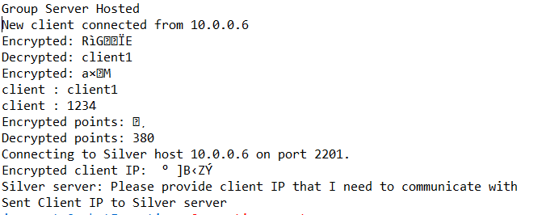

Step 8: Category Server will encrypt the list of product S.no price bonus points and quantity and will send to the client by decrypting its IP from group server.

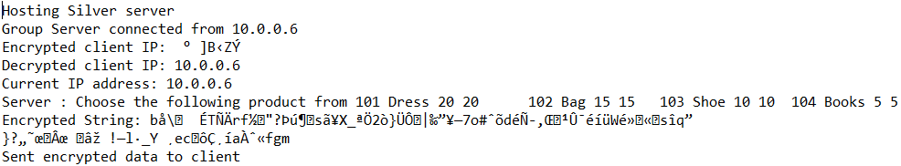

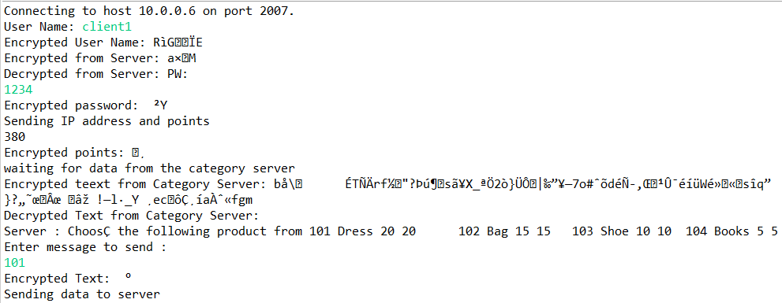  
Step 9: Client need to provide S.no which will be encrypted and sent

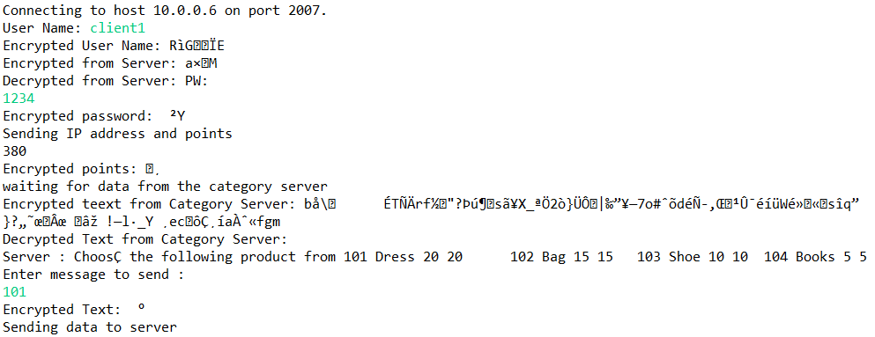

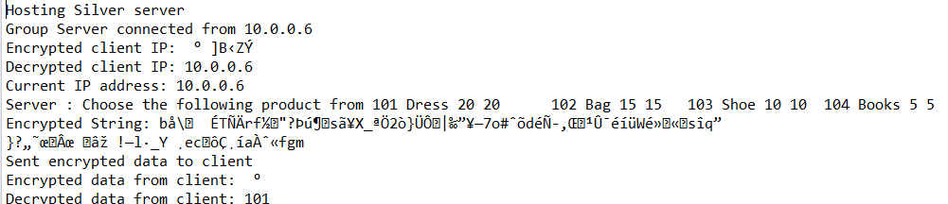

Step 9: If it’s a valid Sno then server will ask to enter the quantity which will be encrypted and sent. If it is not a valid s.no then again the list of products will be displayed for client to choose which will happen through encryption and decryption.  
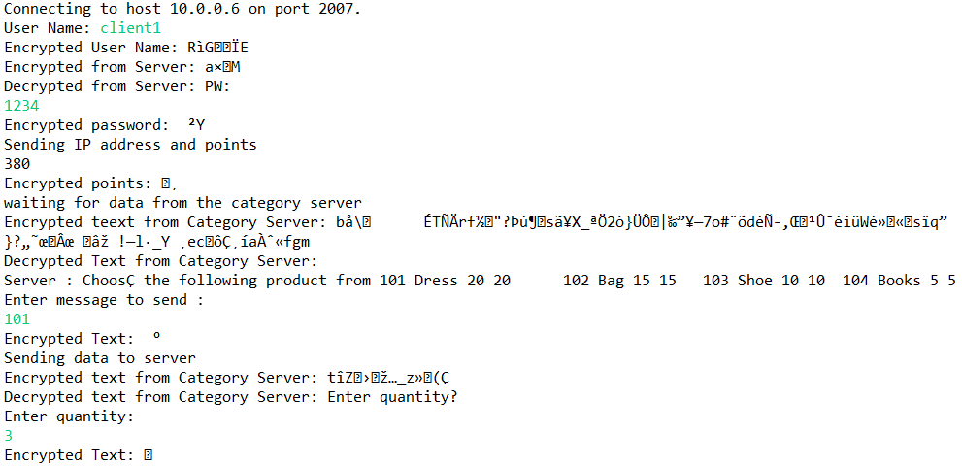

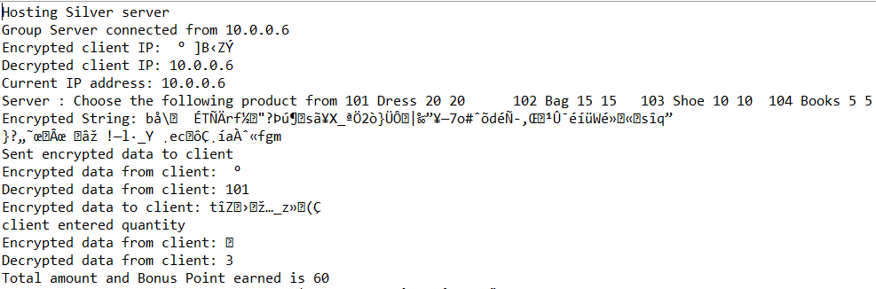

Step 10: After entering the quantity. It will display the total amount, bonus and discount calculated.   
Finally it will display the final amount after discount will be displayed.

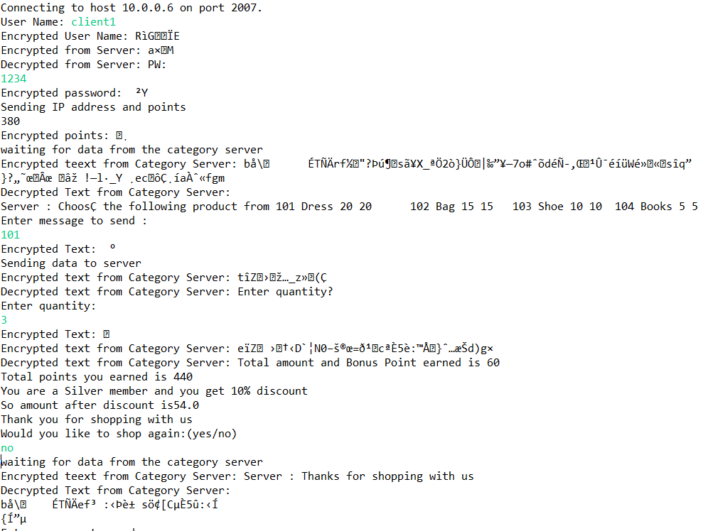  
Step11: Would you like to choose another product yes or no. If yes again repeat from step 6.   
Step12: Points file will be updated after every transaction.