ReadMe :

Step1 : Compile and run the server program



Step2 : Compile and run the client program(TripleDES) which will initially ask for the text to encrypt.



Step 3 : Once text is entered it creates key and encrypts the text using the key

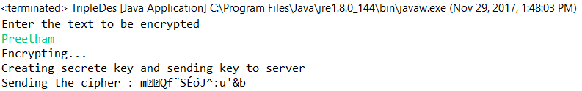

Step 4: After creating the cipher it will be sent to server along with the key

Step 5: Server receives the cipher text and key and decrypts the cipher



Step 6 : Server encrypts the decrypted message with new key and generates a new cipher text

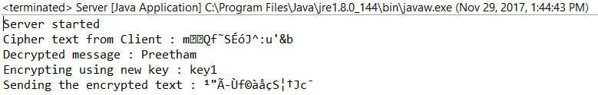

Step 7 : Server encrypts the new key using the key received from the server and sends the encrypted key to the client

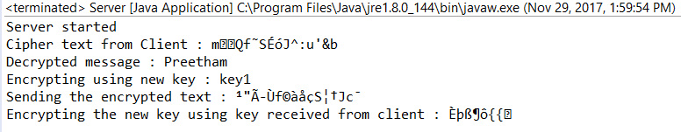

Step 8 : Client receives the encrypted key and encrypted cipher using the new key

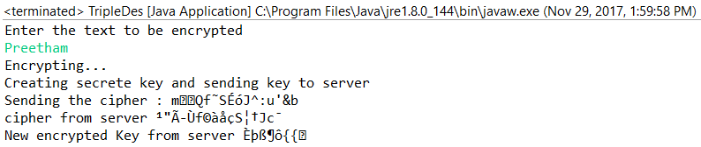

Step 9 : Client decrypts the new key using its own key and uses the new key to decrypt the new cipher text

