Smart Feedback Collection and Analysis System

Industry Project Title | Smart Feedback Collection and Analysis System
Name of the Company | Tata Consultancy Services (TCS)
Name of the Institute | JNTUH University College of Engineering Manthani

Start Date | End Date | Total Effort (hrs.) | Project Environment | Tools used
10th October 2025 | 5th November 2025 | 90 hours | Node.js, Express.js, HTML, CSS, JavaScript, MongoDB, Sentiment Analysis API, Chart.js | Visual Studio Code, Postman, GitHub, Browser Developer Tools

TABLE OF CONTENT
- Acknowledgements
- Objective and Scope
- Problem Statement
- Existing Approaches
- Approach / Methodology - Tools and Technologies used
- Workflow
- Assumptions
- Implementation - Data collection, Processing Steps, Diagrams - Charts, Table
- Solution Design
- Challenges & Opportunities
- Reflections on the project
- Recommendations
- Outcome / Conclusion
- Enhancement Scope
- Link to code and executable file
- Research questions and responses
- References

ACKNOWLEDGEMENTS
I sincerely express my gratitude to Tata Consultancy Services (TCS) for providing this valuable opportunity to work on the Smart Feedback Collection and Analysis System project.
I would also like to thank JNTUH University College of Engineering Manthani for their support and guidance throughout this project.
This experience allowed me to gain hands-on exposure to full-stack web development, sentiment analysis, and real-time data visualization.

OBJECTIVE AND SCOPE
OBJECTIVE
To design and implement a web-based Smart Feedback Collection and Analysis System that enables users to provide feedback online, automatically analyzes the feedback sentiment, and provides administrators with visual insights for better decision-making.
SCOPE
- Collect real-time feedback through a user-friendly web interface.
- Automatically classify feedback as Positive, Negative, or Neutral using NLP-based sentiment analysis.
- Display analytics and trends in a dashboard with charts.
- Support multiple user roles (Guest, Registered User, Admin).
- Store and manage feedback efficiently using MongoDB.
- Ensure scalability and extensibility for future enhancements.

PROBLEM STATEMENT
Organizations often face challenges in analyzing user feedback effectively. Manual methods are tedious, inconsistent, and lack real-time insights.
Existing feedback collection systems do not leverage machine learning or sentiment analysis to understand user emotions or satisfaction levels.
Hence, there is a need for an intelligent and automated platform that can collect, analyze, and visualize feedback efficiently.

EXISTING APPROACHES
Traditional feedback collection relies on manual reviews or basic form submissions without analysis.
They often fail to provide:
- Automated sentiment detection
- Centralized dashboards
- Real-time data visualization
- Scalable backend processing
While some enterprise tools offer analytics, they are costly and lack customization for educational or event-based use.

APPROACH / METHODOLOGY - TOOLS AND TECHNOLOGIES USED
TOOLS AND TECHNOLOGIES
- Frontend:HTML5, CSS3, JavaScript, Chart.js
- Backend: Node.js, Express.js
- Database: MongoDB
- Libraries: Sentiment Analysis API (NPM), CORS, JWT Authentication
- Development Tools: VS Code, Postman, GitHubb
- Testing Tools: Postman, MySQL Workbench
- Operating System: Windows 11

METHODOLOGY
The project follows an Agile iterative model, involving:
- Database schema design.
- Backend API creation.
- Frontend integration with AJAX calls.
- Sentiment analysis integration.
- Dashboard and visualization development.
- Testing and deployment simulation.
WORKFLOW
[Frontend (HTML/CSS/JS)] <----> [Backend (Node.js + Express.js)] <----> [MongoDB Database]
|
v
[Sentiment Analysis API]

Workflow Steps
- User Interaction: Guest or registered users provide feedback using a form.
- Data Submission: Feedback data is sent asynchronously to the backend via AJAX.
- Sentiment Processing: The backend processes the feedback using the Sentiment API.
- Storage: Classified feedback is stored in MongoDB with metadata.
- Visualization: Admin accesses the dashboard to view graphical summaries (Pie & Bar Charts).
- Insights: Reports display percentages of positive, negative, and neutral responses
ASSUMPTIONS
- Users provide meaningful feedback in English.
- Database connection remains active during all transactions.
- APIs and network requests function reliably.
- Only authorized users can access admin dashboards.

IMPLEMENTATION - DATA COLLECTION, PROCESSING STEPS, DIAGRAMS - CHARTS, TABLE
DATA COLLECTION
Feedback is collected via HTML forms containing text areas and rating fields.
Each entry is linked to the user or guest account.

Processing Steps:
- Receive user input in JSON format.
- Clean and preprocess text (remove special symbols).
- Run text through Sentiment API.
- Assign polarity: Positive / Negative / Neutral.
- Store in MongoDB with timestamps and user ID.
VISUALIZATION
Admin dashboard built using Chart.js includes:
Pie Chart – Sentiment distribution
Bar Chart – Feedback count trends
Table – Detailed feedback logs
SOLUTION DESIGN
Folder Structure
backend/
├─ server.js
├─ src/
│ ├─ routes/
│ ├─ models/
│ ├─ controllers/
│ ├─ utils/
│ │ └─ sentiment.js
│ └─ config/
│ └─ db.js
frontend/
├─ index.html
├─ feedback.html
├─ app.js
├─ styles.css
├─ assets/
│ ├─ images/
│ └─ icons/
WEBAPP FLOW
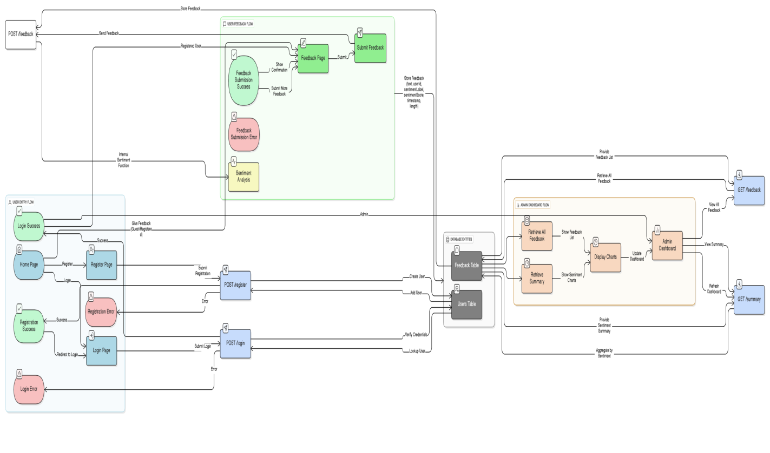

Database Schema (MongoDB)
users: { name, email, password, role }
feedback: { feedbackText, sentimentLabel, sentimentScore, createdAt }
WIREFRAMES (TEXT-BASED)
HomePage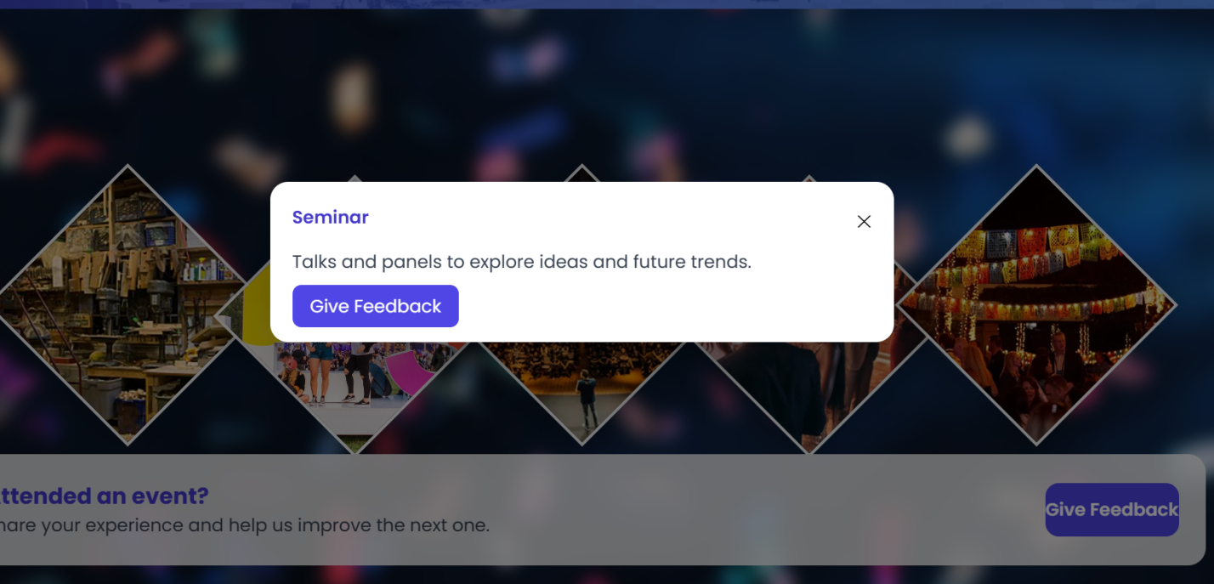
Login Page
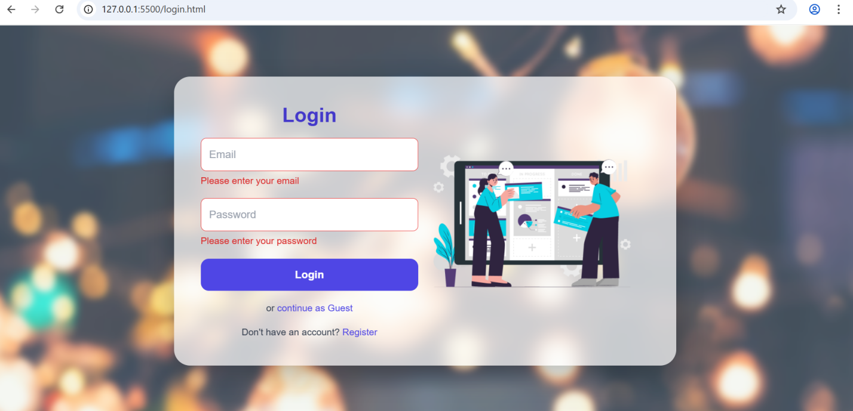
Registration page
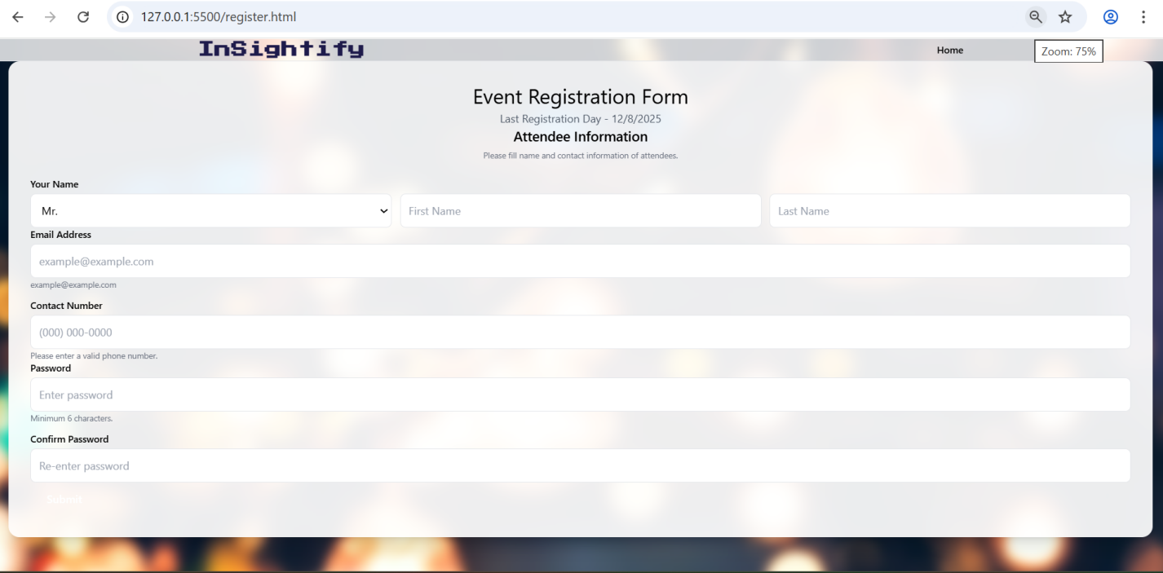
Feedback Form
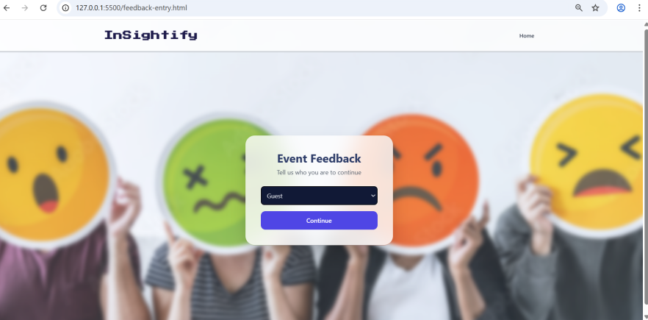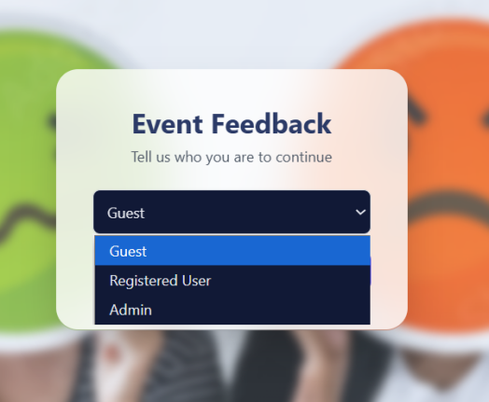

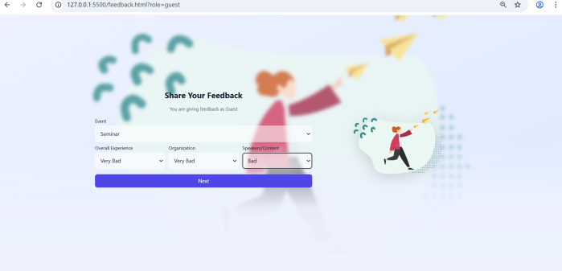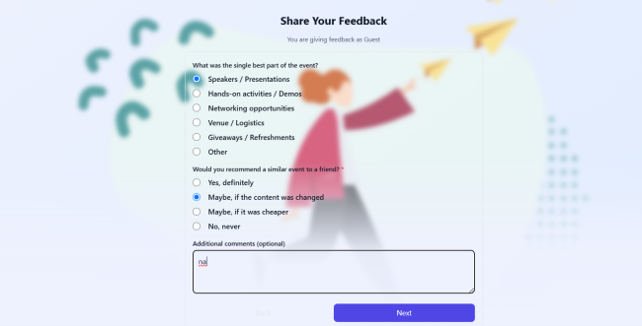

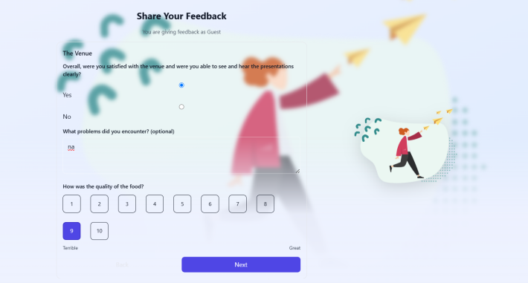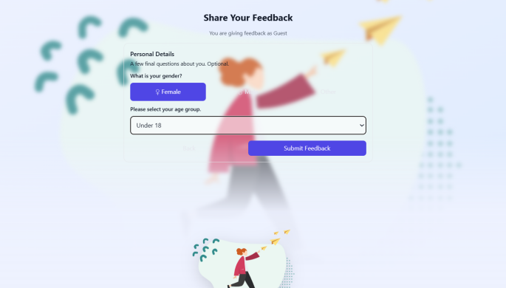
Sentiment analysis
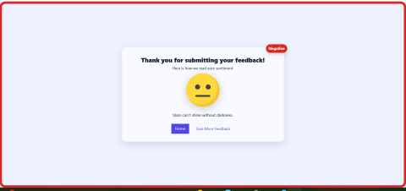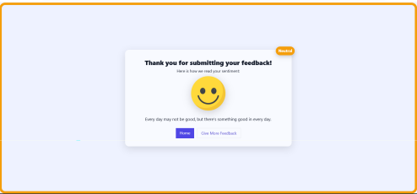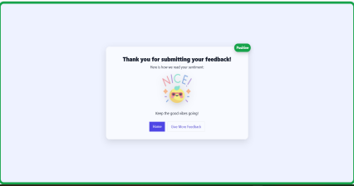

Dashboard
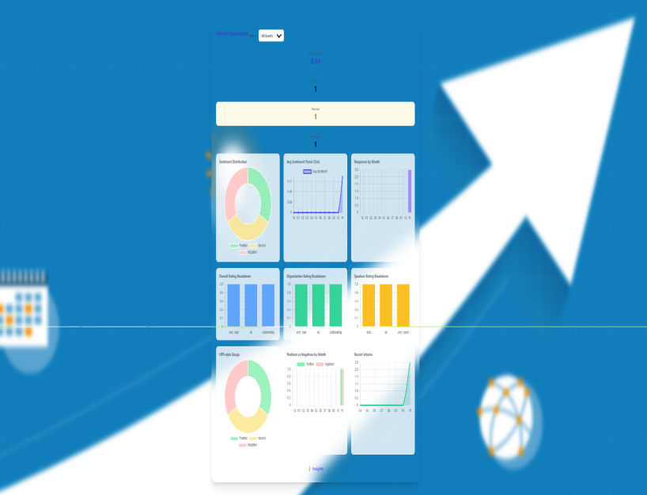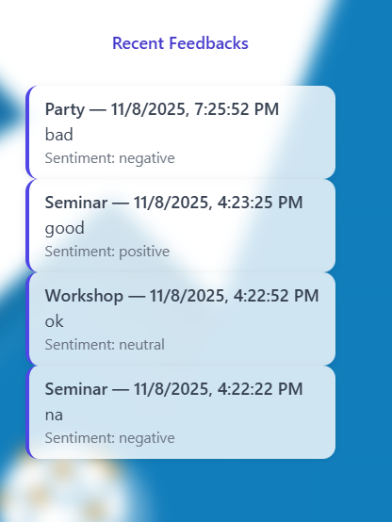

CHALLENGES & OPPORTUNITIES
CHALLENGES
- Ensuring API response speed under load.
- Managing asynchronous calls in JavaScript effectively.
- Maintaining high accuracy in sentiment classification.
OPPORTUNITIES
- Extendable to other industries for survey management.
- Can integrate AI-based models for deeper analysis.
- Deployable on cloud for scalable enterprise usage.

REFLECTIONS ON THE PROJECT
This project helped strengthen my understanding of full-stack development, backend APIs, and real-time data visualization.
Working with Node.js, Express, and MongoDB improved my ability to design scalable systems and understand data flow between components.

RECOMMENDATIONS
- Add multilingual feedback analysis using translation APIs.
- Include role-based dashboards and data export options.
- Integrate deep learning models for improved sentiment accuracy.
- Deploy the system on cloud platforms like AWS or Render.

OUTCOME / CONCLUSION
The Smart Feedback Collection and Analysis System automates user feedback management efficiently.
It performs sentiment classification using NLP, visualizes data in real time, and improves decision-making for event and organizational analysis.

ENHANCEMENT SCOPE
- Integrate live chat and real-time sentiment monitoring.
- Add PDF/Excel report generation.
- Create a mobile version for quick feedback submissions.
- Implement email notifications for new feedback entries.

LINK TO CODE AND EXECUTABLE FILE
The complete source code and setup guide are available in the attached the following links:
https://github.com/preethi-41/smart-feedback-system.git
To run:
node server.js # Start backend
Open index.html # Launch frontend

RESEARCH QUESTIONS AND RESPONSES
Q1: How effective is sentiment analysis for real-time feedback?
A1: With basic NLP models, accuracy ranges from 85–90%, which is sufficient for general feedback analysis.
Q2: What architecture best supports scalability?
A2: MVC-based Node.js + NoSQL structure supports modular and scalable design.
Q3: How does visualization improve decision-making?
A3: Graphical dashboards allow quick identification of trends and satisfaction levels.

REFERENCES
- Node.js Documentation – https://nodejs.org
- Express.js – https://expressjs.com
- MongoDB – https://www.mongodb.com
- Chart.js – https://www.chartjs.org
- Sentiment API – https://www.npmjs.com/package/sentiment
- TCS Project Guidelines – https://www.tcs.com

