1. Write a program to sort array of numbers in asc order.

Input -> size : 5, elements: 6,87,65,21,1

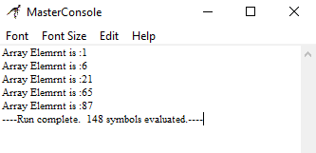

1. Write a program to generating anagrams
2. Write a program to do string search

Input: String -> Preethi, searchString - > ee

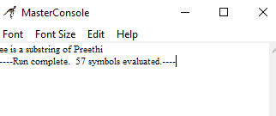

Input: String -> Preethi, searchString -> al

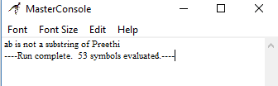

1. Write a program to check whether enter string is a palindrome or not

Input: civic

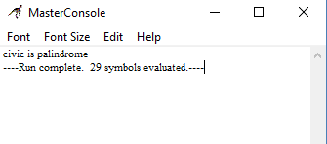

Input: Preethi

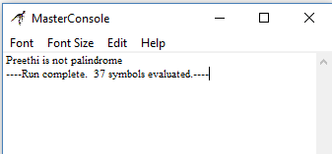

1. Write a program to print the Armstrong numbers between x,y. x, y should be user inputs.

Input: x -> 1, y -> 500

