Audience Sensitivity, Content Compliance, and Format Preference Analysis of the France Top 50 Playlist

Preethi Naga
Department of Computer Science and Engineering
Gokaraju Lailavathi Engineering College
Internship Project under Unified Mentor in collaboration with Atlantic Recording Corporation

Abstract
Data-driven streaming optimization is common in the music industry for release scheduling‚ playlist placement‚ and geographic targeting․ In several markets‚ such as France where cultural factors limit streaming‚ album factors including obscenity of lyrics‚ release format‚ track length‚ and track order are very important for success on the local charts․ We build the analysis of audience sensitivity towards content compliance and format preference of France Top 50 playlist․ Then‚ we will use exploratory data analysis (EDA)‚ statistical indicators and interactive dashboards to examine the explicit content‚ the album type and the total number of album tracks with the ranking․ The analysis revealed a preference for clean songs in the higher chart positions‚ preference for single releases and maximum listener engagement for medium-length songs․ A Streamlit dashboard was created to make planned recommendations to Atlantic Recording Corporation to release songs in certain geographic markets and to pitch songs to playlists․
Keywords: playlist analytics‚ music intelligence‚ explicit content analysis‚ streamlit dashboard‚ France Top 50‚ business intelligence‚ data analytics․

I. INTRODUCTION
The global music industry has undergone a major transformation with the emergence of streaming platforms and algorithm-driven playlist ecosystems. Among these, country-specific playlists serve as strong indicators of regional audience preferences and cultural expectations. The France Top 50 playlist reflects a market characterized by heightened sensitivity toward lyrical appropriateness, structured release formats, and longer catalog engagement.
For multinational music organizations such as Atlantic Recording Corporation, understanding localized market dynamics is critical for optimizing release strategy. A generalized global approach may not align with France’s culturally distinct listener behavior, particularly regarding explicit content and album structure.
This research aims to provide a detailed analytical assessment of playlist content attributes and their impact on ranking performance in the French market.

II. PROBLEM STATEMENT
Despite having access to daily France Top 50 playlist snapshots, Atlantic Recording Corporation lacks clarity on several strategic questions:
- How does explicit content perform relative to clean tracks?
- Are singles preferred over album tracks in France?
- What song duration aligns best with audience acceptance?
- Does album size strengthen or dilute track performance?
- Which content attributes dominate higher rank tiers?
The absence of these insights can lead to suboptimal release strategies, ineffective playlist pitching, and increased compliance risk.

III. OBJECTIVES
The major objectives of this study are:
- To analyze explicit vs clean content representation
- To study single vs album track preference
- To measure duration-based audience acceptance
- To evaluate album size impact on popularity
- To develop a business intelligence dashboard
- To provide data-backed strategic recommendations

IV. DATASET DESCRIPTION
The dataset used for this study consists of daily snapshots of the France Top 50 playlist.

Table I: Dataset Attributes
Attribute | Description
date | Playlist snapshot date
position | Rank from 1 to 50
song | Song title
artist | Artist name
popularity | Popularity score
duration_ms | Track duration in milliseconds
album_type | Single / Album / Compilation
total_tracks | Total tracks in album
is_explicit | Explicit content flag
album_cover_url | Cover image URL

V. METHODOLOGY
The project methodology follows the IEEE-style research workflow.

A. Data Preprocessing
The raw dataset was cleaned and transformed using Python and Pandas.
The preprocessing steps included:
- conversion of date fields into datetime format
- normalization of album type labels
- conversion of duration from milliseconds to minutes
- handling null values
- validation of explicit flags
The transformed feature is represented as:
Durationmin=Durationms60000Duration_{min} = \frac{Duration_{ms}}{60000}Durationmin​=60000Durationms​​Error! Filename not specified.

B. Exploratory Data Analysis
EDA was performed to identify structural patterns.
The following analyses were conducted:
- Explicit content sensitivity analysis
- Format preference analysis
- Duration distribution analysis
- Album size correlation analysis
- Rank-tier comparison

C. KPI Framework
The following KPIs were computed:
- Explicit Content Share
- Clean Content Dominance Ratio
- Single vs Album Ratio
- Average Song Duration
- Album Size Impact Index
- Content Acceptance Score
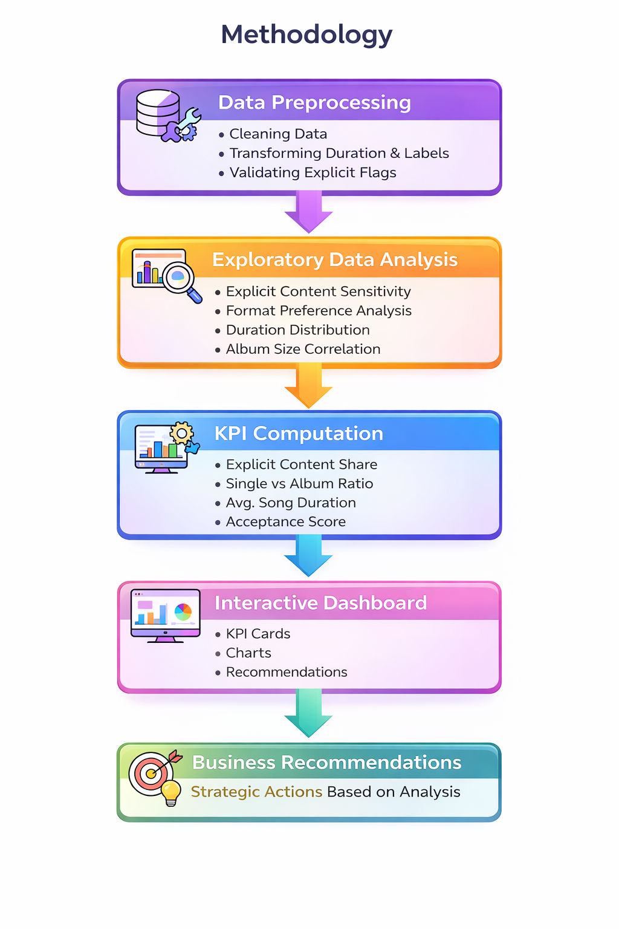

VI. ANALYSIS AND RESULTS

A. Explicit Content Sensitivity Analysis
Explicit content share was calculated as:
Explicit Share=Explicit TracksTotal Tracks×100Explicit\ Share = \frac{Explicit\ Tracks}{Total\ Tracks} \times 100Explicit Share=Total TracksExplicit Tracks​×100Error! Filename not specified.
The analysis revealed that clean tracks consistently dominate higher rank positions, especially in the Top 10.
This indicates that the French market exhibits stronger sensitivity toward lyrical appropriateness and compliance.

B. Release Format Preference
Tracks were categorized into:
- single
- album
- compilation
The findings suggest that singles account for the majority of top-ranked tracks, indicating faster audience adoption and stronger playlist suitability.

C. Duration Preference Analysis
Track duration was divided into three buckets:
- Short: < 2.5 minutes
- Medium: 2.5–3.5 minutes
- Long: > 3.5 minutes
The medium-duration range showed the highest popularity concentration.
This suggests an optimal duration window aligned with listener retention.

D. Album Structure Impact
Correlation analysis was performed between total tracks and popularity.
r=corr(total_tracks,popularity)r = corr(total\_tracks, popularity)r=corr(total_tracks,popularity)Error! Filename not specified.
A mild negative relationship was observed, suggesting possible album dilution effects where larger albums reduce the visibility of individual tracks.

E. Rank-Tier Content Concentration
The dataset was segmented into:
- Top 10
- Top 25
- Top 50
This analysis helped identify preferred content profiles.
The Top 10 showed stronger representation of:
- clean content
- single releases
- medium-duration songs

VII. DASHBOARD IMPLEMENTATION
A Streamlit-based interactive dashboard was developed for real-time analytical exploration.

Core Features
- KPI summary cards
- trend over time visualization
- explicit vs clean pie chart
- album format distribution
- duration histogram
- rank tier comparison
- insight panel
- business recommendation module

User Controls
- date range selector
- rank tier filter
- explicit toggle
- album type filter
This dashboard acts as a decision-support system for business stakeholders.

VIII. KEY INSIGHTS
The study generated the following major insights:
- Clean tracks dominate higher ranking tiers.
- Singles outperform album tracks in short-term playlist visibility.
- Songs around 3 minutes show highest acceptance.
- Larger albums may dilute track-level popularity.
- France demonstrates strong cultural sensitivity toward explicit content.

IX. BUSINESS RECOMMENDATIONS
Based on analytical findings, the following recommendations are proposed for Atlantic Recording Corporation:

A. Content Compliance Strategy
Prioritize clean versions for France-specific releases to maximize compliance and acceptance.

B. Release Strategy
Focus on single-based rollout campaigns for playlist pitching.

C. Duration Optimization
Maintain track duration in the 2.5–3.5 minute range.

D. Album Structuring
Avoid excessively large albums for playlist-focused releases.

E. Localization
Adopt country-specific content strategies rather than global uniform release policies.

X. CONCLUSION
This research successfully transforms playlist-level metadata into strategic intelligence tailored for the French music market.
The project combines statistical analysis, dashboard development, and business recommendations to support localized music release strategies.
The findings reinforce the importance of clean content dominance, single release preference, and duration optimization in France.
This work demonstrates the role of data analytics in supporting music industry decision-making and regional content strategy.

XI. FUTURE SCOPE
Future enhancements may include:
- predictive modeling for chart rank forecasting
- sentiment analysis on lyrical content
- cross-country market comparison
- artist performance clustering
- machine learning recommendation systems

REFERENCES
[1] Spotify Charts and playlist analytics literature
[2] Streaming platform market behavior studies
[3] Python documentation for Pandas and Streamlit
[4] Business intelligence dashboard design methodologies

Figures and Dashboard Outputs
Figure 1: KPI Dashboard Overview
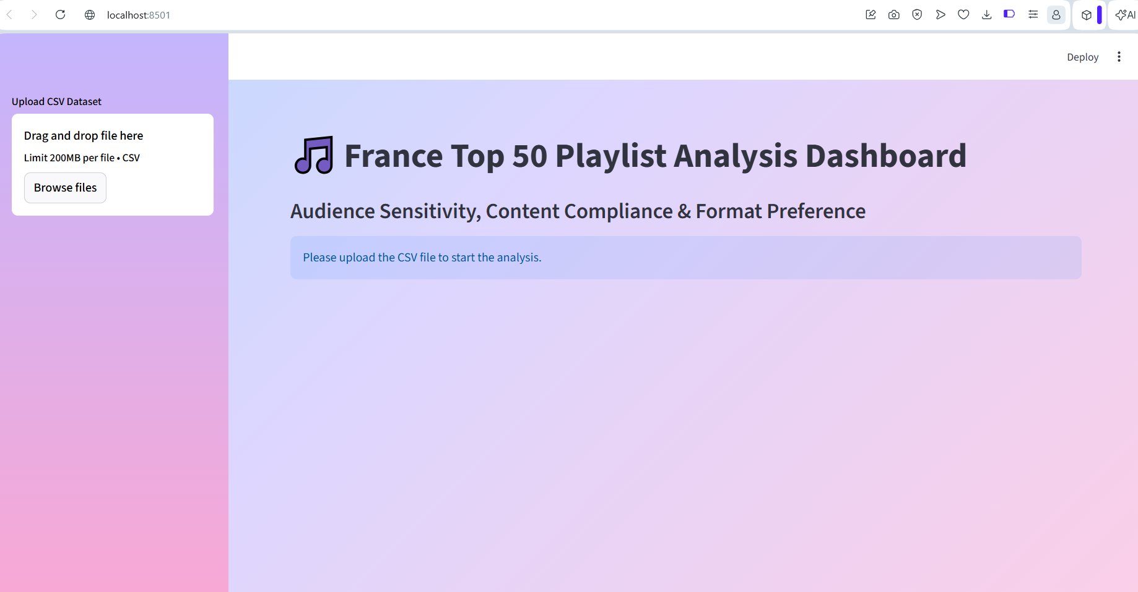
Fig1

Figure 2: Popularity Trend Over Time
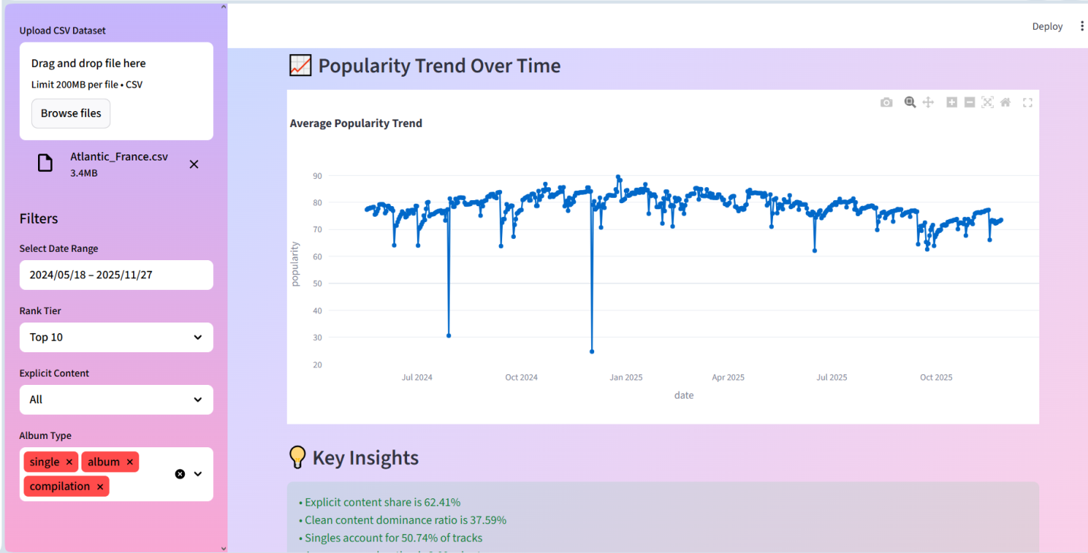
Fig 2

Figure 3: Explicit vs Clean Content Analysis
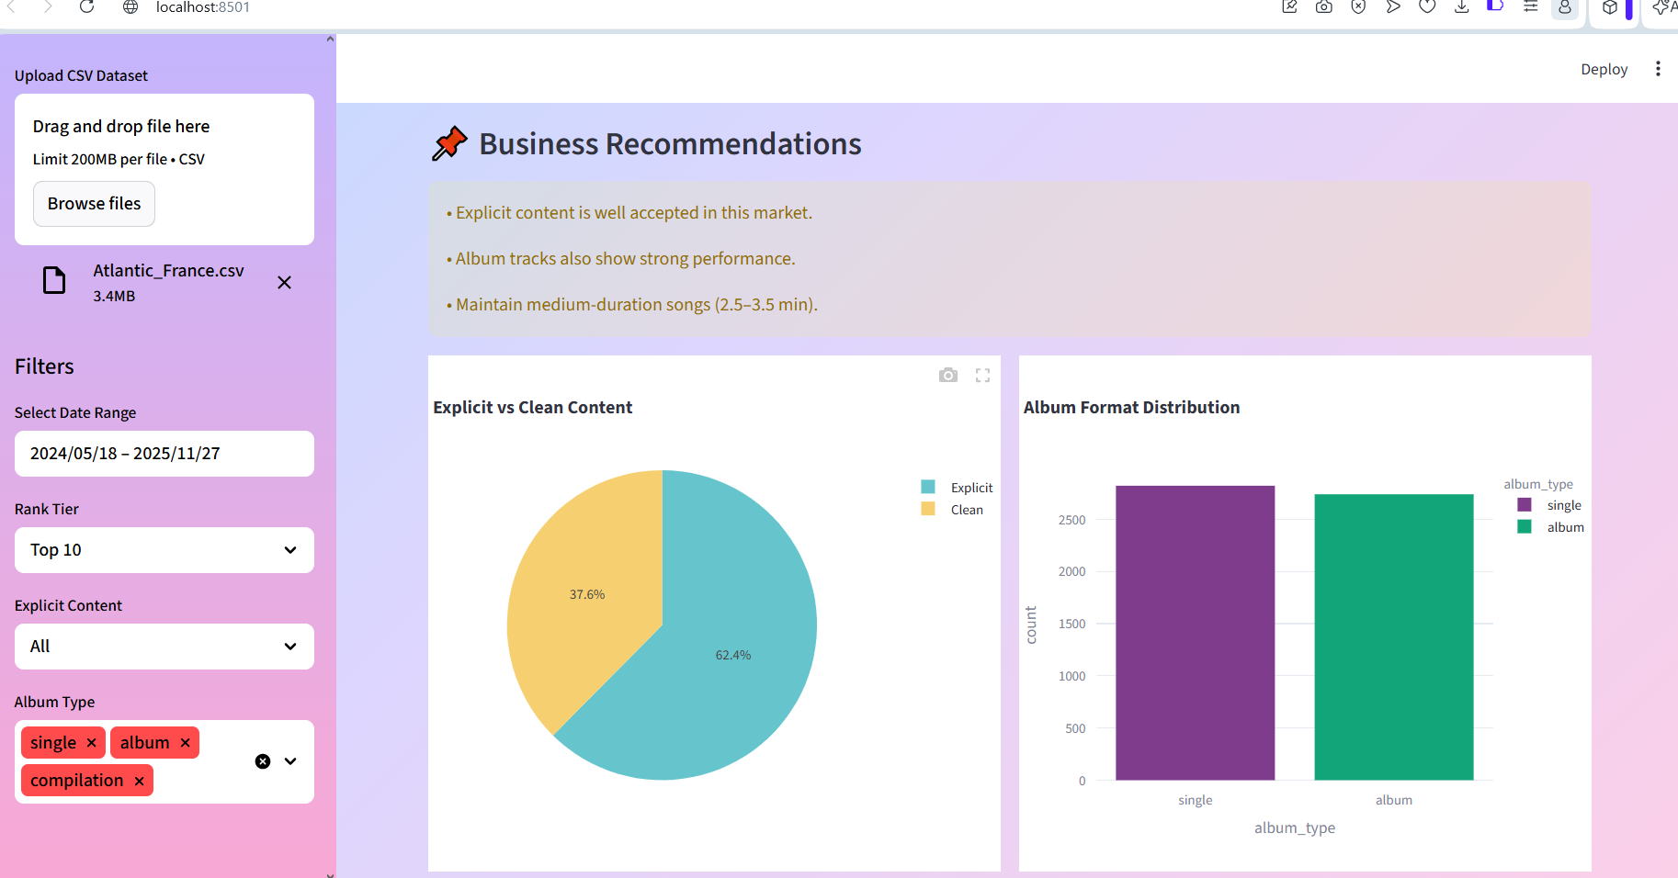
Fig1 3

Figure 4: Song Duration Distribution
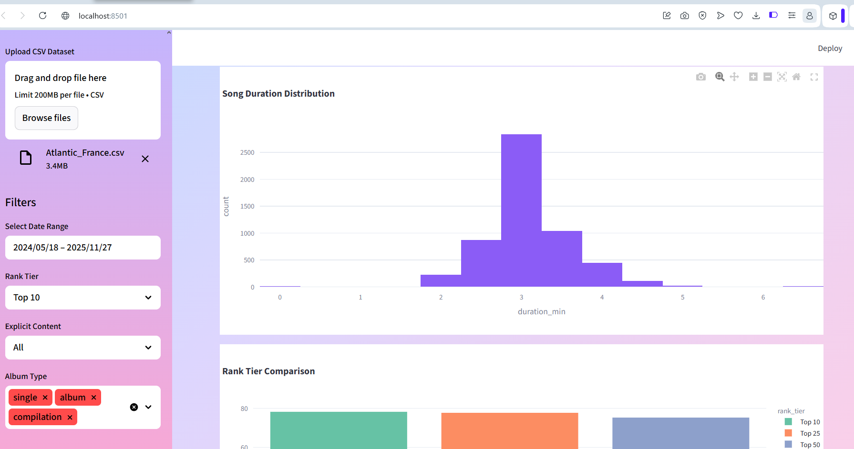
Fig 4

Figure 5: Rank Tier Comparison and dataset preview
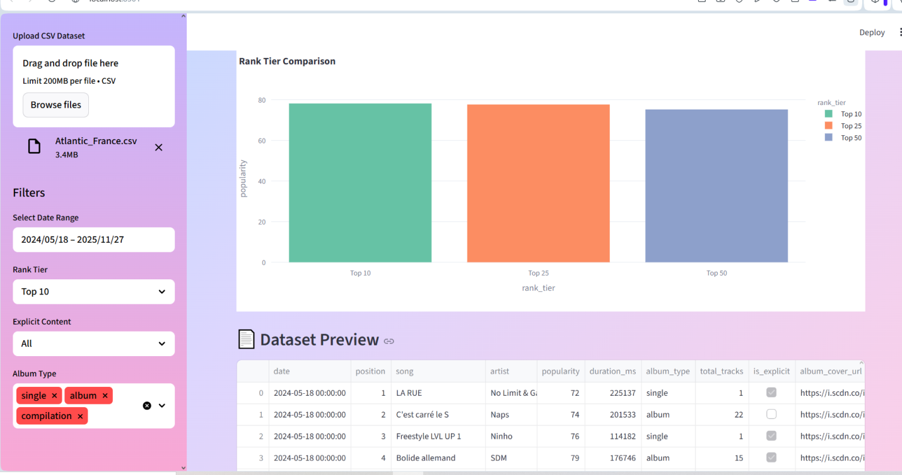
Fig 5

