AWS Cloud Analytics Pipeline: NYC Taxi Trip Data
Portfolio Project — Preethi Somaraju

Why This Project
Closes a real AWS skill gap identified from Preethi's actual target job postings — specifically S3, Glue, and Athena — building on her existing SQL and Python foundation. Rather than a generic tutorial exercise, the project topic was chosen by analyzing which in-demand skill was least represented in her existing portfolio.

Architecture / How It Works
The pipeline downloads the latest available month (May 2026) of NYC Taxi & Limousine Commission (TLC) yellow taxi trip data — a real, publicly available dataset — from its CloudFront-hosted endpoint, uploads it to a personal S3 bucket, catalogs the schema with an AWS Glue crawler, queries the cataloged table with Amazon Athena, and analyzes the results in Python using boto3 and pandas.
Important real-world correction discovered during the build: the public s3://nyc-tlc bucket denies direct S3 listing (s3:ListBucket) even to authenticated AWS accounts. The data is actually served through a public CloudFront endpoint instead, so the pipeline sources it from there and re-hosts it in a personally owned S3 bucket, which Glue and Athena can then list and query normally.
- Download latest month's Parquet file from the public CloudFront endpoint
- Upload to a personal S3 bucket
- AWS Glue crawler builds the Data Catalog schema automatically
- Amazon Athena runs serverless SQL queries against the cataloged table
- Results pulled into pandas via boto3 for analysis and visualization

Business Value
Demonstrates practical, hands-on AWS cloud data engineering skills — S3 data lake storage, Glue Data Catalog, and Athena serverless SQL — directly relevant to Data Analyst and Data Scientist job postings that list AWS as a required or preferred skill.

Key Findings
Metric | Value
Total trips (May 2026) | 4,038,773
Average trip distance | 4.98 miles
Average fare | $21.56
Average trip duration | 19.0 minutes
Peak hour | 6 PM (279,829 trips)
Quietest hour | 2 AM (55,893 trips)
Longest avg. trip duration | 3 PM (~22.8 min)
Shortest avg. trip duration | 2 AM (~14.0 min)
Trip volume peaks in the early evening (5–6 PM), consistent with the evening commute. Average trip duration peaks mid-afternoon (2–3 PM) despite shorter average trip distances during those hours, suggesting mid-afternoon traffic congestion rather than longer trips.
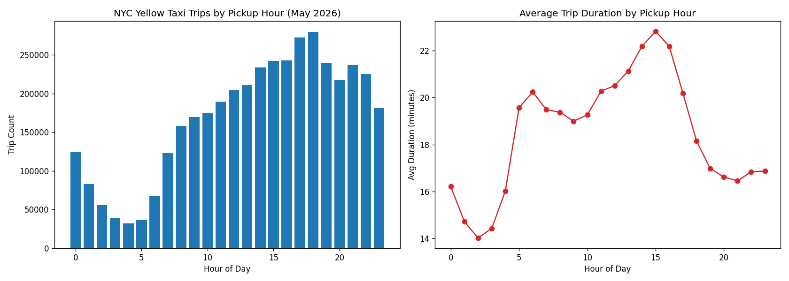

Tech Stack
AWS S3, AWS Glue, Amazon Athena, boto3, pandas, matplotlib, IAM Identity Center (SSO)

References
- AWS Open Data Registry — NYC TLC Trip Records: https://registry.opendata.aws/nyc-tlc-trip-records-pds/
- NYC TLC Trip Record Data documentation: https://www1.nyc.gov/site/tlc/about/tlc-trip-record-data.page

