*Steps to create ARFF file*

* Fill the details in a notepad and save it with .arff extension .
* Open the weka file now.
* Select the attributes and notice the values and a bar chart is shown to represent the values and attributes.
* Below is the sample data which is to written in notepad.

@relation students

@attribute rollnumber numeric @attribute name string @attribute Dept {cse,ece,eee,it} @attribute age numeric

@attribute year date "yyyy-mm-dd"

@data

1,preethi,cse,20,"2000-09-21" 2,preethi,eee,20,"2000-02-14"

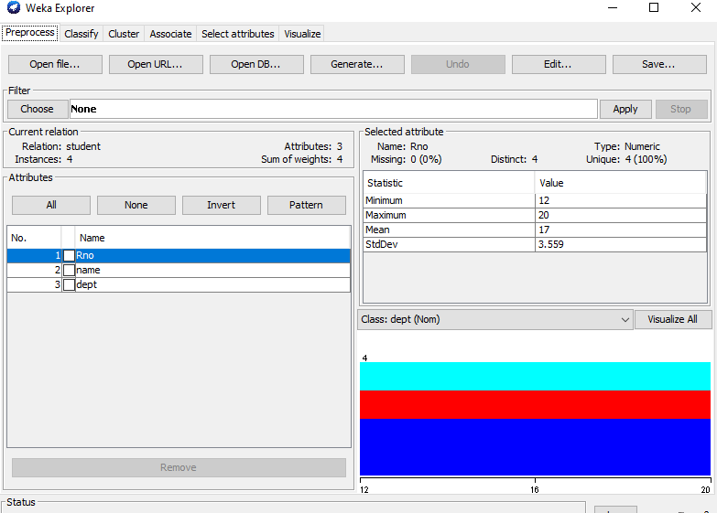

* Now select visualize all button.
* After visualizing it shows the histogram of all the attributes.
* The histogram chart is shown below:

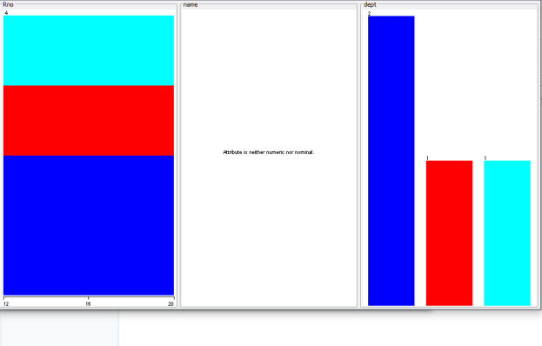

* Try to change the attribute values and check the difference.

