AI-Powered Adaptive Academic Guidance and Personalized Learning Platform
AD23731 Foundations of Agentic AI - Mini-Project Submitted by
PREETHI AH 231501121


Department of Artificial Intelligence and Mechine Learning

(An Autonomous Institution, Affiliated to Anna University, Chennai)

SEPTEMBER 2026

BONAFIDE CERTIFICATE
Certified that this mini-project report “An AI-Powered Adaptive Academic Guidance and Personalized Learning Platform “ is the Bonafide work of Preethi AH 231501121VII Semester, B.Tech. Artificial Intelligence and Machine learning Department in partial fulfilment of the requirements of the course AD23731 – Foundations of Agentic AI during the Academic Year 2026 – 2027.

Faculty in-charge

Submitted to mini-project viva voce examination held on: ………………………

INTERNAL EXAMINER EXTERNAL EXAMINER

TABLE OF CONTENTS
- Introduction 5
  - Background and Motivation 5
  - Need for Agentic AI 5
  - Project Objectives 5
- Problem Statement and Business Case 6
  - Problem Definition 6
  - Business and Real-World Context 6
  - Project Scope and Assumptions 6
- User and Stakeholder Analysis 7
  - Target Users 7
  - Stakeholder Identification 7
  - User Requirements 7
  - Typical User Journey 7
- Proposed Agentic AI Solution 8
  - Overall Solution & Tech Stack 8
  - Key Features 8
  - Agent-Based Approach 8
- Dataset / Knowledge Sources 9
  - Dataset Description & Data Flow 9
  - Tools and Technologies Used 9
  - Data Privacy and Handling 9
- Agent Architecture & Database Design 10
  - Agent Components & Tools 10
  - Agent Memory & Reasoning Flow 10
  - Relational Database Schema 11
- Agent Workflow, Orchestration & MCP 12
  - LangGraph Orchestration & Task Decomposition 12
  - Dynamic State Flush & Resilience Mechanics 12
  - Model Context Protocol (MCP) Integration 12
- System Implementation & Interfaces 13
  - Workflow Implementation 13
  - System Interfaces & Screenshots 13
  - Source-Code Repository 13
- Experimental Evaluation and Results 14
  - Evaluation Metrics & Methodology 14
  - Performance Results & Metric Achievement 14
  - Analysis and Discussion 14
- Comparison, Innovation and Scalability 15
  - Comparison with Baseline Approaches 15
  - Advantages, Innovation & Scalability 15
  - Limitations and Challenges 15
  - Source code repository 15
- Conclusion and Future Work 16
  - Conclusion 16

ABSTRACT
AcademicPilot AI is a web-based personalized academic guidance platform designed to support students through continuous, adaptive, and intelligent learning assistance. The system is designed using a multi-agent architecture in which a central Academic Coordinator works with specialized agents such as the Academic Detective Agent, Study Planner Agent, Resource Recommendation Agent, Mentor Agent, Examiner Agent, and Progress Monitor Agent. These agents collaboratively analyze the student’s academic performance, identify weak subjects and topics, recommend suitable learning materials, provide explanations, generate adaptive questions, evaluate responses, and update the learning path based on improvement.
The main feature of the system is its closed-loop learning process: Observe → Analyze → Plan → Learn → Practice → Evaluate → Update → Re-plan. A dynamic student state is maintained using topic mastery, accuracy, attempts, assessment history, and learning progress so that the system can decide what the student should study next. In addition to the student module, a Teacher/Admin Dashboard is provided for adding subjects and topics, uploading learning resources, managing questions, monitoring student performance, and reviewing AI recommendations and agent activities. This allows human academic supervision while the AI system performs personalized guidance.
The proposed implementation uses React for the frontend, FastAPI for the backend, LangGraph for agent orchestration, and SQLite/PostgreSQL for data storage, with RAG support for retrieving relevant study materials. The proposed system aims to function as a personal academic support team that continuously adapts to each student’s learning needs and progress.
Keywords: AcademicPilot AI, multi-agent systems, adaptive assessment, student state, retrieval-augmented generation, LangGraph, personalized academic guidance.

Report scope
This report develops the AcademicPilot AI project specification into a detailed system design, implementation plan and evaluation framework. Chapters 4 to 11 follow the organizational structure of the supplied EduAgent sample, while the technical content describes AcademicPilot AI. Numerical walkthroughs are illustrative; measured implementation results and application screenshots were not included in the supplied project text.

TABLE OF CONTENTS
Chapter | Title | Page
1 | INTRODUCTION | 5
2 | PROBLEM STATEMENT AND BUSINESS CASE | 6
3 | USER AND STAKEHOLDER ANALYSIS | 7
4 | PROPOSED AGENTIC AI SOLUTION | 8
5 | DATASET AND KNOWLEDGE SOURCES | 10
6 | AGENT ARCHITECTURE AND DATABASE DESIGN | 12
7 | AGENT WORKFLOW ORCHESTRATION AND RAG | 15
8 | SYSTEM IMPLEMENTATION AND INTERFACES | 18
9 | EXPERIMENTAL EVALUATION AND RESULTS | 21
10 | COMPARISON INNOVATION AND SCALABILITY | 24
11 | CONCLUSION AND FUTURE WORK | 26

List of figures
Figure 4.1 AcademicPilot AI system architecture
Figure 6.1 Core database relationships
Figure 7.1 Conditional agent workflow
Figure 7.2 Resource ingestion and grounded tutoring
Figure 8.1 Student dashboard interface design

List of tables
Tables 4.1–4.2 Technology stack and agent responsibilities
Tables 5.1–5.2 Knowledge sources and data controls
Tables 6.1–6.3 Student state and relational schema
Tables 7.1–7.2 Routing policy and mastery bands
Tables 8.1–8.3 Modules, APIs and interfaces
Tables 9.1–9.3 Metrics, test cases and illustrative results
Table 10.1 Comparison with baseline approaches

CHAPTER 1 INTRODUCTION

1.1 Background and Motivation
Students have different learning abilities, strengths, and weaknesses. A fixed learning path may not be suitable for every learner. For example, a student may perform well in one DBMS topic but struggle repeatedly with another topic such as Normalization. The motivation behind AcademicPilot AI is to create a system that can recognize these differences and provide personalized academic support.
The system tracks information such as topic mastery, quiz accuracy, previous mistakes, assessment history, attempts, and learning progress. Based on this information, it can recommend what the student should study next, whether more explanation is needed, or whether the difficulty should be increased or decreased. This helps students receive support according to their actual learning condition.

1.2 Need for Agentic AI
A normal chatbot mainly follows a simple pattern: Student → Question → Answer. However, academic guidance requires continuous observation, planning, evaluation, and decision-making. Agentic AI is useful because different academic responsibilities can be handled by specialized agents while a central coordinator decides which agent should act next.

1.3 Project Objectives
The main objective of AcademicPilot AI is to develop a personalized and adaptive academic guidance platform. The system aims to identify weak subjects and topics, maintain a dynamic student state, recommend suitable learning resources, generate adaptive questions, evaluate performance, track improvement, and automatically re-plan learning activities. It also provides a Teacher/Admin Dashboard for managing subjects, topics, resources, questions, and student progress.

CHAPTER 2 PROBLEM STATEMENT AND BUSINESS CASE

2.1 Problem Definition
The main problem is the lack of adaptive and continuous academic support for individual students. Traditional systems generally provide static content, fixed assessments, or simple chatbot-based assistance. They do not continuously track topic mastery, repeated mistakes, assessment history, or improvement over time.
AcademicPilot AI solves this problem by maintaining a dynamic student state and using multiple specialized AI agents to identify weak topics, recommend suitable learning materials, generate adaptive questions, evaluate student performance, and re-plan the learning path. The system therefore changes its guidance according to the student’s latest academic condition rather than following a fixed sequence.

2.2 Business and Real World Context
The proposed system can be useful in colleges, schools, online learning platforms, coaching centres, and training organizations where teachers need to support many students with different learning requirements. Manually monitoring every student’s topic-level progress can be difficult and time-consuming.
AcademicPilot AI can assist teachers by automatically identifying weak areas, tracking student progress, and suggesting suitable interventions. The Teacher/Admin Dashboard allows educators to manage subjects, topics, questions, and learning resources while monitoring student performance. This can reduce repetitive academic monitoring work and provide students with more timely support.

2.3 Project Scope and Assumptions
The scope of the project includes student registration and authentication, dynamic subject and topic management, personalized academic state tracking, weakness identification, study planning, resource recommendation, mentor support, adaptive assessment generation, performance evaluation, progress monitoring, and automatic re-planning. A Teacher/Admin Dashboard is also included for content management and student supervision.

CHAPTER 3 USER AND STAKEHOLDER ANALYSIS

3.1 Target Users
The primary users of AcademicPilot AI are students, self-learners, and educators. Students use the system to understand difficult concepts, identify weak topics, practice adaptive questions, and monitor their academic improvement. Self-learners can use the platform to study different subjects independently and receive guidance based on their current mastery level. Teachers and administrators use the system to add subjects and topics, upload learning resources, manage questions, monitor student performance, and review AI recommendations.

3.2 Stakeholder Identification
Stakeholder | Role and interest
Student/Learner | Registers in the system, selects subjects, learns topics, asks the Mentor Agent for explanations, completes adaptive assessments, and views progress.
Teacher /Admin | Adds subjects and topics, uploads learning materials, manages questions, and monitors weak topics and student progress.
Academic Coordinator Agent | Controls the multi-agent workflow and decides whether the student should learn, practice, review, reassess, or move to the next topic
Project Team | Develops and maintains the frontend, backend, database, LangGraph workflow, RAG module, agents, and system configuration.
Project Supervisor | Reviews the architecture, implementation, agent coordination, academic relevance, and project results.
LLM / AI Service | Supports explanation, question generation, recommendations, and other intelligent agent activities through a configurable AI mode

3.3 User Requirements
The student should be able to create an account, log in, view the academic dashboard, and enroll in any available subject. The learner should be able to open a topic, receive personalized explanations, access recommended learning materials, and complete questions at different difficulty levels. The system should automatically evaluate student responses, record mistakes, update topic mastery, and recommend the next suitable learning action.

CHAPTER 4 PROPOSED AGENTIC AI SOLUTION

4.1 Overall Solution and Technology Stack
AcademicPilot AI organizes academic guidance around a persistent record of each learner’s goals, topic knowledge and previous responses. The Academic Brain selects an appropriate specialist agent, receives its structured result and decides the next action. The learner can therefore move between explanation, practice and review as new evidence becomes available.
React with Tailwind CSS is selected for the student and teacher interfaces. FastAPI provides the backend boundary, while LangGraph represents agent state and conditional transitions. SQLite supports a local prototype; PostgreSQL is the intended relational option for a shared deployment. ChromaDB holds embeddings for approved learning materials. Model and embedding providers remain configurable.
Table 4.1 Selected technology stack
Layer | Selection | Project responsibility
Frontend | React and Tailwind CSS | Separate student and teacher views; dynamic subject and topic lists.
Backend | Python and FastAPI | Validate requests, enforce access and expose learning operations.
Orchestration | LangGraph | Pass shared state and route to the required agent.
Relational data | SQLite or PostgreSQL | Persist users, attempts, plans and progress.
Retrieval | ChromaDB and configurable embeddings | Find relevant chunks from approved academic resources.
Generation | Configurable LLM API | Produce explanations, questions and rubric-based feedback.

4.2 Key Features
The system combines weakness detection, personalized planning, document-grounded explanations, adaptive assessment and progress tracking. Teachers manage the subject catalogue, resources and questions, and can review learner progress and agent activity. Students access the original learning resource alongside the guidance derived from it.
Subjects, topics, subtopics and questions are stored as records rather than fixed interface slots. Additional practice is requested when the available evidence is insufficient. Session limits, pagination and rate controls can bound each operation without imposing a permanent five-subject or five-question limit.

4.3 Agent Based Approach
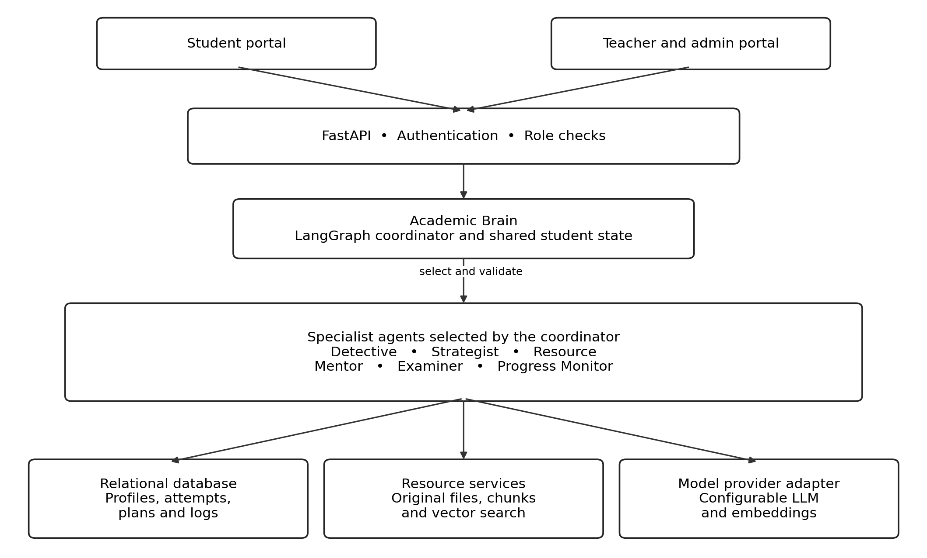
Figure 4.1 AcademicPilot AI system architecture
The diagram groups services and agent responsibilities. It is a component view; the conditional execution routes are shown in Figure 7.1. The coordinator can reuse an existing diagnosis or plan and does not need to invoke every specialist on each request. An external LLM is accessed through a backend provider adapter.
Table 4.2 Responsibilities of the seven agents
Agent | Main responsibility
Academic Brain | Select the next action from the current state and coordinate specialist outputs.
Academic Detective | Identify weak concepts, recurring errors and changes in performance.
Strategist | Create and revise a feasible plan using goals, deadlines and study time.
Resource Agent | Retrieve authorized learning material relevant to the concept and level.
Mentor | Explain the concept, provide an example and check understanding.
Examiner | Generate targeted questions and evaluate responses using suitable rules.
Progress Monitor | Update performance history and report improvement or regression.

CHAPTER 5 DATASET AND KNOWLEDGE SOURCES

5.1 Knowledge Sources and Data Flow
AcademicPilot AI is specified as an application built around a pretrained language model, approved learning resources and evolving student records. The supplied project does not identify a public training dataset or a model fine-tuning experiment. Its operational data consists of resources entered by teachers and interactions produced while learners use the application.
Table 5.1 Knowledge sources and their use
Source | Stored information | Use in the system
Academic profile | Goals, study time, subject enrolments and learning level | Initial planning and choice of explanation depth.
Subject catalogue | Subjects, topics, subtopics and objectives | Scope lessons, resource search and assessment.
Learning resources | PDFs, notes, examples, links and document metadata | Retrieve evidence and present the original material.
Question records | Type, topic, difficulty, answer key and explanation | Provide reviewed items and validate generated questions.
Interaction history | Answers, scores, mistakes, timestamps and completion | Update mastery and target repeated errors.
Teacher input | Corrections, approved resources and progress review | Supervise learning content and resolve uncertain grading.
Demonstration records | Example students, subjects and assessment histories | Show application behavior without claiming study results.

During a learning request, the backend combines the current topic state with relevant resource chunks. The selected agent produces a result that is validated before it is returned or persisted. A submitted assessment creates new evidence, updates the topic state and may trigger a revised recommendation.

5.2 Resource Preparation
Each upload is associated with a subject, topic, owner and access scope. Text extraction preserves document and page identifiers. The extracted content is divided into overlapping chunks and embedded for similarity search. Chunk size, overlap, retrieval count and embedding model are configuration choices to be evaluated on the project corpus; values from the EduAgent sample are not treated as AcademicPilot settings.

5.3 Data Privacy and Handling
The relational database stores authoritative student and assessment records. The vector index contains searchable representations of resource text, and the file store retains the source documents needed by the student viewer. Keeping these responsibilities separate makes deletion, replacement and access checks easier to manage.
Table 5.2 Required controls for project data
Data category | Required handling
Student identity and credentials | Hash passwords, verify sessions and restrict profile access to the owner or authorized staff.
Student progress | Filter queries by authorized student and course scope; do not trust an arbitrary student ID from the client.
Learning documents | Validate type and size; retain ownership and visibility metadata for both files and chunks.
Model requests | Send only the information needed for the current task; exclude passwords and service credentials.
API keys | Read server-side configuration; never send provider secrets to the browser.
Activity records | Store task summaries, routing decisions and error status; avoid retaining private reasoning or credentials.
Deletion and replacement | Remove or invalidate corresponding chunks, file references and dependent recommendations.

5.4 Data Quality and Evaluation Separation
Uploaded materials may contain outdated explanations, missing pages or extraction errors. The ingestion process should expose whether a file is ready, empty, failed or awaiting review. A scanned PDF requires OCR support before its text can be retrieved; an empty extraction must not be presented as a successfully searchable document.
A retrieval evaluation set should pair held-out questions with teacher-identified relevant passages. Question-generation checks should use topics and prompts that were not used to tune the templates. A learning-outcome study needs a separate pre-test and post-test, with question equivalence and participant conditions recorded. Reusing the same quiz as both training practice and final evaluation would overstate improvement.

5.5 Scope of Learning
The application adapts by updating student records, plans and retrieval context. This is different from retraining the language model after every answer. Unless a separate fine-tuning pipeline is introduced and evaluated, the model parameters remain unchanged while the learner-specific state evolves.

CHAPTER 6 AGENT ARCHITECTURE AND DATABASE DESIGN

6.1 Agent Components and Communication
Each specialist receives a bounded task from the coordinator. A request identifies the student, topic, session, state version and purpose of the action. The response contains a structured result, evidence references, completion status and any validation error. This protocol supports explicit handoffs without requiring every agent to exchange unrestricted text with every other agent.
For example, the Detective may report repeated errors involving partial dependency. The coordinator passes that diagnosis to the Strategist, which requests a short revision activity. The Resource Agent locates relevant notes, the Mentor explains the example, and the Examiner produces a question aligned with the same weakness. The Monitor then records the resulting evidence.

6.2 Agent Memory and Reasoning Flow
Table 6.1 Student state and memory design
State group | Representative fields | Persistence
Identity and goal | student_id, goal_id, target_score, exam_date | Relational profile and goals.
Topic evidence | topic_id, attempts, accuracy, mastery, weak_concepts | Topic progress and attempt history.
Learning context | difficulty, recent_mistakes, resource_ids, plan_item_id | Persist relevant values; load per request.
Working state | request_id, intent, selected_agent, outputs, errors | Bounded workflow state.
Session context | session_id, active_topic, activity_status | Learning session record.
Audit evidence | agent, action, reason_summary, duration, state_version | Agent log linked to the session.

A workflow reads the latest state, performs an authorized action, validates its output and commits the resulting change. Durable memory is stored in the database rather than relying entirely on conversation history. When a student returns in a later session, the coordinator reloads the relevant topic evidence and latest plan.

6.3 Consistency Rules
Each assessment submission needs a unique identifier so that a repeated network request does not count the same attempt twice. The score, progress update and performance snapshot should be committed together. Concurrent requests must check the current state version or use an equivalent transaction strategy before replacing the mastery value.

6.4 Relational Database Schema
Table 6.2 Identity curriculum and resource entities
Entity | Important fields | Relationship or constraint
users | id PK, name, email, password_hash, role | Unique email; role controls permitted operations.
students | id PK, user_id FK, academic_level | One student profile per learner account.
subjects | id PK, name, description | Independent catalogue records.
topics | id PK, subject_id FK, name, objective | Many topics belong to one subject.
subtopics | id PK, topic_id FK, name | Many subtopics belong to one topic.
student_subjects | student_id FK, subject_id FK, enrolled_at | Unique student and subject pair.
learning_resources | id PK, topic_id FK, owner_id FK, type, file_ref, status | Original file and its authorized scope.
resource_chunks | id PK, resource_id FK, page, text_ref, vector_id | Links vector matches back to a source resource.
questions | id PK, topic_id FK, subtopic_id FK, type, text, options, answer, difficulty | Store provenance and reviewed status; subtopic may be optional.

Table 6.3 Learning assessment and audit entities
Entity | Important fields | Relationship or constraint
question_attempts | id PK, student_id FK, question_id FK, session_id FK, answer, score, submitted_at | Unique submission key prevents double counting.
student_topic_progress | student_id FK, topic_id FK, mastery, accuracy, attempts, difficulty, version | One current state per student and topic.
learning_sessions | id PK, student_id FK, topic_id FK, started_at, status | Groups related learning actions.
study_plans and items | plan_id, student_id FK, goal_id FK; item_id, topic_id FK, action, status | A plan has many ordered activities.
student_goals | id PK, student_id FK, target, deadline | Several goals may belong to one learner.
performance_history | id PK, student_id FK, topic_id FK, mastery, recorded_at | Append timestamped progress snapshots.
recommendations | id PK, student_id FK, topic_id FK, action, rationale | Retain the selected next step and its context.
agent_logs | id PK, session_id FK, agent, task, status, duration | Trace each agent action to a learning session.

6.5 Database Relationships
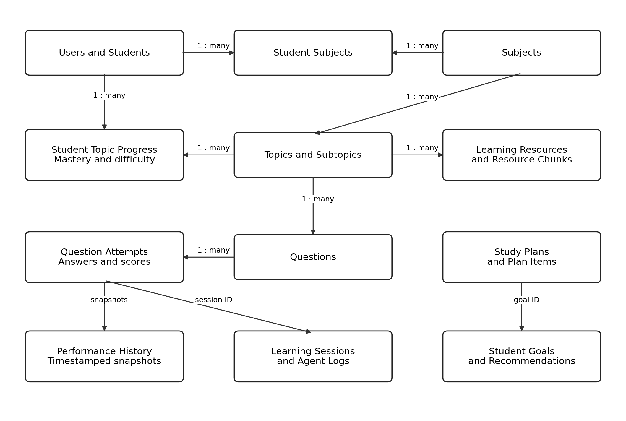
Figure 6.1 Core database relationships
The diagram highlights the main paths through the schema; Table 6.2 and Table 6.3 describe the full logical entity groups. Student Subjects resolves the many-to-many relationship between learners and subjects. Student Topic Progress similarly associates a learner with each topic being studied.

6.6 Dynamic Growth and Referential Integrity
Adding a new subject creates a new row and does not require an additional database column or a frontend redesign. Topic and question queries use identifiers, filters and pagination. This satisfies the requirement for flexible content growth while acknowledging that every deployment still has storage and processing limits.
Question attempts preserve the question version or a snapshot of the graded content so that later edits do not alter historical scores. If a resource is withdrawn, its indexed chunks must no longer appear in retrieval results. Removing a topic with existing assessment history should use an archival policy or an explicit dependency check rather than silently discarding learner evidence.

CHAPTER 7 AGENT WORKFLOW ORCHESTRATION AND RAG

7.1 Task Decomposition and Conditional Routing
The learning cycle is Observe, Analyze, Plan, Learn, Practice, Evaluate, Update and Re-plan. These stages describe progress across interactions; they do not require one HTTP request to continue indefinitely. A request ends after it returns a lesson, questions, feedback or a recommendation. The next learner action resumes the cycle with newly persisted state.
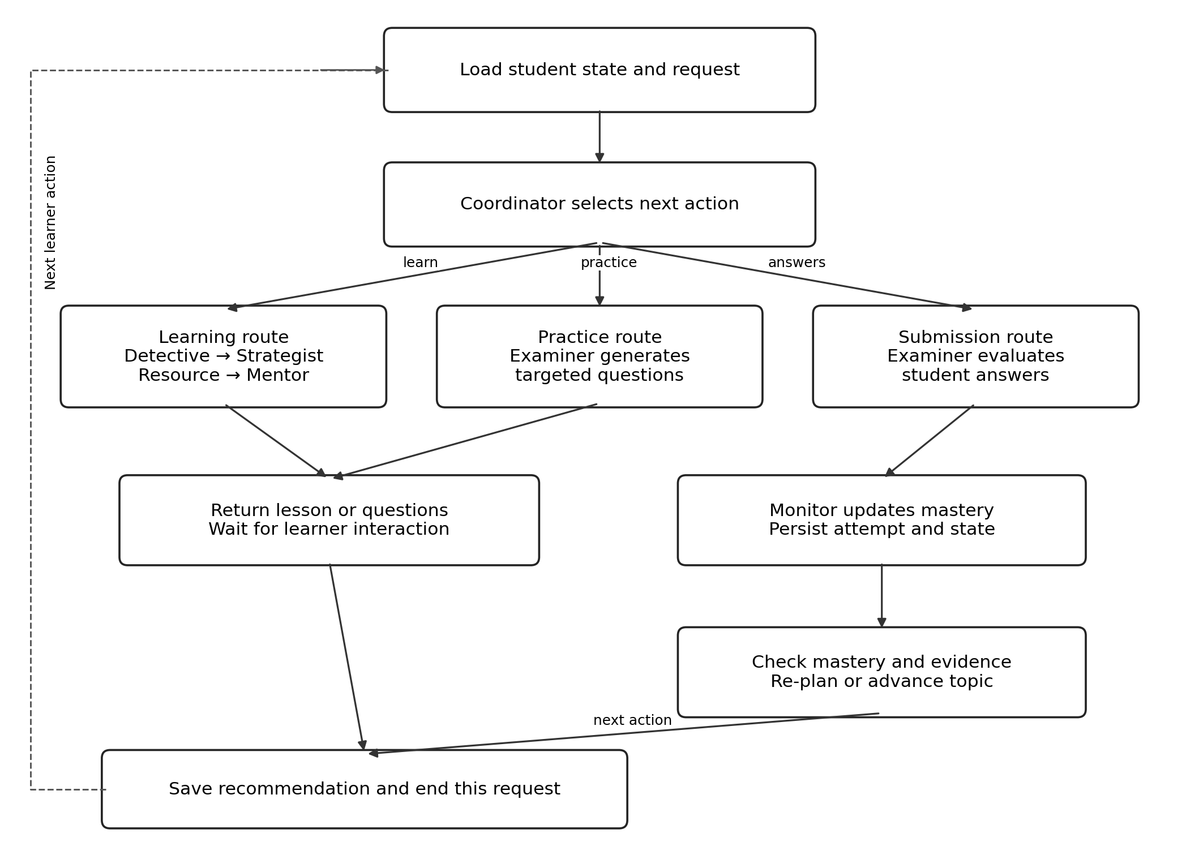
Figure 7.1 Conditional agent workflow
The coordinator first checks the requested action and available evidence. A question about a concept enters the learning route; a practice request enters question generation; a submitted answer enters evaluation. The next recommendation is recorded after the relevant result has been validated.

7.2 Agent Selection and Replanning Policy
Table 7.1 Proposed routing policy
Condition | Selected action | Expected state effect
No usable topic history | Run diagnosis or a short baseline assessment | Establish initial evidence without assuming zero ability.
Weak topic with repeated errors | Detective, Strategist, Resource and Mentor | Create a focused revision activity.
Student requests practice | Examiner | Generate a bounded batch matched to the current need.
Student submits answers | Examiner then Monitor | Save score, update mastery and record mistakes.
Mastery improves but evidence is limited | Continue targeted practice | Collect further evidence at a suitable difficulty.
Mastery and evidence requirements are met | Increase challenge or select the next topic | Record a reason for progression.
Performance declines | Re-diagnose and revise the plan | Return to a weak concept or prerequisite.
Provider failure or invalid output | Return a recoverable error or reviewed fallback | Avoid recording unvalidated content as success.

7.3 Mastery Calculation
A transparent starting policy combines overall accuracy, recent performance and a designated assessment score. Let A be topic accuracy, R be accuracy over a configured recent window and E be the latest assessment percentage. A proposed mastery value is:
M = wA × A + wR × R + wE × E, with wA + wR + wE = 1.
For an illustrative configuration, wA = 0.50, wR = 0.25 and wE = 0.25. When A = 60, R = 80 and E = 72, the result is M = 68. A missing component is excluded and the remaining weights are normalized; missing evidence should not automatically be scored as zero. The weighting is a design choice, not a validated measure of knowledge.
Table 7.2 Proposed configurable mastery bands
Mastery value | Interpretation | Default next action
0 ≤ M ≤ 40 | Beginner or weak evidence of mastery | Explanation and basic practice.
40 < M ≤ 60 | Developing | Target repeated mistakes.
60 < M ≤ 80 | Good progress | Mixed practice and application.
80 < M ≤ 100 | Candidate for mastery | Check evidence sufficiency before progression.

7.4 Retrieval Augmented Generation
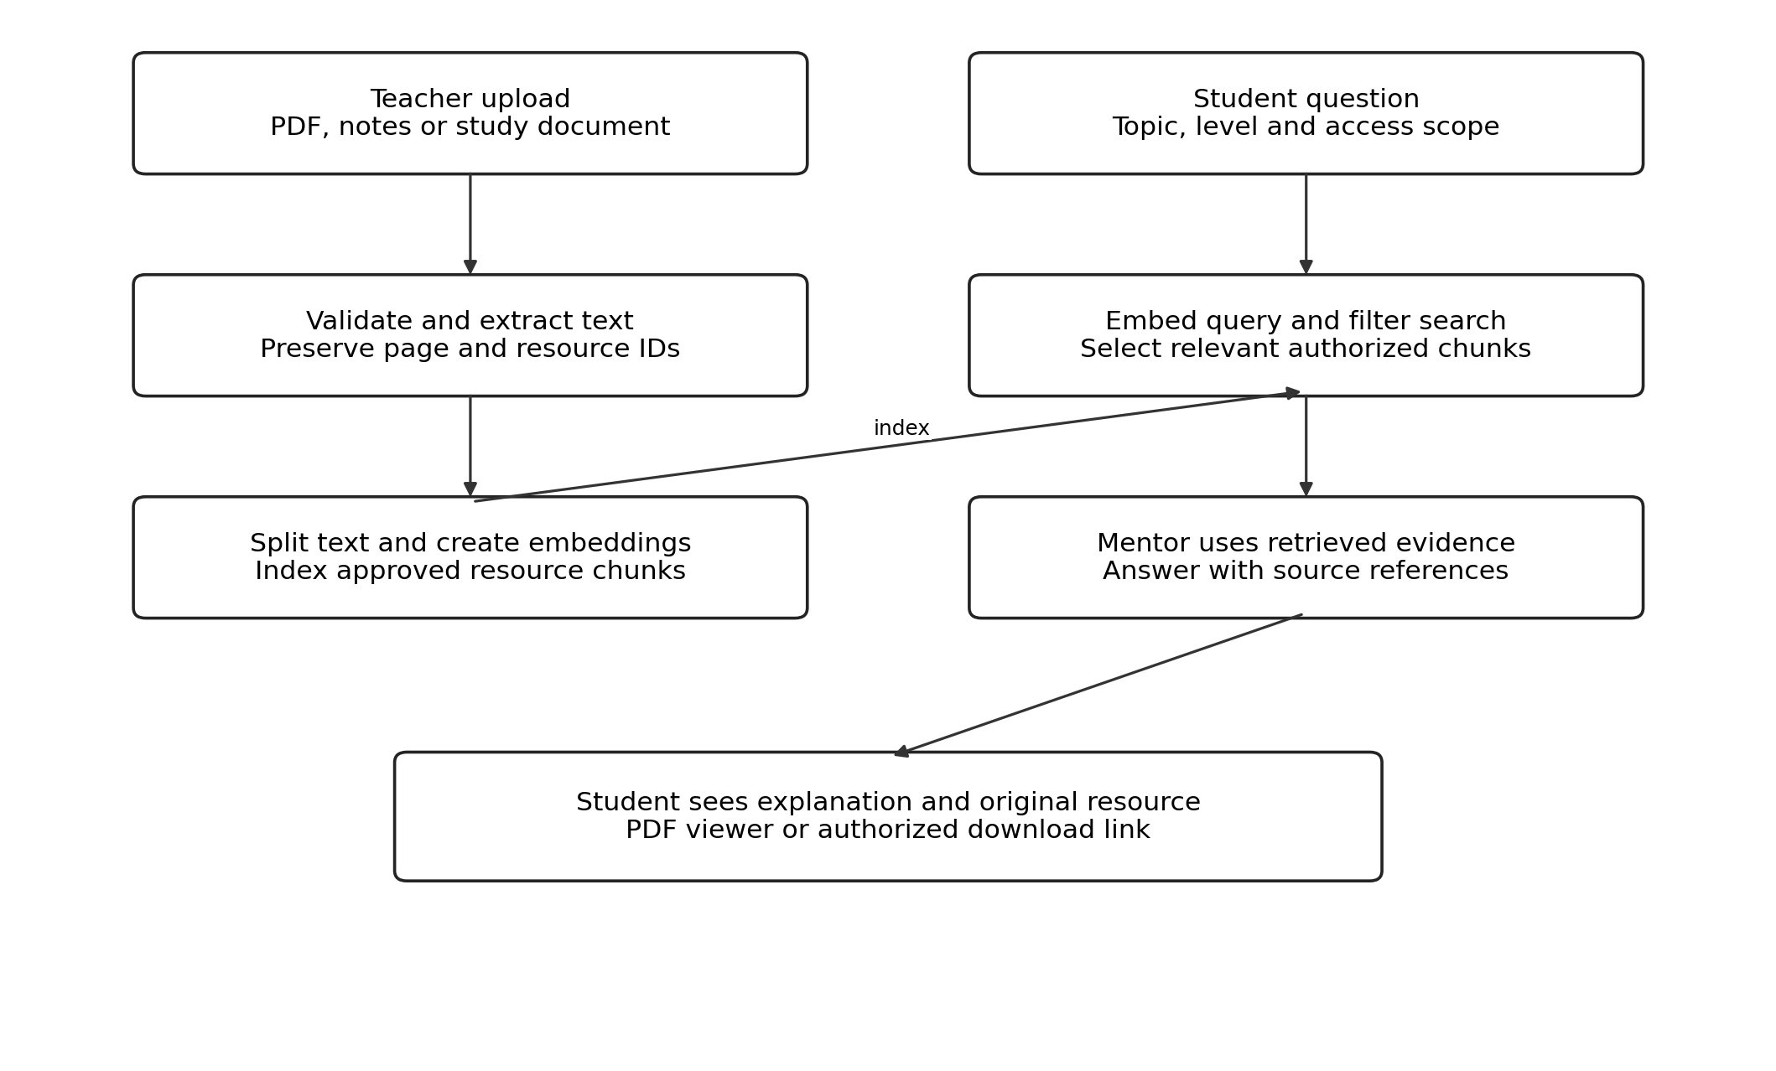
Figure 7.2 Resource ingestion and grounded tutoring
The Resource Agent searches within the student’s authorized subject and topic scope. The Mentor receives selected passages with their source identifiers and explains the requested concept at the learner’s current level. A source link allows the student to inspect the original PDF or other resource. A retrieval miss should be reported clearly rather than presenting an invented passage as a citation.

7.5 Adaptive Questions and Stopping Conditions
Question generation includes the learning objective, current difficulty, repeated mistakes and recently used items. The response is checked for a supported question type, an answer key, consistent options and a usable explanation. Objective responses are graded against stored rules. Open-ended responses require a rubric, a reasoned score summary and a path for teacher review when grading is uncertain.
The number of questions is adjustable for each activity. Additional batches can be offered until the evidence requirement is met, the student chooses to stop, or a configured time or attempt budget is reached. Progress is saved at each boundary. This supports continued practice without forcing an endless automated loop or interpreting repeated retries as independent proof of mastery.

CHAPTER 8 SYSTEM IMPLEMENTATION AND INTERFACES

8.1 Implementation Organization
The following implementation specification translates the supplied project requirements into modules and interfaces. It does not assert that a source repository or running deployment was inspected. React pages communicate with FastAPI; backend services encapsulate persistence, retrieval and provider access; agent nodes exchange typed state through the workflow.
Table 8.1 Proposed implementation modules
Module | Responsibilities
frontend | Authentication pages, student views, teacher tools and progress displays.
backend/agents | Coordinator, Detective, Strategist, Resource, Mentor, Examiner and Monitor.
backend/workflows | Conditional graph transitions, state schema and bounded execution.
backend/api | Authenticated routes for subjects, resources, assessments and plans.
backend/models and database | Relational entities, queries, migrations and transaction handling.
backend/rag | Extraction, chunking, embeddings, filtering and source attribution.
backend/services | Grading rules, mastery policy, provider adapter and file access.
tests and demo data | Repeatable fixtures, test scenarios and labelled demonstration records.

8.2 Learning Workflow Implementation
A learning request is authenticated before the backend loads the learner and topic. The coordinator evaluates the request against the latest state, executes the required route and validates the returned result. Only the fields required by the user interface are exposed. Agent activity is recorded with request and session identifiers for later review.
Assessment submission first verifies ownership of the activity and checks for a duplicate submission. The Examiner evaluates each item using the stored scoring method. The Monitor recalculates progress and appends a history snapshot. The coordinator then stores a recommendation such as revise a concept, continue practice or attempt a harder activity.
Resource ingestion is separated from viewing. An uploaded PDF remains available through a controlled file endpoint after indexing. The student resource screen displays processing status and opens the original file. Extracted text used for RAG is therefore an additional capability rather than a replacement for the learning document.

8.3 Proposed API Contracts
Table 8.2 API operations and access boundaries
Method and path | Purpose | Authorized role
POST /api/auth/register | Create a learner account with validated profile data. | Public registration policy
POST /api/auth/login | Authenticate and return a session credential. | Registered user
GET /api/me/dashboard | Read the current learner’s progress and next action. | Student
GET /api/subjects | List accessible subjects with pagination. | Student or teacher
GET /api/subjects/{id}/topics | List topics within an authorized subject. | Student or teacher
POST /api/learning/turn | Request explanation, planning or learning support. | Student
POST /api/assessments | Generate a targeted question batch. | Student
POST /api/assessments/{id}/submit | Submit answers once and receive feedback. | Assessment owner
GET /api/me/progress | Read topic scores and historical snapshots. | Student
POST /api/resources | Upload a subject or topic learning resource. | Teacher or admin
GET /api/resources/{id}/file | View or download an authorized original file. | Authorized learner or staff
POST /api/admin/subjects | Create a subject without changing the schema. | Teacher or admin by policy
GET /api/admin/students/{id}/progress | Review learner progress within teaching scope. | Authorized teacher or admin
GET /api/admin/agent-logs | Inspect action summaries and execution status. | Authorized staff

These route names are proposed contracts for AcademicPilot AI. They should be aligned with the actual backend during implementation. A response should include the requested data, status and a trace identifier; validation failures should return actionable messages without disclosing internal secrets.

8.4 Configuration and Deployment
The local configuration specifies database location, provider credentials, embedding model, resource directory and allowed frontend origins. A demo configuration uses clearly labelled fixtures or a deterministic provider. Live model behavior and demo behavior must remain distinguishable in the interface and evaluation records. Shared deployment additionally requires HTTPS, backups and controlled service access.

8.5 System Interfaces
Table 8.3 Required pages and visible behavior
Interface | Content and actions
Login and registration | Validate inputs, display access errors and route by role.
Student dashboard | Show current subjects, mastery, weak topics, goals and the next activity.
My Subjects and Topic Details | Search subjects; open topic objectives, resources and recent evidence.
Learn and Ask Mentor | Display explanations, examples, source links and a short understanding check.
Practice and Assessment | Render supported question types, save responses and show feedback after submission.
Study Plan and Goals | Show ordered tasks, available study time, deadlines and reasons for revisions.
Resources | Open an authorized original PDF or resource link and display ingestion status.
Progress | Show attempts, difficulty, historical mastery and recurring errors.
Teacher dashboard | Manage subjects, topics, resources and questions; inspect learner progress.
Agent Activity | Show specialist actions, concise decision summaries and execution status.

8.6 Student Dashboard Design
The dashboard emphasizes the next useful learning action. Subject cards are data-driven, with search or scrolling when the catalogue grows. A weak-topic panel links directly to the relevant learning activity. Progress values are displayed with their time range so that a student can distinguish a recent quiz result from overall topic mastery.

Figure 8.1 Student dashboard interface design, not a captured application screen

CHAPTER 9 EXPERIMENTAL EVALUATION AND RESULTS

9.1 Evaluation Methodology
Evaluation must distinguish correct software behavior from effective teaching. Routing, data persistence and access control can be checked with deterministic fixtures. Retrieval and generated content require reference answers and human review. Evidence of improved student learning requires a separate participant study. The supplied project text contains illustrative scenarios but no executed benchmark logs or measured learning outcomes.
Table 9.1 Evaluation metrics and required evidence
Metric | Calculation or method | Evidence required
Routing correctness | Correct selected routes divided by tested cases | Expected route for each controlled state and intent.
Question validity | Valid items divided by generated items | Checks for objective, type, key, options and explanation.
Objective grading accuracy | Correct grading decisions divided by reviewed decisions | Teacher-approved answers and edge cases.
Retrieval recall at k | Relevant chunks retrieved divided by all relevant chunks | Held-out queries with labelled relevant chunks.
Citation support | Supported factual claims divided by reviewed factual claims | Human review against cited resource passages.
State persistence | Correct saved and reloaded fields divided by checked fields | Before-and-after snapshots across sessions.
Response latency | Median and 95th-percentile elapsed request time | Timed runs with provider and workload recorded.
Workflow completion | Successful complete cycles divided by attempted cycles | Learn, practice, submit, update and re-plan traces.
Learning gain | Post-test percentage minus pre-test percentage | Equivalent assessments and documented study conditions.

9.2 Experimental Conditions
Each run should record the application version, model provider, model identifier, database, resource corpus, hardware and number of requests. Demo and live-provider results should be reported separately. Retrieval parameters and mastery thresholds must be fixed before comparing alternatives. Failed or timed-out requests must remain in the reported totals.
The baseline comparison should hold resources, topics and evaluation questions constant. A fixed-path version can then be compared with the adaptive workflow to examine whether state-based interventions improve the selected outcome. No superiority claim is justified until those observations are collected.

9.3 Functional Test Cases
Table 9.2 Test specification and acceptance criteria
ID | Scenario | Expected result
T01 | Register a new valid learner | A separate learner profile is created and login succeeds.
T02 | Add more than five subjects and topics | All records remain accessible through search or pagination.
T03 | Open another learner’s assessment by changing its ID | Access is denied; no private answers are disclosed.
T04 | Upload a readable PDF and open it as a student | Authorized original PDF is visible; indexed passages retain sources.
T05 | Upload an empty or unsupported file | A clear error or review status appears; no false ready status.
T06 | Request help for a known weak concept | The learning route uses relevant history and topic context.
T07 | Request additional practice after poor performance | A new targeted batch is offered without a fixed five-item cap.
T08 | Submit the same assessment twice | Only one counted submission and state update are recorded.
T09 | Resume after logout or restart | Saved mastery, goals and plan are restored for the same learner.
T10 | Search with no relevant authorized resource | The system reports limited evidence without invented citations.
T11 | Receive malformed model-generated questions | Validation rejects or repairs output within a bounded retry policy.
T12 | Simulate a provider timeout | The request returns a recoverable status and preserves prior progress.
T13 | Meet mastery threshold with too few observations | The system requests more evidence before declaring mastery.
T14 | Show repeated mistakes despite recent high scores | The plan retains targeted revision for the unresolved concept.

Execution status: the cases above are acceptance tests specified for this report. No pass count is assigned because test execution evidence was not supplied. A completed evaluation should record actual result, pass or fail status, timestamp and the relevant trace for each case.

9.4 Qualitative Review
Teachers should review whether explanations suit the learner’s level, generated questions match the objective and feedback identifies the actual misconception. A technically valid JSON response can still contain an incorrect explanation; structure checks alone must not be described as educational accuracy.

9.5 Illustrative Adaptive Learning Walkthrough
The following example demonstrates the proposed mastery calculation and routing behavior. It is a worked design example using fictional scores, not a measurement from a deployed system. The weights are 0.50 for cumulative accuracy, 0.25 for recent accuracy and 0.25 for the designated assessment score.
Table 9.3 Illustrative mastery updates for Normalization
Stage | A | R | E | M | Coordinator action
Initial evidence | 40 | 40 | 40 | 40.0 | Explain foundations and assign basic practice.
After guided learning | 50 | 70 | 60 | 57.5 | Target recurring dependency errors.
After further practice | 65 | 85 | 80 | 73.75 | Offer mixed application questions.
After assessment | 78 | 92 | 90 | 84.5 | Check evidence sufficiency and readiness to progress.

At the final stage, M = 0.50 × 78 + 0.25 × 92 + 0.25 × 90 = 84.5. This falls in the candidate-for-mastery band. Progression still depends on the number, coverage and independence of the observations; the percentage alone does not prove durable understanding.

9.6 Expected Agent Activity Trace
An illustrative trace begins when the Detective flags repeated mistakes about partial dependency. The Strategist schedules a short revision task. The Resource Agent supplies an approved passage, and the Mentor explains it using a worked table example. The Examiner generates a new item targeting that concept. After submission, the Monitor records the score and updated mastery, and the coordinator chooses further practice or the next topic.

9.7 Results and Discussion
The report establishes a coherent design for the complete guidance cycle and identifies the evidence required to evaluate it. It does not establish a measured accuracy, response time, retrieval score or improvement rate. The benchmark values reported for EduAgent belong to that separate sample and are not transferable to AcademicPilot AI.
The proposed weighting and thresholds make the system’s decisions inspectable, but they also introduce assumptions. Repeated exposure to similar questions can increase accuracy without improving transfer. Recent performance may fluctuate because of fatigue or question difficulty. A stronger evaluation therefore combines unseen assessment items, delayed retention checks and teacher judgment with software tests.

CHAPTER 10 COMPARISON INNOVATION AND SCALABILITY

10.1 Comparison with Baseline Approaches
Table 10.1 Design comparison with baseline approaches
Aspect | Fixed learning portal | Single prompt assistant | AcademicPilot AI design
Learning path | Predetermined sequence | Depends on current request | Updated from topic evidence and goals.
Personalization | Common material for a class | Uses supplied prompt context | Uses persistent learner state.
Resource support | Browse or search a catalogue | May rely on model knowledge | Retrieve approved passages with source access.
Assessment | Fixed bank or fixed assignment | Ad hoc question request | Configurable batches targeting mistakes and level.
Progress evidence | Scores in separate records | Often absent across sessions | Topic history, mastery and plan changes.
Coordination | Independent features | Single generation step | Conditional specialist-agent handoffs.
Teacher involvement | Content administration | Usually external to the chat | Resource, question and learner supervision.
Extensibility | Depends on portal design | Prompt changes | Separate services, providers and normalized entities.

These are conceptual baselines rather than universal descriptions of every learning product. The table explains the intended design differences; it is not a benchmark establishing that AcademicPilot AI outperforms an existing platform.

10.2 Project Contribution
The central contribution is the combination of a dynamic academic state, explicit specialist coordination and repeated replanning. A low score becomes an input to a targeted intervention, and the outcome of that intervention changes the next recommendation. The agent activity view makes these handoffs visible for explanation and demonstration.
The project does not claim to invent multi-agent AI, RAG or personalized learning. Its focus is a student-level architecture that connects these ideas through clear state transitions and durable records. The optional career guidance agent is outside the seven-agent core and can be added later when a reliable skill and role mapping is available.

10.3 Scalability and Limitations

Dynamic Data Growth
Normalized tables remove fixed catalogue limits, but operational capacity remains finite. List endpoints should paginate subjects, questions and logs. Indexes on student, topic and timestamp fields support common progress queries. Resource extraction and embedding can be moved to background jobs so that long uploads do not block ordinary learning requests.

Service and Model Scaling
A shared deployment can use PostgreSQL, a managed file store and independently scalable API workers. Provider adapters allow a different model to be selected without changing the student state schema. Queue limits, request budgets and bounded retries control load. Caches may reuse public resource processing, but student-specific outputs must retain the correct access scope.

Content and Assessment Limitations
Generated explanations can be incomplete or incorrect. Retrieval reduces unsupported answering only when the source itself is accurate and the retrieved passage is relevant. Open-ended grading may vary between model runs, so consequential assessments need teacher review. Model-generated questions must be checked for answer leakage, ambiguity and repeated wording.

Evidence and Access Limitations
A learner with little history cannot be diagnosed with the same confidence as one with several independent assessments. The system should expose insufficient evidence and collect a baseline. Accessibility, language support and low-bandwidth resource access also affect the practical usefulness of the platform and require user testing.

10.4 Source Code and Reproducibility
No AcademicPilot AI source-code repository or build archive was provided with the project text for this report. The EduAgent GitHub address is a sample-project reference and must not be presented as the repository for this project. Reproducible implementation evidence should include the actual source version, setup instructions, configuration example, schema migrations, test records and labelled screenshots from a running build.
Before practical submission, measured results should be added to Chapter 9 using the same metric definitions, and captured screens should replace or supplement the clearly labelled interface design in Chapter 8. The architectural content and illustrative walkthrough remain usable without misrepresenting those missing observations.

CHAPTER 11 CONCLUSION AND FUTURE WORK

11.1 Conclusion
AcademicPilot AI is designed to provide personalized academic guidance through a coordinated team of seven agents. The Academic Brain chooses specialist actions, the Detective identifies learning needs, the Strategist revises the plan, the Resource Agent locates relevant material, the Mentor explains concepts, the Examiner manages assessment and the Monitor updates progress. Together, these responsibilities support an Observe, Analyze, Plan, Learn, Practice, Evaluate, Update and Re-plan cycle.
The design uses dynamic subject and topic records, configurable question batches and a persistent student state. It links learning resources, assessment evidence and next-step recommendations rather than treating them as unrelated activities. Separate student and teacher interfaces provide personalized support with human supervision, while activity logs make the coordination process visible.
This report specifies the architecture, data model, workflow, interfaces and evaluation method in detail. The expected benefit is more relevant and timely guidance as the learner’s state changes. Establishing that benefit requires implementation tests and learning-outcome evidence; the illustrative calculations in this report demonstrate the decision policy without claiming experimental success.

11.2 Future Work
The first priority is implementation validation: complete the core workflows, execute the acceptance tests and measure live-provider behavior on approved materials. Teacher review should be used to refine the mastery policy, grading rubrics and progression criteria before making strong educational claims.
Subsequent work can add multilingual explanations, OCR for scanned notes, voice interaction and more accessible resource viewers. Retrieval can be improved through hybrid search and reranking, evaluated on a larger and more varied question set. A prerequisite model can help distinguish missing foundations from isolated topic errors.
Longer-term development can introduce career-oriented skill mapping, delayed retention checks and teacher analytics across authorized cohorts. These extensions should preserve the project’s central principle: every recommendation should be grounded in the learner’s current evidence, and every new outcome should inform the next academic action.

