

**i CAb Provision Management System**

**REPORT**

***Submitted***

***by***

**APSARA MALAR G.K.J -921312104011**

**PREETHI T -921312104117**

***in partial fulfillment for the award of the degree***

***of***

**BACHELOR OF ENGINEERING**

***IN***

**COMPUTER SCIENCE AND ENGINEERING**

**PSNA COLLEGE OF ENGINEERING AND TECHNOLOGY, DINDIGUL.**

**ANNA UNIVERSITY : CHENNAI 600 025**

**APRIL 2016**

**BONAFIDE CERTIFICATE**

Certified that this project report **“i CAb Provision Management System**

**"** is the bonafide work of **“APSARA MALAR G.K.J(921312104011) and PREETHI T(9213122104117)** who carried out the project work under my supervision.

|  |  |
| --- | --- |
| **SIGNATURE**  Dr.D.SHANTHI M.E.,Ph.D., | **SIGNATURE**  Mr.D.SHANTHI M.E.,Ph.D., |
| **HEAD OF THE DEPARTMENT** | **SUPERVISOR** |
|  |  |
| Professor & Head  Department of CSE,  PSNA College of Engg and Tech,  Dindigul – 625 522. | Associate professor  Department of CSE,  PSNA College of Engg and Tech,  Dindigul – 625 522. |

Submitted for the University Project viva-voce held on ________________

**INTERNAL EXAMINER EXTERNAL EXAMINER**

**DECLARATION**

I hereby declare that work entitled **“i Cab Provision Management System”** is submitted in partial fulfillment of the requirement for the award of the degree in B.E Anna University, Chennai is a record of my own work carried out by me during the academic year 2012-2016 under the supervision and guidance of  **Dr.D.SHANTHI M.E.,Ph.D Department of COMPUTER SCIENCE AND ENGINEERING, PSNA College of Engineering and Technology**.The extent and source of information are derived from the existing literature and have been indicated to the dissertion at the appropriate places. The matter embodied in this work is original and has not been submitted for the award of any degree or diploma either in this or any other university.

Candidate Signature Candidate Signature **APSARA MALAR G.K.J PREETHI T**

**(921312104011) (921312104117)**

I certify that the declaration made above by the candidate is true.

**Signature of the Supervisor**

**Dr.D.SHANTHI M.E.,Ph.D**

**HOD / CSE**

**ACKNOWLEDGEMENT**

It is our first duty and moral responsibility to express our praise and gratitude to the Lord Almighty, we also thank our parents who have encouraged us with good spirit by their incessant prayers to complete this project.

We would like to express our sincere thanks to the founder of our Institution late **Thiru.R.S.Kothandaraman** and our chairperson **Tmt.K.Dhanalakshmi Ammal**.

We also thank our Directors **Rtn. MPHF R.S.K.Raguraam,** late **Dr.R.S.K.LakshmanaPrabu , Thiru R.S.K.Sugumaran** for providing us various formalities needed for successful completion of our project work.

We express our sincere thanks to our beloved Principal **Dr.V.Soundarajan M.E.,Ph.D** for furnishing essential faculty to carry-out this project. We would like to cordially thank our Head of the Department Professor **Dr.D.Shanthi M.E.,Ph.D** for her kind co-operation and advice.

We express our sincere thanks to our **project coordinator Dr.D.Shanthi M.E.,Ph.D** for her guidance. We are very grateful to our guide **Dr.D.Shanthi M.E.,Ph.D ,HOD** Department of Computer Science and Engineering, who is behind our project for the overwhelming support and made us to complete the project successfully.

**ABSTRACT**

Our project “Organization-wide Secure **CA**b **Pro**vision Management System (iCAProM)” involves design and implementation of a web based platform for organization wide secure cab provisioning for its employees. The application enables the organization to provide a safe and secure platform for requesting for and utilizing the organization’s transport facilities based on a set of entitlement rules, booking a vehicle, tracking availability positions of vehicles at different points in time, tracking the position of vehicles against time and verification of the credentials of the drivers. The system maintains a database of the transport system that includes the details of the vehicles, the drivers, their background information, the details of the employees such as their profile information, addresses for the purposes of pick up, drop off, the route maps and the like. Employees are grouped into two categories (1) those who need cab on a shift basis (2) those who need cab on an event basis (late night drops). Choice of category of booking, cancellation, managing booking for a coworker, security features specifically for women employees are some of the features.  
 Google maps are used to plot the most efficient routes, providing suggestions of routes to the cab operators to improve carbon footprint. The employees are assigned cabs based on a minimum distance algorithm and clustering algorithm while going from office to home and maximum distance algorithm while going from home to office.

We have used HTML/CSS/Bootstrap/JQuery for our front end and Xamp for our server needs. We have envisioned at creating our application as an open source tool within our organization so that our diverse talent pool of developers can be utilized to further improve the application towards community service.

**TABLE OF CONTENTS**

|  |  |  |
| --- | --- | --- |
| **CHAPTER** | **TITLE** | **PAGE NO** |
|  | ABSTRACT | v |
| 1 | INTRODUCTION | 1 |
|  | 1.1 iCAB | 1 |
|  | 1.2 PROBLEM DEFINITION | 1 |
|  | 1.3 AIM | 1 |
|  | 1.4 OBJECTIVES | 1 |
|  | 1.5 OVERVIEW | 2 |
| 2 | SYSTEM REQUIREMENTS | 2 |
|  | 2.1 EXISTING SYSTEM | 2 |
|  | 2.2 PROPOSED SYSTEM | 3 |
|  | 2.2.1 BEST FEATURES OF THE SYSTEM | 3 |
|  | 2.3 SYSTEM REQUIREMENTS | 4 |
|  | 2.4 FUNCTIONAL AND NON-  FUNCTIONAL REQUIREMENTS | 4 |
|  | 2.4.1 FUNCTIONAL REQUIREMENTS | 4 |
|  | 2.4.2 NON FUNCTIONAL  REQUIREMENTS | 5 |
|  | 2.5 HARDWARE AND SOFTWARE  SPECIFICATION | 5 |
|  | 2.5.1 HARDWARE REQUIREMENTS | 5 |
|  | 2.5.2 SOFTWARE SPECIFICATIONS | 6 |
| 3 | SYSTEM ANALYSIS AND DESIGN | 7 |
|  | 3.1 SYSTEM ANALYSIS | 7 |
|  | 3.1.2 SYSTEM LIFE CYCLE | 8 |
|  | 3.2 SYSTEM STUDY | 9 |
|  | 3.2.1 APACHE TOMCAT 7.0.53 | 10 |
|  | 3.2.2 JDK 1.7 | 10 |
|  | 3.2.3 ECLIPSE KEPLER | 11 |
|  | 3.2.4 HTML | 11 |
|  | 3.2.5 BOOTSTRAP | 12 |
|  | 3.2.6 GOOGLE MAP API | 13 |
|  | 3.3 SYSTEM FEATURES | 13 |
|  | 3.4 SYSTEM DESIGN | 16 |
|  | 3.4.1 PRELIMINARY OR GENERAL  DESIGN | 16 |
|  | 3.4.2 STRUCTURED OR DETAILED  DESIGN | 16 |
|  | 3.4.3 WEB APPLICATION | 19 |
|  | 3.4.4 MOBILE APPLICATION | 20 |
|  | 3.4.4.1 NATIVE APPLICATION | 20 |
|  | 3.4.4.2 HYBRID APPLICATION | 20 |
|  | 3.5 DATABASE | 21 |
|  | 3.6 ENTITY RELATIONSHIP DIAGRAM | 24 |
| 4 | SYSTEM IMPLEMENTATION AND DESIGN | 25 |
|  | 4.1 PROJECT DESCRIPTION | 25 |
|  | 4.2 TESTING | 26 |
|  | 4.2.1 TYPES OF TESTING | 27 |
|  | UNIT TESTING | 27 |
|  | INTEGRATION TESTING | 28 |
|  | FUNCTIONAL TESTING | 28 |
|  | SYSTEM TESTING | 28 |
|  | STRESS TESTING | 28 |
|  | PERFORMANCE TESTING | 28 |
|  | USABILITY TESTING | 29 |
|  | ACCEPTANCE TESTING | 29 |
|  | REGRESSION TESTING | 29 |
|  | BETA TESTING | 29 |
|  | BLACKBOX TESTING | 29 |
|  | WHITEBOX TESTING | 30 |
|  | TEST REPORT BY SYSTEM  ANALYST PROGRAMMER | 30 |
|  | USER TEST REPORT | 31 |
|  | 4.3 PROCESS FLOW DIAGRAM | 33 |
|  | 4.4 MODULES OF STUDY | 34 |
| 5 | SNAPSHOTS | 35 |
| 6 | CONCLUSION | 39 |
|  | REFERENCE | 40 |

**TABLE OF FIGURES**

|  |  |  |
| --- | --- | --- |
| **CHAPTER** | **FIGURE** | **PAGE NO.** |
| 3 | 3.1.1 PARTS OF A SYSTEM | 7 |
|  | 3.1.3 SDLC | 9 |
|  | 3.4.2.1 DFD LEVEL 0 | 17 |
|  | 3.4.2.2 DFD LEVEL 1 | 18 |
|  | 3.4.2.3 DFD LEVEL 2 | 19 |
|  | 3.4.5.1 WEB APPLICATION DEVELOPMENT PHASES | 21 |
|  | 3.4.1 ER DIAGRAM | 24 |
| 4 | 4.3.1 PROCESS FLOW DIAGRAM | 34 |
| 5 | 5.1 EMPLOYEE DETAILS SCREEN | 36 |
|  | 5.2 CAB BOOKING CONFIRMATION | 37 |
|  | 5.3 SPECIFICATION GUIDELINES SCREEN | 38 |

**CHAPTER 1**

**INTRODUCTION**

**1.1 iCab**

iCab is a web based application that allows employees in a company to book their cab as and when needed.

**1.2 PROBLEM DEFINITION**

Cab Service is an innovative thought to simplify the Transportation problems of Employees of an organization. In the present System, Organization maintains a person for the allocating and proper functioning of transportation. Authorized person maintains the transportation details in papers, which is a tedious task if any updations or changes need to be done at a later date. Hence, this application has been proposed to provide online cab service to employees.

**1.3 AIM**

To implement a web application that provides employees with ease of transportation booking/rebooking, reduced carbon footprint, Improves safety for women cab users.

* 1. **OBJECTIVES**

The main objective is to implement a cab booking web application that performs following tasks:

* Scalability- Tasks that need to be performed with large number of employees
* Ease of Transportation booking.

**1.5 OVERVIEW**

In this application, cab service is provided to employees in an organization from 10.00pm to 6.00am in dual basis (either coming to office or going to home).Here the employees are provided with two options-specific and range basis. Based on the details provided by the employees, their requests are initiated and processed.

**CHAPTER 2**

**SYSTEM REQUIREMENTS**

**2.1 EXISTING SYSTEM**:

Currently when an employee wishes to hire a cab, it is mandatory to do booking (in/,) prior to two hours of service. Once the request is being made, it is necessary that they should wait until the maximum size of the cab is reached. Here the users are made to wait until 3 or more passengers (as required by the cab) are travelling in the same direction have applied irrespective of the time slot they require the cab for. This provides inconvenience to employees due to long waiting time.

And also the cab booking confirmation is sent through electronic mail to the employees, which is not always accessible at ease.

**2.2 PROPOSED SYSTEM:**

To overcome the above difficulties, this cab booking system reduces the waiting time, since route allotment is done based on shortest pickup location and time. So that the users need not wait until maximum cab size is reached every time.

Allows employees to book for cabs online instead of going through the mailing process. They have access to continuous update on the cab allotted and the time. The waiting time is reduced as the minimum distance algorithm or the maximum distance algorithm is used to allot passengers within a given time slot. Thereby allotting the required number of passenger for a cab at the earliest. Here instead of grouping passengers travelling in the same direction irrespective of the timeslot, the minimum distance and maximum distance algorithms are used as required. This way the passenger will get their cab within their desired time slot. Also route efficiency is not compromised in this process while the user comfort is also taken into account.

As a future enhancement, this cab booking system may be modified such that it sends the booking confirmation through message in mobile phone, thereby providing easy access to the users.

**2.2.1 BEST FEATURES OF THE SYSTEM**

* It is 100% accurate. There is no chance of any records being missed.
* It works at very high speed.
* It is scalable.
* It can be scheduled to run every day as soon as the request is received.
* Users can easily reschedule their travel timing 2 hours prior to the travel time. This can be done for a single date of multiple dates.

**2.3 SYSTEM REQUIREMENT**

To be used efficiently all computer software needs certain hardware components or other software resources to be present on a computer. These requirements are known as (computer) system requirements. Most software defines two sets of system requirements: minimum and recommended. With increasing demand for higher processing power and resources in newer versions of software, system requirements tend to increase over time. Industry analysts suggest that this trend plays a bigger part in driving upgrades to existing computer systems than technological advancements.

**2.4 FUNCTIONAL AND NON FUNCTIONAL REQUIREMENTS**

**2.4.1 FUNCTIONAL REQUIREMENT**

Functional requirement as the product capabilities are things that a product must do for its users. Functional requirements define how software behaves to meet user needs. A functional requirement is a requirement that, when satisfied, will allow the user to perform some kind of function.

**2.4.2 NON FUNCTIONAL REQUIREMENT**

Non functional requirements as the quality attributes, design and implementation constraints, and external interfaces which a product must have. Quality attributes are often affectionately called the “ilities” because the names of many of them end in ility. Examples of quality attributes include availability, maintainability, performance, portability, reliability, robustness, security, scalability, testability, usability and others. Many non-functional requirements are global in nature; they are applied to an entire system.

**2.5 HARDWARE AND SOFTWARE SPECIFICATION**

**2.5.1 HARDWARE REQUIREMENTS**

The most common set of requirements defined by any operating system or software application is the physical computer resources, also known as hardware. A hardware requirement list is often accompanied by a Hardware Compatibility List(HCL), especially in case of operating systems. An HCL lists tested, compatible and sometimes incompatible hardware devices for a particular operating system or application.

* SYSTEM : Windows System
* PROCESSOR : Pentium IV
* SPEED : 2.0 GHz
* MEMORY : 256 MB RAM
* HARD DISK DRIVE : 40 GB and above.
* Wi-Fi connectivity

**SERVER**

1. **DEVELOPMENT SERVER:**

A development server is a type of server that is designed to facilitate the development and testing of programs, websites, software or applications for software programmers. It provides a run-time environment, as well as all hardware/software utilities that are essential to program debugging and development.

**Specification-**16GB RAM

1. **TESTING SERVER:**

The testing server can be your local computer, a development server, a staging server, or a production server. Dreamweaver automatically syncs dynamic documents to your testing server when you open, create, or save changes made to dynamic documents.

**Specification-**16GB RAM

1. **PRODUCTION/LIVE SERVER**

A production server is a type of server that is used to deploy and host live websites or Web applications. It hosts websites and Web applications that have undergone extensive development and testing before they are validated as production ready.

**2.5.2 SOFTWARE SPECIFICATION**

Software requirements deal with defining software resource requirements and requirements that need to be installed on a computer to provide optimal functioning of an application. These requirements are generally not included in the software installation package and need to be installed separately before the software is installed.

* PLATFORM : Windows 7
* LANGUAGE USED : JAVA, HTML, BOOTSTRAP,JQUERY,PHP DATABASE USED : MySQL
* TOOLS USED : Eclipse Kepler
* SERVER :XAMPP

**CHAPTER 3**

**SYSTEM ANALYSIS AND DESIGN**

**3.1 SYSTEM ANALYSIS**

Systems are created to solve problems. One can think of the systems approach as an organized way of dealing with a problem. In this dynamic world, the subject system analysis and design, mainly deals with the software development activities. A collection of components that work together to realize some objectives forms a system. Basically there are three major components in every system, namely input, processing and output.

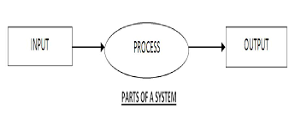

**Fig 3.1.1 Parts Of a System**

In a system the different components are connected with each other and they are interdependent. The objective of the system demands that some output is produced as a result of processing the suitable inputs. A well designed system also includes an additional element referred to as ‘control’ that provides a way feedback to achieve desired objectives of the system.

System analysis is a process of collecting factual data, understand the process involved, identifying problems and recommending feasible suggestions for improving the system functioning. This involves studying the business processes, gathering operational data, understand the information flow, finding out bottlenecks and evolving solutions for overcoming the weaknesses of the system so as to achieve the organizational goals. System analysis also includes subdividing of complex process involving the entire system, identification of data store and manual processes. The major objectives of system analysis are to find answers for each business process:

What is being done, How is it being done, Who is doing it, When is he doing it, Why is it being done and How can it be improved? It is more of a thinking process and involves the creative skills of the system analyst.

It attempts to give birth to a new efficient system that satisfies the current needs of the user and has scope for future growth within the organizational constraints. The result of this process is a logical system design. System analysis is an iterative process that continues until a preferred and acceptable solution emerges.

**3.1.2 SYSTEM LIFE CYCLE**

System life cycle is an organizational process of developing and maintaining systems. It helps in establishing a system project plan, because it gives overall list of processes and sub-processes required for developing a system. System development life cycle means combination of various activities. In other words we can say that various activities put together are referred as system development life cycle. In the system analysis and design terminology, the system development life cycle also means software development life cycle. The different phases of system development life cycle is shown in this diagram.

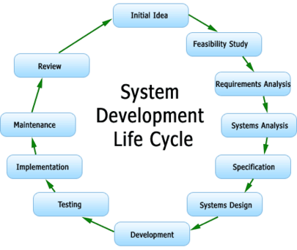

**Fig 3.1.3 SDLC**

**3.2 SYSTEM STUDY**

For the development of Robotic Process Automation the following packages are used:

**3.2.1 OPEN SOURCE**

Open source software is software whose source code is available for modification or enhancement by all the users.

"Source code" is the part of software that most computer users don't ever see, it is the code computer programmers can manipulate to change how a piece of software a "program" or "application" works. Programmers who have access to a computer program's source code can improve that program by adding features to it or fixing parts that don't always work correctly.

DIFFERENCE BETWEEN OPEN SOURCE SOFTWARE AND OTHER SOFTWARES:

Some software has source code that cannot be modified by anyone but the person, team, or organization who created it and maintains exclusive control over it. This kind of software is frequently called "proprietary software" or "closed source" software, because its source code is the property of its original authors, who are the only ones legally allowed to copy or modify it. Microsoft Word and Adobe Photoshop are examples of proprietary software. In order to use proprietary software, computer users must agree (usually by signing a license displayed the first time they run this software) that they will not do anything with the software that the software's authors have not expressly permitted.

Open source software is different. Its authors make its source code available to others who would like to view that code, copy it, learn from it, alter it, or share it. LibreOffice and the GNU Image Manipulation Program are examples of open source software. As they do with proprietary software, users must accept the terms of a license when they use open source software—but the legal terms of open source licenses differ dramatically from those of proprietary licenses. Open source software licenses promote collaboration and sharing because they allow other people to make modifications to source code and incorporate those changes into their own projects. Some open source licenses ensure that anyone who alters and then shares a program with others must also share that program's source code without charging a licensing fee for it. In other words, computer programmers can access, view, and modify open source software whenever they like as long as they let others do the same when they share their work. In fact, they could be violating the terms of some open source licenses if they don't do this.

In this project we are going make this app as open source software because anyone can view and modify open source software, someone might spot and correct errors and other reason is programmers can work on a piece of open source software without asking for permission from original authors, open source software is generally fixed, updated, and upgraded quickly.

**Open source over propriety software**:

The difference comes in the form of licensing agreements. Open source software agreements usually allow the third party users to make use of the source code according to their needs under the condition; they contribute a part of their work back to the community and not make monetary profits when using the open source software.

**3.2.2 APACHE TOMCAT 7.0.53**

Apache Tomcat is an open source software implementation of the Java Servlet and Java Server Pages technologies. The Java Servlet and Java Server Pages specifications are developed under the Java Community Process.

It is developed in an open and participatory environment and released under the Apache License version 2. Apache Tomcat is intended to be a collaboration of the best-of-breed developers from around the world. Apache Tomcat powers numerous large-scale, mission-critical web applications across a diverse range of industries and organizations. It also provides by default a HTTP connector on port 8080, which helps it to work as a HTTP server.

Apache Tomcat, Tomcat, Apache, the Apache feather, and the Apache Tomcat project logo are trademarks of the Apache Software Foundation.

**3.2.3 JDK 1.7**

The Java Development Kit (JDK) is an implementation of either one of the Java SE, Java EE or Java ME platforms[1]released by Oracle Corporation in the form of a binary product aimed at Java developers on Solaris, Linux, Mac OS X or Windows.

The JDK includes a private JVM and a few other resources to finish the recipe to a Java Application. Since the introduction of the Java platform, it has been by far the most widely used Software Development Kit (SDK).On 17 November 2006, Sun announced that it would be released under the GNU General Public License (GPL), thus making it free software.

**3.2.4 ECLIPSE KEPLER**

In computer programming, Eclipse is an integrated development environment (IDE). It contains a base workspace and an extensible plug-insystem for customizing the environment. Written mostly in Java, Eclipse can be used to develop applications. By means of various plug-ins, Eclipse may also be used to develop applications in other programming languages: Ada, ABAP, C, C++, COBOL, Fortran, Haskell, JavaScript, Lasso, Lua, Natural, Perl, PHP, Prolog, Python, R, Ruby (including Ruby on Rails framework), Scala, Clojure, Groovy, Scheme, and Erlang. It can also be used to develop packages for the software Mathematica. Development environments include the Eclipse Java development tools (JDT) for Java and Scala, Eclipse CDT for C/C++ and Eclipse PDT for PHP, among others.

The initial codebase originated from IBM VisualAge. The Eclipse software development kit (SDK), which includes the Java development tools, is meant for Java developers. Users can extend its abilities by installing plug-ins written for the Eclipse Platform, such as development toolkits for other programming languages, and can write and contribute their own plug-in modules.

Released under the terms of the Eclipse Public License, Eclipse SDK is free and open source software (although it is incompatible with the GNU General Public License). It was one of the first IDEs to run under GNU Classpath and it runs without problems under IcedTea.

**3.2.5 HTML**

HyperText Markup Language, commonly referred to as HTML, is the standard markup language used to create web pages. Along with CSS, and JavaScript, HTML is a cornerstone technology used to create web pages, as well as to create user interfaces for mobile and web applications. Web browsers can read HTML files and render them into visible or audible web pages. HTML describes the structure of a website semantically along with cues for presentation, making it a markup language, rather than a programming language.

HTML elements form the building blocks of HTML pages. HTML allows images and other objects to be embedded and it can be used to create interactive forms. It provides a means to create structured documents by denoting structural semantics for text such as headings, paragraphs, lists, links, quotes and other items. HTML elements are delineated by tags, written using angle brackets. Tags such as <img /> and<input /> introduce content into the page directly. Others such as <p>...</p> surround and provide information about document text and may include other tags as sub-elements. Browsers do not display the HTML tags, but use them to interpret the content of the page.

HTML can embed scripts written in languages such as JavaScript which affect the behavior of HTML web pages. HTML markup can also refer the browser to Cascading Style Sheets (CSS) to define the look and layout of text and other material. The World Wide Web Consortium (W3C), maintainer of both the HTML and the CSS standards, has encouraged the use of CSS over explicit presentational HTML since 1997.

**3.2.6 BOOTSTRAP**

Bootstrap is a free and open-source collection of tools for creating websites and web applications. It contains HTML- and CSS-based design templates for typography, forms, buttons, navigation and other interface components, as well as optional JavaScript extensions. It aims to ease the development of dynamic websites and web applications.

Bootstrap is a front end web framework, that is, an interface for the user, unlike the server-side code which resides on the "back end" or server.

Bootstrap is compatible with the latest versions of the Google Chrome, Firefox, Internet Explorer, Opera, and Safari browsers, although some of these browsers are not supported on all platforms.

**3.2.7** **GOOGLE MAP API**

The Google Maps JavaScript API has been designed to load quickly and work well on mobile devices. In particular, it has been focused on development for advanced mobile devices such as Android and iOS handsets. Mobile devices have smaller screen sizes than typical browsers on the desktop. As well, they often have particular behavior specific to those devices (such as "pinch-to-zoom"). If the application has to work well on mobile devices, then:

• Set the <div> containing your map to have width and height attributes of 100%.

**3.3 SYSTEM FEATURES**

Java is a general-purpose computer programming language that is concurrent, class-based, object-oriented, and specifically designed to have as few implementation dependencies as possible. It is intended to let application developers "write once, run anywhere” (WORA) meaning that compiled Java code can run on all platforms that support Java without the need for recompilation. Java applications are typically compiled to bytecode that can run on any Java virtual machine (JVM) regardless of computer architecture. As of 2015, Java is one of the most popular programming languages in use, particularly for client-server web applications, with a reported 9 million developers. Java was originally developed by James Goslingat Sun Microsystems (which has since merged into Oracle Corporation) and released in 1995 as a core component of Sun Microsystems’ Java platform. The language derives much of its syntax from C and C++, but it has fewer low-level facilities than either of them.

Five primary goals in the creation of Java language :

• Simple, object-oriented and familiar

• Robust and secure

• Architecture-neutral and portable

• High performance

• Interpreted, threaded, and dynamic

HyperText Markup Language, commonly referred to as HTML, is the standard markup language used to create web pages. It is written in the form of HTML elements consisting of tags enclosed in angle brackets (like <html>). HTML tags most commonly come in pairs like <h1> and </h1>, although some tags represent empty elements and so are unpaired, for example <img>. The first tag in a pair is the start tag, and the second tag is the end tag (they are also called opening tags and closing tags).

Web browsers can read HTML files and compose them into visible or audible web pages. Browsers do not display the HTML tags and scripts, but use them to interpret the content of the page. HTML describes the structure of a website semantically along with cues for presentation, making it a markup language, rather than a programming language.

HTML elements form the building blocks of all websites. HTML allows images and objects to be embedded and can be used to create interactive forms. It provides a means to create structured documents by denoting structural semantics for text such as headings, paragraphs, lists, links, quotes and other items. It can embed scripts written in languages such as JavaScript which affect the behavior of HTML web pages.

Web browsers can also refer to Cascading Style Sheets (CSS) to define the look and layout of text and other material. The World Wide Web Consortium (W3C), maintainer of both the HTML and the CSS standards, encourages the use of CSS over explicit presentational HTML.

In computer programming, Eclipse is an integrated development environment (IDE). It contains a base workspace and an extensible plug-in system for customizing the environment. Written mostly in Java, Eclipse can be used to develop applications. By means of various plug-ins, Eclipse may also be used to develop applications in other programming languages: Ada, ABAP, C, C++, COBOL, Fortran, Haskell, JavaScript, Lasso, Lua, Natural, Perl, PHP, Prolog, Python, R, Ruby (including Ruby on Rails framework), Scala, Clojure, Groovy, Scheme, and Erlang. It can also be used to develop packages for the software Mathematica. Development environments include the Eclipse Java development tools (JDT) for Java and Scala, Eclipse CDT for C/C++ and Eclipse PDT for PHP, among others.

The initial codebase originated from IBM VisualAge. The Eclipse software development kit (SDK), which includes the Java development tools, is meant for Java developers. Users can extend its abilities by installing plug-ins written for the Eclipse Platform, such as development toolkits for other programming languages, and can write and contribute their own plug-in modules.

Released under the terms of the Eclipse Public License, Eclipse SDK is free and open source software (although it is incompatible with the GNU General Public License). It was one of the first IDEs to run under GNU Classpath and it runs without problems under IcedTea.

**3.4 SYSTEM DESIGN**

Based on the user requirements and the detailed analysis of the existing system, the new system must be designed. This is the phase of system designing. It is the most crucial phase in the developments of a system. The logical system design arrived at as a result of systems analysis is converted into physical system design. Normally the design proceeds in two stages:

**3.4.1 PRELIMINARY OR GENERAL DESIGN**

In the preliminary or general design, the features of the new system are specified. The costs of implementing these features and the benefits to be derived are estimated. If the project is still considered to be feasible, we move to the detailed design stage.

**3.4.2 STRUCTURED OR DETAILED DESIGN**

In the detailed designed stage, computer oriented work begins in earnest. At this stage, the design of the system becomes more structured. Structure design is a blue print of a computer system solution to a given problem having the same components and inter relationships among the same components as the original problem. Input, output, databases, forms, codification schemes and processing specifications are drawn up in detail.

In the design stage, the programming language and the hardware and software platform in which the new system will run are also decided. There are several tools and techniques used for describing the system design of the system. The tool and technique used is Data Flow Diagram (DFD).

A **data flow diagram** (**DFD**) is a graphical representation of the "flow" of data through an information system, modelling its processaspects. A DFD is often used as a preliminary step to create an overview of the system, which can later be elaborated. DFDs can also be used for the visualization of data processing (structured design).

A DFD shows what kind of information will be input to and output from the system, where the data will come from and go to, and where the data will be stored. It does not show information about the timing of process or information about whether processes will operate in sequence or in parallel.

**LEVEL 0:**

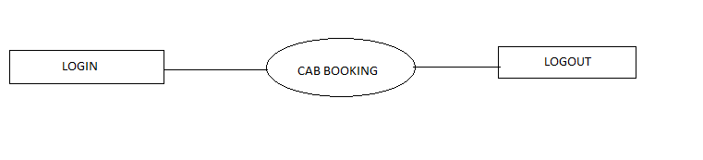**Fig.3.4.2.1 DFD Level 0**

**LEVEL 1:**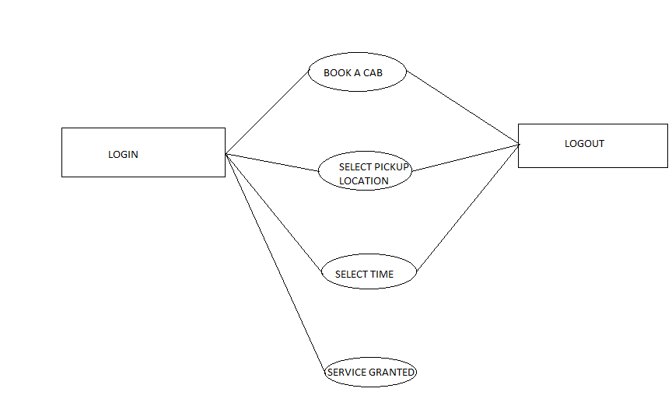

**Fig.3.4.2.2 DFD Level 1**

**LEVEL 2:**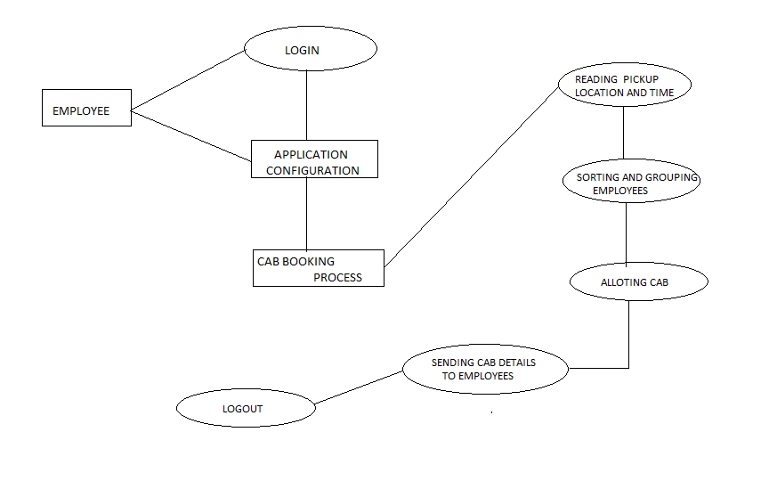

**Fig.3.4.2.3 DFD Level 2**

**3.4.3 WEB APPLICATION**

In computing, a **web application** or **web app** is a client–server software application which the client (or user interface) runs in a web browser.

Web applications are popular due to the ubiquity of web browsers, and the convenience of using a web browser as a client to update and maintain web applications without distributing and installing software on potentially thousands of client computers is a key reason for their popularity, as is the inherent support for cross-platform compatibility. Common web applications include webmail, online retail sales, online auctions, wikis, instant messaging services and many other functions.

**3.4.4 MOBILE APPLICATION**

A **mobile application** is a computer program designed to run on mobile devices such as smartphones and tablet computers. Most such devices are sold with several apps bundled as pre-installed software, such as a web browser, email client, calendar, mapping program, and an app for buying music or other media or more apps. Some pre-installed apps can be removed by an ordinary uninstall process, thus leaving more storage space for desired ones. Where the software does not allow this, some devices can be rooted to eliminate the undesired apps.

Mobile **native application** stand in contrast to software applications that run on desktop computers, and to web applications which run in mobile web browsers rather than directly on the mobile device.

**3.4.4.1 NATIVE APPLICATION**

**Native apps** live on the device and are accessed through icons on the device home screen. Native apps are installed through an application store (such as Google Play or Apple’s App Store). They are developed specifically for one platform, and can take full advantage of all the device features — they can use the camera, the GPS, the accelerometer, the compass, the list of contacts, and so on. They can also incorporate gestures (either standard operating-system gestures or new, app-defined gestures). And native apps can use the device’s notification system and can work offline.

**3.4.4.2 HYBRID APPLICATION**

Hybrid mobile apps are like any other apps you’ll find on your phone. They install on your device. You can find them in app stores. With them, you can play games, engage your friends through social media, take photos, track your health, and much more.

**3.4.5 WEB APPLICATION DEVELOPMENT PHASES**

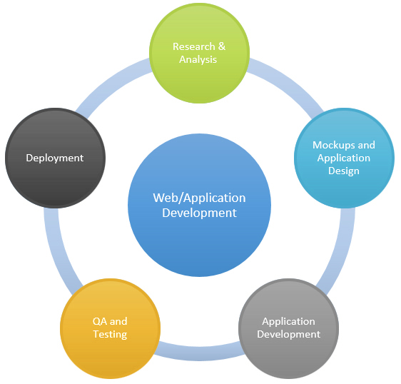

**FIG 3.4.5.1 WEB APPLICATION DEVELOPMENT PHASES**

**3.5 DATABASE**

A database is an organized collection of data. The data is typically organized to model relevant aspects of reality(for example, the availability of rooms in hotels), in a way that supports processes requiring this information(for example, finding a hotel with vacancies). A general purpose database management system(DBMS) is a software system design to allow the definition, creation, querying, update and administration of databases. Well known DBMSs include MySQL database. It consists of only one table in our system and that is

iCab Table.

iCab table is used to store the details of employees. It consists of the columns such as Date, Request_Id, Employee_name,Employee_location, Time, Status, Cab_details. This database resides inside the organization where the employee works.

When the cab booking is approved for an employee and the service has been completed,then the approved record in the database which resides at the topmost position is moved to the end of the database. Another alternative idea is to create a new Database and table and move the approved records of the old database to the new one.

**TABLE-1 - iCab**

**SERIAL NO COLUMN NAME DATA**

1. Date Date

2. Request_Id Int(20)

3. Employee_name Varchar(20)

4. Start_location Varchar(20)

5. End_location Varchar(20)

6. Time Time

7. Status Varchar(20)

8. Cab_Details Varchar(20)

9. Driver_Details Varchar(20)

**TABLE-2 –iDrivers**

This table resides in the database of the organization that provides cab to the employees. The admin of the organization can either approve the cab routes based on the app suggestions or can make changes to the route and drivers assigned .In such scenario, the changes should also be applied to other cabs that are affected by the above change .This change should in turn be updated in the database of the organization. This database is not accessible to the organization or the employee.

**SERIAL NO COLUMN NAME DATA**

1. Date Date

2. Cab_number Varchar(20)

3. Driver_details Varchar(20)

4. Travel_time Time

5. Passenger1_name Varchar(20)

6. Passenger1_location Varchar(20)

7. Passenger2_name Varchar(20)

8. Passenger2_location Varchar(20)

9. Passenger3_name Varchar(20)

10. Passenger3_location Varchar(20)

11. Passenger4_name Varchar(20)

12. Passenger4_location Varchar(20)

**3.6 ENTITY RELATIONSHIP DIAGRAM:**

An entity-relationship diagram (ERD) is a graphical representation of an information system that shows the relationship between people, objects, places, concepts or events within that system. An ERD is a data modeling technique that can help define business processes and can be used as the foundation for a relational database.

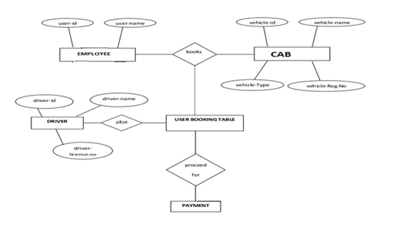

**Fig 3.4.1 ER-Diagram**

**CHAPTER 4**

**SYSTEM IMPLEMENTAION AND TESTING**

**4.1 PROJECT DESCRIPTION:**

Online Cab Booking System specializing in Hiring cabs to employees. It is an online system through which employees can view available cabs; register the cabs, view profile and book cabs. In this application, cab service is provided to employees in an organization from 10.00pm to 6.00am in dual basis (either coming to office or going to home).

This application is particularly designed for employees those who work for night shift, since during morning hours public transport are accessible to them. By providing the cab service , the company assures in providing safety for the employees .

The employee is allowed to have two choices-either as specific or in range. On choosing specific, the current date and shift timing are provided. If the employee wants the service as range basis, it is required to provide the start and end date of that range. An option is also provided to do modification of the dates in between the given range if the employee wants to.

All these employees details are now stored in MySQL database. Now records in the database are sorted and grouped according to date and time of pick up location. With the help of this database the routes calculations are done in google map. Let us assume the maximum size of the cab being four, for going to home from office, first the employee with closest distance from destination is served first. Following this, the next employee is chosen on the basis on closest distance from the previous one. Since the maximum cab accommodation is reached, the rest of the employees should be grouped in similar way. We named this as the minimum distance algorithm.

Now considering the scenario of coming to office, then the employee with farthest distance from destination is served first. Following this, the next employee is chosen on the basis on closest distance from the previous one. Since the maximum cab accommodation is reached, the rest of the employees should be grouped in similar way. We named this as the maximum distance algorithm.

The main constraint to be followed is that, neither a first pickup nor the last drop should be women. If this scenario could not be avoided, we also provide security to travel along with the women.

**4.2 TESTING**

Software testing is the process of evaluating a software item to detect difference between given input and expected output. Also to assess the feature of a software item. Testing assesses the quality of the product .Software testing is a process that should be done during the development process. In other words , software testing is a verification and validation process.

**VERIFICATION :**

Verification is the process to make sure the product satisfies the conditions imposed at the start of the development phase. In other words ,to make sure the product behaves the way we want it to .

**VALIDATION :**

Validation is the process to make sure that the product satisfies the specified requirements at the end of the development phase. In other words ,to make sure the product is built as per customer requirements.

**4.2.1 TYPES OF TESTING :**

There are many types of testing like :

* Unit Testing
* Integration Testing
* Functional Testing
* System Testing
* Stress Testing
* Performance Testing
* Usability Testing
* Acceptance Testing
* Regression Testing
* Beta Testing
* Black Box Testing
* White Box Testing

**UNIT TESTING :**

Unit testing is the testing of an individual unit of group of related units. It falls under the class of white box testing .It is often done by the programmer to test that the unit he/she has implementation is producing the expected output against given input.

**INTEGRATION TESTING :**

Integration testing is the testing in which a group of components are combined to produce output. Also, the interaction between software and hardware is tested in integration testing if software and hardware components have any relation. It may fall under both white box and black box testing.

**FUNCTIONAL TESTING :**

Functional testing is the testing to ensure that the specified functionality required in the system requirements works. It falls under the class of blackbox testing.

**SYSTEM TESTING :**

System testing is the testing to ensure that by putting the software in different environment it still works. System testing is done with fullsystem implementation and environment. It falls under the class of black box testing.

**STRESS TESTING :**

Stress testing is the testing to evaluate how system behaves under unfavorable conditions. Testing is conducted at beyond limits of the specifications. It falls under the class of black box testing.

**PERFORMANCE TESTING :**

Performance testing is the testing to assess the speed and effectiveness of the system and to make sure it is generating result within a specified time as in the performance requirements. It falls under the class of black box testing .

**USABILITY TESTING :**

Usability testing is performed to the perspective of the client ,to evaluate how GUI is user-friendly? How easily can the client learn? After learning how to use, how proficiently can the client perform? How pleasing is it to use its design? This falls under the class of black box testing

**ACCEPTANCE TESTING :**

Acceptance testing is often done by the customer to ensure that the delivered product meets the requirement and works as the customer expected. It falls under the class of black box testing.

**REGRESSION TESTING :**

Regression testing is the testing after the modification of a system, component, or group of related units to ensure that the modification is working correctly and not damaging or imposing other modules to produce unexpected results. It falls under the class of black box testing.

**BETA TESTING:**

Beta testing is the testing which is done by end-users , a team outside development or publicly releasing full pre-versions of the product which is known as beta version. The aim of beta testing is to cover unexpected errors. It falls under the class of black box testing.

**BLACKBOX TESTING:**

Black box testing is a testing technique that ignores the internal mechanisms of the system and focuses on the input and the output generated against any input and execution of the system. It is also called as functional testing.

**WHITEBOX TESTING :**

White box testing is a testing technique that takes into account the internal mechanisms of a system. It is also called as structural testing and glass box testing. Black box testing is often used for validation and white box testing is often used for verification.

**TEST REPORT BY SYSTEM ANALYST PROGRAMMER**

|  |  |  |
| --- | --- | --- |
| **S.NO** | **TESTING PARAMETER** | **OBSERVATION** |
| 1. | **INTERFACE TESTING**   1. Mouse/Tab Navigation 2. User Friendlines 3. Consistent Menus 4. Consistent Graphical Buttons | OK  OK  OK  OK |
| 2. | **VALIDATION TESTING**   1. Check for improper or inconsistent typing 2. Check for erroneous initialization or default values 3. Check for incorrect variables names 4. Check for inconsistent data types | OK  OK  OK |
| 3. | **DATA INTEGRITY AND SECURITY TESTING**   1. Data Insert/Delete/Update 2. Condition(underflow,overflow) 3. Check for unauthorized access of data 4. Check for data availability | OK  OK  OK  OK |
| 4. | **EFFICIENCY TESTING**   1. Throughput of the System 2. Response time of the System 3. Online Disk Storage 4. Primary Memory Required by System | OK  OK  OK  OK |
| 5. | **ERROR HANDLING ROUTINES**   1. Error Description are Intelligent / understandable 2. Error recovery is smooth 3. All error handling routines are tested and executed at least ones. | OK  OK  OK |

**USER TEST REPORT**

|  |  |  |
| --- | --- | --- |
| **S.NO** | **TESTING PARAMETER** | **OBSERVATION** |
| **1.** | **TEST FOR PULLED DOWN MENUS AND MOUSE OPERATION**   1. All the relevant pull down menus, Scroll Bar, Dialog Boxes and Buttons functioning properly? 2. Is the Appropriate menu bar displayed in the appropriate context? 3. Are all menu function and pull down Sub-function properly listed? 4. Does each menu function perform according to design specification? 5. Is it Possible to Invoke each menu function using alternative keys? 6. Is all data content with in the window properly addressable mouse, keys and key board? 7. Does the window Properly generate when it is over written then recalled? 8. Is the active window Properly Highlighted? | YES  YES  YES  YES  YES  YES  YES    YES |
| **2.** | **TEST FOR DATA ENTRY LEVEL**   1. Is alphanumeric data entry properly echoed and input to the system? 2. Do graphical modes of data entry such as scrollbars works properly? 3. Are data input messages intelligible? 4. Is invalid data properly recognized? 5. Is all input Data entry Properly saved? | YES  YES  YES  YES  YES |
| **3.** | **TEST FOR VERIFYING OUTPUTS**   1. Whether output displayed is according to requirement and printed with proper alignment? 2. If calculation are there, do you check them? 3. Are report formats according to need? 4. Are reports can be printed or printer? | YES  YES  YES  YES |

**4.3 PROCESS FLOW DIAGRAM**

A **process flow diagram** (**PFD**) is a diagram commonly used in chemical and process engineering to indicate the general flow of plant processes and equipment. The PFD displays the relationship between *major* equipment of a plant facility and does not show minor details such as piping details and designations. Another commonly used term for a PFD is a flowsheet.

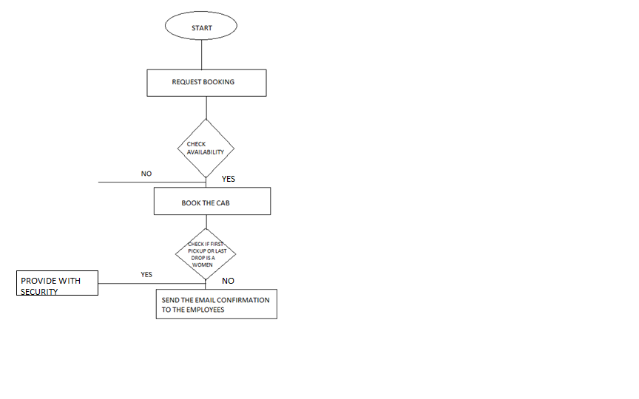

**Fig 4.3.1 PROCESS FLOW DIAGRAM**

**4.4 MODULES OF STUDY**

**MODULE 1**

The first module of the project deals with entering the employee details. It requires details such as Name, Employee ID, Pickup and Drop location, Manager details, Contact number, Department.

The employees are classified as either daily basis or monthly basis and provided with service accordingly.

**MODULE 2**

In module two, the employees are grouped according to the nearest pickup location and efficient google map route is sent to the cab driver. In this way, the service of ease transportation is provided to the employees.

**CHAPTER 5**

**USABILITY,PERSONA AND SNAPSHOTS**

**USABILITY:**

**USE CASE DIAGRAM:**

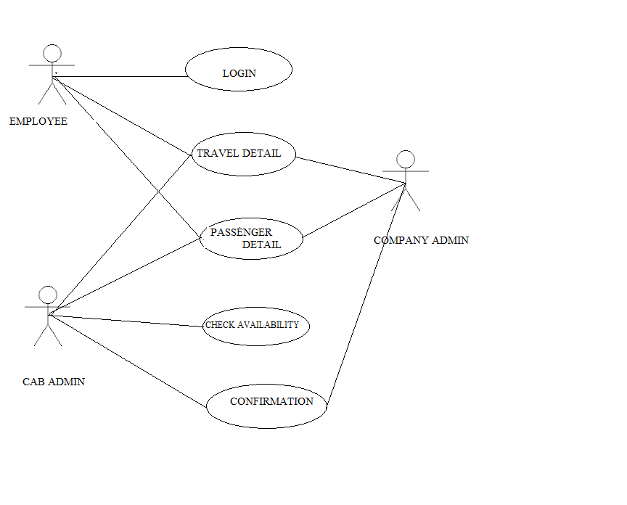

**Fig 5.1 Use Case Diagram**

**USE CASE SCENARIO:**

In this scenario, there are 3 personas involved. They include employee, cab admin and company admin. To start up with, the employee has to first login into the application and provide their passenger details like employee id, name, mobile number. They are also asked to provide travel details like shift time, start and end destination.

After the details are being entered by the employee, the company admin comes into role.This person now verifies the employee details and allocates the cab as per requirement.

These details are forwarded to cab admin. He is responsible for allotting cab and send the confirmation to company admin.

PERSONAS:

There are three personas involved in our project. They are:

* Employee
* Cab Admin
* Company Admin

Here the employee can only logon to application and provide their details. Whereas they are not allowed update any changes in database.This is shown in figure 5.2-employee details screen.

The company admin has access to view the employee details and he has the rights to allot the efficient route and send those details to cab admin.

The cab admin has access to view the passenger details and allot the cab as per the requirements to the employees.In addition,the cab admin may be provided with facility of changing the routes and cab allotment as per his wish.This feature may be added as future enhancement to the application.

**Screen for entering employee details**:

Here the employee details such as Name, ID, Manager name, Department, Mobile Number, Shift Timing, Starting Point, Designation are obtained. It is not mandatory to give all details, since when the employee provides his name or employee Id, the remaining fields are autofilled. On clicking Submit Request button, the details are stored in a database. If either the start or end location is not specified, then an alert message such as “Please fill out this” appears. And also the employee is required to provide valid details such as data input within that range. If any of the constraints is violated, it also shows an error by stating what that error is.

The employee is allowed to have two choices-either as specific or in range. On choosing specific, the current date and shift timing are provided. If the employee wants the service as range basis, it is required to provide the start and end date of that range. An option is also provided to do modification of the dates in between the given range if the employee wants to.

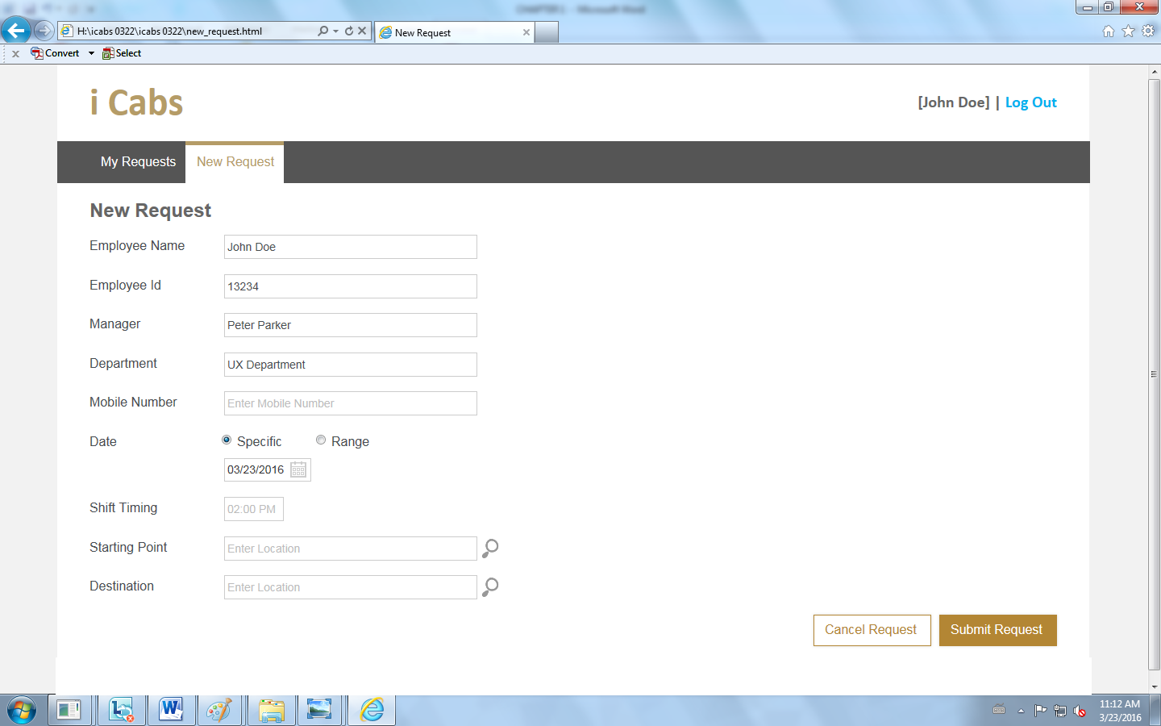

**Fig 5.2 Employee Details screen**

**Screen for Pending/approval of service:**

After the employee details being entered into database, the pending or approval of request can be seen by employee through this screen.Here the confirmed booking time,status are displayed.

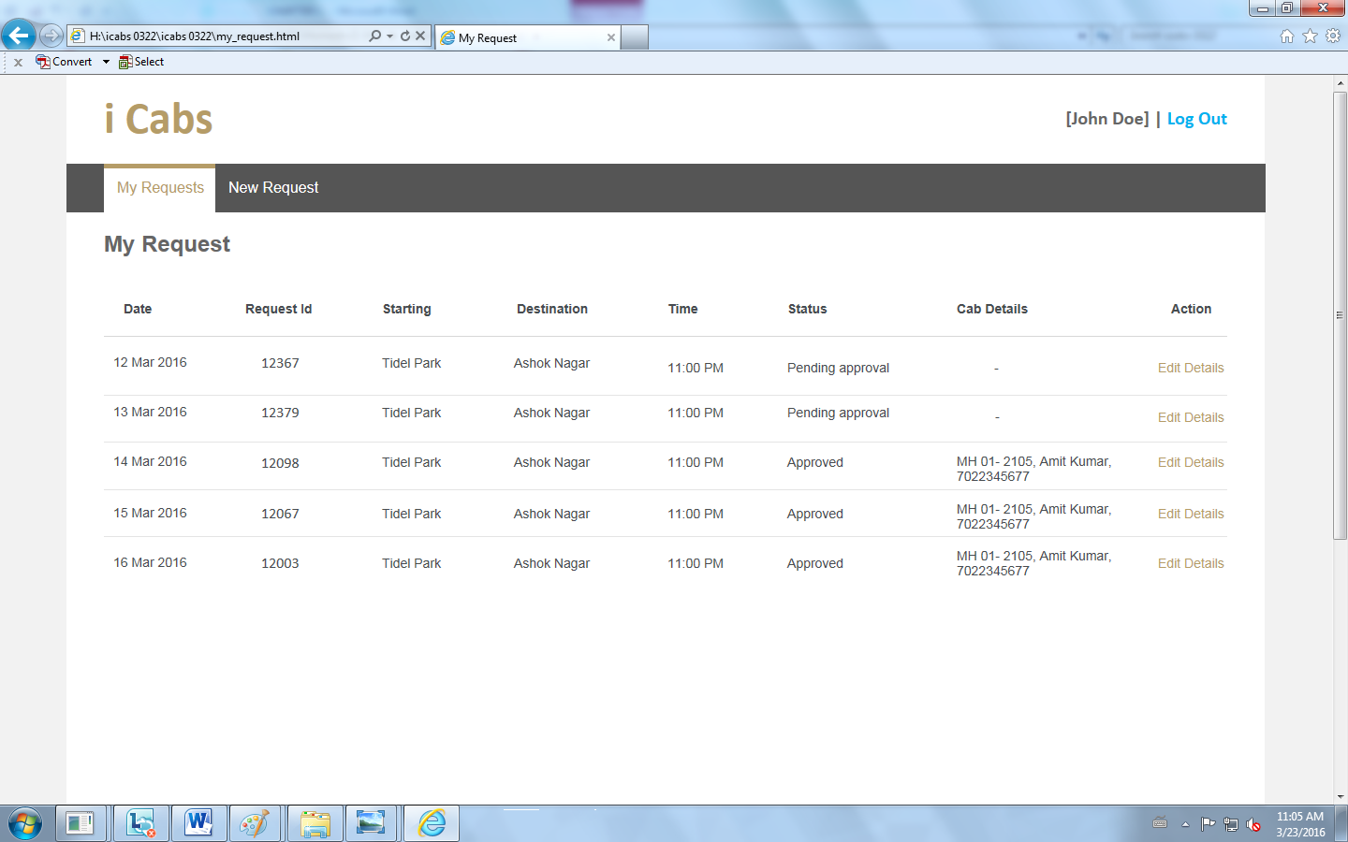

**Fig 5.3 Cab booking confirmation screen**

**Screen for specification guidelines:**

This screen specifies all the design details such as height, width in pixels, the font size, font type and font color for each screen attribute.

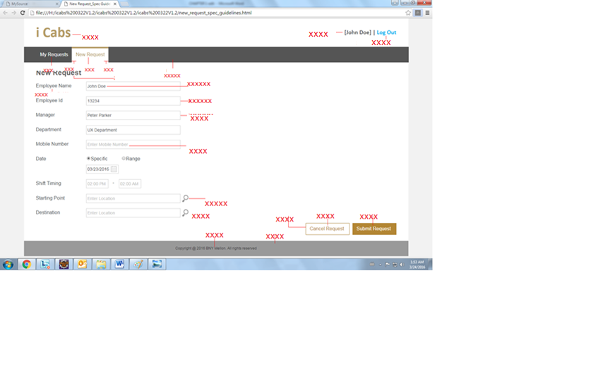

**Fig 5.4 Specification Guideline Screen**

**CHAPTER 6**

**CONCLUSION**

The project aims in implementing a web application that provides the employees with cab service. It reduces the effort of manually maintaining the transportation details. Our project satisfies the following :

* To provide user-friendly interface
* To produce well formatted output display
* This application satisfies the needs of the user in reasonable time
* This application provides safety to women since they are not last drop or first pickup
* It can handle any number of requests at a time without redundancy.
* Reduces carbon footprint while maintaining the user conform.

**REFERENCE**

**WEBSITES**

1. [https://github.com/twbs/**bootstrap**](https://github.com/twbs/bootstrap)
2. [https://developers.**google**.com/**maps**/](https://developers.google.com/maps/)
3. [www.geeksforgeeks.org/**shortest**-**path**-for-directed-acyclic-graphs/](http://www.geeksforgeeks.org/shortest-path-for-directed-acyclic-graphs/)
4. [https://www.siteground.com/tutorials/**php**.../**php**_mysql_**connection**.htm](https://www.siteground.com/tutorials/php.../php_mysql_connection.htm)
5. [www.w3schools.com](http://www.w3schools.com) for tutorials

**BOOKS**

1. Paul hudson “php in a nutshell”
2. George reese “java database best practices”
3. Alper dincer “google maps javascript api cookbook”