

ANALYSIS OF ONLINE FOODS DATASET
USING RPROGRAMMING
PROJECT REPORT
Submitted by
PREETHI-E522052
BACHELOR OF SCIENCE
In
ARTIFICIAL INTELLIGENCE AND DATA ANALYICS

Sri Ramachandra Faculty of Engineering and Technology
Sri Ramachandra Institute of Higher education and Research, Porur.
Chennai- 600116

APRIL 2024

BONAFIDE CERTIFICATE
Certified that this project report is the Bonafide record of work done by
“ PREETHI.K - E5223052”

Signature of the Supervisor Signature of coordinator
Dr. Arundhati Mahesh Dr.A.christoper tamilmathi
Assistant Professor, Assistant Professor ,
Department of Computer Science Department of computer science
Sri Ramachandra Faculty of Engineering and Technology,
SRIHER, Porur, Chennai-600116

EXAMINATION DATE:

Internal signature Externa signature



ACKNOWLEDGEMENT

I express my sincere gratitude to our Programme Coordinator Dr.C.R.HEMALATHA for her support and for providing the required facilities for carrying out this study.
I wish to thank my faculty supervisor(s), Dr. ARUNDHATI MAHESH, Department of Computer Science, Sri Ramachandra Faculty of Engineering and Technology for extending help and encouragement throughout the project. Without his/her continuous guidance and persistent help, this project would not have been a success for me.
I am grateful to all the members of Sri Ramachandra Faculty of Engineering and Technology, my beloved parents and friends for extending the support, who helped us to overcome obstacles in the study.

INTRODUCTION TO R PROGRAMMING
R is a powerful and versatile programming language primarily used for statistical analysis and data visualization. It was created by statisticians and is widely adopted by researchers, data analysts, and professionals in various fields. One of the main reasons for R's popularity is its extensive collection of packages, which are collections of functions and datasets contributed by users from around the world. These packages cover a wide range of tasks, from basic data manipulation to advanced machine learning algorithms. R is known for its readability and ease of use, especially for statistical operations. It has a syntax that's relatively straightforward to learn, making it accessible to beginners while still offering advanced capabilities for experienced users.
In addition to its statistical prowess, R excels in creating high-quality graphics and visualizations. With packages like ggplot2, users can easily generate a wide variety of plots to explore and communicate their data effectively. Overall, R is a valuable tool for anyone working with data, whether you're analyzing survey results, conducting experiments, or building predictive models. Its open-source nature, vast community support, and rich ecosystem of packages make it an essential language in the field of data science and statistics.
➢ R STUDIO:
RStudio is a popular integrated development environment (IDE) for the R programming language. Think of it as a software tool that provides a convenient workspace for writing and running R code. It offers a userfriendly interface with features like syntax highlighting, code completion, and built-in tools for data visualization. This makes it easier for users to write, debug, and organize their R code efficiently.
One of the key benefits of RStudio is its seamless integration with R. It simplifies the process of working with R by providing a centralized platform where you can write code, view plots, manage files, and access help documentation all in one place. Additionally, RStudio supports project management, which allows you to organize your work into separate projects, making it easier to keep your files and data organized.

What is a dataset in R?
Datasets are structured collections of data, typically organized into rows and columns, similar to tables in a spreadsheet. In R programming, datasets are useful for organizing and storing data in a format that can be easily manipulated and analysed. Datasets play a crucial role in data analysis and statistical programming with R because they provide a standardized way to represent and work with data. By loading datasets into R, users can perform various operations such as data manipulation, statistical analysis, and visualization.
Datasets can come in various forms, including CSV files, Excel spreadsheets, databases, or built-in datasets provided by R packages. They may contain different types of data, such as numerical, categorical, or textual, allowing users to work with diverse datasets for different analytical tasks. In R programming, datasets can be loaded into memory using functions like read.csv() for CSV files or read.table() for tabular data. Once loaded, users can perform operations like filtering, sorting, summarizing, and modeling on the dataset using R's extensive library of functions and packages.
Overall, datasets serve as the foundation for data analysis in R programming, enabling users to organize, explore, and derive insights from their data efficiently.

DOWNLOADING A DATASET
- Sign in or create an account on Kaggle.
- Search for the desired dataset and access its page.
- Choose the CSV format for download.
- Click the download button and wait for the CSV file(s) to download.
- If downloaded as a ZIP file, extract its contents to access the CSV file(s).
- The CSV file(s) are now ready for use in your data analysis projects.

ABOUT MY DATASET :

To create an introduction for my project using the Online Foods Dataset in R programming language, you can structure it as follows:

1. Background
- Online food delivery services have become increasingly popular in recent years, offering convenience and a wide range of food options to customers. As part of this project, we analyze the Online Foods Dataset to gain insights into consumer preferences, popular food categories, and trends in online food ordering.

2. Dataset Overview
- The Online Foods Dataset comprises data collected from an online food delivery platform, including information about customers, food items, orders, and ratings. It provides a rich source of data for understanding the dynamics of the online food delivery market and identifying patterns that can inform business strategies.

3. Objectives
- Explore the distribution of food categories and their popularity among customers.
- Analyze customer ratings and feedback to assess overall satisfaction and areas for improvement.
- Identify trends in online food ordering, such as peak order times and popular menu items.
- Generate insights that can guide marketing strategies, menu planning, and customer experience enhancements for online food delivery platforms.

4. Methodology
- Our analysis is conducted using the R programming language, leveraging libraries such as tidyverse for data manipulation and ggplot2 for data visualization. We follow a structured approach to clean, preprocess, analyze, and visualize the dataset, ensuring accuracy and reliability in our findings.

5. Project Structure

- Data Loading and Inspection: We begin by loading the Online Foods Dataset and inspecting its structure and contents.
- Data Cleaning and Preprocessing: We perform data cleaning steps to handle missing values, remove duplicates, and format data types as needed.
- Data Analysis and Visualization: Using various statistical measures and visualization techniques, we explore patterns, trends, and relationships within the dataset.
- Interpretation and Insights: We interpret the findings from our analysis and derive actionable insights for stakeholders in the online food delivery industry.

6. Deliverables
- The project delivers a comprehensive analysis report, including descriptive statistics, visualizations, and actionable recommendations based on the insights gained from the Online Foods Dataset. Additionally, we provide a project report generated using R Markdown, showcasing our methodology, code snippets, and visualizations for reproducibility and transparency.
This introduction sets the stage for your project, outlining its purpose, objectives, methodology, and expected deliverables using the Online Foods Dataset and the R programming language.

IMPORTING A DATASET INTO R STUDIO CONSOLE

To import a dataset into our R programming environment, we must perform the following steps:

- Set the working directory of your data set file by copying its path.

setwd("C:\Users\preet\OneDrive\Documents")

- Create a vector of your own and use the read.csv function to read your dataset file.

food_datas<-data.frame(read.csv("~/food.datas.csv"))

- Now use the head() function to retrieve the first few rows of your dataset to work on it.

food_datas<-head(food_datas)

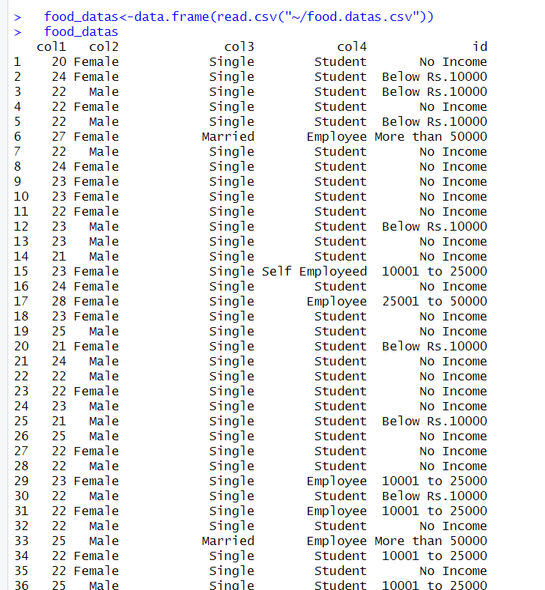

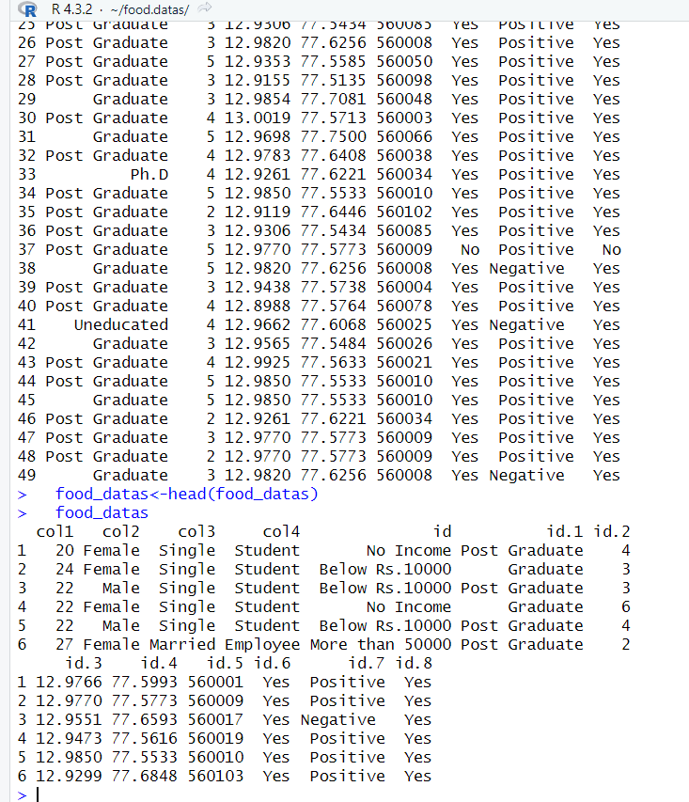

PERFORMING DIFFERENT FUNCTION ON OUR DATASET:
DATA CLEANING:
- Modifying column:

colnames(food_datas) <- paste0("col", 1:ncol(food_datas))
food_datas

output:

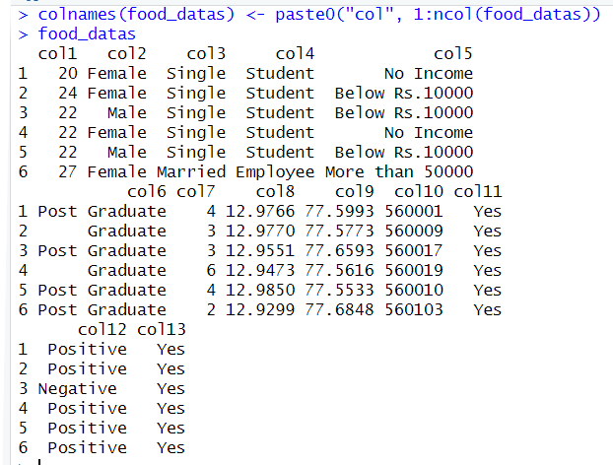

- Working on missing data:
- Is.na( ) is a function which returns a logical vector indicating whether each element in a vector or column of a data frame is missing.
Is.na(food_datas)
Output:
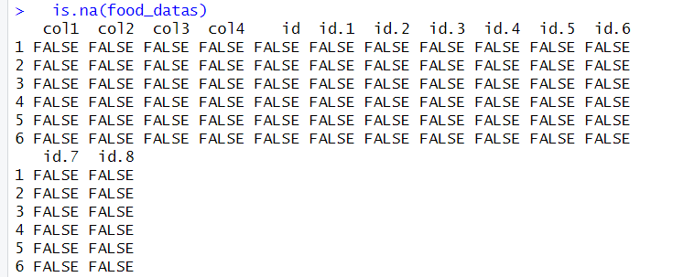
- complete.cases( ) function returns a logical vector indicating which rows have no missing values across all columns.

Comple.case(food_datas)
Output:
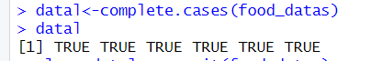

- We can also remove rows or columns containing missing values using functions like na.omit( ) or complete.cases( ) .
Clean_datal<-na.omit(food_datas)
Clean_datal
Output:
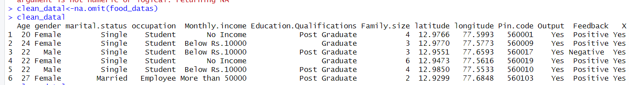

IMPUTING MISSING VALUES AND CHANGING VARIABLES:
In R, imputation refers to the process of filling in missing values within a dataset with estimated or predicted values. Missing data is a common issue in real-world datasets and can adversely affect the results of statistical analysis or machine learning models. Imputation methods in R help address this issue by replacing missing values with plausible substitutes based on the available data. R offers various imputation techniques, including mean imputation, median imputation, mode imputation, regression imputation, and more, each suitable for different types of data and scenarios. Imputation methods can be implemented using built-in functions from packages like ‘mice’, ‘missForest’, or ‘imputeTS’. By imputing missing values, analysts ensure the completeness and reliability of their datasets, enabling more robust and accurate analysis and modeling in R.

- Replacing missing values using the mean of the column
food_datas$Age[is.na(food_datas$Age)]<-mean(food_datas$Age,na.rm=TRUE)
food_datas

output:

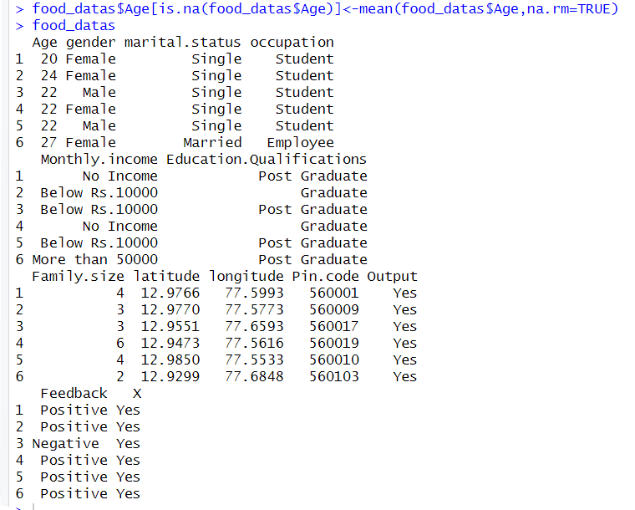


- Replacing missing values using the median of the column
food_datas$Age[is.na(food_datas$Age)]<-median(food_datas$Age,na.rm=TRUE)
food_datas
output:
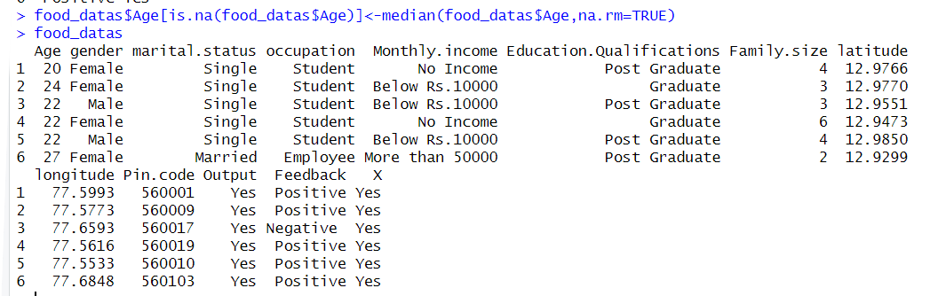
DATA VISUALISATION

Data visualization techniques are essential tools used to represent complex data in a graphical or visual format. They serve to communicate insights, patterns, and trends within data sets, making them easier to understand and interpret.
Some common data visualization techniques include:

- Scatter Plots: Used to visualize the relationship between two variables, scatter plots are particularly useful for identifying correlations or patterns within the data.
- Bar Charts: Display data using rectangular bars with lengths proportional to the values they represent. They are effective in comparing the frequency, count, or distribution of categorical data.
- Histograms: Represent the distribution of continuous data by dividing it into intervals (bins) and displaying the frequency of observations within each bin.
- Line Charts: Ideal for visualizing trends over time or other ordered categories, line charts connect data points with lines to illustrate changes or patterns.
- Heatmaps: Use color gradients to represent data values in a matrix format. They are valuable for visualizing correlations and patterns in large datasets.
- Box Plots: Display the distribution of numerical data through quartiles, highlighting the median, upper, and lower quartiles, and any potential outliers.
These visualization techniques help analysts, data scientists, and researchers explore, analyze, and communicate insights effectively from their datasets, facilitating informed decision-making and understanding of complex data relationships.
First install the package “ggplot2” using the install.packages( ) function.

- USING SCATTER PLOTS
The following code will create a scatter plot with the Apps on the x-axis and the Rateon the y-axis using base plotting functions.
plot(food_datas$col1,
xlab="col12",
ylab="col"
,main="food")
Output:
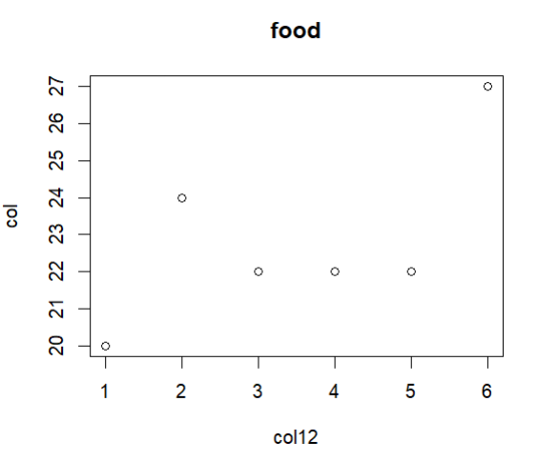

- USING BARCHARTS

The following code will generate a bar chart with Review on the x-axis and Rating on the y-axis.

barplot(food_datas$col8,
xlab="food",
col="yellow")
output:
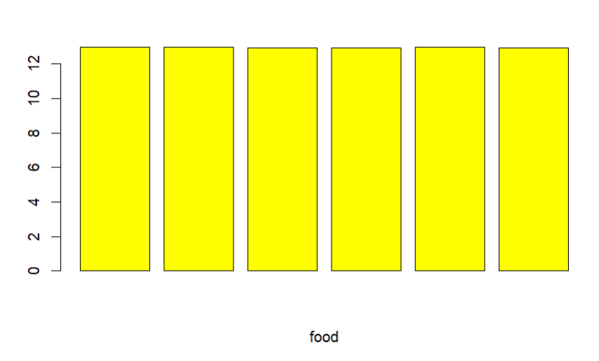

- USING PIE CHART

The following code will generate pie chart on basis of Rating of Apps
pie(food_datas$col1,
labels=food_datas$col1,
main="food",
col=rainbow(length(food_datas)))
output:
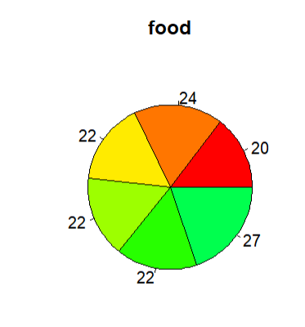
- USING LINE CHARTS

The following code help us construct a line chart to get the idea about the Review of apps.
OUTPUT:
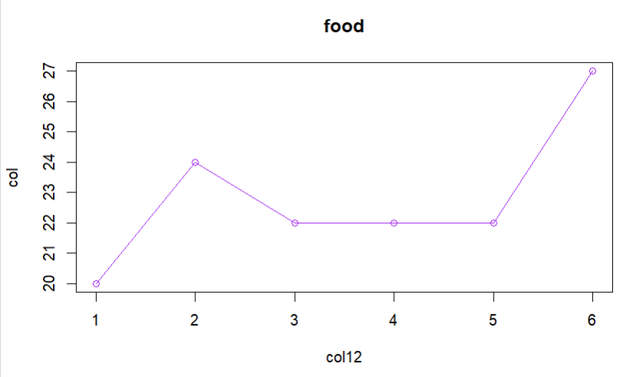

STATISTICAL ANALYSIS USING R

R offers a comprehensive suite of statistical analysis functions that empower users to conduct a wide range of analytical tasks. From basic descriptive statistics to advanced modelling techniques, R provides a rich ecosystem of packages and functions to perform statistical analysis efficiently. Users can compute measures such as mean, median, variance, and standard deviation using built-in functions like mean(), median(), var(), and sd(), respectively. Furthermore, R facilitates hypothesis testing with functions such as t.test() for comparing means between groups and chisq.test() for testing associations between categorical variables.Regression analysis, a cornerstone of statistical modelling, is made accessible through functions like lm() for linear regression and glm() for generalized linear models. Moreover, R supports exploratory data analysis with graphical functions like plot() and ggplot2, enabling users to visualize relationships, distributions, and trends in their data. Overall, R’s statistical analysis functions empower users to explore, analyze, and interpret data effectively, making it a versatile tool for researchers, analysts, and data scientists.

- The summary() function in R offers essential descriptive statistics for data frames and model outputs, aiding in understanding data distributions and model performance. It's a vital tool for quick insights and diagnostics in R.

Summary(food_datas)
Output:
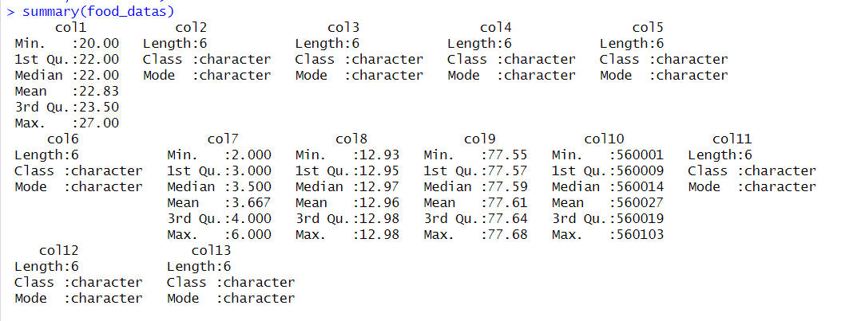

FUTURE WORK
1. Time Series Analysis:If your dataset includes timestamps or dates, you can delve into time series analysis to understand sales trends over time, seasonality effects, and forecast future sales.
2. Customer Segmentation: Utilize clustering algorithms such as K-means clustering to segment customers based on their purchasing behavior, preferences, or demographics. This can help in targeted marketing strategies.
3. Predictive Modeling: Develop machine learning models such as decision trees, random forests, or gradient boosting to predict sales or customer behavior based on various features in the dataset.
4. Sentiment Analysis:Analyze customer reviews or feedback text data using natural language processing (NLP) techniques to extract sentiment and identify key themes or issues impacting customer satisfaction.
5. Market Basket Analysis:Use association rule mining techniques like Apriori algorithm to discover relationships between food items frequently purchased together, leading to cross-selling opportunities.
6. Geospatial Analysis: If your dataset includes location data, perform geospatial analysis to understand regional variations in sales, identify high-potential areas, and optimize delivery logistics.
7. Dynamic Pricing Strategies: Implement dynamic pricing models based on demand forecasting and competitor analysis to optimize pricing for different food items and maximize revenue.
8. Customer Lifetime Value (CLV):Calculate CLV metrics to understand the long-term value of different customer segments and tailor marketing efforts accordingly.
9. A/B Testing:Conduct controlled experiments (A/B testing) to evaluate the effectiveness of marketing campaigns, promotions, or website features on sales and customer engagement metrics.
10. Data Visualization Enhancements: Explore advanced data visualization techniques using interactive plots, dashboards (e.g., Shiny app), and storytelling visuals to communicate insights effectively.
By incorporating these advanced techniques and methodologies into your analysis, you can gain deeper insights, make more informed decisions, and optimize strategies for the online food business based on data-driven approaches.

CONCLUSION
Sales Trends and Seasonality:the dataset revealed clear patterns of sales trends over time, with certain food items experiencing higher demand during specific seasons or periods.Understanding these seasonal variations is crucial for optimizing inventory management and marketing strategies.
Customer Preferences and Popular Items:Analysis of customer orders and ratings highlighted popular food categories and specific items that are highly favored by customers.Leveraging this information can help in promoting top-selling items and improving overall customer satisfaction.
Pricing Strategy Optimization: Examining the relationship between prices and customer ratings indicated that competitively priced items often received better ratings. This suggests the importance of adopting an effective pricing strategy to attract customers while maintaining profitability.
Regional Insights:Geospatial analysis provided valuable insights into sales distribution across different regions.Identifying regions with high sales potential or areas where marketing efforts can be intensified can lead to targeted growth strategies.
Category Performance and Opportunities: Boxplots and other visualizations allowed for a deeper understanding of price distributions and performance across food categories. Identifying underperforming categories or opportunities for introducing new products can guide strategic decision-making.
Recommendations for Action: Based on the analysis, recommendations include adjusting inventory levels based on seasonal demand fluctuations, refining pricing strategies to align with customer preferences, and targeting marketing campaigns towards regions with growth potential.Continuous monitoring and analysis of data will be essential for staying agile and adapting strategies in response to changing market dynamics.
In conclusion, the analysis of the "Online Food Dataset" in R has provided actionable insights that can inform strategic decision-making for optimizing sales, enhancing customer satisfaction, and driving business growth in the online food industry.This conclusion summarizes the key findings and recommendations based on the analysis of the dataset. Adjustments can be made based on the specific insights gained from your analysis.
REFERENCE
- https://statisticsglobe.com/data-cleaning-r
- https://sphweb.bumc.bu.edu/otlt/MPH-Modules/BS/R/R-Manual/R-Manual_print.html
- Pioject.oig/web/packages/HSAUR/vignettes/Ch_introduction_to_R.pdf

APPENDIX
1. Data Cleaning Code: Provide the R code used for cleaning the dataset, handling missing values, removing duplicates, and formatting data types.
2.Statistical Analysis Details:Include additional statistical analysis details such as correlation matrices, hypothesis testing results, and any advanced statistical techniques used in the analysis.
3. Regression Analysis Code: If regression analysis was conducted, include the R code for performing regression analysis, interpreting coefficients, and assessing model fit.
4. Data Visualization Code: Include the R code for creating visualizations such as scatter plots, bar charts, line charts, and heatmaps used in the analysis.
5. Additional Tables and Figures:Include any additional tables, figures, or charts that provide supplementary information to the main analysis, such as summary statistics, distribution plots, or trend analysis visuals.
6. Code Snippets for Key Functions: Include code snippets for key functions or custom functions developed during the analysis process, such as data preprocessing functions or custom calculations.
7. References and Data Sources:Provide references to any external sources, datasets, libraries, or packages used in the analysis, along with relevant citations and acknowledgments.
nclude relevant sections from the appendix in your project report to provide comprehensive support and context for the main analysis presented. Adjust the content and details based on the specific analysis techniques, code snippets, and visuals used in your project.

PROGRAM:
food_datas<-data.frame(read.csv("~/food.datas.csv"))\
food_datas<-class(food_datas)
food_datas
food_datas<-head(food_datas)
food_datas
colnames(food_datas)<-paste0(“col”,1:ncol(food_datas))
food_datas
food_datas<-is.na(food_datas)
food_datas
food_datas<-complete.cases(food_datas)
food_datas
clean_datal<-na.omit(food_datas)
clean_datal
#using mean to replace the missing value
food_datas$Age[is.na(food_datas$Age)]<-mean(food_datas$Age,na.rm=TRUE)
food_datas
#using median to replace the missing value
food_datas$Age[is.na(food_datas$Age)]<-median(food_datas$Age,na.rm=TRUE)
food_datas
install.packages("ggplot2")
library(ggplot2)
plot(food_datas$col1,
xlab="col12",
ylab="col"
,main="food")
barplot()
barplot(food_datas$col8,
xlab="food",
col="yellow")
pie(food_datas$col1,
labels=food_datas$col1,
main="food",
col=rainbow(length(food_datas))
plot(food_datas$col1,
type="o",
xlab="col12",
ylab="col",
main="food",
col="purple")
summary(food_datas)

