2.Design PDA using simulator to accept input string aabb

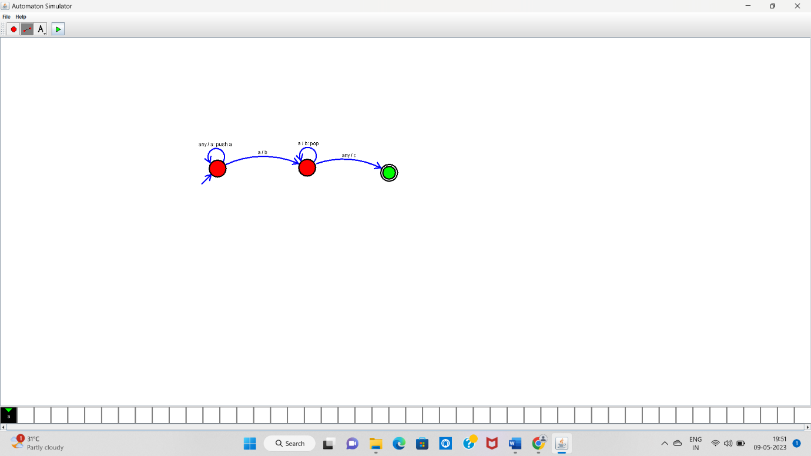

aabb-----Accepted