1.Desing DFA using simulator to accept input string a , ac and bac

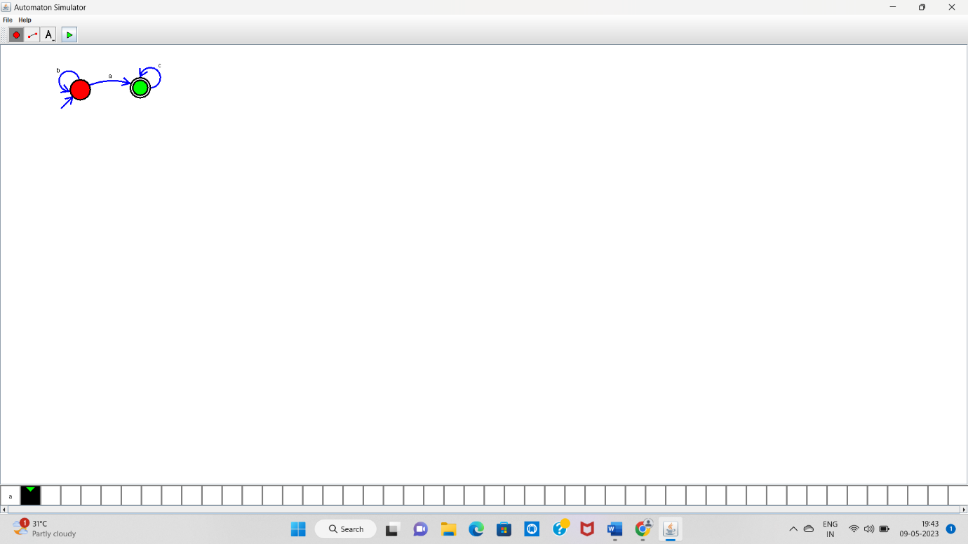

a-------- Accepted

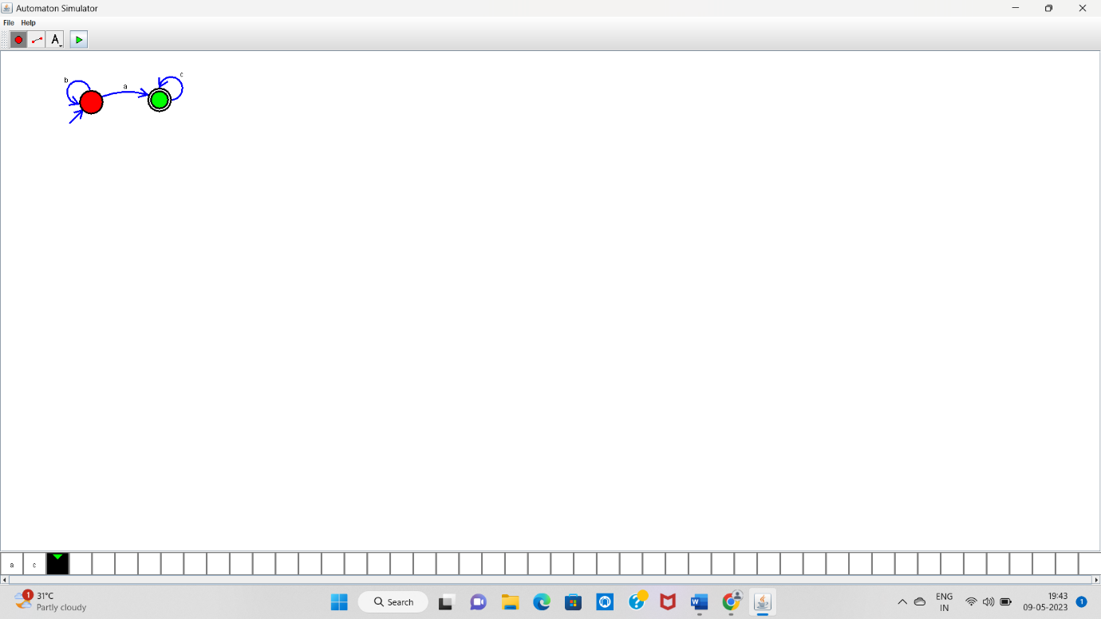

ac------Accepted

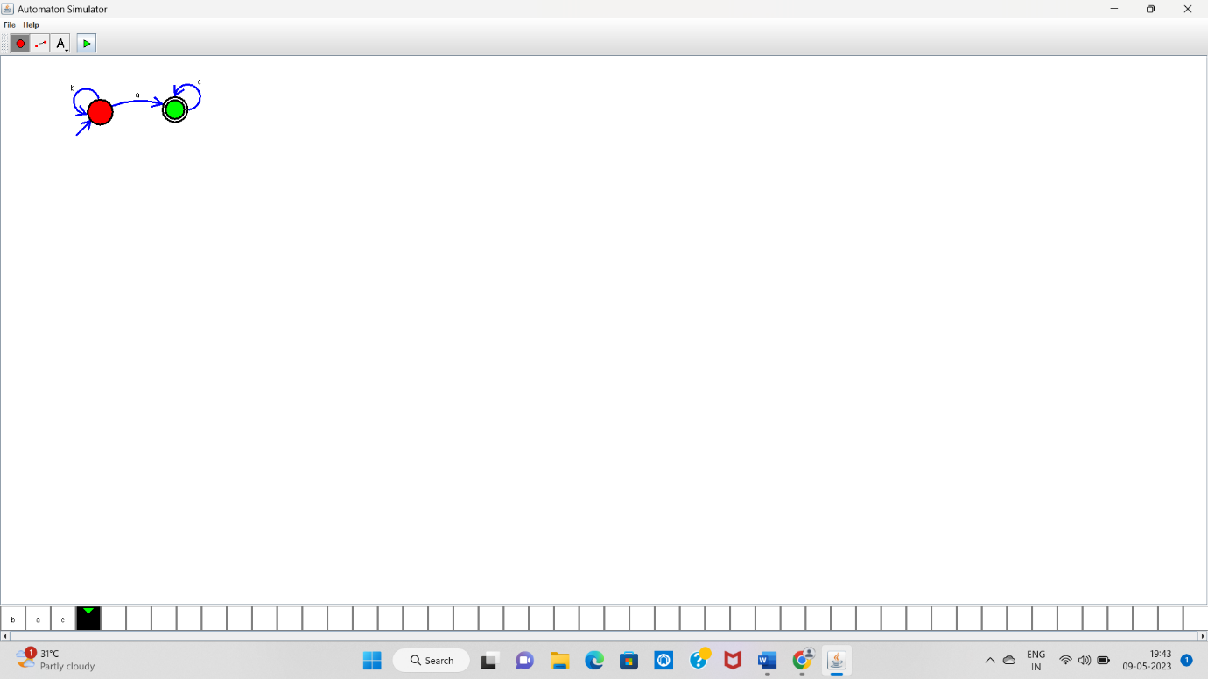

bac------Accepted