1. **Write a C program to print the following message as**

**\*\*\*WELCOME \*\*\***

**TO**

**\*\*\* PPS LAB \*\*\***

**C program**

#include<stdio.h>

void main()

{

printf("***WELCOME***\n TO\n***PPS LAB***");

}

**Output:**

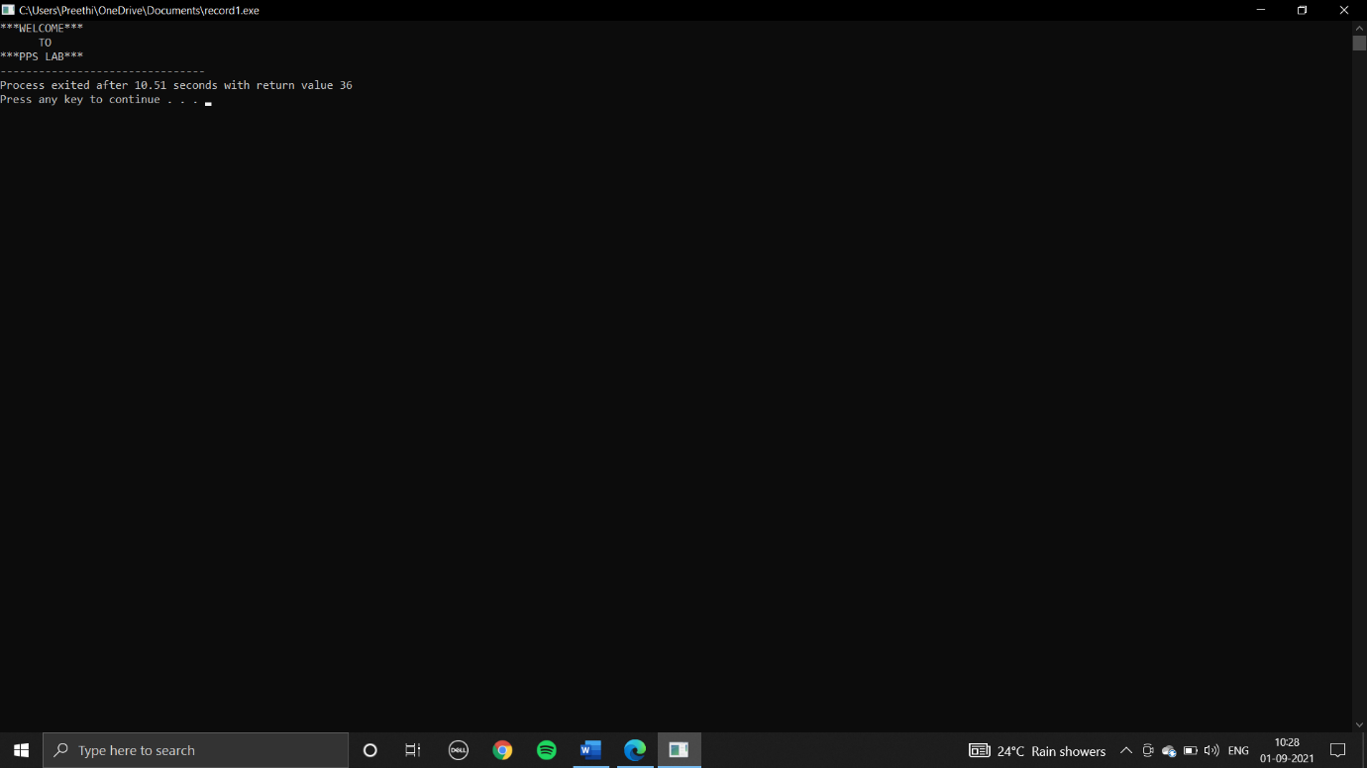

1. **Write a C program to print the progress report of a student based on the following conditions. Marks Grade 90- 100 A 80-89 B 70-79 C 51- 69 D < 50 Fail The student attempts exam in 5 subjects ( Mathematics, Science, Telugu, Social and English). Print Marks and grade subject wise along with the total score of the student. Input: 5 subject Marks**

**C program:**