1.load a CSV file and display the first 10 rows along with column names.
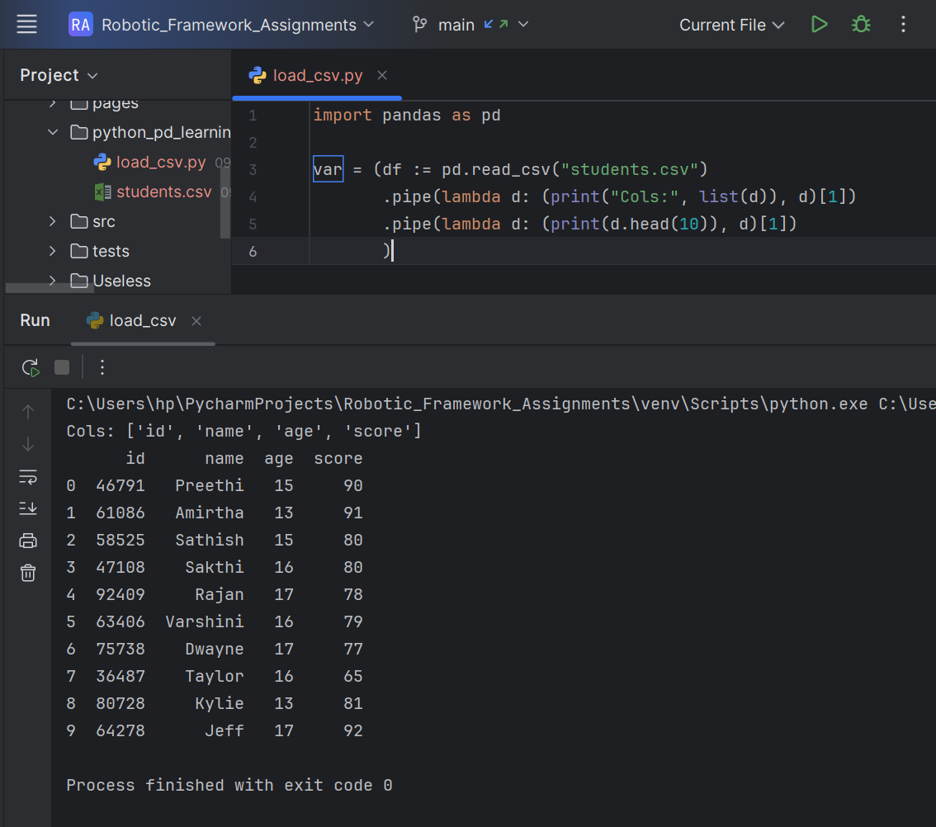
2.Given a DataFrame, fill missing values using the mean of the respective column.
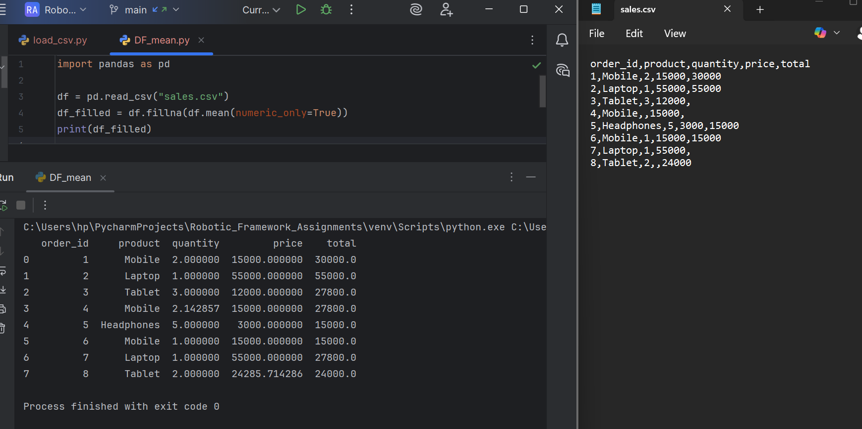
3.Write a program to group employees by department and calculate average salary.
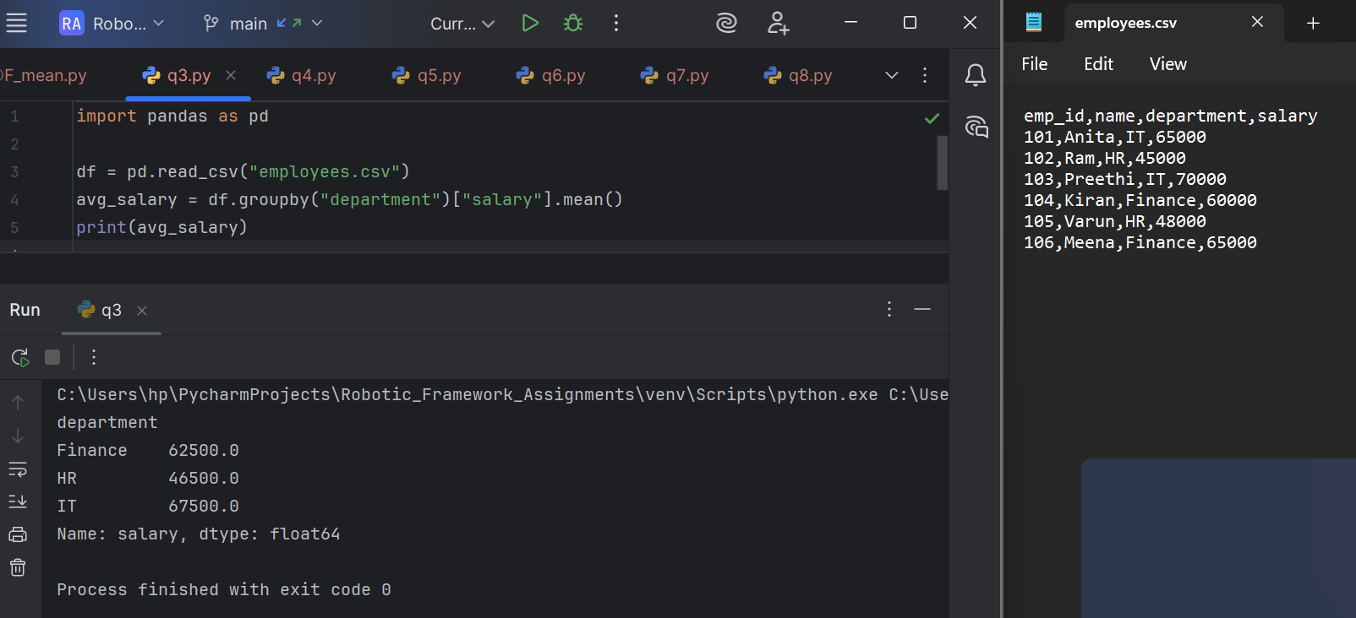
4.Merge two DataFrames (employee details and salary details) using merge().
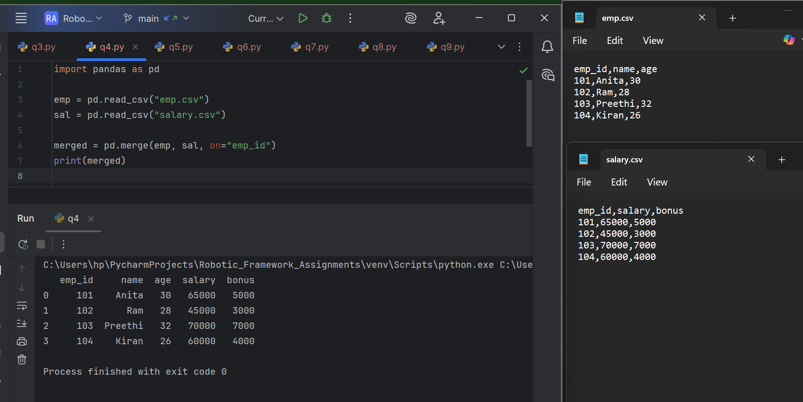

5.Create a pivot table to show sales per month per region.
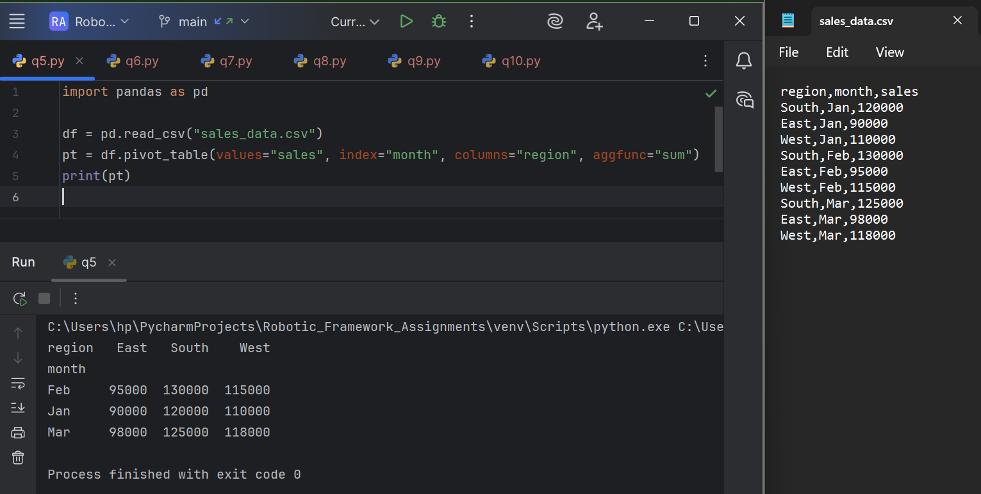
6.write a program to remove duplicate rows from a DataFrame.
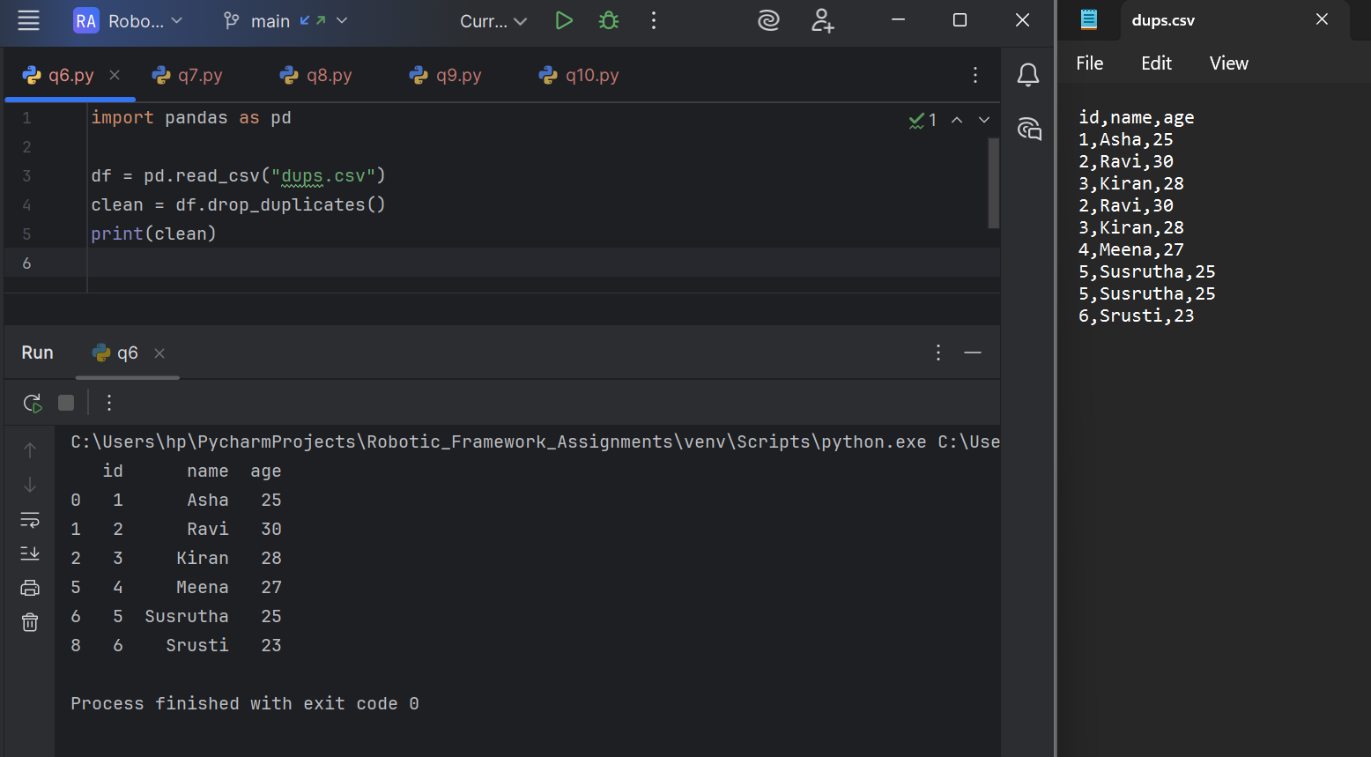

7.Convert a column with categorical values into dummy variables using get_dummies().
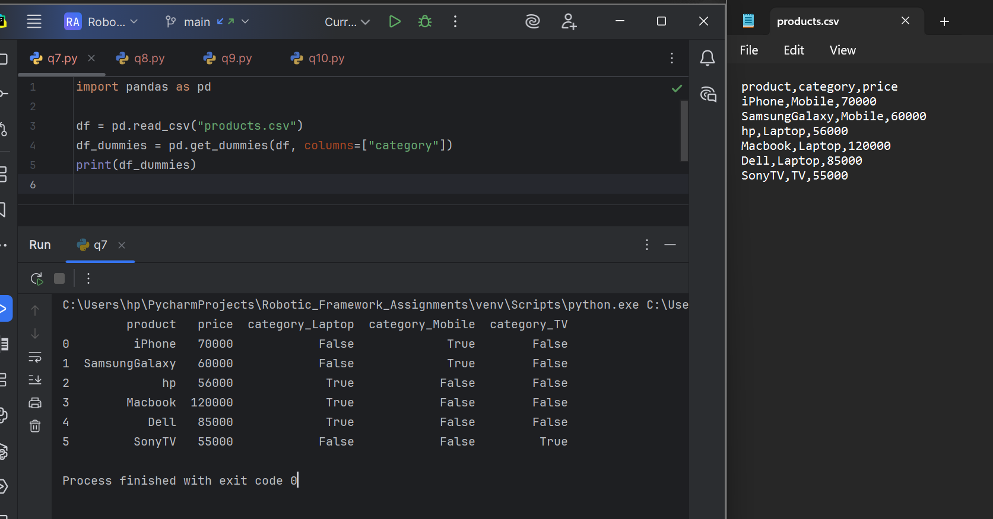
8.Given a time-series DataFrame, resample it into weekly summaries.
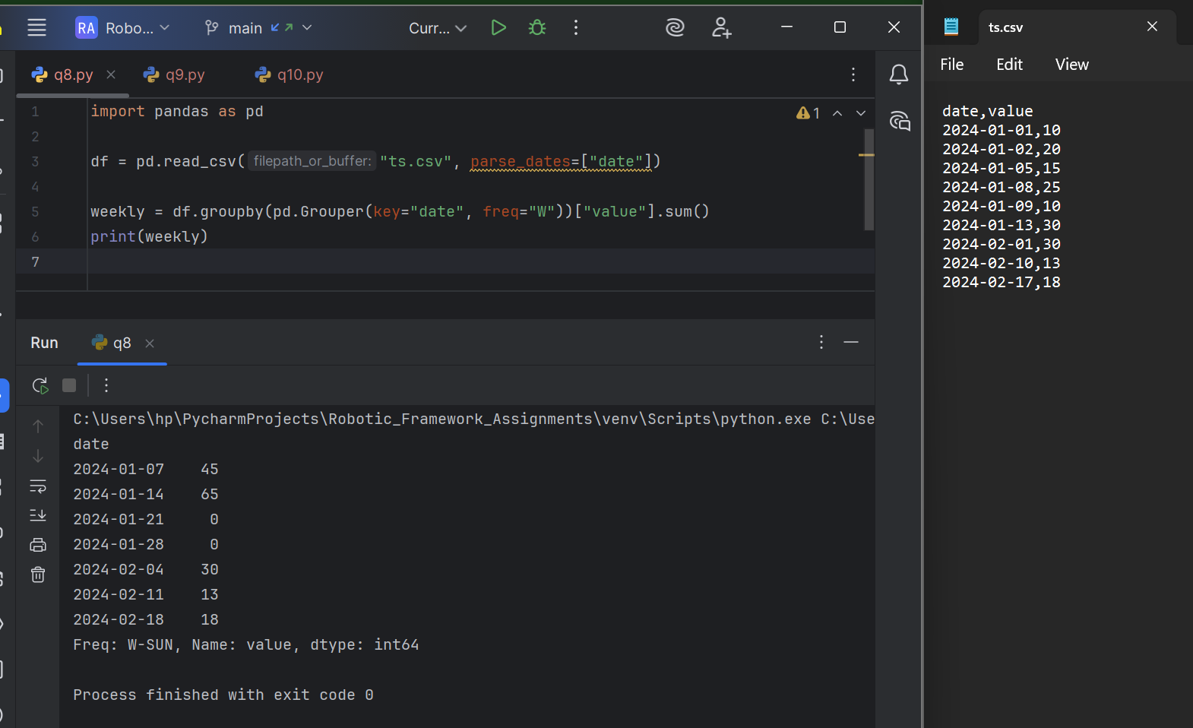

9. Write a program to find the correlation matrix of all numerical columns.
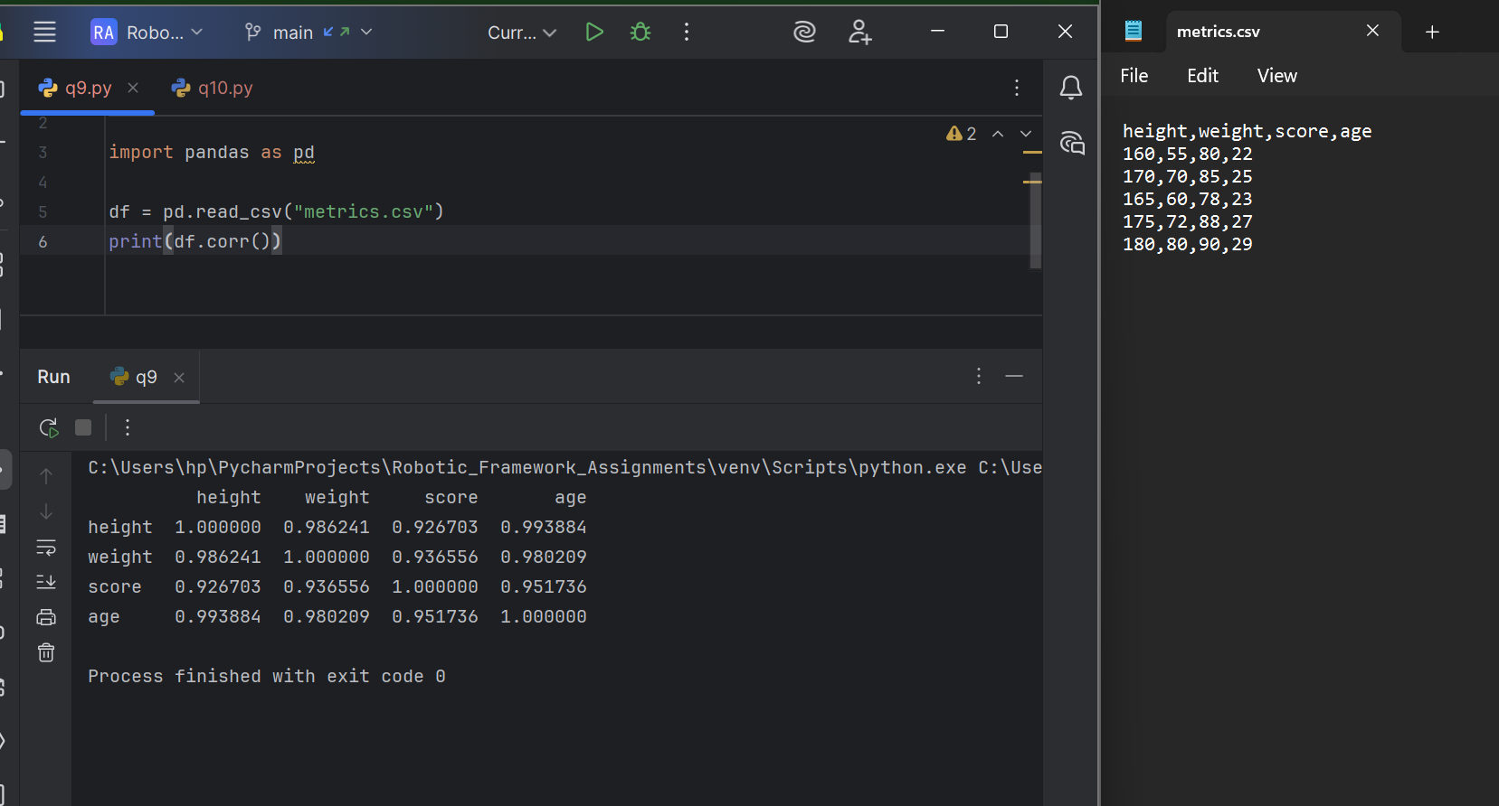
10.Plot a bar chart showing total sales for each product category using Pandas built-in plotting.
