Multi-User Login Test Report
This report contains screenshots for every execution.
--------------

Test 1: standard_user
Expected: success – Result: PASS
PASS: standard_user (pwd: secret_sauce)
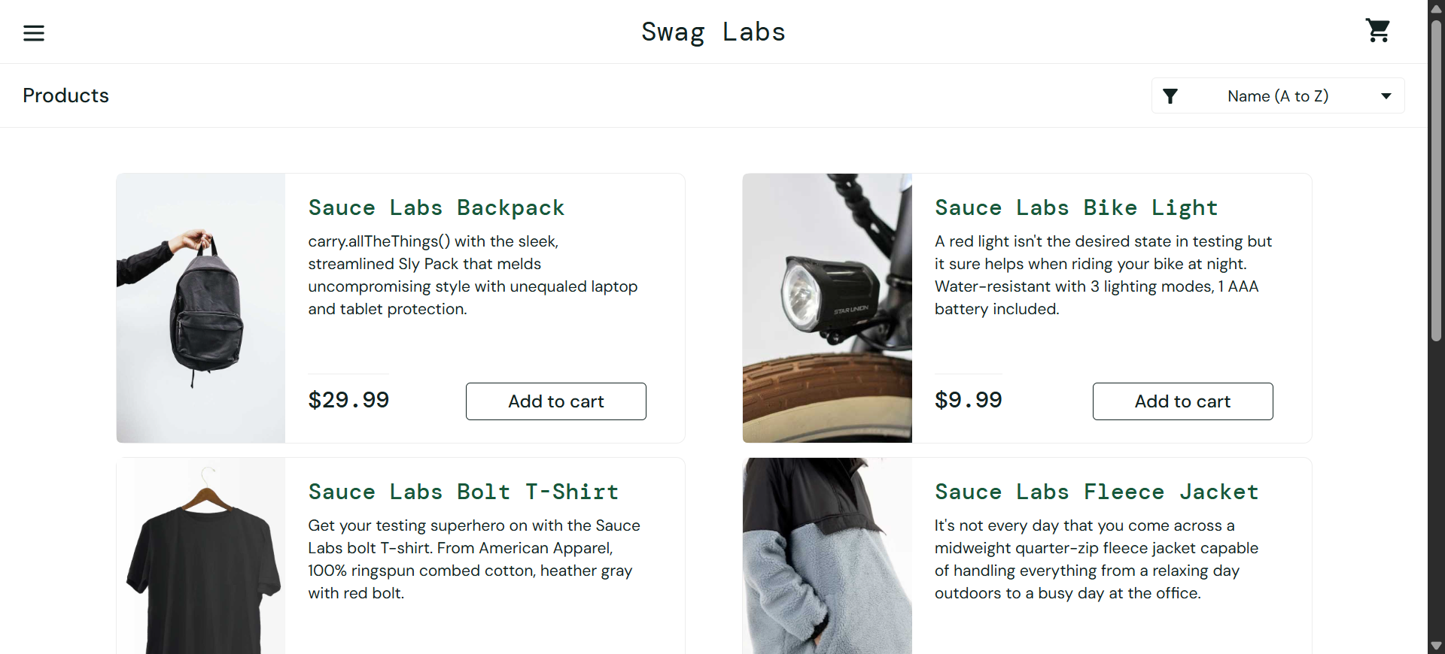

--------------

Test 2: locked_out_user
Expected: success – Result: FAIL
FAIL: locked_out_user (pwd: secret_sauce)
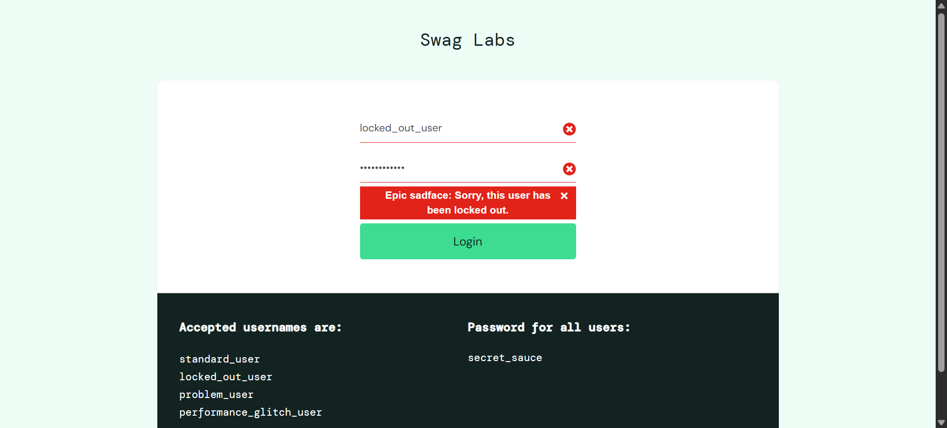

--------------

Test 3: problem_user
Expected: success – Result: PASS
PASS: problem_user (pwd: secret_sauce)
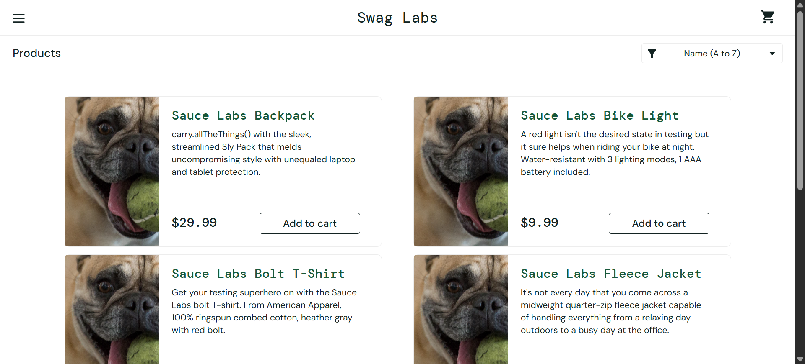

--------------

Test 4: performance_glitch_user
Expected: success – Result: PASS
PASS: performance_glitch_user (pwd: secret_sauce)

--------------

Test 5: standard_user
Expected: fail – Result: PASS
PASS: standard_user (pwd: wrong_password)
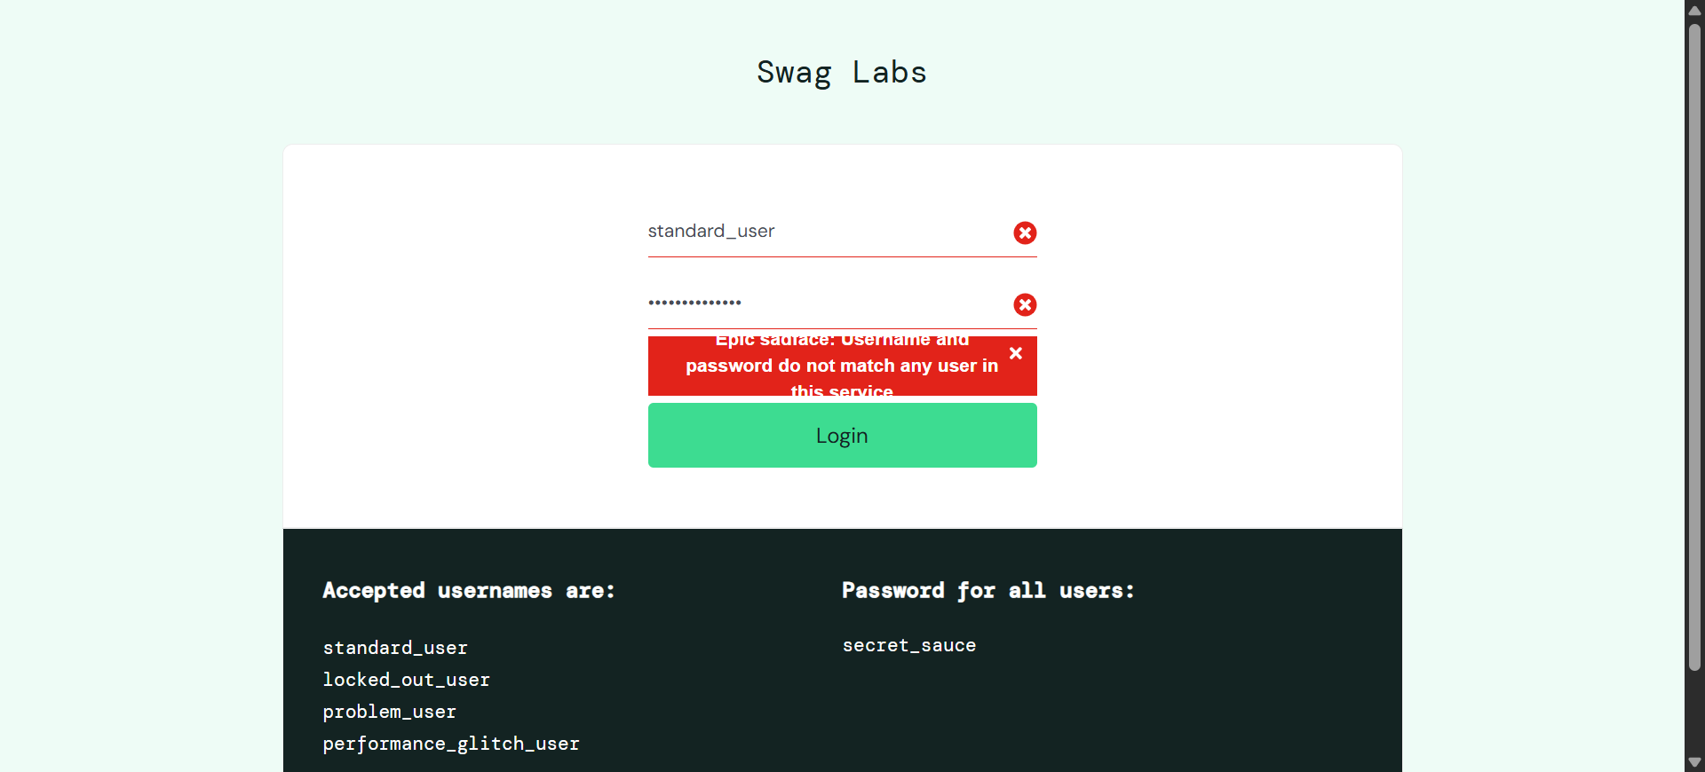

--------------

Test 6: locked_out_user
Expected: fail – Result: PASS
PASS: locked_out_user (pwd: wrong_password)
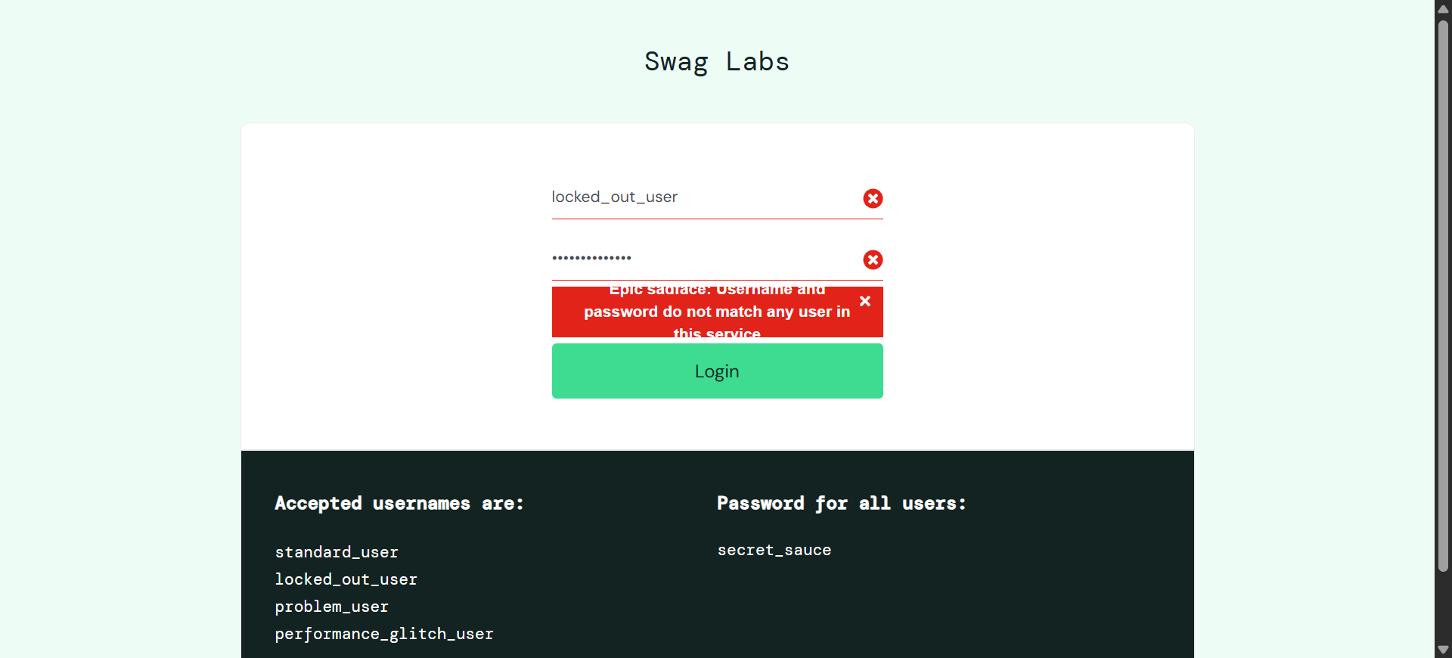

--------------

Test 7: problem_user
Expected: fail – Result: PASS
PASS: problem_user (pwd: wrong_password)
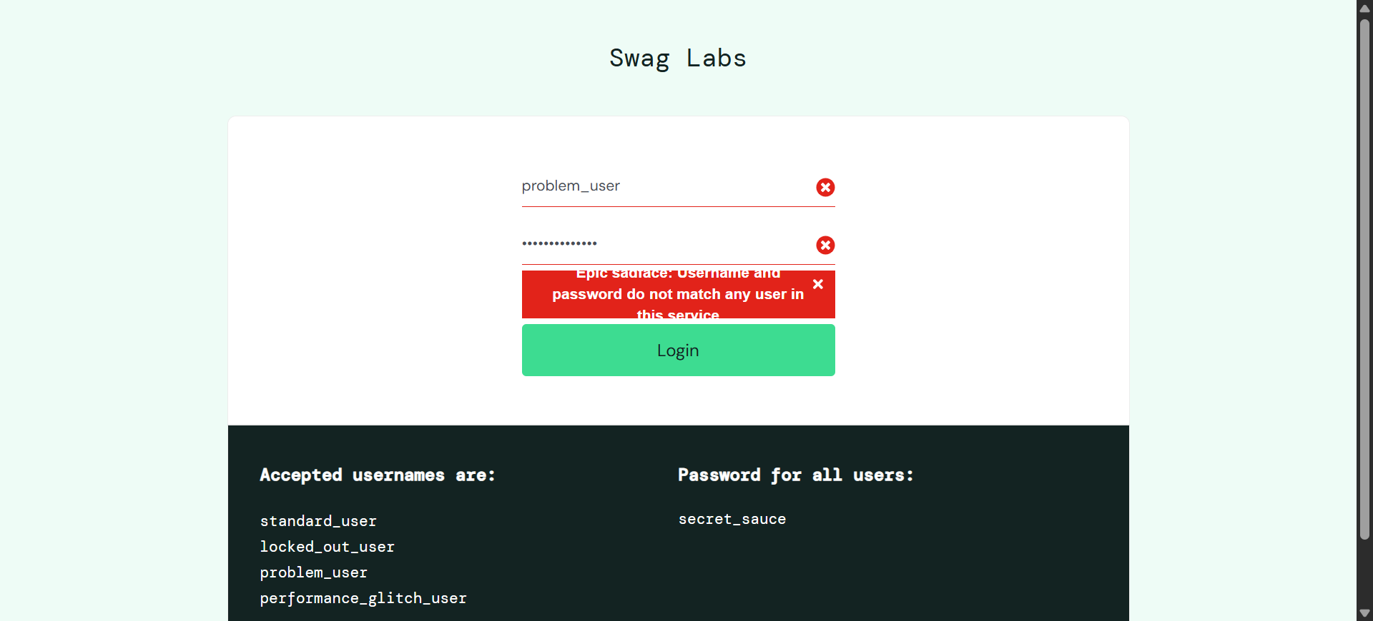

--------------

Test 8: performance_glitch_user
Expected: fail – Result: PASS
PASS: performance_glitch_user (pwd: wrong_password)
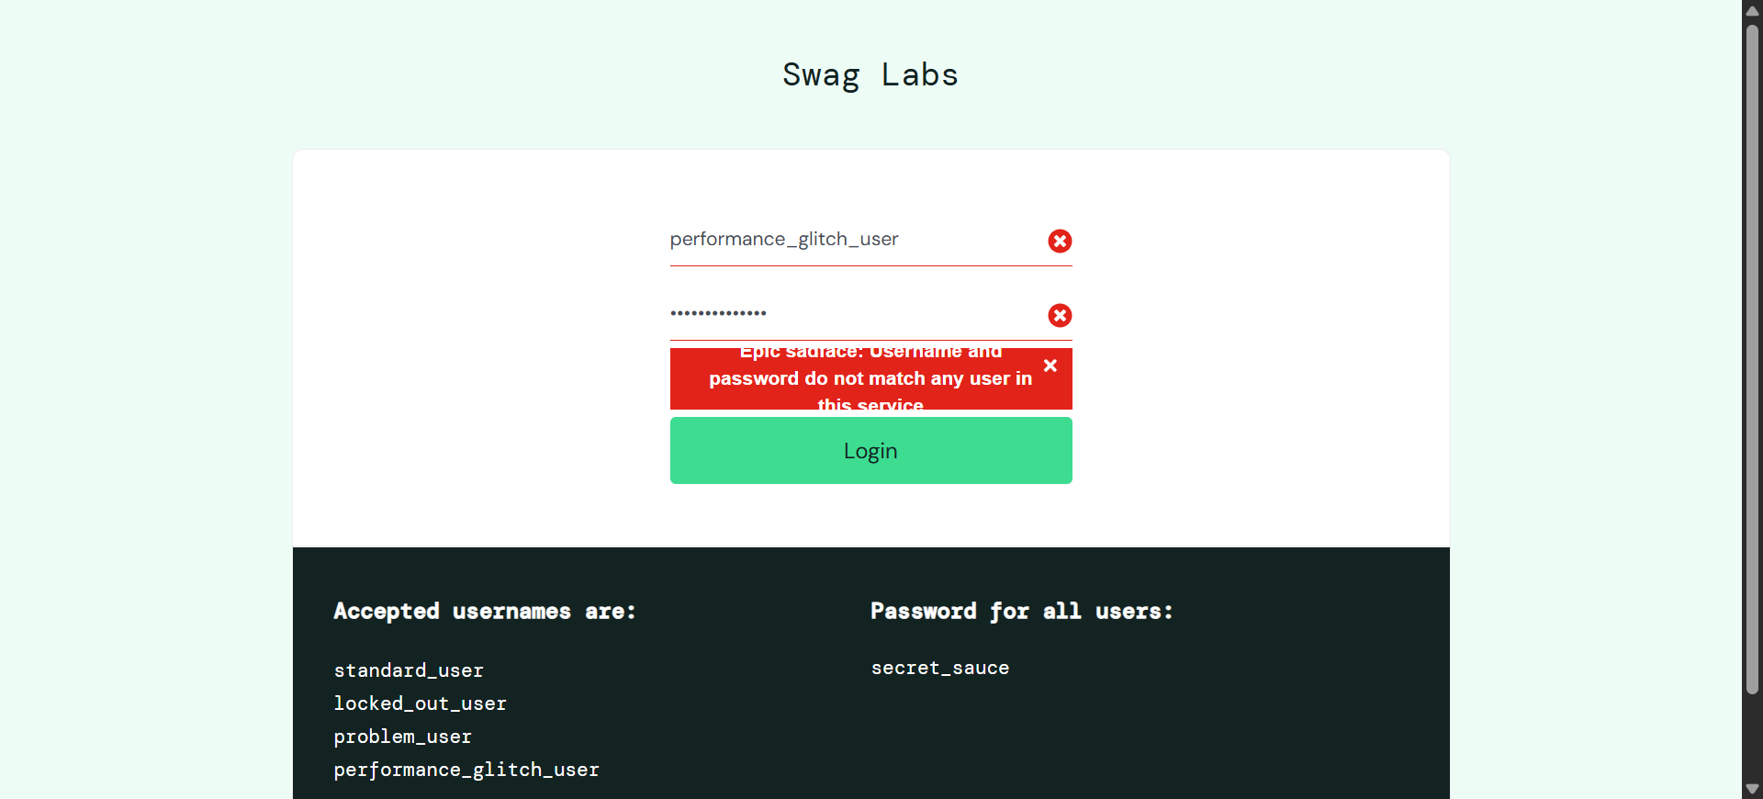

--------------
--------------
All tests completed.

