Multi-User Login Test Report
This report shows login results for multiple users.
--------------

Login Success: standard_user
User successfully logged in and reached inventory page.
Success: Inventory page for standard_user
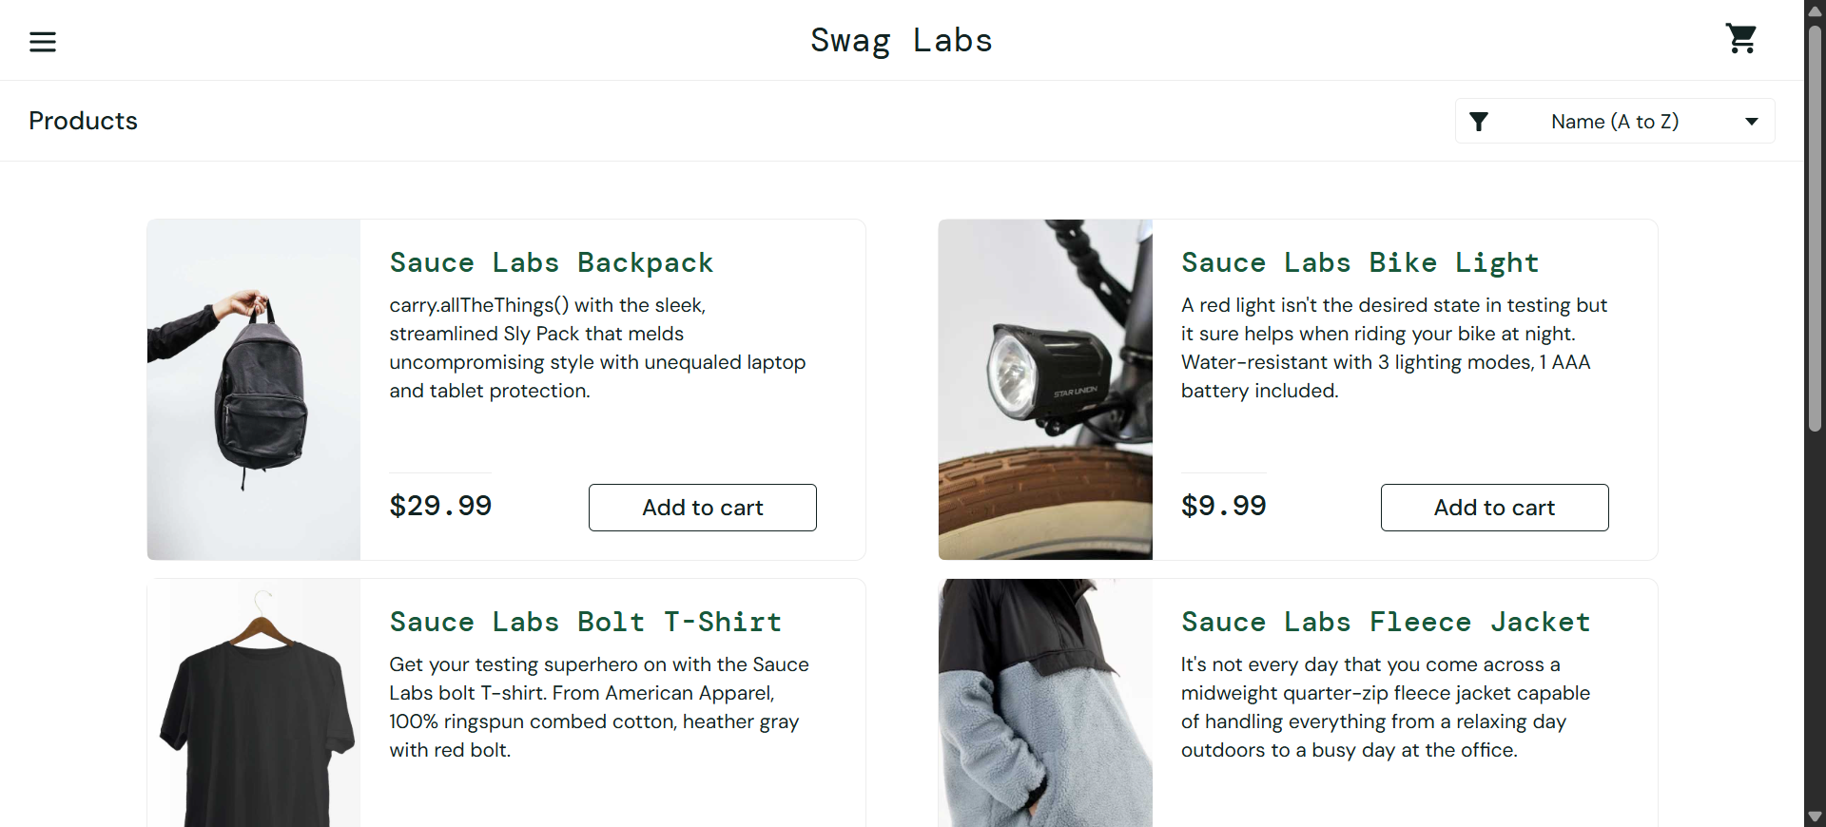

--------------

Login Failed (Expected): locked_out_user
User is locked out as expected.
Error: Locked out for locked_out_user
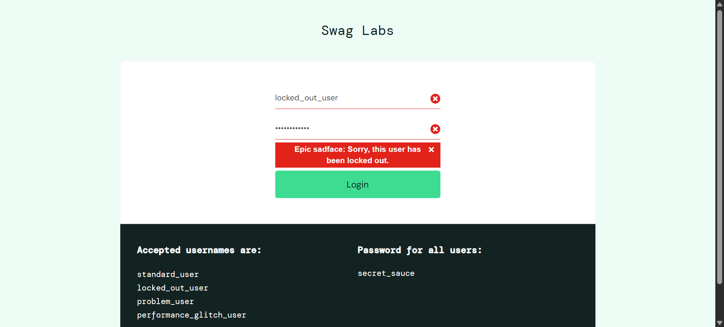

--------------

Login Success: problem_user
User successfully logged in and reached inventory page.
Success: Inventory page for problem_user
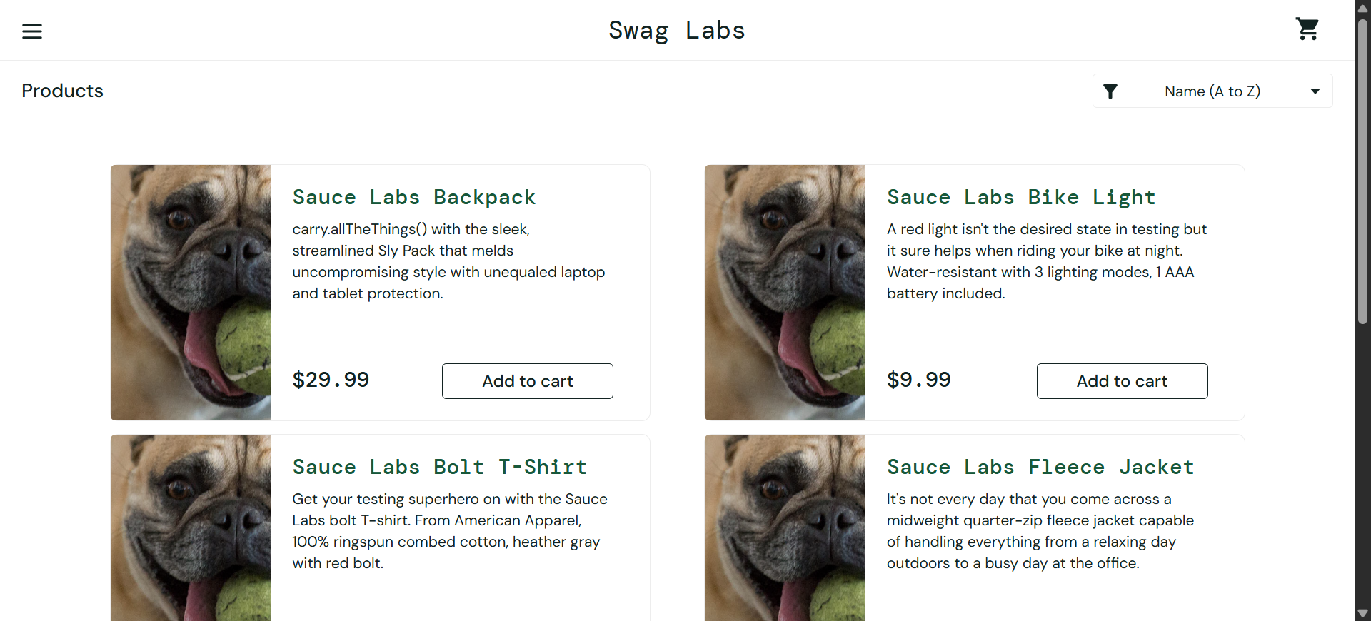

--------------

Login Success: performance_glitch_user
User successfully logged in and reached inventory page.
Success: Inventory page for performance_glitch_user

--------------
--------------
All tests completed successfully.

