

PROJECT REPORT ON
“GTTC BELAGAVI COLLEGE FAQ CHATBOT”

DIPLOMA IN ARTIFICIAL INTELLIGENCE AND MACHINE LEARNING
Submitted as part of the 3rd internal assessment requirements for the subject.

BY
Preethi G.R
8080153
Amruta Chikkanagoudar
8080151
Mohammadibrahim Farooq Basarikatti
8080122
Subject : Image procesing and Natural language processing

SUBMITTED TO: Mr. Ambaprasad sir

ABSTRACT
The GTTC Belagavi College FAQ Chatbot is a text-based chatbot developed to answer frequently asked questions related to Government Tool Room & Training Centre (GTTC), Belagavi.
The project uses basic Natural Language Processing (NLP) techniques such as tokenization, stopword handling, keyword and pattern matching, intent detection, sentiment analysis, and predefined responses.
Students can enter questions related to college timings, departments, courses, admission, fees, contact details, website, library timings, examinations, short-term courses, location, placements, and Artificial Intelligence and Machine Learning.
The system processes the student's question, identifies the possible intent, and provides an appropriate predefined answer. It also displays NLP analysis such as tokens, filtered tokens, intent, confidence, and sentiment.
The project provides a simple web-based interface and demonstrates how basic NLP techniques can be used to create a practical college FAQ chatbot.
––

TABLE OF CONTENTS

Sl. No. | CONTENTS | PAGE NO.
1 | Introduction | 4–4
2 | Problem Statement & Aim | 4–4
3 | Objectives | 4–5
4 | Proposed System | 5–5
5 | Scope | 5–5
6 | Technologies Used | 6–6
7 | Working Principle | 7–7
8 | System Modules | 7–8
9 | Object Recognition & Tracking | 8–8
10 | Advantages , Applications & Limitation | 9–9
11 | Testing & Results | 10–10
12 | Conclusion | 11–11

INTRODUCTION
Natural Language Processing is a branch of Artificial Intelligence that helps computers understand and process human language.
Students often have common questions about a college, such as available courses, admission, fees, working hours, contact details, examinations, and placements. Finding answers to these questions manually can take time.
The GTTC Belagavi College FAQ Chatbot is developed to provide quick answers to commonly asked questions.
The user enters a question through the chatbot interface. The system processes the text using basic NLP techniques and identifies the related question category. It then provides a predefined answer from the FAQ knowledge base.
The project demonstrates how basic NLP can be used to develop a simple and practical chatbot without requiring a large machine-learning model.
Problem Statement
Students may have many questions about college courses, admission, fees, timings, departments, examinations, contact details, and placements.
Searching for each answer manually can take additional time.
Therefore, there is a need for a simple chatbot that can understand common student questions and provide appropriate answers quickly.
Aim of the Project
The aim of this project is to develop a GTTC Belagavi College FAQ Chatbot that accepts student questions and provides suitable predefined answers using basic Natural Language Processing techniques.
The system also demonstrates tokenization, stopword handling, intent detection, confidence, and sentiment analysis
.

OBJECTIVES
The main objectives of the project are:
- To create a small FAQ knowledge base for GTTC Belagavi.
- To accept questions from students through a user interface.
- To preprocess user questions.
- To divide the question into individual tokens.
- To remove common stopwords.
- To identify keywords and patterns in user questions.
- To recognize the intent of the question.
- To provide an appropriate predefined response.
- To detect simple positive, negative, and neutral sentiment.
PROPOSED SYSTEM: The proposed system is a GTTC Belagavi College FAQ Chatbot.
The student enters a question in the chatbot interface. The system receives the input and processes the text.
The question is tokenized and common stopwords are handled. The system then uses keyword and pattern matching to identify the possible intent.
After identifying the intent, the chatbot searches its predefined FAQ knowledge base and displays the appropriate response.
The system can answer questions related to:
- College timings
- Departments
- Courses
- AIML
- Admission
- Fees
- Contact
- Website
- Library
- Examinations
- Short-term courses
- Location
- Placements
- Principal
If the question is not recognized, the system provides a fallback response.
SCOPE OF THE PROJECT
The scope of the GTTC Belagavi FAQ Chatbot includes:
- Answering frequently asked college questions.
- Providing course information.
- Providing admission-related information.
- Providing fee information.
- Providing college timing information.
- Providing contact and website information.
- Providing library and examination information.
- Providing short-term course information.
- Providing location information.
- Providing placement information.
- Providing AIML-related information.
- Detecting basic user sentiment.
- Displaying NLP analysis.
- Providing fallback responses for unknown questions.
The project can be extended with a larger database and more advanced NLP techniques in the future.
TECHNOLOGIES USED
TECHNOLOGIES USED
Technology | Use
Python | Develops the NLP chatbot program
Natural Language Processing | Processes and analyzes user questions
HTML | Creates chatbot webpage structure
CSS | Designs the chatbot interface
JavaScript | Provides chatbot interaction and browser logic
CSV | Stores sample FAQ dataset
Regular Expressions | Used for tokenization and pattern matching
Python
Python is used as the main programming language for the NLP chatbot.
Natural Language Processing
NLP techniques are used to process the student's natural-language question and identify important words and patterns.
HTML
HTML is used to create the structure of the chatbot webpage.
CSS
CSS is used to create the attractive card-style chatbot interface.
JavaScript
JavaScript is used for browser-side chatbot logic and interaction.
CSV Dataset
The project includes an FAQ dataset in CSV format containing sample questions and related information.

WORKING PRINCIPLE
The working of the chatbot can be explained in the following steps:
Step 1: User Input
The student enters a question into the chatbot.
Example:
What courses are available?
Step 2: Tokenization
The sentence is divided into individual tokens.
Step 3: Stopword Removal
Unnecessary common words are removed.
Step 4: Pattern Matching
The system checks the remaining words against predefined patterns.
Step 5: Intent Detection
The system identifies the question as a courses intent.
Step 6: FAQ Search
The corresponding answer is selected from the FAQ knowledge base.
Step 7: Response
The chatbot displays the answer.
Step 8: NLP Analysis
The system can also display:
- Tokens
- Filtered tokens
- Intent
- Confidence

PROJECT FILES AND THEIR FUNCTIONS
File | Function
chatbot.py | Main Python NLP chatbot
index.html | Web page structure
styles.css | Web page design
app.js | Browser-side chatbot functionality
faq_dataset.csv | FAQ question and answer dataset
sample_test_cases.txt | Sample testing questions
README.txt | Project instructions
PROJECT_REPORT.md | Project report information
PRESENTATION_8_SLIDES.md | Presentation content

USER INTERFACE
The project provides a modern chatbot-style interface.
Main interface features include:
- Chat window
- Message input box
- Send button
- FAQ category buttons
- Dark/light mode
- NLP analysis panel
- Intent display
- Confidence display
- Sentiment display
- Course information cards
- Placement information
- Source information
The interface is designed to make the chatbot easy for students to use.
ADVANTAGES , APPLICATIONS and LIMITATIONS
ADVANTAGES

Advantages
- Easy to use
- Quick answers
- Reduces repeated enquiries
- Simple implementation
- User-friendly interface
- .
APPLICATIONS
The developed chatbot successfully demonstrates basic Natural Language Processing techniques.
The system can:
- Accept student questions.
- Tokenize the input.
- Remove stopwords.
- Identify common intents.
- Match questions with predefined patterns.
- Retrieve suitable FAQ responses.
- Detect basic sentiment.
- Display confidence information.
- Handle unknown questions.
- Provide an interactive web interface.

LIMITATIONS
- The chatbot mainly supports predefined questions.
- It uses rule-based pattern matching.
- It cannot understand every type of natural-language question.
- The FAQ database is limited.
- It does not use a large trained language model.
- Some college information needs to be updated manually.
- Basic sentiment analysis may not understand complex sentences.

TESTING
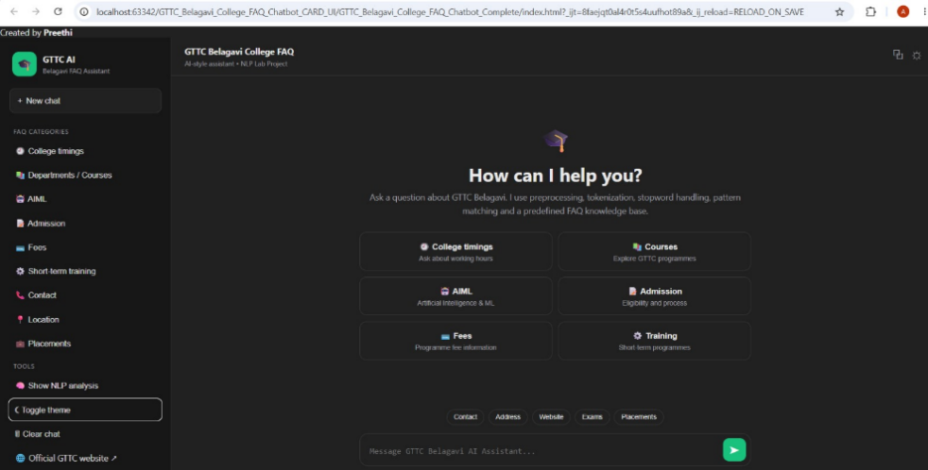

SAMPLE INPUT AND OUTPUT
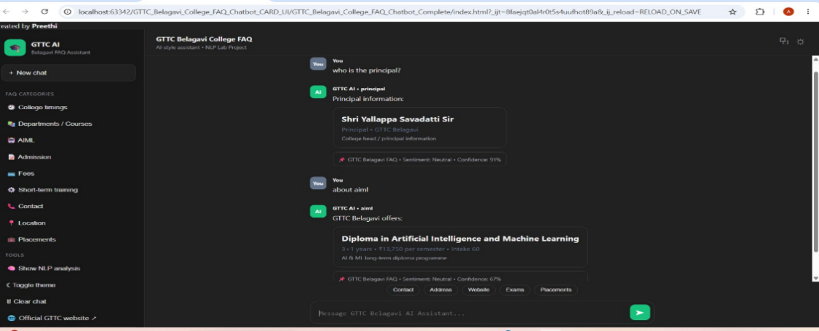

CONCLUSION
The GTTC Belagavi College FAQ Chatbot demonstrates the practical use of Natural Language Processing for answering common student questions.
The system uses tokenization, stopword removal, pattern matching, intent detection, predefined responses and basic sentiment analysis.
The chatbot provides a simple way for students to obtain frequently required college information. The project also demonstrates how Python and web technologies can be combined to create an interactive NLP application.
Overall, the project provides a good practical implementation of basic NLP concepts and can be extended into a more intelligent college information assistant in the future.

