
INDUSTRIAL ESTATE KHANAPUR ROAD
UDYAMBAAG BELAGAVI-590008
In partial fulfillment for the award of

“DIPLOMA IN ARTIFICIAL INTELLIGENCE AND MACHINE LEARNING”
PROJECT REPORT ON
“COLOR VISION”

SUBMITTED TO: Ambaprasad sir

Subject : Image procesing and nlp

Name : PREETHI G.R

Roll.No : 8080153

Problem Statement

The traditional process of performing image processing requires separate software and technical knowledge. Users may find it difficult to apply basic image processing operations such as grayscale conversion, binary conversion, blurring, thresholding, and edge detection.

Therefore, the proposed system is a web-based Smart Image Processing System developed using Flask, Python, OpenCV, HTML, CSS, and JavaScript. It allows users to upload an image, select an image processing operation, process the image, and view the original and processed images through a web interface.

Objective
The main objectives of the Smart Image Processing System are:
- To develop a simple and user-friendly web-based image processing application.
- To allow users to upload images through a browser.
- To process images using the OpenCV library.
- To provide multiple image processing techniques.
- To perform grayscale and binary conversion.
- To support JPG, PNG, and BMP image formats.
- To provide RGB-to-Grayscale and RGB-to-HSV conversion.
- To improve image contrast using histogram equalization.
- To adjust brightness and contrast.
- To perform average, Gaussian, and Laplacian filtering.
- To perform morphological operations such as erosion, dilation, opening, and closing.
- To display the original and processed images for comparison.
- To save processed images automatically in the static/results folder.
- To return the processing result to the frontend using a JSON response
- .

Introduction
INTRODUCTION
The Smart Image Processing System is a web-based application developed using Python Flask and OpenCV.
The system provides an interactive interface called VisionLab, where users can upload an image and select different image processing operations.
The Flask framework is used to create the web server and handle HTTP requests. OpenCV is used to perform image processing operations, while NumPy is used to handle image data in array form.
The uploaded image is received by the Flask /process route using a POST request. The image data is converted into a NumPy array and decoded using:
cv2.imdecode()
An ImageProcessor class is used to organize the different processing methods. Depending on the operation selected by the user, the corresponding method is executed.
The processed image is then saved in the:
static/results/
folder using a unique filename generated with the uuid module.
Finally, Flask returns a JSON response containing the processed image URL and selected operation. JavaScript receives the response and displays the processed image on the webpage.

4. FEATURES OF THE SYSTEM
4.1 Image Upload
Users can select an image from their computer using the upload interface.
The system also supports drag-and-drop image uploading through JavaScript.

4.2 Display Original Image
The uploaded image can be displayed without applying any processing.
def display(self):
return self.image.copy()

4.3 Grayscale Conversion
The system converts a color image into a grayscale image.
cv2.cvtColor(
self.image,
cv2.COLOR_BGR2GRAY
)

4.4 Binary Thresholding
The grayscale image is converted into black and white using a threshold value of 127.
_, binary_image = cv2.threshold(
gray,
127,
255,
cv2.THRESH_BINARY
)

4.5 Image Format Support
The system provides options for saving images as:
- JPG
- PNG
- BMP

4.6 RGB/BGR to Grayscale
The system converts color information into a single grayscale intensity channel.

4.7 RGB/BGR to HSV
The system converts the image from BGR color space to HSV color space.
HSV contains:
- Hue
- Saturation
- Value
The processed HSV image is converted back to BGR for browser display.

4.8 Histogram Equalization
Histogram equalization improves the contrast of a grayscale image.
cv2.equalizeHist(gray)

4.9 Brightness and Contrast
The system changes brightness and contrast using:
cv2.convertScaleAbs(
image,
alpha=1.5,
beta=40
)
Here:
- alpha = 1.5 controls contrast.
- beta = 40 controls brightness.

4.10 Average Filter
The average filter smooths the image and helps reduce noise.
cv2.blur(
self.image,
(5, 5)
)

4.11 Gaussian Filter
Gaussian filtering smooths the image using a Gaussian kernel.
cv2.GaussianBlur(
self.image,
(5, 5),
0
)

4.12 Laplacian Filter
The Laplacian filter detects rapid intensity changes and highlights image details and edges.
cv2.Laplacian(
gray,
cv2.CV_64F
)

4.13 Morphological Operations
The system provides four morphological operations:
- Erosion
- Dilation
- Opening
- Closing
These operations work on binary images.

4.14 Result Saving
Every processed image is saved inside:
static/results/
A unique filename is created using UUID:
filename = str(uuid.uuid4()) + extension
This prevents filename conflicts.

4.15 JSON Response
After processing, Flask sends a JSON response containing:
{
"success": true,
"result": "/static/results/filename.png",
"operation": "grayscale"
}
Features
The major features of the system are:
1. Image Upload
Users can upload an image through the web interface.
2. File Validation
The system accepts only supported image formats:
- JPG
- JPEG
- PNG
- BMP
- WEBP

3. Secure Filename
secure_filename() is used to create a safe filename for uploaded images.
4. Original Image
The uploaded image can be displayed without modification.
5. Grayscale Conversion
The color image is converted into a grayscale image using OpenCV.
6. Binary Conversion
The grayscale image is converted into a black-and-white binary image using thresholding.
7. Gaussian Blur
Gaussian filtering is applied to reduce noise and smooth the image.
8. Edge Detection
Canny edge detection is used to identify edges and boundaries in the image.
9. Thresholding
Thresholding separates image regions based on pixel intensity.
10. Result Display
The application displays the original image and processed image side by side.
11. Download Option
The processed image can be downloaded from the result section.
12. Responsive Interface
The CSS design allows the application to work on different screen sizes.
Methodology Diagram
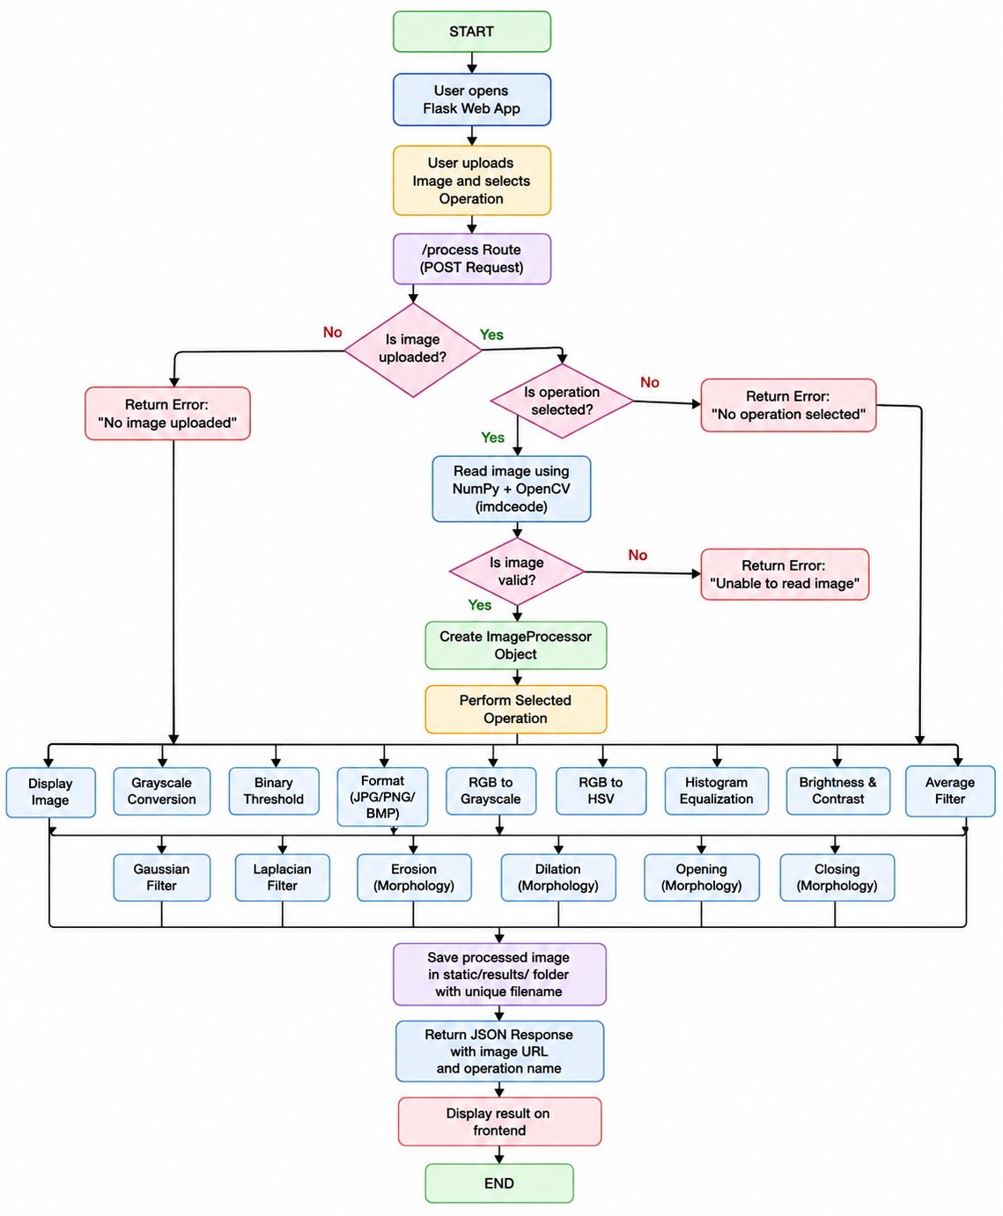

IMAGE PROCESSING OPERATIONS
The system implements the following operations:
No. | Operation | OpenCV Technique
1 | Display | Image copy
2 | Grayscale | cv2.cvtColor()
3 | Binary | cv2.threshold()
4 | JPG | cv2.imwrite()
5 | PNG | cv2.imwrite()
6 | BMP | cv2.imwrite()
7 | RGB → Grayscale | cv2.cvtColor()
8 | RGB → HSV | cv2.cvtColor()
9 | Histogram Equalization | cv2.equalizeHist()
10 | Brightness & Contrast | cv2.convertScaleAbs()
11 | Average Filter | cv2.blur()
12 | Gaussian Filter | cv2.GaussianBlur()
13 | Laplacian Filter | cv2.Laplacian()
14 | Erosion | cv2.erode()
15 | Dilation | cv2.dilate()
16 | Opening | cv2.morphologyEx()
17 | Closing | cv2.morphologyEx()

Advantages
- Easy to use – The graphical web interface is simple and user-friendly.
- Web-based system – Image processing can be performed through a browser.
- Multiple operations – Several image processing operations are available.
- Fast processing – OpenCV provides efficient image processing.
- File validation – Invalid file formats are rejected.
- Secure file handling – secure_filename() helps prevent unsafe filenames.
- Real-time feedback – JavaScript displays the selected file and processing status.
- Responsive design – The interface adapts to different screen sizes.
- Automatic output saving – Processed images are automatically stored.
- Simple implementation – The system can be easily modified and extended.

Disadvantages

- The system mainly supports basic image processing operations.
- It does not perform advanced AI-based image recognition.
- Processing very large images may require more memory and processing time.
- The current application does not provide advanced image enhancement tools.
- The quality of thresholding may depend on the selected threshold value.
- Canny edge detection requires suitable threshold values for better results.
- The application is mainly designed for individual image processing.
- The Flask development server is not suitable for large-scale production deployment without proper deployment configuration.

Scope and Limitations
Scope
The project can be extended in the future with more advanced image processing and AI features.
Possible future improvements include:
- Image resizing and cropping.
- Image rotation.
- Brightness and contrast adjustment.
- Noise removal.
- Histogram equalization.
- Advanced segmentation.
- Face detection.
- Object detection.
- Image classification using Machine Learning or Deep Learning.
- Webcam-based image processing.
- Multiple image processing.
- Cloud-based image processing.
- User login and image history.
- More download and sharing options.

Limitations
The current system has some limitations:
- It supports only predefined image processing operations.
- It does not currently use a trained deep learning model.
- It processes one uploaded image at a time.
- Image quality may change depending on the selected operation and output format.
- Very large images can increase processing time.
- The application requires a working Python and Flask environment.
- The current system is primarily intended for basic educational and demonstration purposes.

.
Predicted Image
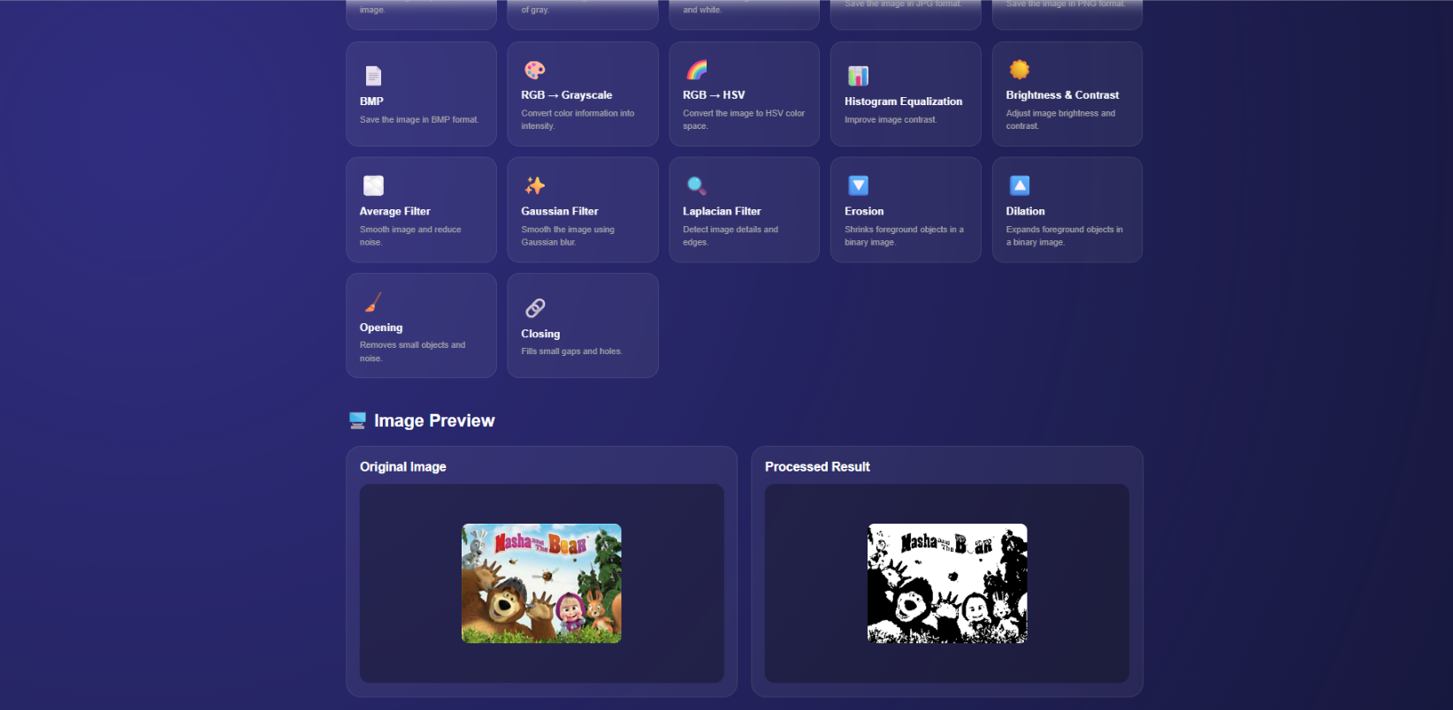

THANK YOU

