Date: 12/11/24

**DSA Practice Problems**

1. **Anagram**

class Solution {

public static boolean areAnagrams(String s1, String s2) {

if(s1.length()!=s2.length()){

return false;

}

int[] count=new int[26];

for(int i=0;i<s1.length();i++){

count[s1.charAt(i)-'a']++;

}

for(int i=0;i<s2.length();i++){

count[s2.charAt(i)-'a']--;

}

for(int i=0;i<26;i++){

if(count[i]!=0){

return false;

}

}

return true;

}

}

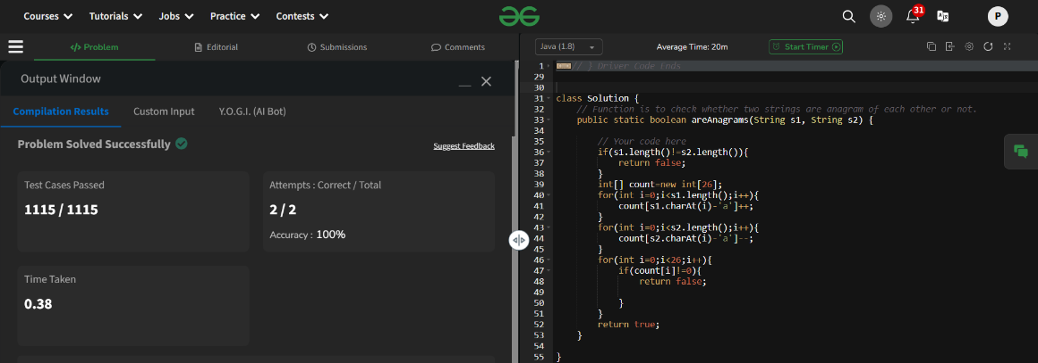

Time Complexity: O(n)

1. **Row with max 1s'**

class Solution {

public int rowWithMax1s(int arr[][]) {

int maxrow=-1;

int row=arr.length;

int column=arr[0].length;

int i=0;

int j=column-1;

while(i<row && j >=0){

if(arr[i][j]==0){

i++;

}

else{

maxrow=i;

j--;

}

}

return maxrow;

}

}

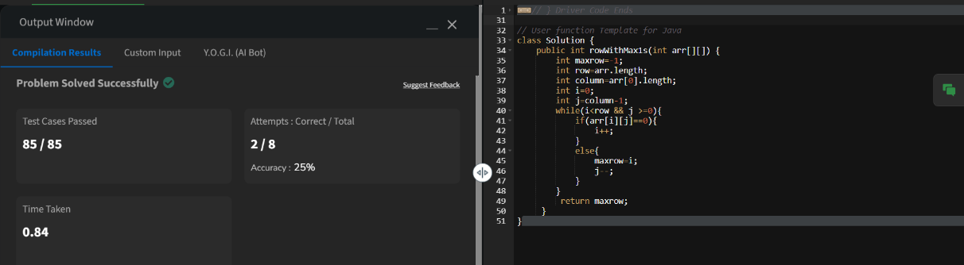

Time Complexity: O(M+N)

1. **Longest consecutive subsequence**

class Solution {

public int findLongestConseqSubseq(int[] arr) {

int n=arr.length;

if(n==0){

return 0;

}

Arrays.sort(arr);

int maxlen=1;

int curr_len=1;

for(int i=1;i<n;i++){

if(arr[i]!=arr[i-1]){

if(arr[i-1]+1==arr[i]){

curr_len++;

}

else{

curr_len=1;

}

maxlen=Math.max(curr_len,maxlen);

}

}

return maxlen;

}

}

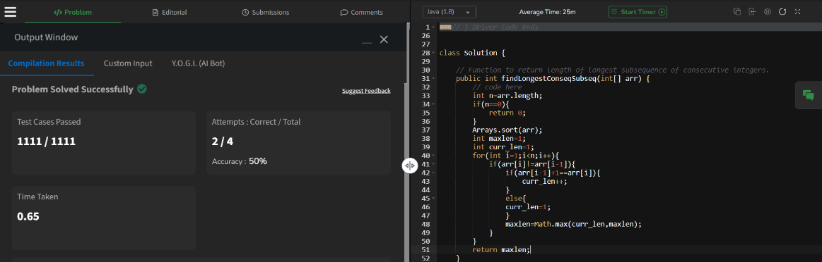

Time Complexity: O(n log n)

1. **Longest palindrome in a string**

class Solution {

static String longestPalindrome(String s) {

String result="";

int maxlen=0;

int left=0;

int right=0;

for(int i=0;i<s.length();i++){

left=right=i;

while(left>=0 && right<s.length() &&s.charAt(left)==s.charAt(right)){

if(maxlen<right-left+1){

result=s.substring(left,right+1);

maxlen=right-left+1;

}

left--;

right++;

}

left=right=i;

right++;

while(left>=0 && right<s.length() &&s.charAt(left)==s.charAt(right)){

if(maxlen<right-left+1){

result=s.substring(left,right+1);

maxlen=right-left+1;

}

left--;

right++;

}

}

return result;

}

}

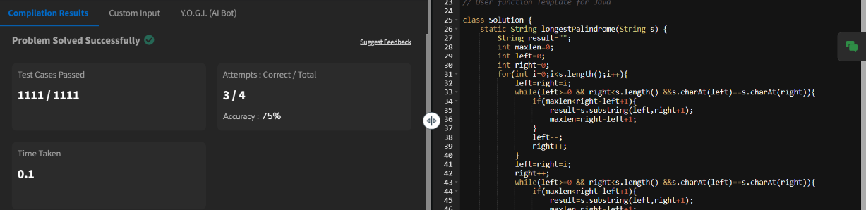

Time Complexity: O(n^2)

1. **Rat in a maze problem**

class Solution {

public ArrayList<String> findPath(int[][] mat) {

int N = mat.length;

if (mat[0][0] == 0 || mat[N - 1][N - 1] == 0) {

return new ArrayList<>();

}

Map<String, int[]> dirs = new HashMap<>();

dirs.put("U", new int[]{-1, 0});

dirs.put("R", new int[]{0, 1});

dirs.put("L", new int[]{0, -1});

dirs.put("D", new int[]{1, 0});

boolean[][] visited = new boolean[N][N];

ArrayList<String> paths = new ArrayList<>();

DFS(0, 0, "", mat, visited, paths, dirs, N);

Collections.sort(paths);

return paths;

}

private void DFS(int r, int c, String curr, int[][] mat, boolean[][] visited, ArrayList<String> paths, Map<String, int[]> dirs, int N) {

if (r == N - 1 && c == N - 1) {

paths.add(curr);

return;

}

visited[r][c] = true;

for (Map.Entry<String, int[]> entry : dirs.entrySet()) {

int nr = r + entry.getValue()[0];

int nc = c + entry.getValue()[1];

if (isValid(nr, nc, mat, visited, N)) {

DFS(nr, nc, curr + entry.getKey(), mat, visited, paths, dirs, N);

}

}

visited[r][c] = false;

}

private boolean isValid(int r, int c, int[][] mat, boolean[][] visited, int N) {

return r >= 0 && r < N && c >= 0 && c < N && mat[r][c] == 1 && !visited[r][c];

}

}

