**Date:** 14/11/24

**DSA Practice Problems**

1. **Stock Buy and Sell**

class Solution{

public ArrayList<ArrayList<Integer>> stockBuySell(int[] A, int N){

ArrayList<ArrayList<Integer>> result=new ArrayList<>() ;

for(int i=0;i<N-1;i++){

if(A[i+1]>A[i]){

ArrayList<Integer> pair=new ArrayList<>();

pair.add(i);

pair.add(i+1);

result.add(pair);

}

}

return result;

}

}

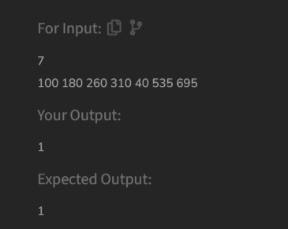

Time Complexity: O(N)

1. **Coin Change (Count Ways)**

class Solution {

public int count(int coins[], int Sum) {

int[] dp = new int[Sum+1];

dp[0]=1;

for(int coin : coins){

for(int j=coin;j<=Sum;j++){

dp[j]+=dp[j-coin];

}

}

return dp[Sum];

    }

}

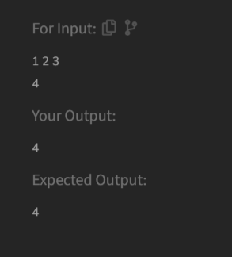

Time Complexity: O(N*Sum)

1. **First and Last Occurrence**

class GFG {

ArrayList<Integer> find(int arr[], int x) {

ArrayList<Integer> res=new ArrayList<>();

int first=-1;

int last=-1;

int start=0;

int end=arr.length-1;

while(start<=end){

int mid=(start+end)/2;

if(arr[mid]==x){

first=mid;

end=mid-1;

}

else if(arr[mid]<x){

start=mid+1;

}

else{

end=mid-1;

}

}

start=0;

end=arr.length-1;

while(start<=end){

int mid=(start+end)/2;

if(arr[mid]==x){

last=mid;

start=mid+1;

}

else if(arr[mid]<x){

start=mid+1;

}

else{

end=mid-1;

}

}

res.add(first);

res.add(last);

return res;

}

}

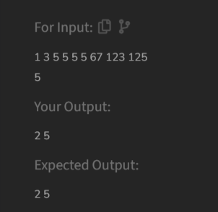

Time Complexity: O(log N)

1. **Find Transition Point**

class Solution {

int transitionPoint(int arr[]) {

int ind=-1;

for(int i=0;i<arr.length;i++){

if(arr[i]==1){

ind=i;

break;

}

}

return ind;

}

}

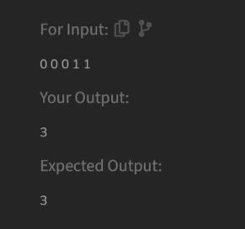

Time Complexity: O(N)

1. **First Repeating Element**

class Solution {

public static int firstRepeated(int[] arr) {

HashSet<Integer> freq = new HashSet<>();

int firstindex = -1;

for (int i = arr.length - 1; i >= 0; i--) {

if (freq.contains(arr[i])) {

firstindex = i + 1;

} else {

freq.add(arr[i]);

}

}

return firstindex;

}

}

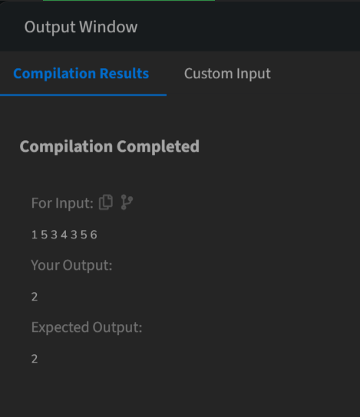

Time Complexity: O(N)

1. **Remove Duplicates Sorted Array**

class Solution {

public int remove_duplicate(List<Integer> arr) {

if (arr.size() == 0) return 0;

int j = 0;

for (int i = 1; i < arr.size(); i++) {

if (!arr.get(i).equals(arr.get(j))) {

j++;

arr.set(j, arr.get(i));

}

}

return j + 1;

}

}

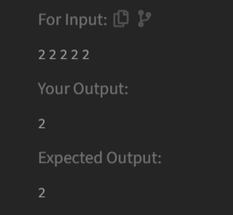

Time Complexity: O(N)

1. **Maximum Index**

class Solution {

int maxIndexDiff(int[] arr) {

int n=arr.length;

int[] leftMin = new int[n];

int[] rightMax = new int[n];

leftMin[0] = arr[0];

for (int i = 1; i < n; i++) {

leftMin[i] = Math.min(leftMin[i - 1], arr[i]);

}

rightMax[n - 1] = arr[n - 1];

for (int i = n - 2; i >= 0; i--) {

rightMax[i] = Math.max(rightMax[i + 1], arr[i]);

}

int i = 0, j = 0, ans = -1;

while (i < n && j < n) {

if (leftMin[i] <= rightMax[j]) {

ans = Math.max(ans, j - i);

j++;

} else {

i++;

}

}

return ans;

}

}

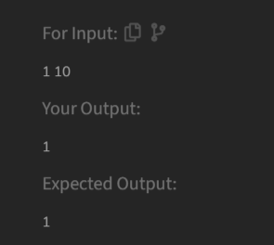

Time Complexity: O(n)

1. **Wave Array**

class Solution {

public static String convertToWave(int[] arr) {

int n=arr.length;

for(int i=0;i<n-1;i+=2){

int temp=arr[i];

arr[i]=arr[i+1];

arr[i+1]=temp;

}

return Arrays.toString(arr);

}

}

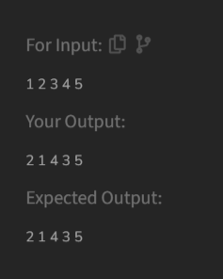

Time Complexity: O(N)