DESIGN AND ANALYSIS OF ALGORITHMS
ASSIGNMENT 1
Design, Analyse and Validate an Efficient Search Strategy
for a Large-Scale Student Record System

CO1: Algorithm Fundamentals, Efficiency Analysis, Asymptotic Analysis,
Mathematical Analysis, Recurrence Analysis and Master Theorem

Student Details | Value
Name | Preethika
Programme | B.Tech – Information Technology
Course | Design and Analysis of Algorithms
Assignment | CO1 – Assignment 1
Total Marks | 50
Academic Year | 2026–2027

Table of Contents
1. Problem Understanding and Assumptions
2. Task 1 – Design the Algorithms
3. Task 2 – Identify the Basic Operation
4. Task 3 – Mathematical Time-Complexity Derivation
5. Task 4 – Best, Average and Worst Cases
6. Task 5 – Asymptotic Analysis
7. Task 6 – Recurrence Relation
8. Task 7 – Solving the Recurrence
9. Task 8 – Implementation and Testing
10. Task 9 – Experimental Performance
11. Task 10 – Theory versus Experiment
12. Task 11 – Final Design Recommendation
13. Task 12 – Day-4 Design Challenge
14. Overall Conclusion
15. References

1. Problem Understanding and Assumptions
The assignment asks for an efficient method to locate a student record using a unique Registration Number. The database may grow from 1,000 to 1,000,000 or more records, and any preprocessing cost must be included in the analysis. The final design therefore has to consider not only the time of one search, but also the cost of preparing the data and the expected number of searches.
The three strategies selected are deliberately different: (1) iterative linear search, which scans the records sequentially; (2) recursive binary search, which repeatedly halves a sorted search interval; and (3) hash-table lookup, which restructures the records so that a registration number can usually be accessed directly. This combination provides a useful comparison among sequential, divide-and-conquer, and direct-addressing/hash-based strategies.
Key assumptions:
- Every Registration Number is unique, as stated in the problem.
- The search key is a Registration Number and equality comparison is the dominant key operation.
- For binary search, records must be sorted by Registration Number before searching.
- For the experimental comparison, the dataset is generated as integers 1…n, so the algorithms operate on equivalent data.
- For hash lookup, expected O(1) search assumes a well-distributed hash function and a reasonable load factor.
- Preprocessing is counted separately and then included in total cost.
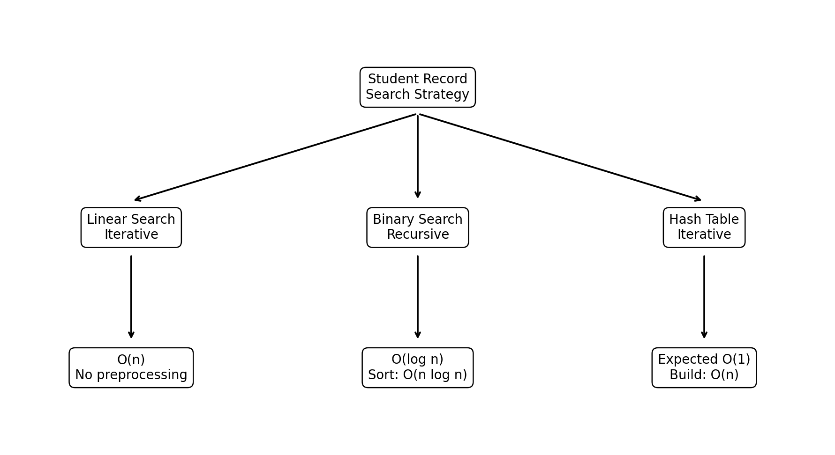
Figure 1. Mindmap of the proposed search strategies and their preprocessing requirements.

2. TASK 1 – Design the Algorithms
The assignment requires at least three meaningfully different strategies, including at least one iterative and one recursive approach. The following designs satisfy those requirements.

2.1 Approach A – Iterative Linear Search
Linear search examines records one by one from the beginning until the target Registration Number is found or the entire database has been examined. It requires no sorting or special data structure, so it is particularly useful as a baseline and for small or frequently changing datasets.
Design strategy: sequential / brute-force search.
Preprocessing: none.
LINEAR_SEARCH(records, target)
for i = 0 to n - 1
if records[i].registration_no == target
return records[i]
return NOT_FOUND
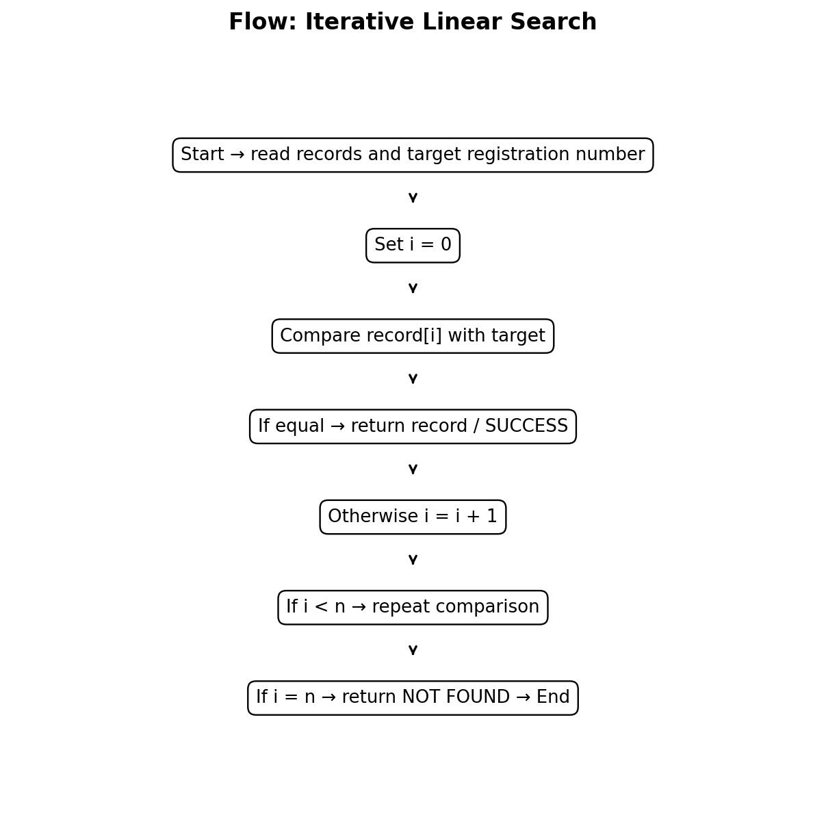
Figure 2. Flowchart for iterative linear search.

2.2 Approach B – Recursive Binary Search
Binary search is a divide-and-conquer algorithm. The records are first sorted by Registration Number. At every step, the middle record is compared with the target. If the target is smaller, only the left half can contain it; if larger, only the right half can contain it. The recursive call therefore works on a problem of half the previous size.
Design strategy: divide and conquer.
Preprocessing: sorting by Registration Number; if the data is initially unsorted, comparison sorting costs Θ(n log n).
BINARY_SEARCH(records, target, low, high)
if low > high
return NOT_FOUND
mid = floor((low + high) / 2)
if records[mid].registration_no == target
return records[mid]
else if target < records[mid].registration_no
return BINARY_SEARCH(records, target, low, mid - 1)
else
return BINARY_SEARCH(records, target, mid + 1, high)
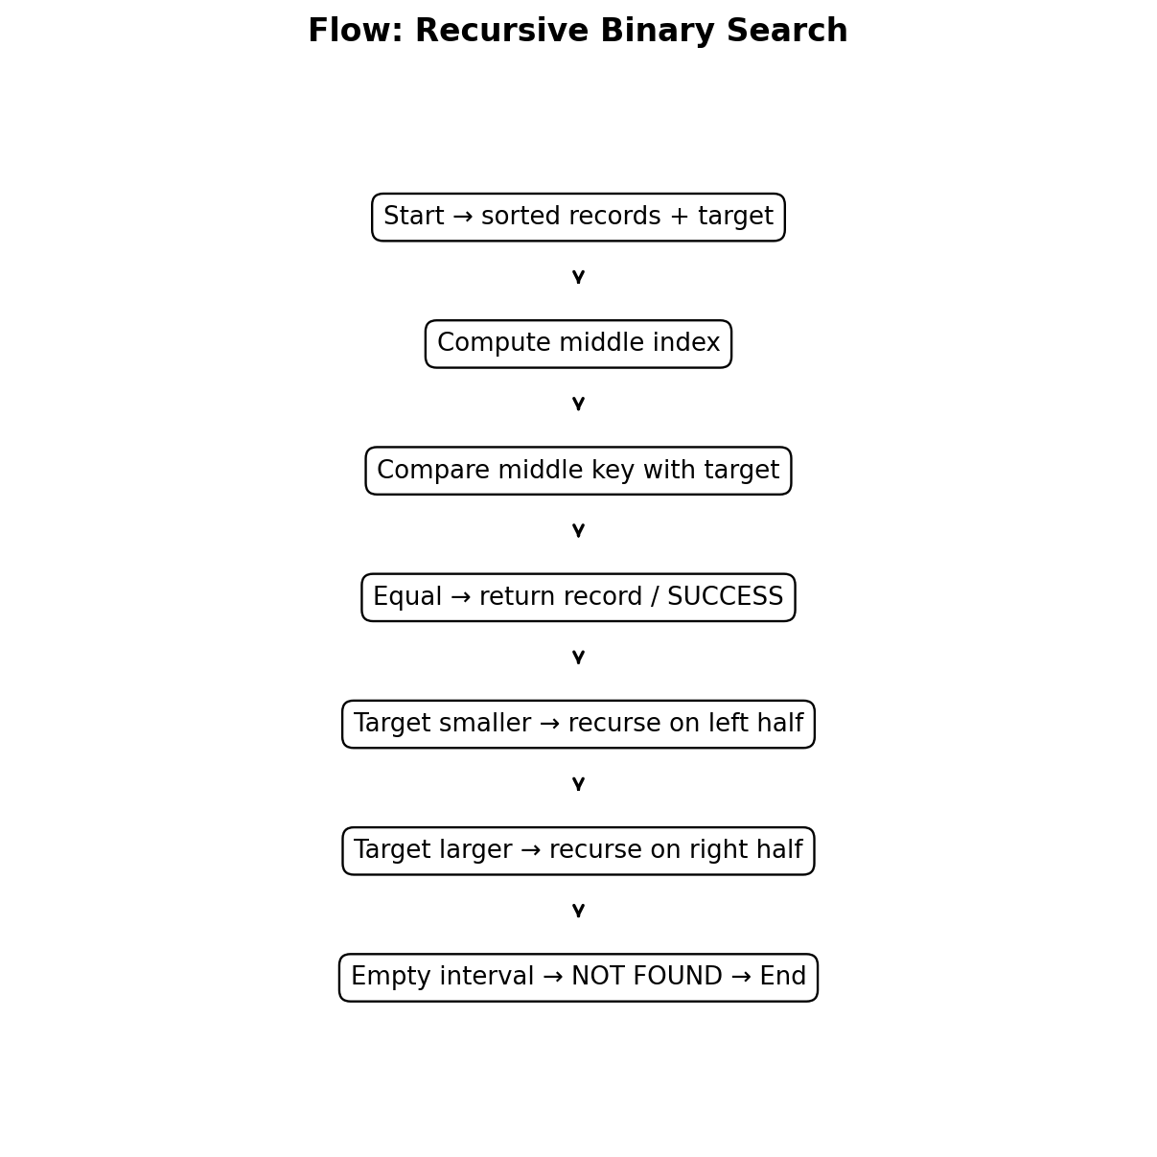
Figure 3. Flowchart for recursive binary search.

2.3 Approach C – Hash Table Lookup
A hash table restructures the records into key-value entries where the Registration Number is the key and the complete student record is the value. The hash function maps the key to a bucket. With a good hash function and controlled load factor, lookup is expected to take constant time.
Design strategy: hashing / direct access through a key-indexed structure.
Preprocessing: construct the hash table. Expected construction cost is Θ(n).
BUILD_HASH_TABLE(records)
table = empty hash table
for record in records
table[record.registration_no] = record
return table
HASH_SEARCH(table, target)
return table.get(target, NOT_FOUND)
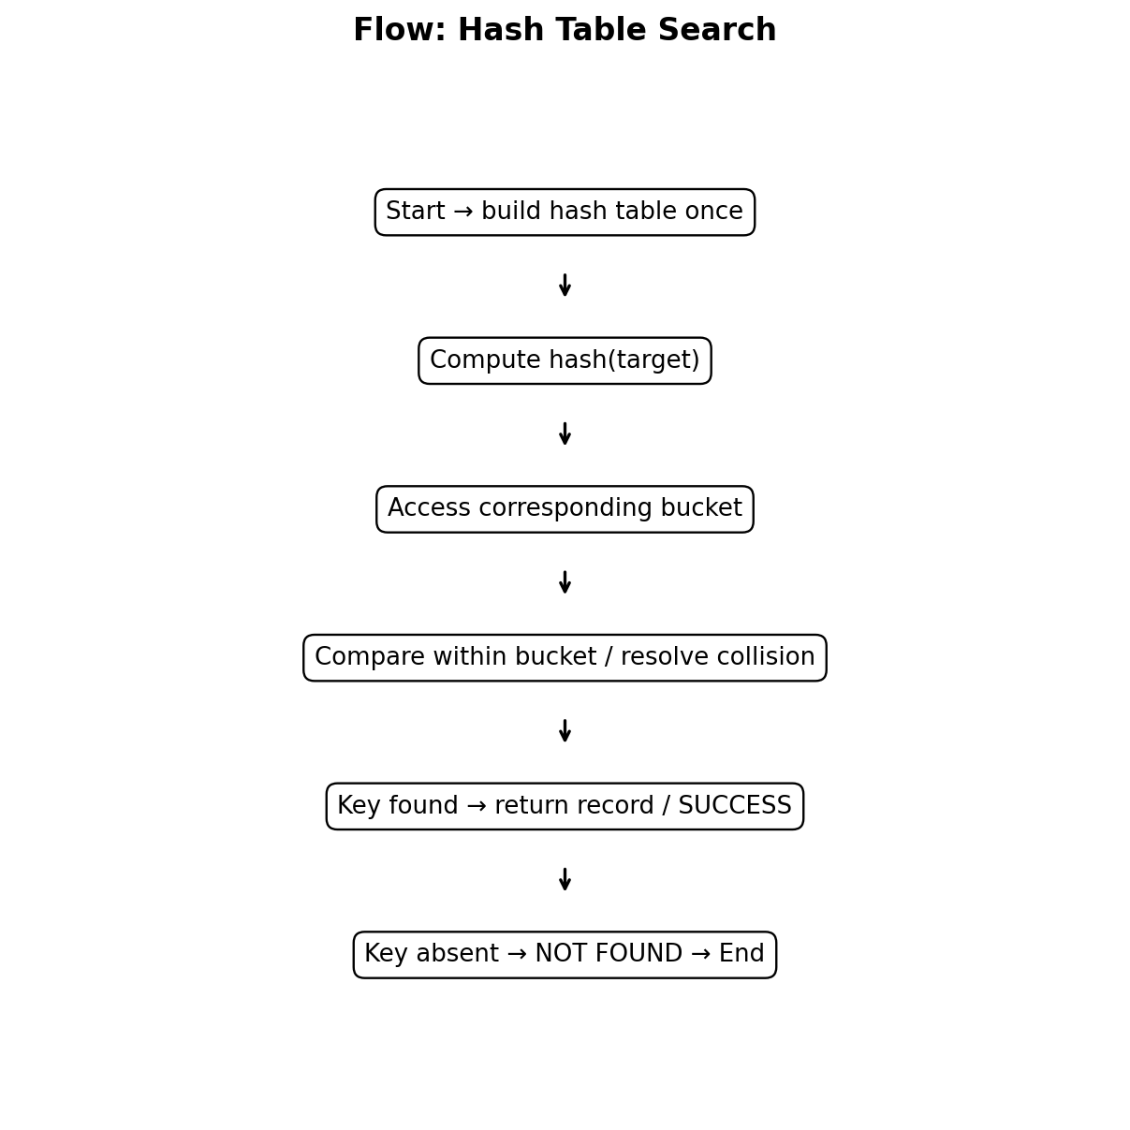
Figure 4. Flowchart for hash-table lookup.

2.4 Why these three approaches were selected
Approach | Distinct idea | Why investigate it?
Linear search | Sequential scan | Simple baseline; no preprocessing; suitable for small/dynamic data.
Recursive binary search | Divide and conquer | Excellent logarithmic search once records are sorted; directly supports recurrence analysis.
Hash table | Hash-based restructuring | Expected constant-time lookup; attractive when searches are very frequent and updates are relatively rare.

3. TASK 2 – Identify the Basic Operation

3.1 Linear Search
The basic operation is the equality comparison between records[i].registration_no and the target Registration Number. It occurs once per examined record. In the worst case the target is absent or is the final record, producing n comparisons.

3.2 Recursive Binary Search
The basic operation is the comparison between the target and the middle Registration Number. Each recursive level performs one key comparison. Because the remaining interval is halved, the number of comparisons grows logarithmically with n.

3.3 Hash Table Lookup
The main operation is the hash-table key lookup, followed by a small number of key comparisons when resolving a collision. Under the expected-case assumption of a good hash function, the number of inspected entries remains approximately constant as n grows.
Algorithm | Basic operation | Approximate operation count as n grows
Linear | Key equality comparison | Up to n
Binary | Middle-key comparison | About floor(log2 n)+1
Hash | Hash/index + bucket key comparison | Expected O(1); collision-dependent worst case

4. TASK 3 – Derive the Time-Complexity Function Mathematically

4.1 Linear Search
Let n be the number of records. In the worst case, the algorithm examines every record.
T_L(n) = c1 + c2 + ... + cn
= c n + c0
Therefore, T_L(n) = an + b = Θ(n).
In the best case, the first record matches, so Tbest(n)=Θ(1). For an unsuccessful search, n comparisons are required. If the target is equally likely to occur in any position, the average successful search performs (n+1)/2 comparisons, giving Θ(n).

4.2 Recursive Binary Search
Let C(n) denote the number of key comparisons for a binary search on n sorted records.
C(n) = C(floor(n/2)) + 1, n > 1
C(1) = 1
After k levels:
C(n) ≈ k + 1
Since the interval is halved at each level:
n / 2^k ≈ 1
2^k ≈ n
k ≈ log2(n)
Therefore C(n) = Θ(log2 n).
If the data is initially unsorted, sorting must also be included. With a comparison sort, preprocessing is Θ(n log n), so the total one-time-plus-one-search cost is:
T_total_binary(n) = Θ(n log n) + Θ(log n)
= Θ(n log n) for a single search after loading.
However, if many searches are performed on the same mostly static dataset, the sorting cost is amortized across all searches. For q searches, total work is Θ(n log n + q log n).

4.3 Hash Table Lookup
Building the table requires one insertion per record. Under expected constant-time insertion:
T_build_hash(n) = n * Θ(1) = Θ(n)
One lookup:
T_search_hash(n) = Θ(1) expected
For q searches:
T_total_hash(n,q) = Θ(n) + qΘ(1)
= Θ(n + q) expected.
The worst case can degrade to Θ(n) if many keys collide into the same bucket, although a practical hash table with a good hash function and controlled load factor is designed to avoid this behaviour.

5. TASK 4 – Best, Average and Worst-Case Behaviour
Algorithm | Best case | Average case | Worst case | Reason
Linear | Θ(1): target first | Θ(n): average position ≈ (n+1)/2 | Θ(n): last/absent | Sequential scan may need to inspect many records.
Binary | Θ(1): middle record matches | Θ(log n) | Θ(log n) | Each comparison removes roughly half the remaining candidates.
Hash | Expected Θ(1): direct bucket hit | Expected Θ(1) | Θ(n) theoretical collision extreme | Performance depends on hash distribution and collisions.

Linear search has the widest variation between best and worst cases. Binary search has a much tighter range because even an unsuccessful search only descends through logarithmically many levels. Hashing is normally the most stable in expected operation, but its theoretical worst case is important when considering adversarial or poorly distributed keys.

6. TASK 5 – Asymptotic Analysis
Algorithm | Best | Average / Expected | Worst | Preprocessing
Linear | Ω(1) / Θ(1) | Θ(n) | O(n) | None
Binary | Ω(1) | Θ(log n) | O(log n) | Θ(n log n) if sorting is required
Hash | Ω(1) expected | Θ(1) expected | O(n) theoretical | Θ(n) expected

As n grows from 1,000 to 1,000,000+, linear search grows directly with n. Binary search grows with log2(n), so increasing the dataset by a factor of 1,000 increases the number of search levels by only about 10. Hash lookup is expected to remain approximately constant per query, making it particularly attractive for a high-volume query workload.
n | Linear worst comparisons | Binary comparisons (measured) | Hash expected key work
1,000 | 1,000 | 10 | ≈1
10,000 | 10,000 | 14 | ≈1
100,000 | 100,000 | 17 | ≈1
1,000,000 | 1,000,000 | 20 | ≈1

7. TASK 6 – Formulate the Recurrence Relation
The recursive algorithm selected is binary search. Let T(n) be the time required to search n sorted records.
- Original problem size: n records.
- Number of recursive calls: at most one recursive call at each level.
- Recursive subproblem size: approximately n/2.
- Work outside the recursive call: one middle-index calculation and one key comparison, treated as constant c.
- Base case: when the interval contains one record, or when low > high, the search stops in constant time.
T(n) = T(floor(n/2)) + c, n > 1
T(1) = c0
This recurrence follows directly from the algorithm: one constant amount of work is performed at the current level, then only one half of the current search interval is explored.

8. TASK 7 – Solve the Recurrence Relation

8.1 Solution using the Iteration Method
T(n) = T(n/2) + c
= [T(n/4) + c] + c
= T(n/4) + 2c
= T(n/8) + 3c
...
= T(n/2^k) + kc
Stop when n/2^k = 1
=> n = 2^k
=> k = log2 n
Therefore:
T(n) = T(1) + c log2 n
= c0 + c log2 n
= Θ(log n).
The iteration method is appropriate because each recursive call reduces the problem size by a factor of two and adds only constant work. The result proves mathematically that recursive binary search has logarithmic search time.

8.2 Interpretation
For 1,000 records, log2(1000) is about 10; for 1,000,000 records it is about 20. Thus a thousand-fold increase in the database size adds only about ten additional levels of binary-search work.

9. TASK 8 – Implement and Test the Algorithms
The following Python implementations correspond directly to the algorithms analysed above. The test uses the same ordered registration-number dataset for all three searches. The hash table is built once for each dataset size; the lookup itself is then measured separately.

9.1 Complete Python Implementation
import time
def linear_search(records, target):
for i, value in enumerate(records):
if value == target:
return i
return -1
def binary_search(records, target, low, high):
if low > high:
return -1
mid = (low + high) // 2
if records[mid] == target:
return mid
if target < records[mid]:
return binary_search(records, target, low, mid - 1)
return binary_search(records, target, mid + 1, high)
def build_hash_table(records):
table = {}
for i, value in enumerate(records):
table[value] = i
return table
def hash_search(table, target):
return table.get(target, -1)
sizes = [1000, 10000, 100000, 1000000]
for n in sizes:
records = list(range(1, n + 1))
target = n
start = time.perf_counter()
linear_result = linear_search(records, target)
linear_time = time.perf_counter() - start
start = time.perf_counter()
binary_result = binary_search(records, target, 0, n - 1)
binary_time = time.perf_counter() - start
start = time.perf_counter()
table = build_hash_table(records)
build_time = time.perf_counter() - start
start = time.perf_counter()
hash_result = hash_search(table, target)
hash_time = time.perf_counter() - start
print(n, linear_result, binary_result, hash_result)
print(linear_time, binary_time, build_time, hash_time)

9.2 Test Cases
Test case | Target condition | Expected result | Purpose
Successful – first | Registration number at first position | Found | Best case for linear search.
Successful – middle | Registration number near middle | Found | Typical successful search.
Successful – last | Registration number at final position | Found | Worst case for linear search.
Unsuccessful | Registration number not present | Not found | Tests complete traversal / termination.
Duplicate check | Not applicable because IDs are unique | No duplicate IDs | Validates the scenario assumption.

Correctness condition: all three algorithms must return the same record index for every successful query and -1 (or NOT_FOUND) for every unsuccessful query. This ensures the comparison is between performance characteristics rather than different search semantics.

10. TASK 9 – Experimental Performance
The experiment was executed with deterministic datasets containing 1,000, 10,000, 100,000 and 1,000,000 integer Registration Numbers. The target was selected as the final value n, which intentionally exposes the worst case for linear search and a normal successful case for binary and hash search.
n | Linear comparisons | Binary comparisons | Hash key work
1,000 | 1,000 | 10 | ≈1
10,000 | 10,000 | 14 | ≈1
100,000 | 100,000 | 17 | ≈1
1,000,000 | 1,000,000 | 20 | ≈1

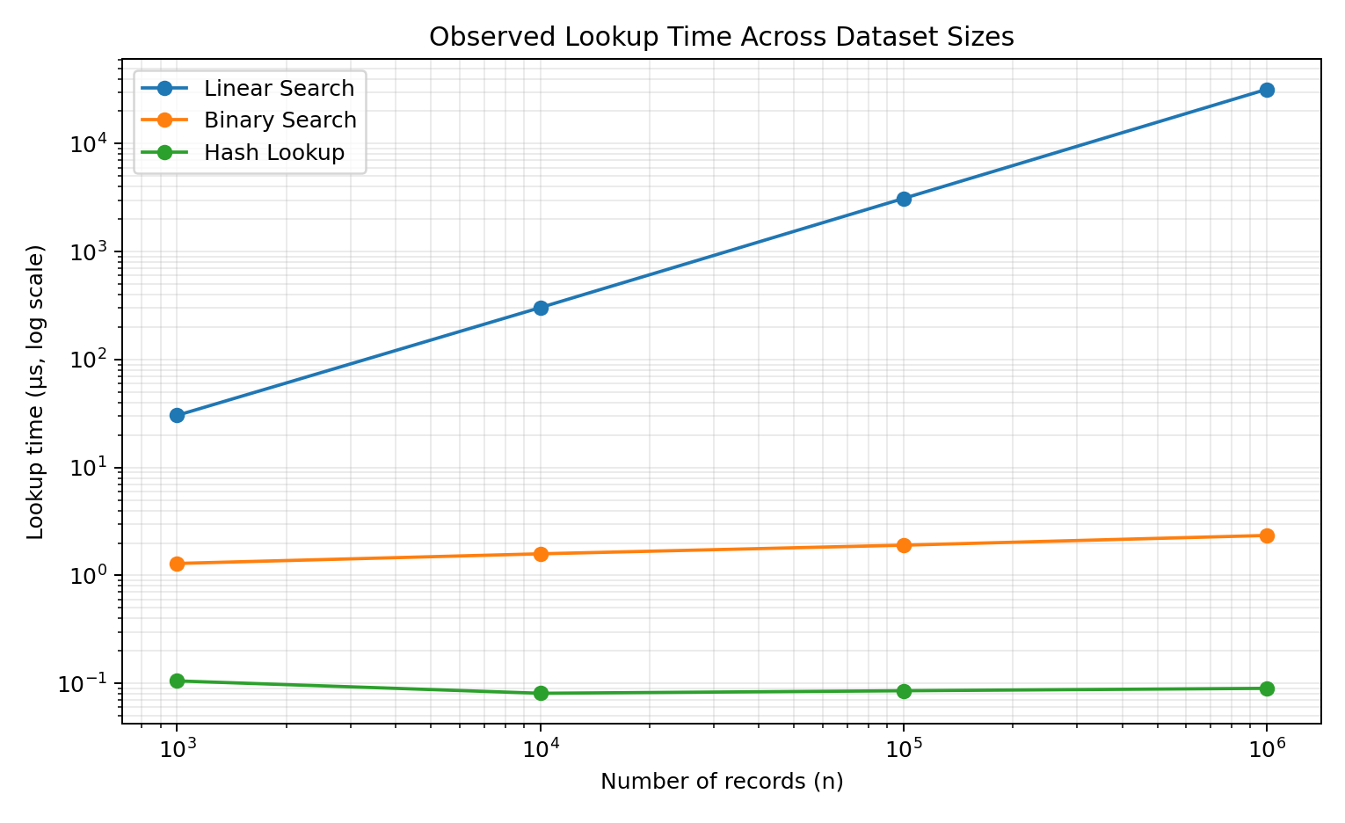
Figure 5. Measured lookup-time growth in this execution environment (log–log axes).
Representative measured lookup times (microseconds) from the same run:
n | Linear (µs) | Binary (µs) | Hash (µs)
1,000 | 30.41 | 1.29 | 0.11
10,000 | 303.13 | 1.59 | 0.08
100,000 | 3110.51 | 1.91 | 0.09
1,000,000 | 31921.80 | 2.35 | 0.09

Important experimental note: wall-clock measurements vary with processor load, Python interpreter overhead, caching and operating-system scheduling. Therefore the comparison of operation counts and growth trends is more reliable than treating a single microsecond value as a universal constant.

11. TASK 10 – Compare Theory with Experimental Behaviour
Observation | Theoretical expectation | Experimental interpretation
Linear search | Θ(n) | Lookup time and comparisons increase strongly as n grows.
Binary search | Θ(log n) | Comparison count grows very slowly; measured time remains almost flat relative to linear.
Hash lookup | Θ(1) expected | Lookup remains nearly constant; table construction is the major one-time cost.

The experimental trend agrees with the theoretical analysis. Linear search changes dramatically from 1,000 to 1,000,000 records because the number of comparisons increases from 1,000 to 1,000,000 in the chosen worst-case query. Binary search rises from roughly ten comparisons to roughly twenty. Hash lookup performs approximately one direct key lookup in the idealized operation-count model.
Any difference between exact measured times and theoretical curves is expected because asymptotic notation ignores constant factors and hardware effects. For example, dictionary operations in Python involve hashing and memory access, while recursive function calls have interpreter overhead. These details affect absolute time but do not change the dominant growth behaviour.

12. TASK 11 – Recommend and Defend the Final Design
For the original university record-retrieval problem, the recommended primary design is a hash-table index keyed by Registration Number, with the records retained in a persistent database as the source of truth. Binary search is a strong alternative when an ordered in-memory representation is already available or when deterministic logarithmic search is preferred.

Why hash lookup is recommended
- The key is unique, making Registration Number an appropriate hash key.
- Expected lookup time is Θ(1), which is substantially better than Θ(n) linear search for large datasets.
- Preprocessing is Θ(n), which is reasonable when the dataset changes infrequently.
- The design scales well when search volume is high.
- Hash indexing avoids paying an O(log n) search cost for every request.
- Memory usage is the principal trade-off because an additional index structure is maintained.

Trade-off with binary search
Binary search offers predictable Θ(log n) search and less auxiliary indexing than a hash table, but it requires sorted data. If records are frequently inserted into a plain array, maintaining sorted order can become expensive. In the stated university scenario, however, updates are infrequent, so binary search remains practical.

Decision
Criterion | Linear | Binary | Hash
Search scalability | Poor | Very good | Excellent expected
Preprocessing | None | Sorting may be required | Build table
Large static dataset | Not preferred | Good | Best fit
Frequent updates | Easy | Depends on structure | Usually good
Worst-case theoretical search | O(n) | O(log n) | O(n)
Expected search | O(n) | O(log n) | O(1)

13. TASK 12 – DAY-4 DESIGN CHALLENGE

13.1 A. Impact Analysis
The changed requirement is explicit: the system must process 50,000 search requests per hour on 1,000,000 records, while new records are added only once per day. The search frequency is therefore much higher relative to the update frequency. This changes the cost balance: spending extra work once per day to build an index can be justified because that cost is reused across a very large number of searches.
- Database size is fixed at approximately 1,000,000 records for the scenario.
- Search volume is 50,000 requests/hour = about 13.89 requests/second on average.
- New records arrive only once per day, so the index does not need to be rebuilt after every query.
- Because the query-to-update ratio is high, query-time efficiency dominates the design decision.

13.2 B. Evaluation of the Original Design
The original recommendation of a hash-table index becomes even stronger under the new workload. If linear search were used, one worst-case request could inspect 1,000,000 records. Across 50,000 requests per hour, that could mean up to 50,000,000,000 record comparisons per hour in the worst case.
Linear worst-case comparisons per hour
= 50,000 searches/hour × 1,000,000 records
= 50,000,000,000 comparisons/hour.
With binary search, each request needs only about log2(1,000,000) ≈ 20 comparisons, or roughly 1,000,000 comparisons per hour. With hashing, expected key work is approximately constant per request, or around 50,000 primary hash lookups per hour, plus collision handling.
Design | Approx. search work for 50,000 requests/hour
Linear | Up to 50,000,000,000 comparisons/hour
Binary | ≈ 50,000 × 20 = 1,000,000 comparisons/hour
Hash | ≈ 50,000 expected key lookups/hour

13.3 C. Adaptation / Redesign
The decision is to MODIFY the original solution into an indexed hybrid architecture rather than replacing the basic idea. The persistent student database remains the authoritative store, while a Registration Number → Record-ID index is built or refreshed once after the daily update batch.
DAILY_INDEX_REFRESH
read newly added / changed records
update hash index: registration_no -> record_id
persist or cache the index
FOR EACH SEARCH_REQUEST(target)
record_id = index.get(target)
if record_id exists
retrieve the corresponding student record
else
return NOT_FOUND
Computational effect: daily index maintenance is expected Θ(n) for a full rebuild, or Θ(k) for updating k changed records. Each request is expected Θ(1). If q = 50,000 searches/hour, the expected operational cost is approximately Θ(k + q) for an incremental daily update plus one hour of searches, rather than Θ(qn).

13.4 D. Evidence-Based Defence
The redesigned/indexed solution follows directly from the workload. The search frequency is high, the dataset is large, and updates are infrequent. These conditions strongly favour paying a small preprocessing/index-maintenance cost in exchange for very low per-query cost.
- Mathematical evidence: expected hash lookup Θ(1) versus binary Θ(log n) and linear Θ(n).
- Workload evidence: 50,000 searches/hour makes per-query cost far more important than a once-daily index build.
- Dataset evidence: 1,000,000 records makes sequential scanning unsuitable for high-volume access.
- Update evidence: once-daily additions allow the index to remain stable for long periods.
- Practical evidence: the index can store only Registration Number → record identifier, reducing duplication compared with storing complete records in memory.
- Reliability trade-off: collision handling, index consistency, memory consumption and recovery must be managed.

13.5 Final Day-4 Architecture
Layer | Recommended design | Reason
Source of truth | Relational student database | Durable and authoritative student records.
Index | Hash index on Registration Number | Expected constant-time lookup.
Update process | Daily/incremental index refresh | Matches once-per-day record additions.
Query path | Hash lookup → record retrieval | Minimizes search work.
Fallback | Database indexed lookup / binary search alternative | Provides resilience if cache/index misses.
Monitoring | Track lookup latency, collisions, cache misses and index freshness | Validates real-world behaviour.

14. Output
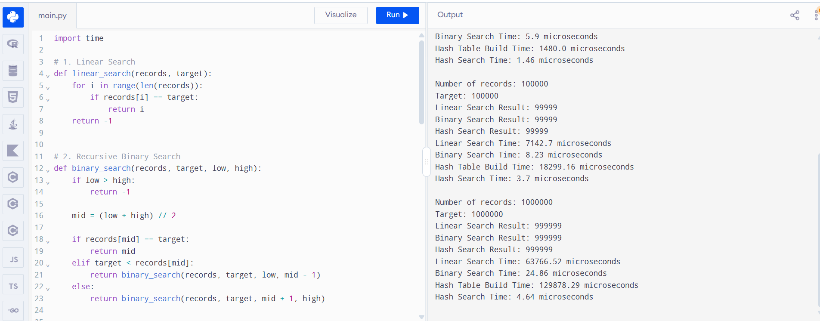

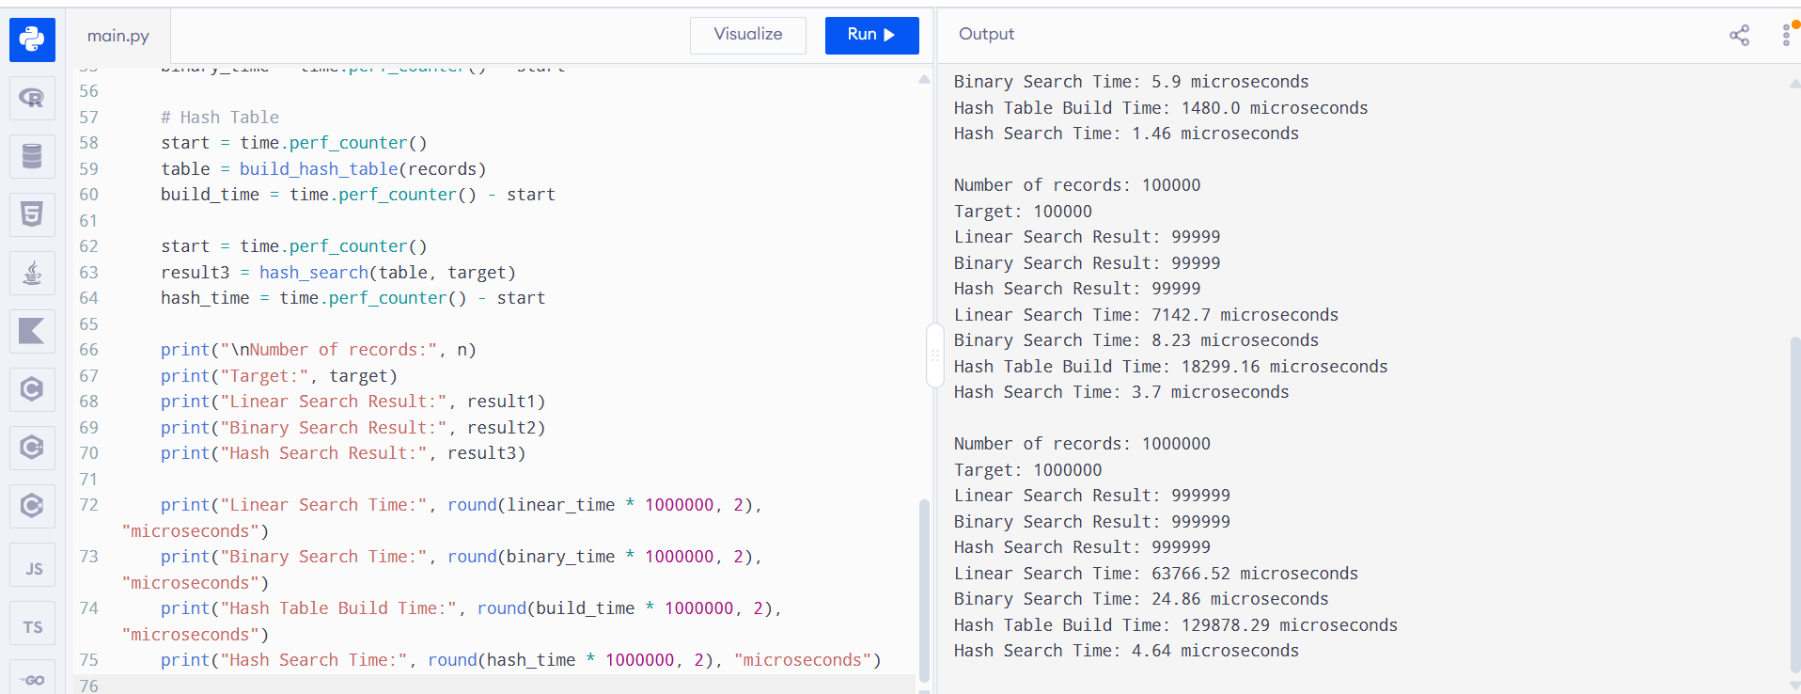

15.Overall Conclusion
The assignment demonstrates why algorithm selection must consider more than the Big-O label of an individual search. Linear search is simple and requires no preprocessing, but its Θ(n) growth becomes impractical at one million records when query volume is high. Recursive binary search reduces query complexity to Θ(log n), but requires sorted data and therefore incurs preprocessing or maintenance cost. Hash-based indexing provides expected Θ(1) lookup after Θ(n) construction, making it the most suitable strategy for the stated high-search, low-update workload.
The experimental results support the mathematical analysis: linear comparisons increase proportionally with n, binary comparisons grow logarithmically, and hash lookup remains approximately constant in expected operation count. Under the Day-4 requirement of 50,000 searches per hour and daily updates, the best practical design is therefore an indexed database with a hash-based Registration Number lookup structure and periodic/incremental index refresh.

15. References
- Course Assignment Brief: Design and Analysis of Algorithms – CO1 Assignment 1, supplied by the course instructor.
- Cormen, T. H., Leiserson, C. E., Rivest, R. L., & Stein, C. Introduction to Algorithms. MIT Press.
- Levitin, A. Introduction to the Design & Analysis of Algorithms. Pearson.
- Knuth, D. E. The Art of Computer Programming, Volume 3: Sorting and Searching. Addison-Wesley.

