Git is a free, open source distributed version control system tool designed to handle everything from small to very large projects with speed and efficiency

Version Control is the management of changes to documents, computer programs, large websites and other collection of information.

There are two types of VCS:

* Centralized Version Control System (CVCS)
* Distributed Version Control System (DVCS)

## ****Centralized VCS****

Centralized version control system (CVCS) uses a central server to store all files and enables team collaboration. It works on a single repository to which users can directly access a central server.

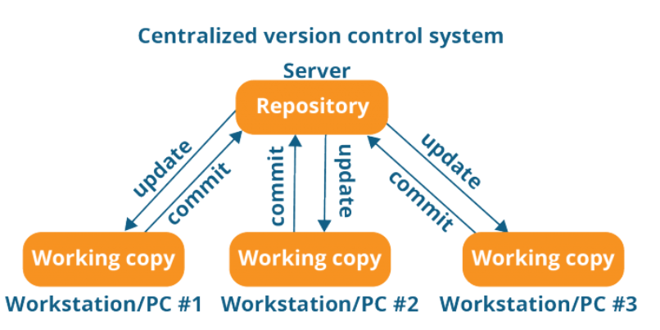

t has some major drawbacks. Some of them are:

* It is not locally available; meaning you always need to be connected to a network to perform any action.
* Since everything is centralized, in any case of the central server getting crashed or corrupted will result in losing the entire data of the project.

## ****Distributed VCS****

## These systems do not necessarily rely on a central server to store all the versions of a project file.

In Distributed VCS, every contributor has a local copy or “clone” of the main repository i.e. everyone maintains a local repository of their own which contains all the files and metadata present in the main repository.

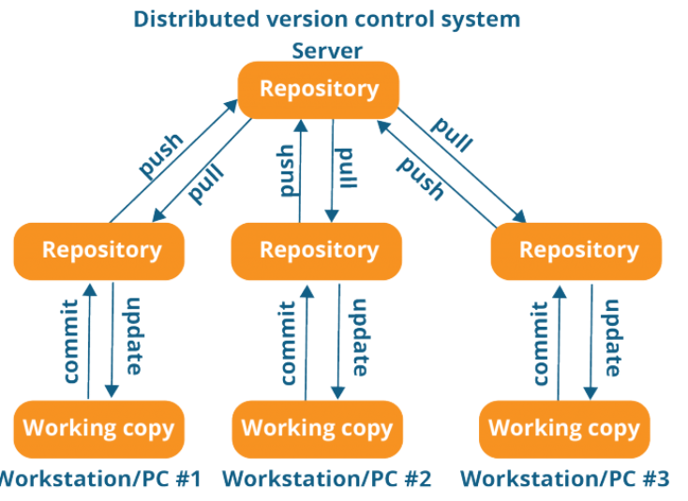

As you can see in the above diagram, every programmer maintains a local repository on its own, which is actually the copy or clone of the central repository on their hard drive. They can commit and update their local repository without any interference.

They can update their local repositories with new data from the central server by an operation called “****pull****” and affect changes to the main repository by an operation called “****push****” from their local repository.

Advantages:

* All operations (except push & pull) are very fast because the tool only needs to access the hard drive, not a remote server. Hence, you do not always need an internet connection.
* Committing new change-sets can be done locally without manipulating the data on the main repository. Once you have a group of change-sets ready, you can push them all at once.
* Since every contributor has a full copy of the project repository, they can share changes with one another if they want to get some feedback before affecting changes in the main repository.
* If the central server gets crashed at any point of time, the lost data can be easily recovered from any one of the contributor’s local repositories.

To Push Local Code into GIT

1. Create a empty repo in bit bucket
2. Go to the local folder and right click and give GIT BASH here (Which opens up the GIT terminal)
3. git init
4. Git add --all
5. Git commit -m “information”
6. Git remote add origin <https://preethikrishna_s@bitbucket.org/preethikrishna_s/nov11_repo2.git>
7. Git push -u origin master

To Clone the GIT Repo toLocal

1. Create an empty folder in the local
2. Right Click,git bash here
3. Give git clone <https://preethikrishna_s@bitbucket.org/preethikrishna_s/nov11_repo2.git>

<https://dzone.com/articles/top-20-git-commands-with-examples>

<https://www.edureka.co/blog/what-is-git/>