**MINI-PROJECT-REPORT**

**FERTILITY_DIAGNOSIS**

**MINI-PROJECT-REPORT**

**COURSE CODE/TITLE:17fe32/17le32/Analytics with R Programming Alongside with Visualization**

Year:III sem:V

17F231-Preethi M-Information Technology

17L307-Bhargavi A-Electronics and Communication Engineering

**DESCRIPTION ABOUT PROJECT:**

This dataset contains the data given by 100 volunteers that provides a semen sample analyzed according to the WHO 2010 criteria. Sperm concentration are related to socio-demographic data, environmental factors, health status, and life habits .This dataset gives the fertility analysis based on some attributes ,by visualizing those data we can predict the outcome of a testing based on fertility.

DESCRIPTION OF ATTRIBUTES:

This consists of **10** attributes:

**1st attribute** :Season in which the analysis was performed. 1) winter, 2) spring, 3) Summer, 4) fall. (-1, -0.33, 0.33, 1)

**2nd attribute:** Age at the time of analysis. 18-36 (0, 1)

**3rd attribute:** Childish diseases (ie , chicken pox, measles, mumps, polio) 1) yes, 2) no. (0, 1)

**4th attribute:** Accident or serious trauma 1) yes, 2) no. (0, 1)

**5th attribute:** Surgical intervention 1) yes, 2) no. (0, 1)

**6th attribute:** High fevers in the last year 1) less than three months ago, 2) more than three months ago, 3) no. (-1, 0, 1)

**7th attribute:** Frequency of alcohol consumption 1) several times a day, 2) every day, 3) several times a week, 4) once a week, 5) hardly ever or never (0, 1)

**8th attribute:** Smoking habit 1) never, 2) occasional 3) daily. (-1, 0, 1)

**9th attribute**: Number of hours spent sitting per day ene-16 (0, 1)

**10th  attribute:** Output: Diagnosis normal (N), altered (O)

**Machine Learing Steps:**

* Loading a file-using delim
* Viewing a file-in the form a table
* Naming the columns-such that each data can be accessed easliy
* Preparing the data for analyzing-mutate is used to modify the given data for visualizing
* Shuffling the data-this is used to get the accurate results
* Cleaning the data-such that no null values can enter into the visualizing
* Separating the data into test set and training data sets
* Visualizing the data in the form of decision tree
* Testing the accuracy

**Diagram:**

Loading a file

Viewing a file

Preparing the data for analyzing

Cleaning the data

Separating the data into test set and training data sets

Visualizing the data in form of decision tree

Testing the accuracy

# Exploratory Data Analysis:

# Library files that needed to be import:

# library(tidyr)

# library(dplyr)

# library(ggplot2)

library(plotly)

# Script And Ouput:

# dataset=read.delim("fertility_Diagnosis.txt",sep=",",header=F)

# View(dataset)

# 

# colnames(dataset)=c("seasons","age","childish_diseases","accidents_trauma", "surgical_intervention","high_fevers","alcohol","smoking","no_of_hours","output")

# View(dataset)

# 

# head(dataset)

# 

# tail(dataset)

# 

# levels(dataset$output)

# 

# glimpse(dataset)

# 

# str(dataset)

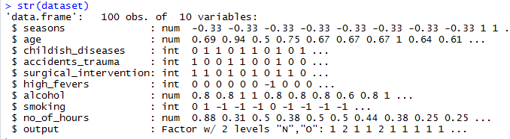

View(dataset %>% filter(dataset$seasons==0.33))

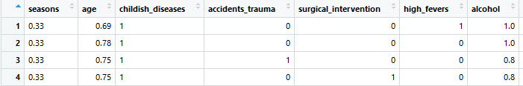

View(dataset %>% filter(dataset$seasons==-0.33))

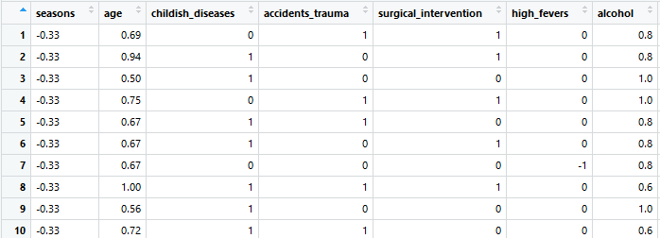

View(dataset %>% filter(dataset$seasons==1))

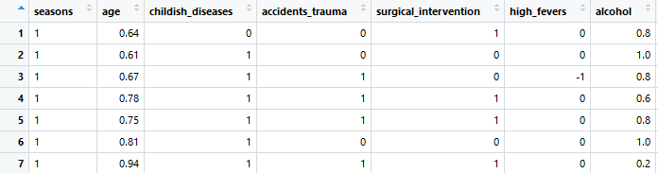

View(dataset %>% filter(dataset$seasons==-1))

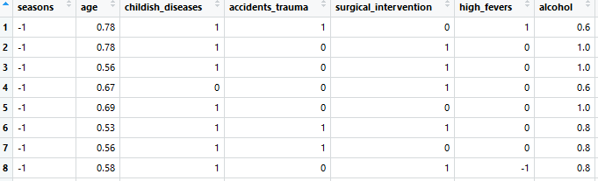

#arrange

View(dataset %>% arrange(desc(dataset$seasons)))

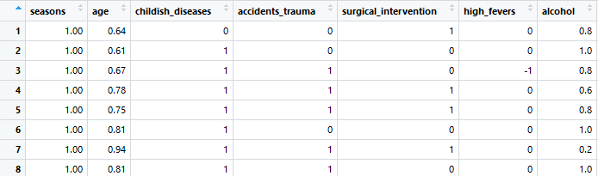

#mutate

View(dataset %>% mutate(age=age*100))

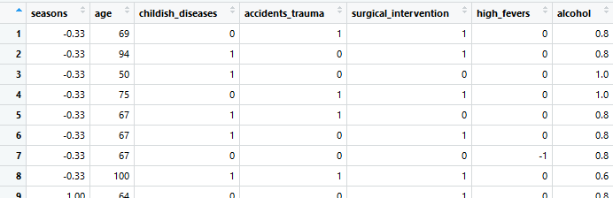

#group_by

#View(group_by(dataset,seasons))

#summarize

summary(dataset)

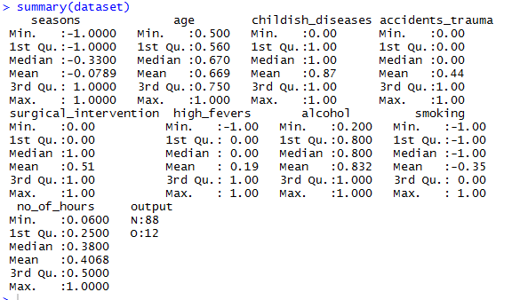

#contingency table

table(dataset$seasons,dataset$childish_diseases)

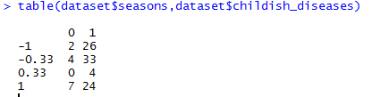

#drop levels:

View(dataset %>% filter(seasons!=-1) %>% droplevels())

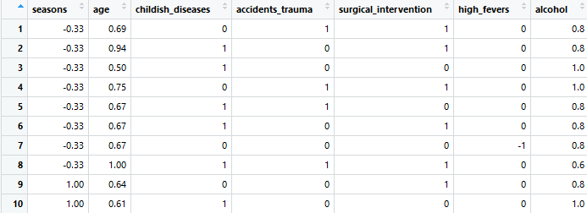

#visualization

library(ggplot2)

data_winter=dataset %>% filter(dataset$seasons==-1)

View(data_winter)

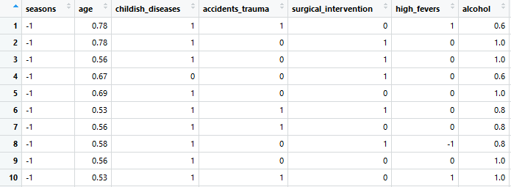

install.packages("plotly")

library(plotly)

#visualizing the fever rate based on seasons

ggplot(data=dataset,aes(x=seasons,y=high_fevers,fill=high_fevers))+geom_col()+ggtitle("sesons vs high fever")

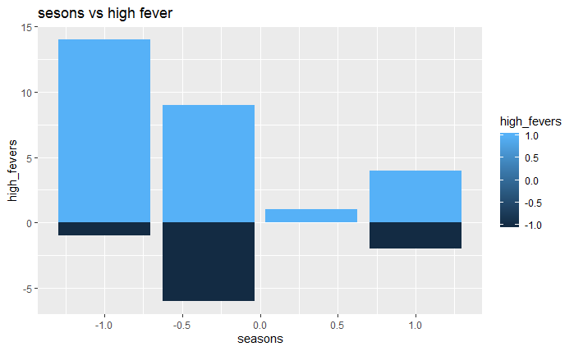

ggplot(data=dataset,aes(x=alcohol))+geom_dotplot(dotsize=0.4)+ggtitle("alcohol levels")

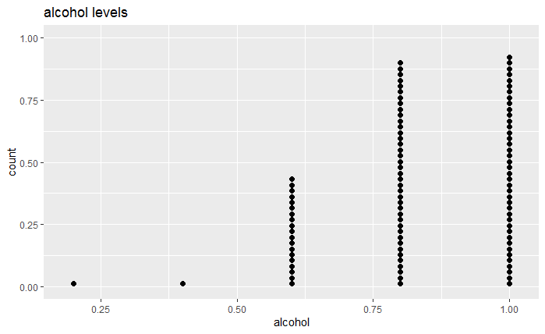

#ggplot using plotly

a=ggplot(data=dataset,aes(x=seasons,fill=surgical_intervention,color=surgical_intervention))+geom_bar()+ggtitle("surgical intervention")

ggplotly(a)

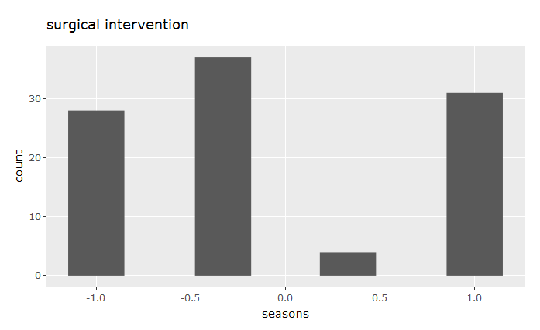

#dot plot

ggplot(data=dataset,aes(x=age,y=high_fevers))+geom_point()+scale_x_log10()+scale_y_log10()+ggtitle("age vs high fever")

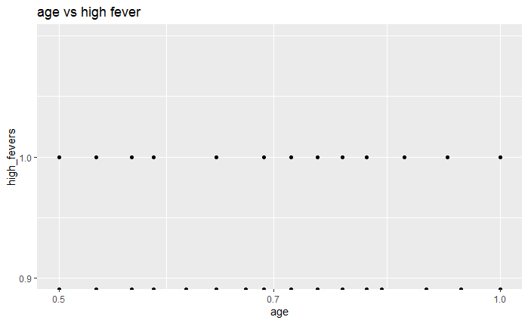#Bar plot

ggplot(data=dataset,aes(x=surgical_intervention,fill=accidents_trauma))+ geom_bar(position = "dodge")+ggtitle("accidents that ended in surgery")

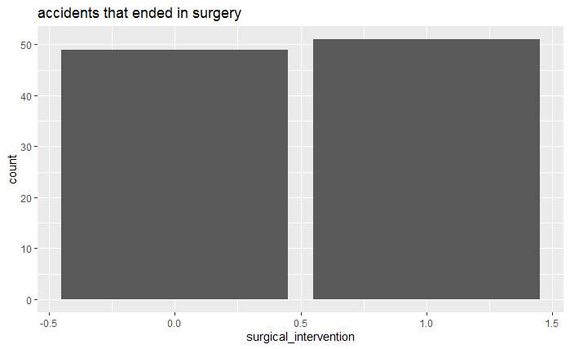

ggplot(data=dataset,aes(x=surgical_intervention,fill=seasons,color=surgical_intervention))+

geom_bar()+facet_wrap(~seasons)+ggtitle("")

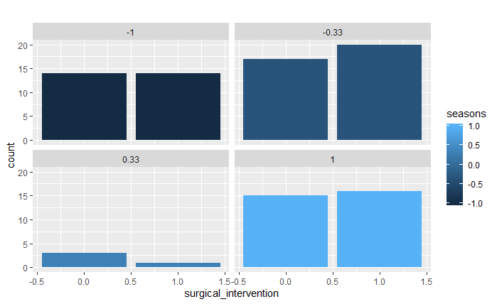

#Histogram

#ggplot(data=dataset,aes(x=age))+geom_histogram()

ggplot(data=dataset,aes(x=age))+geom_histogram(col="red",fill="black")

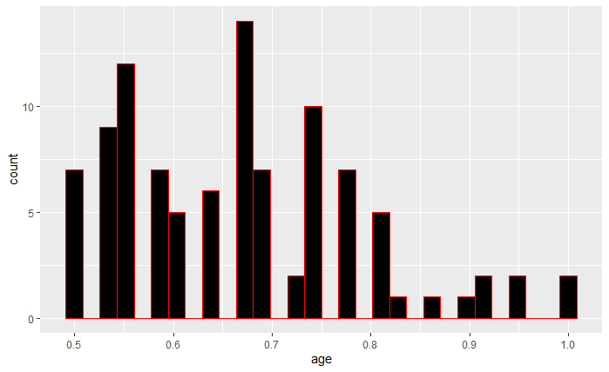

ggplot(data=dataset,aes(x=age))+geom_histogram(col="red",fill="black")+facet_wrap(~seasons)

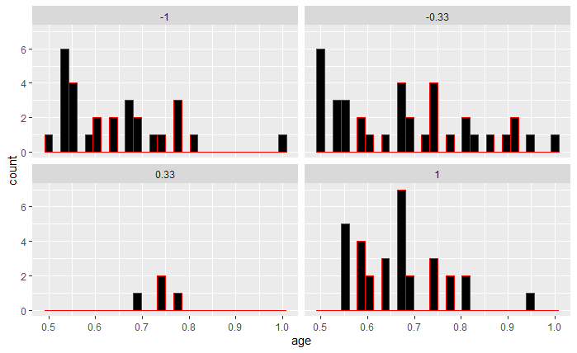

dataset %>% filter(age<0.58) %>% ggplot(aes(x=age))+geom_histogram(col="red",fill="black")

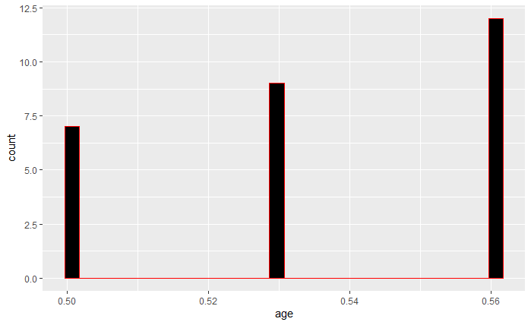

#Density plot

ggplot(data=dataset,aes(x=no_of_hours,fill=childish_diseases))+geom_density(col="black",fill="violet")

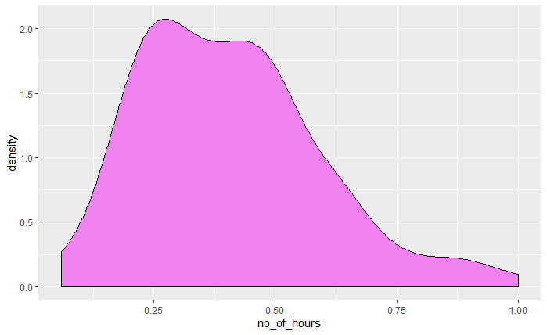

ggplot(data=dataset,aes(x=no_of_hours,fill=as.factor(output)))+

geom_density(alpha=0.3)

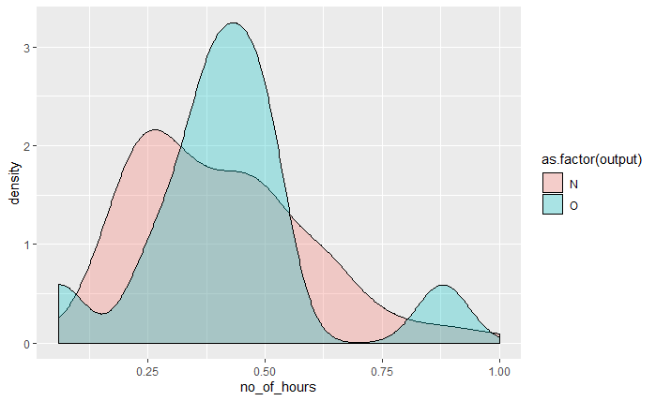

#Box plot

ggplot(data=dataset,aes(x=seasons,y=age,group=1))+geom_boxplot()

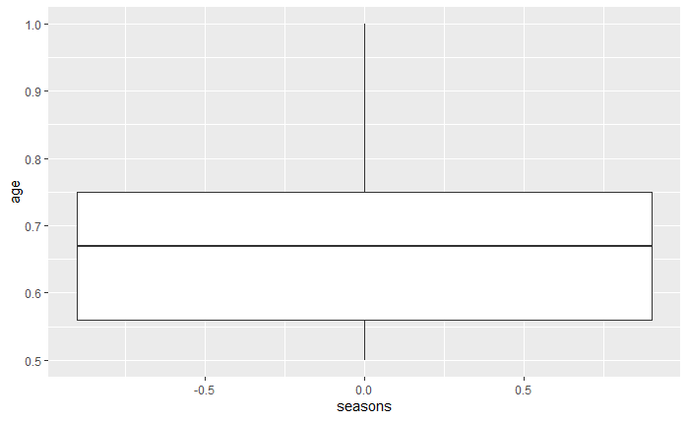

ggplot(data=dataset,aes(x=seasons,y=age,group=1))+geom_boxplot()+coord_flip()

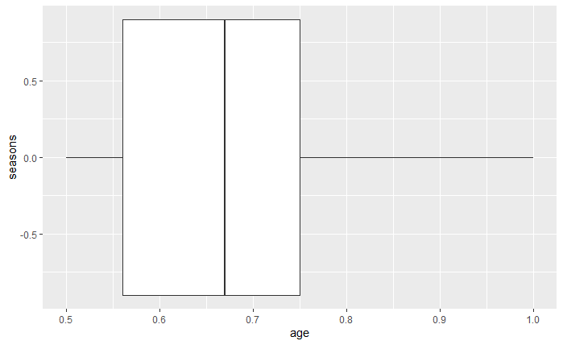

#point

ggplot(dataset,aes(x=no_of_hours,y=alcohol))+geom_point(aes(col=alcohol))+geom_smooth(method = "loess",se=F)

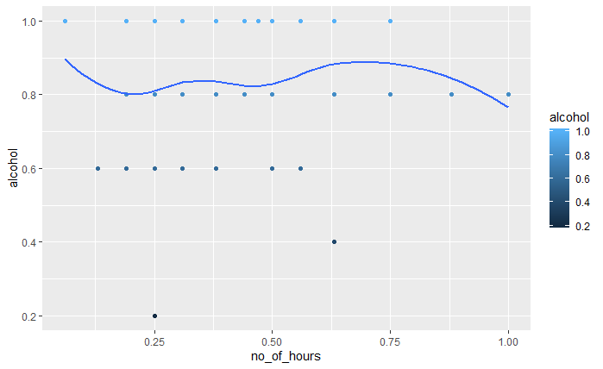

#jitter

ggplot(dataset,aes(x=age,y=output))+geom_jitter(width=0.5,size=2)

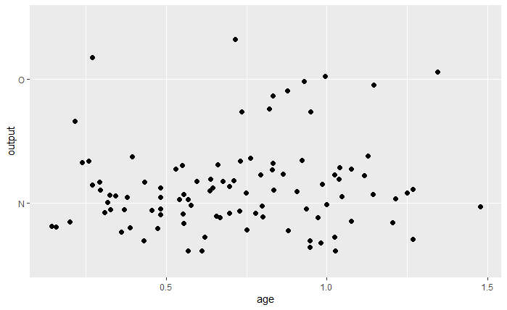

#ggcount(with legend)

ggplot(dataset,aes(x=age,y=output))+geom_count(col="steelblue")

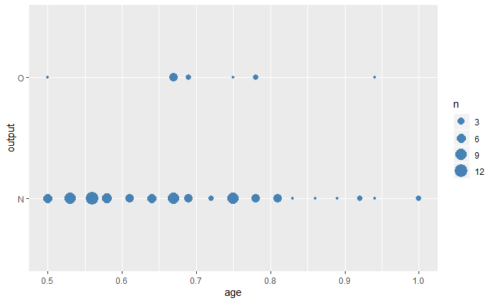

#without legend

ggplot(dataset,aes(x=age,y=output))+geom_count(col="steelblue",show.legend=F)

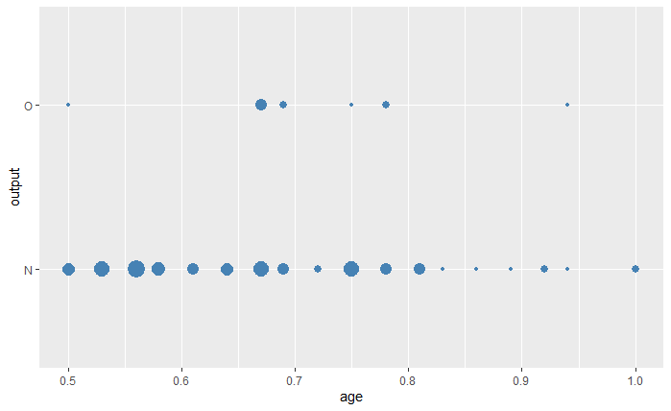

corr <- round(cor(dataset[,-10]),1)library(ggcorrplot)

ggcorrplot(corr, hc.order = TRUE, type = "lower", lab = TRUE,lab_size = 3ggtheme=theme_bw)

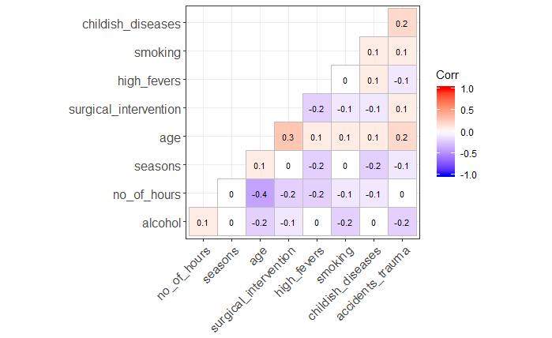

ggplot(dataset, aes(x=output, y=alcohol)) +geom_point(size=3) + geom_segment(aes(x=output,

xend=output, y=0, yend=alcohol))+theme(axis.text.x = element_text(angle=65, vjust=0.6))

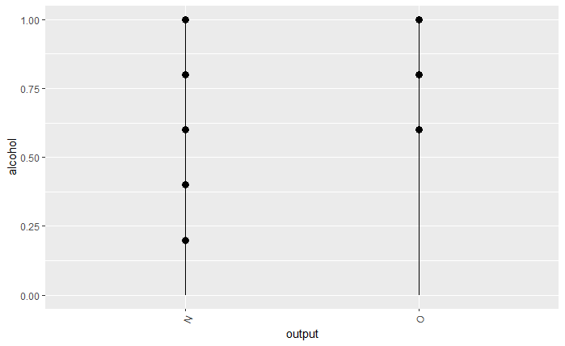

**Machine learning:**

#machine learning concepts

#logistic regression and decesion tree

dataset=read.delim("fertility_Diagnosis.txt",sep=",",header=F)

View(dataset)

colnames(dataset)=c("seasons","age","childish_diseases","accidents_trauma",

"surgical_intervention","high_fevers","alcohol","smoking",

"no_of_hours","output")

View(dataset)

library(dplyr)

dataset=dataset %>% mutate(age=age*100)

dataset=dataset %>% mutate(no_of_hours=((no_of_hours*100)*24)/120)

dataset=dataset %>% mutate(alcohol=alcohol*100)

View(dataset)

#age,trauma,surgery,sitting

#since there is no linearity between the data we go for decision tree

set.seed(678)

shuffle_index=sample(1:nrow(dataset))

dataset=dataset[shuffle_index,]

dim(dataset)

clean_data=dataset %>%select(c("seasons","childish_diseases","high_fevers","alcohol","smoking"))

str(clean_data)

library(caTools)

split=sample.split(clean_data$output,SplitRatio=0.8)

training_set=subset(clean_data,split==TRUE)

test_set=subset(clean_data,split==FALSE)

View(training_set)

View(test_set)

#build a model

library(rpart)

str(clean_data)

fit=rpart(formula=output~.,data=training_set,method="class")

library(rpart.plot)

rpart.plot(fit)

str(clean_data)

library(plotrix)

pred_unseen=predict(object=fit,newdata=test_set,type="class")

pred_unseen

table_mat=table(test_set$output,pred_unseen)

table_mat[1,1]

table_mat

accuracy=sum(diag(table_mat))/sum(table_mat)

accuracy

recall=table_mat[2,2]/(sum(diag(table_mat)))

recall

precession=table_mat[2,2]/(table_mat[2,2]+table_mat[1,2])

precession

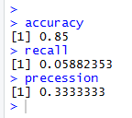

**Decision tree output:**

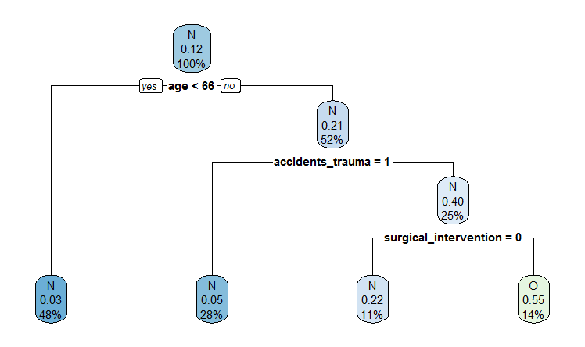

**Conclusion:**

Thus we have analysed the given data set successfully.

**Reference:**

Rpubs:<http://rpubs.com/Preethi_17f231/fertility_analysis>