WEEK 2 REPORT
Superstore Sales: Data Modeling, DAX & Sales Dashboard
(Power BI Desktop)

Submitted by
Preethi Pal D
Roll No: E25DA046
Department name: Bsc Data Science And AI

Objectives
- Establish table relationships and build a clean star-schema data model.
- Write the foundational DAX measures: Total Sales, Total Profit, Total Orders, Total Quantity, Average Sales, and Profit Margin %.
- Construct visual layouts using KPI cards, stacked bar charts, line charts, and a decomposition tree.
- Configure slicers, cross-filtering, interactive tooltips, and drill-down paths.
Problem Statement
Management wants an interactive dashboard to monitor sales, profit, orders, and customers, along with how each region is performing, without having to dig through raw spreadsheets every time a question comes up.
1. Setting Up the Measures Table
Before writing any DAX, a dedicated table named _Measures was created. It holds no raw data of its own — it simply gives every calculation a clean, separate home, so the field list does not turn into a mess of measures scattered across different data tables.
2. Writing the DAX Measures
Inside the _Measures table, the first measure was written using the New measure button: Total Sales = SUM(samplesuperstore[Sales]). The same pattern was then repeated for Total Profit, Total Orders, Total Quantity, Average Sales, and Profit Margin %, each one built with simple, well-named DAX so they could be reused across every card and chart in the report.
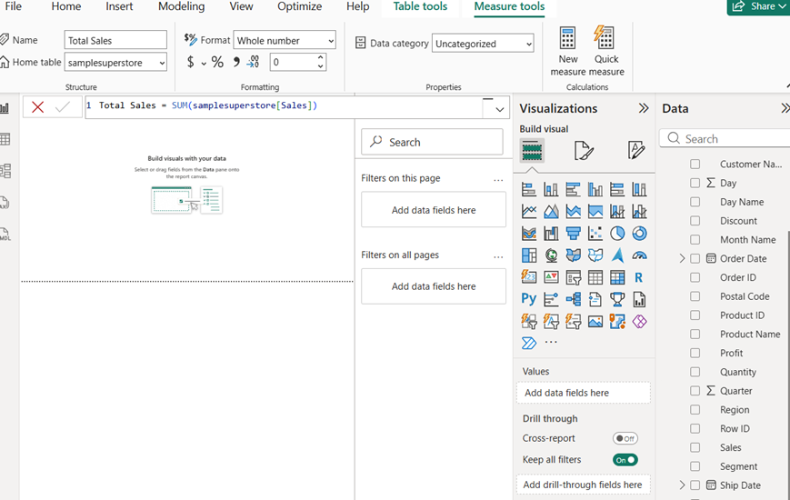
Writing the Total Sales measure in the formula bar, inside the _Measures table.
3. Adding the KPI Cards
With the canvas still empty, the first four KPI cards were placed at the top of the report: Total Profit, Total Sales, Total Orders, and Profit Margin. These are the numbers a manager would want to see first, before looking into anything else.
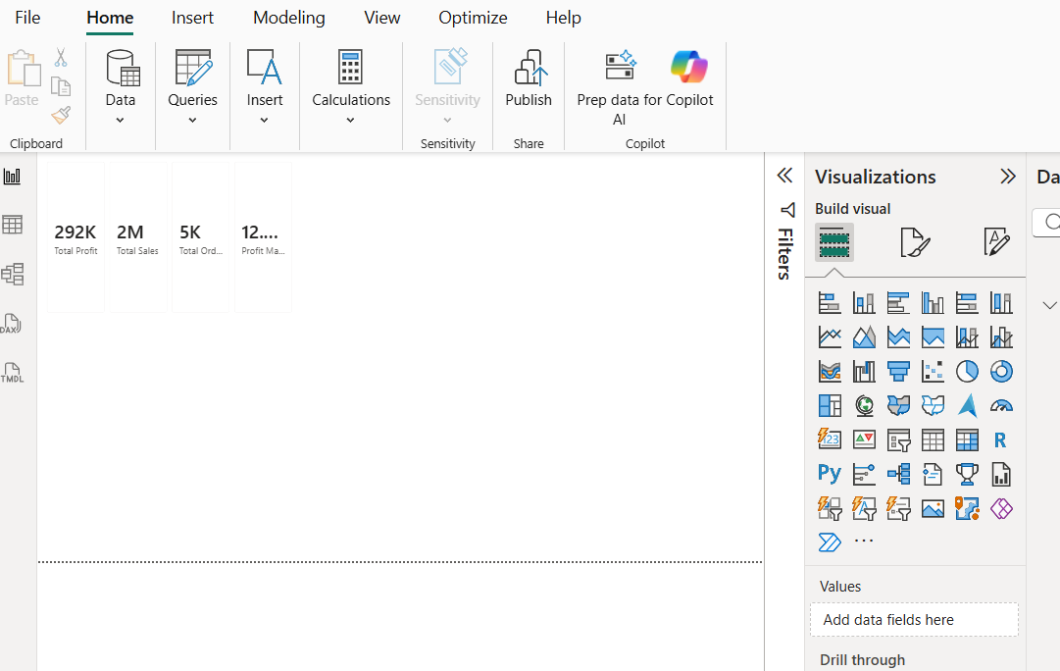
Blank canvas with the first KPI cards placed and the visualization pane open.
4. Adding the Sub-Category Breakdown
A horizontal bar chart showing Total Sales by Sub-Category was added next. Sorting it made it immediately clear which product lines, such as Chairs, Phones, and Storage, were contributing the most to sales.
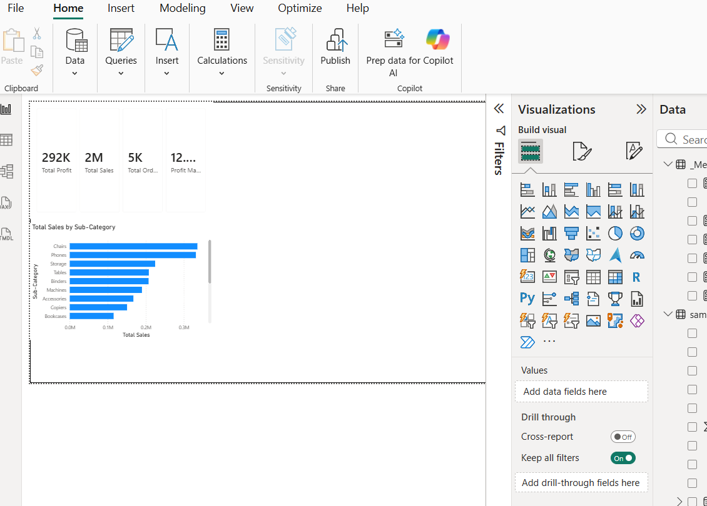
Total Sales by Sub-Category bar chart added below the KPI cards.
5. Tracking Sales Over Time
A line chart plotting Total Sales by Year was added to show the overall trend. This makes it easy to see, at a glance, whether the business is growing year over year.
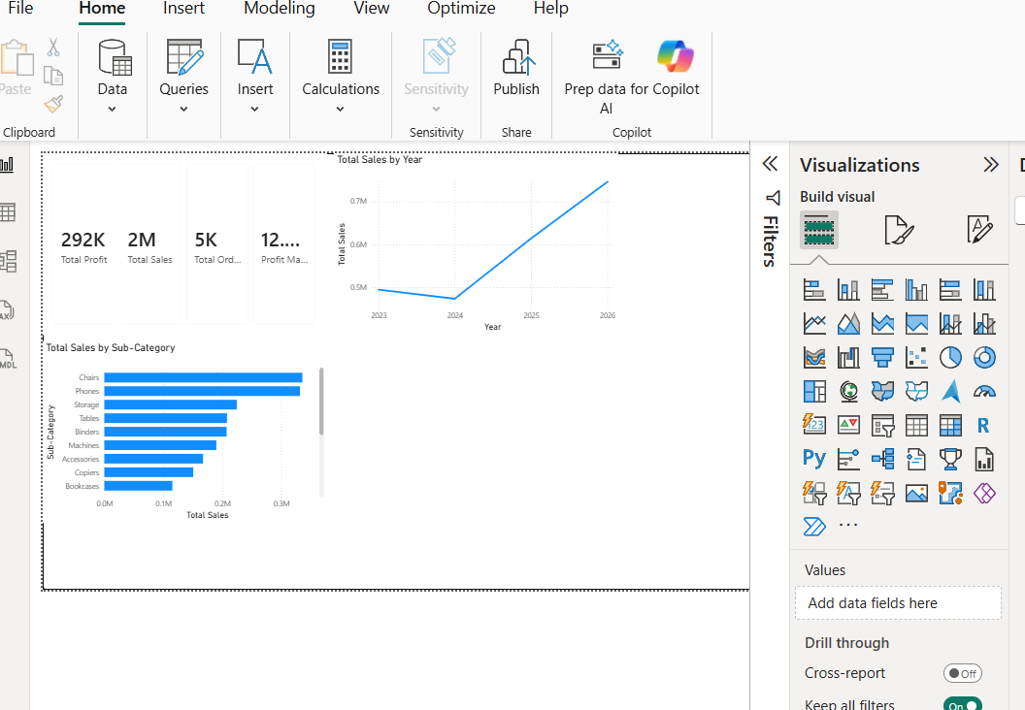
Total Sales by Year line chart added alongside the sub-category breakdown.
6. Building the Decomposition Tree
A decomposition tree on Total Profit was added, allowing anyone viewing the report to explore profit by Category and Region on their own, without needing a separate chart for every possible breakdown.
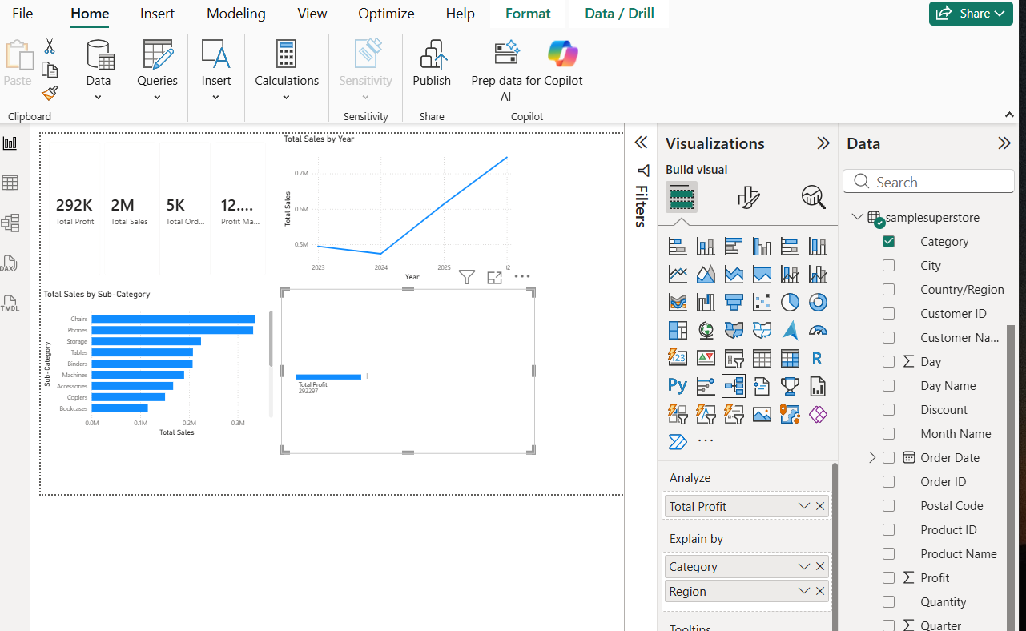
Decomposition tree added, ready to explore Total Profit by Category and Region.
7. Adding a Region Slicer
A checkbox slicer for Region (Central, East, South, West) was added in the top-right corner, so the whole page can be filtered by region without digging through menus.
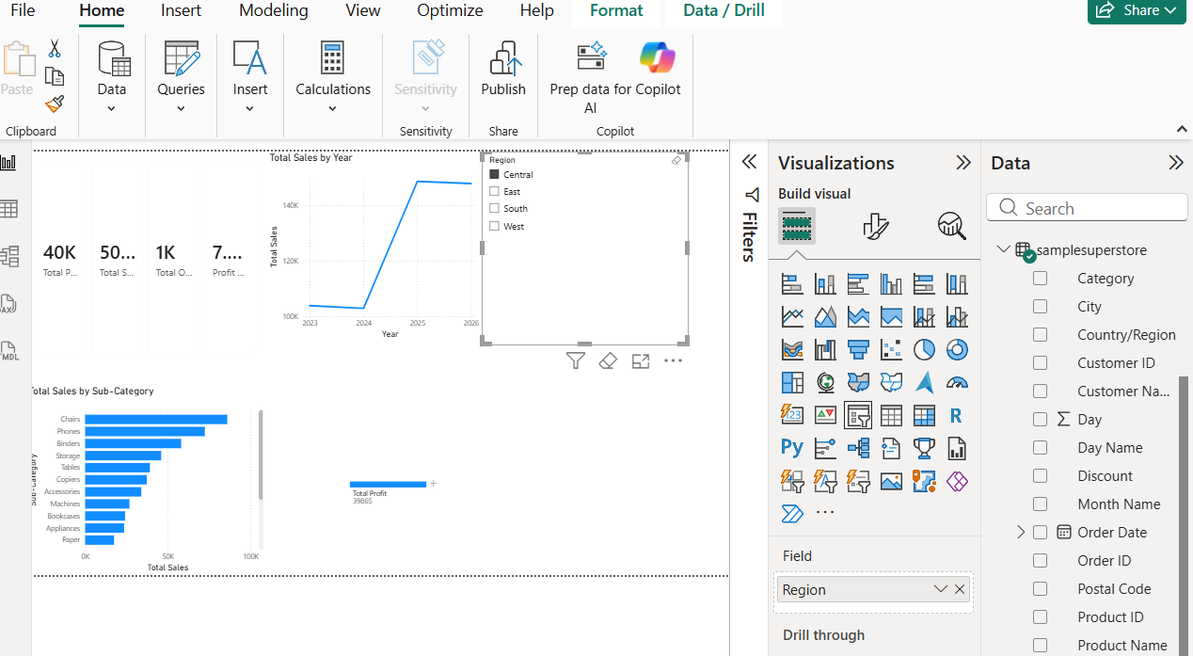
Region slicer added; the KPI cards and charts now update together.
8. Adding a Date Range Slicer
An Order Date range slicer with a draggable timeline was added next to the region slicer, making it easy to zoom into a specific period, such as a single quarter, without altering the underlying data.
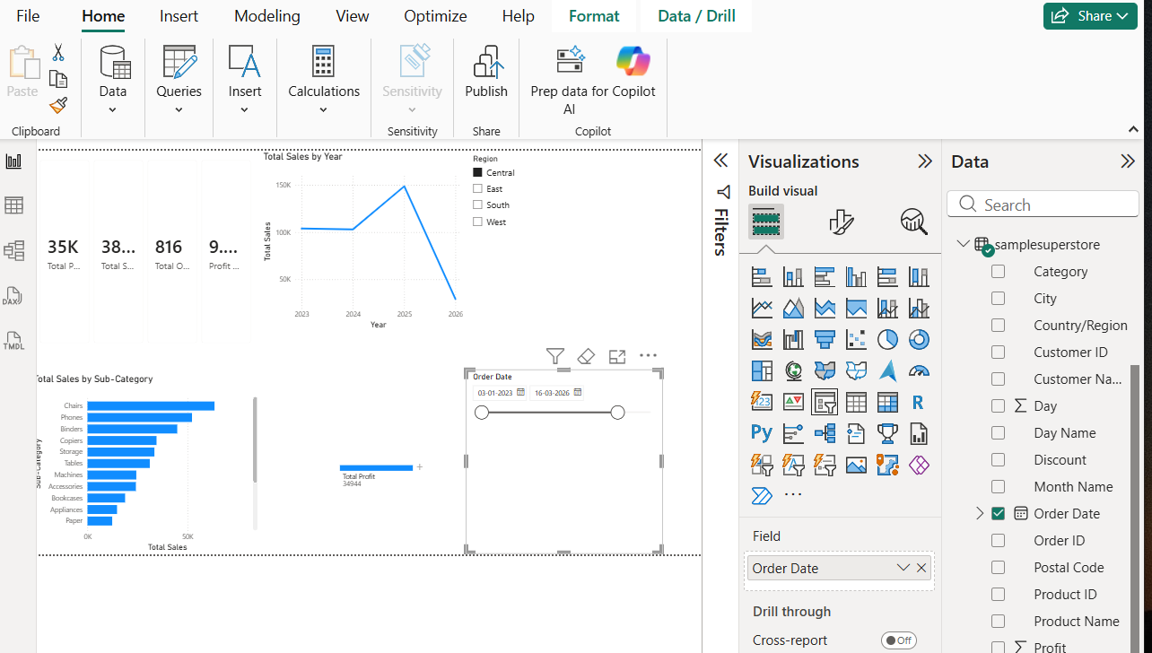
Order Date slicer added, giving the report a full date-range filter.
9. Testing the Interactivity
The decomposition tree was clicked through — Technology, then East — and the whole page responded together: KPI cards, the bar chart, and the line chart all filtered at once. This confirmed that the data model and relationships were working correctly, not just the visuals themselves.
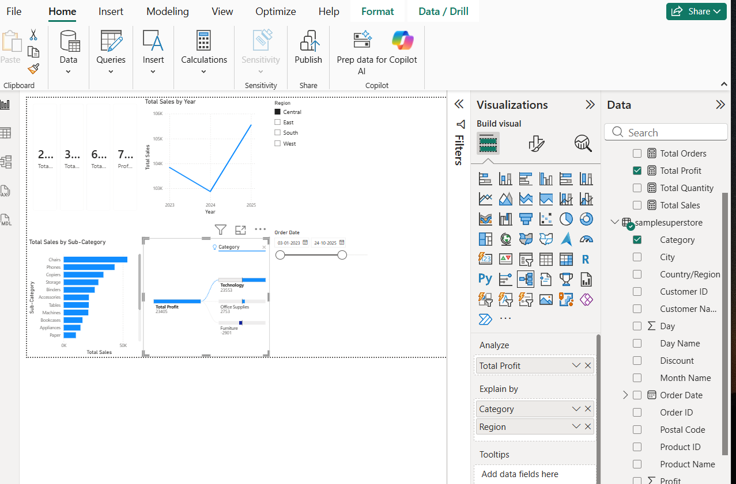
Dashboard filtered live through the decomposition tree (Technology → East).
10. Bringing It All Together
Finally, the layout was reviewed as a whole: KPI cards across the top, the sales trend and region slicer beside them, and the sub-category breakdown and decomposition tree filling out the bottom. This is the finished version, ready to be handed off.
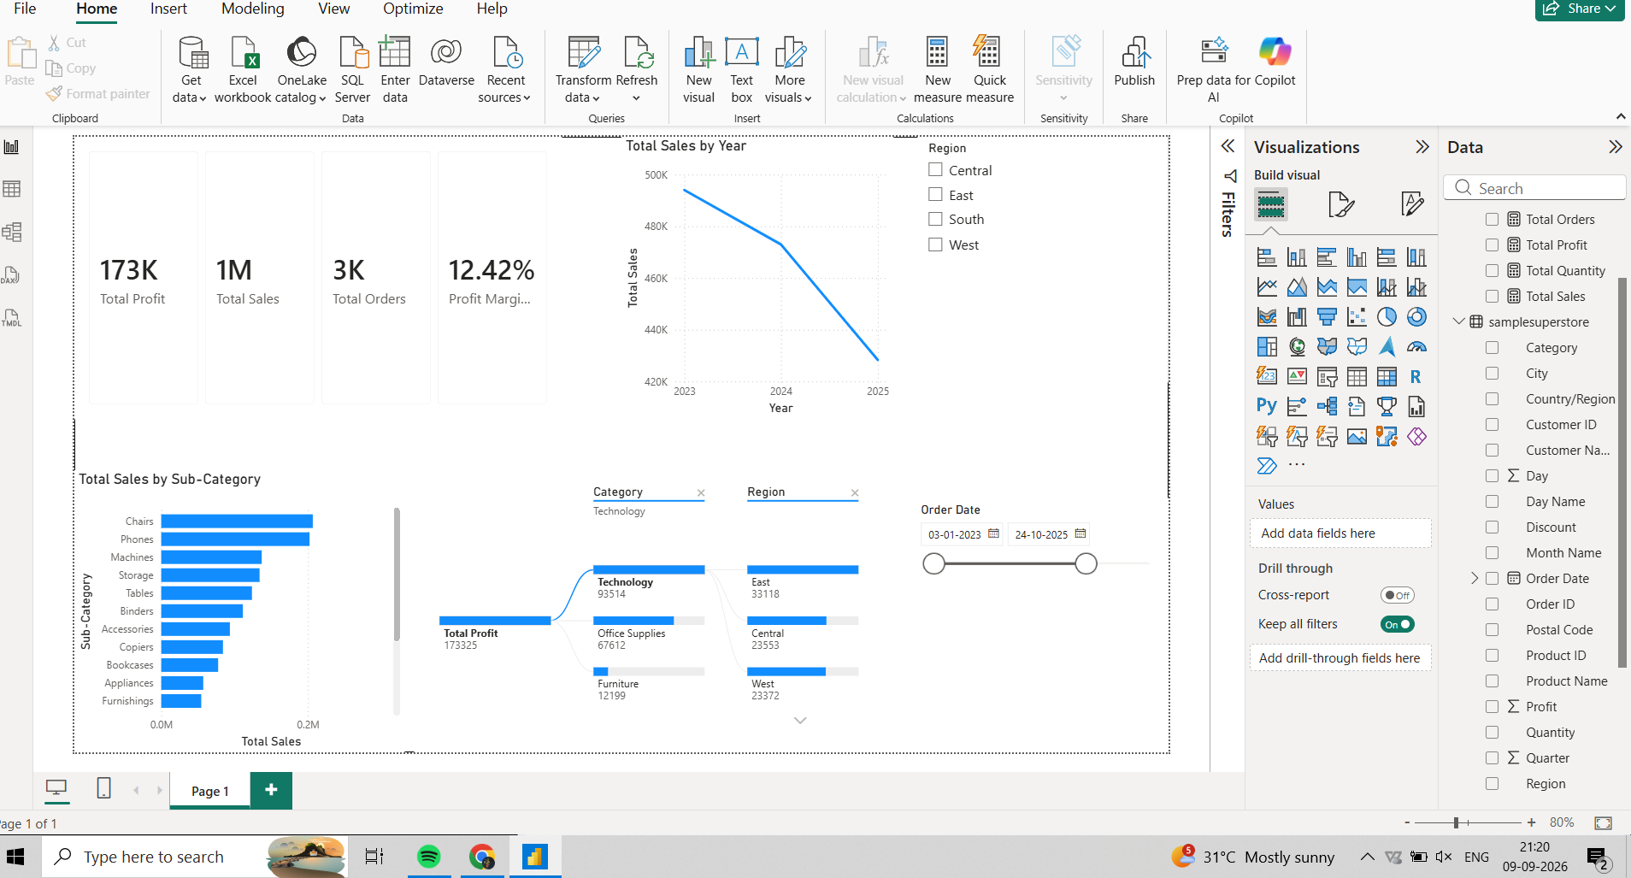
The completed Week 2 dashboard, with all visuals working together.
Summary
- Built a dedicated DAX measure table (_Measures) and wrote the core measures, starting with Total Sales.
- Created a top-line executive summary bar with Total Profit, Total Sales, Total Orders, and Profit Margin KPI cards.
- Added category and regional profitability breakdowns, including a working decomposition tree.
- Configured Region and Order Date slicers for interactive filtering.
- Delivered a fully interactive Superstore Sales Dashboard with cross-filtering and drill-down.

