WEEK 1 REPORT
Superstore Sales: Import and Clean Data in Power BI
(Power BI Desktop)

Submitted by
Preethi Pal D
Roll No: E25DA046
Department name: Bsc Data Science And AI

Objectives
- Open the data in Power BI and look at the Report, Data, and Model views.
- Check the data in Power Query: data types, missing values, and duplicate rows.
- Clean up columns: rename, split, trim text, fix data types.
- Pull out date parts from Order Date: Year, Quarter, Month, Day, Day of Week.

Problem Statement
A store wants to study its sales data to understand customers, products, regions, and profit. Before building a dashboard, the raw Superstore data must first be imported and cleaned in Power BI.

1. Opening Power BI Desktop
Power BI Desktop was opened and a new blank report was created, ready to load data.
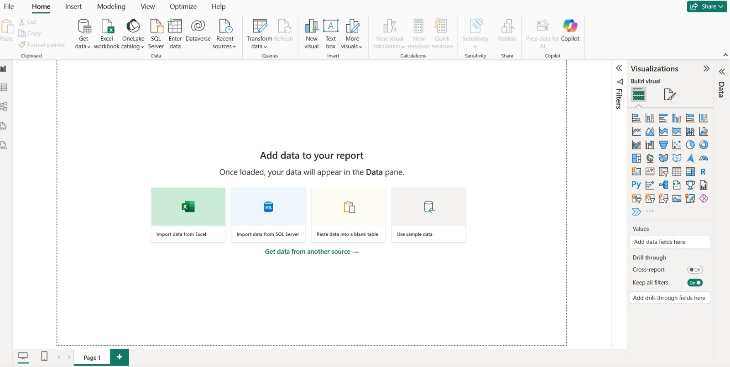
Blank report in Power BI Desktop.

2. Loading the Superstore Data
Get Data was used to choose Text/CSV as the source, since the dataset is a CSV file.
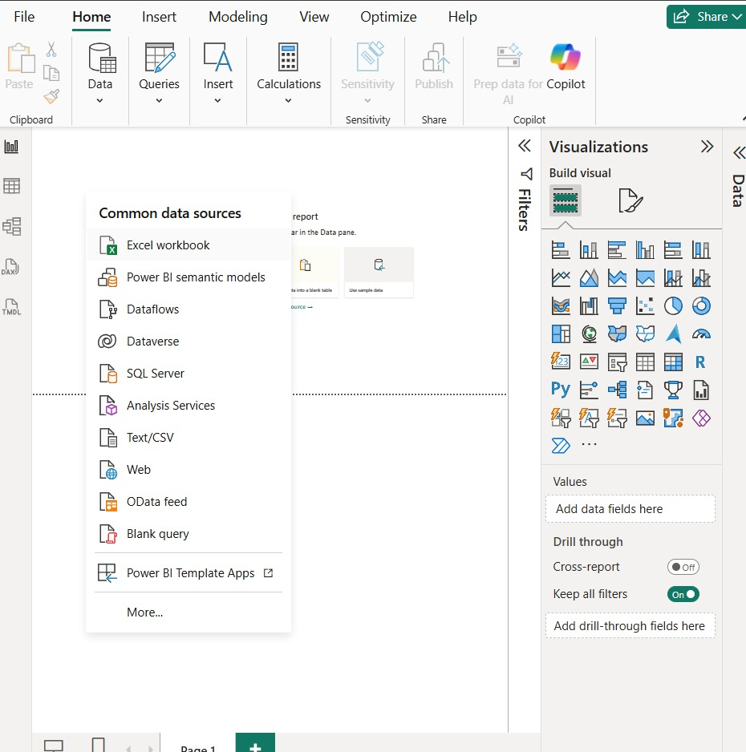
Get Data menu, showing the Text/CSV option.
The samplesuperstore CSV file was selected from the file system.
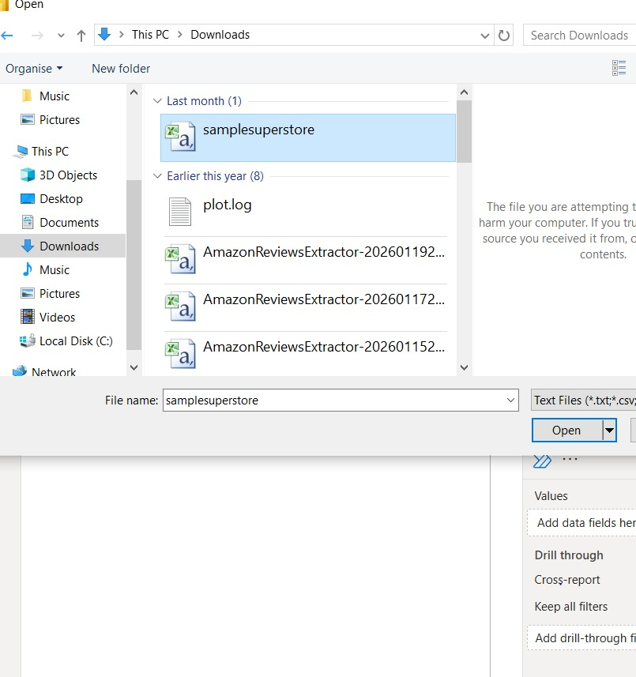
Choosing the samplesuperstore CSV file.
Power BI showed a preview of the raw data. Transform Data was clicked to open Power Query Editor and clean the data before loading it.
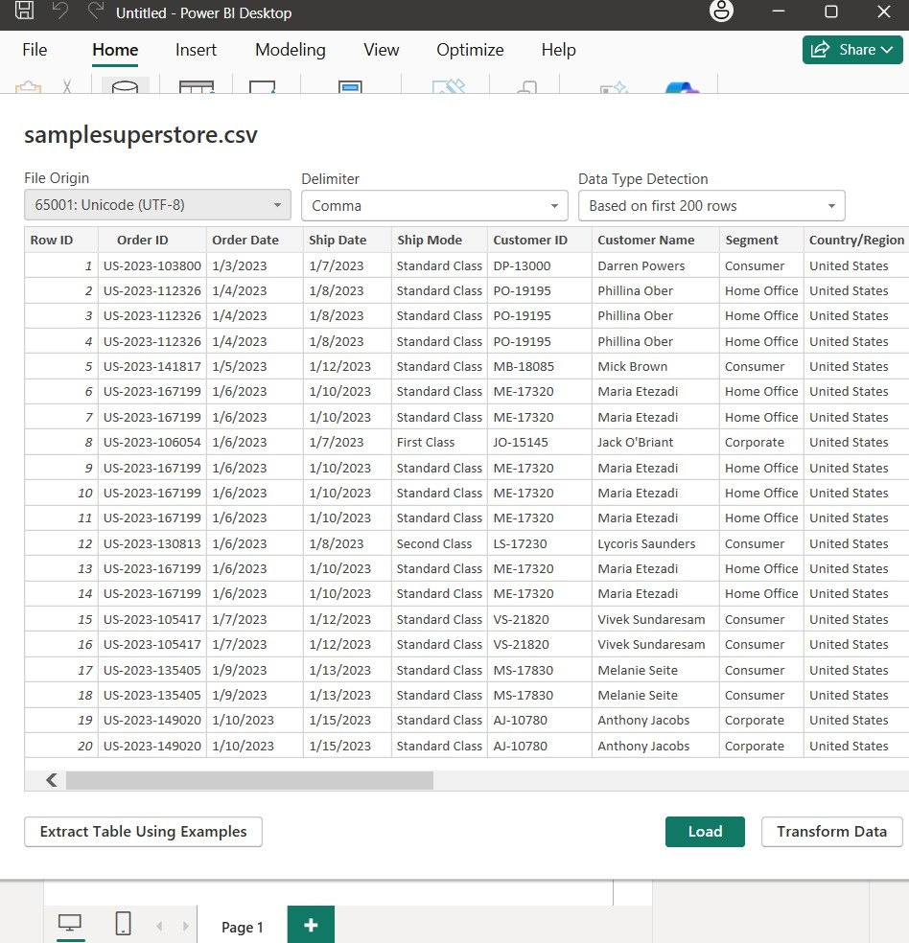
Preview of the raw data before cleaning.

3. Checking Data Types and Missing Values
In Power Query, the Order Date column was converted to a proper Date type using the correct locale, so dates would not be read incorrectly.
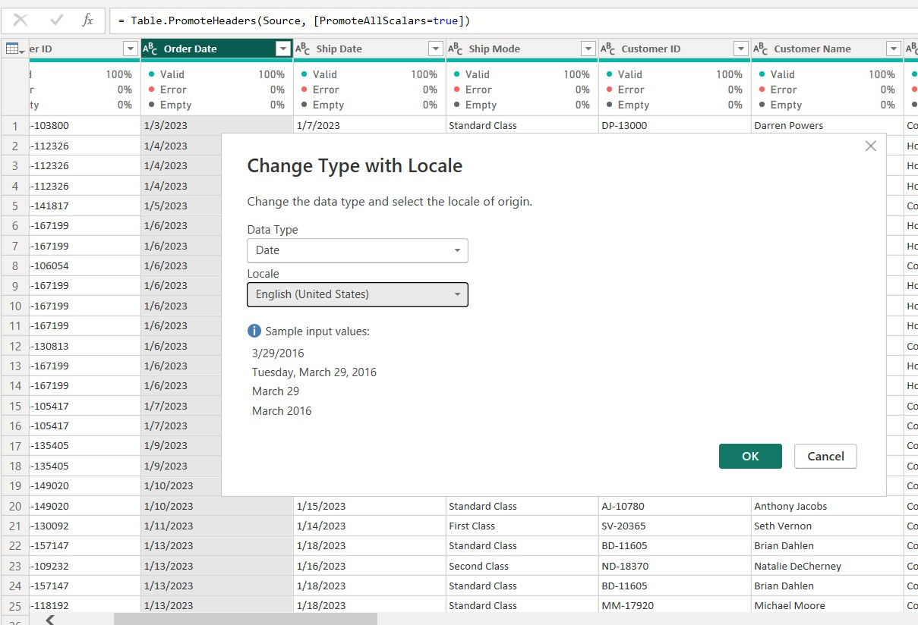
Setting the Order Date column to Date type with the US locale.
Each column was then checked. The Valid/Error/Empty markers showed all key columns were 100% valid, with no missing or wrong values.
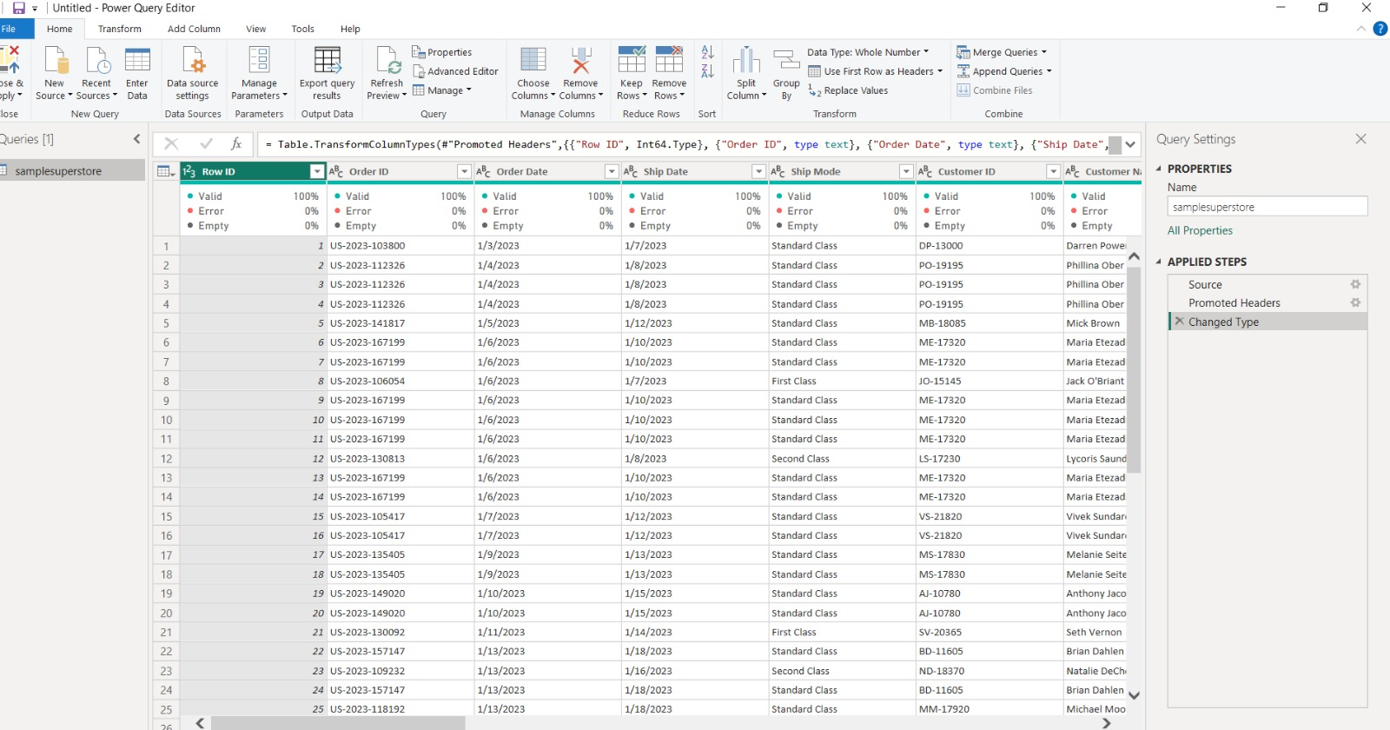
Columns after the date type was fixed.

4. Cleaning Up Text Columns
Columns like Category, Sub-Category and Segment were cleaned using Trim and Clean to remove extra spaces, and Capitalize Each Word to make the text consistent.
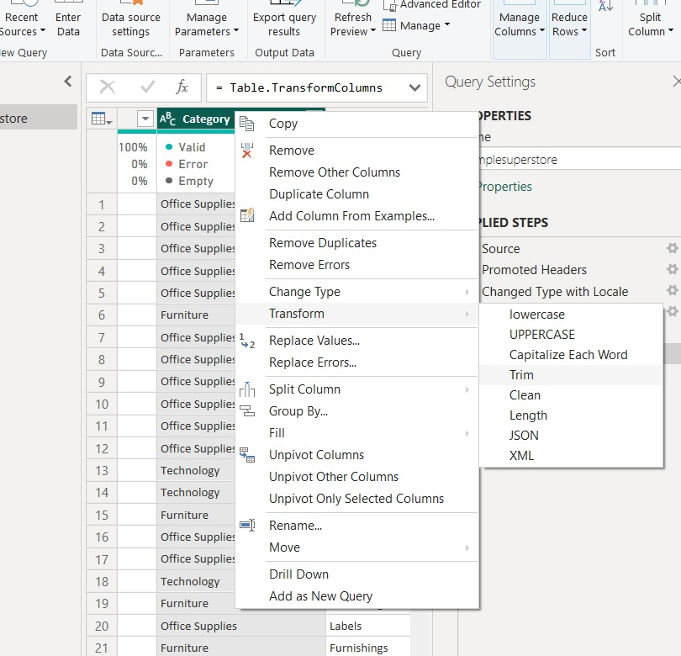
Trim and Capitalize Each Word options on the Category column.

5. Adding Date Columns
Using the Add Column > Date menu on the Order Date column, new columns were added without writing any formulas.
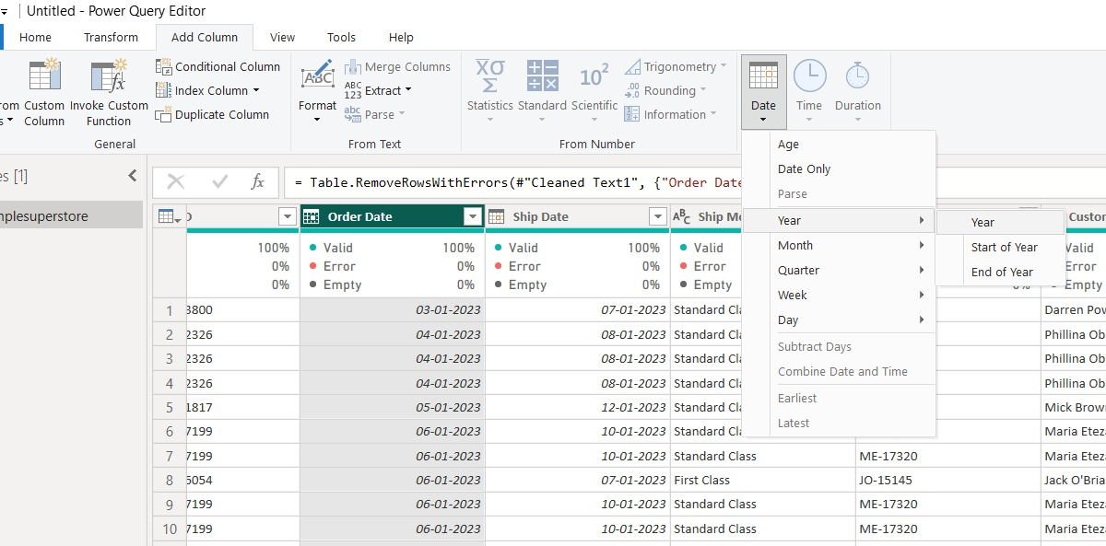
Add Column > Date menu, used to add the Year column.
In the same way, Quarter, Month, Day, and Day of Week columns were also added. These make it easy to filter and group data by time later.

6. Removing Duplicate Rows
Remove Rows > Remove Duplicates was used to keep only unique rows in the table.
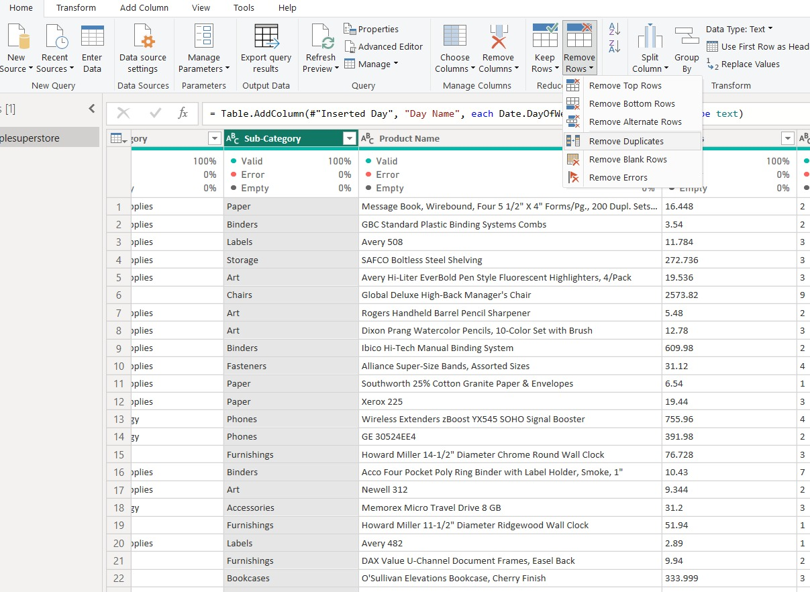
Remove Duplicates option in the menu.
The Applied Steps list on the right shows every cleaning step in order, ending with Removed Duplicates.
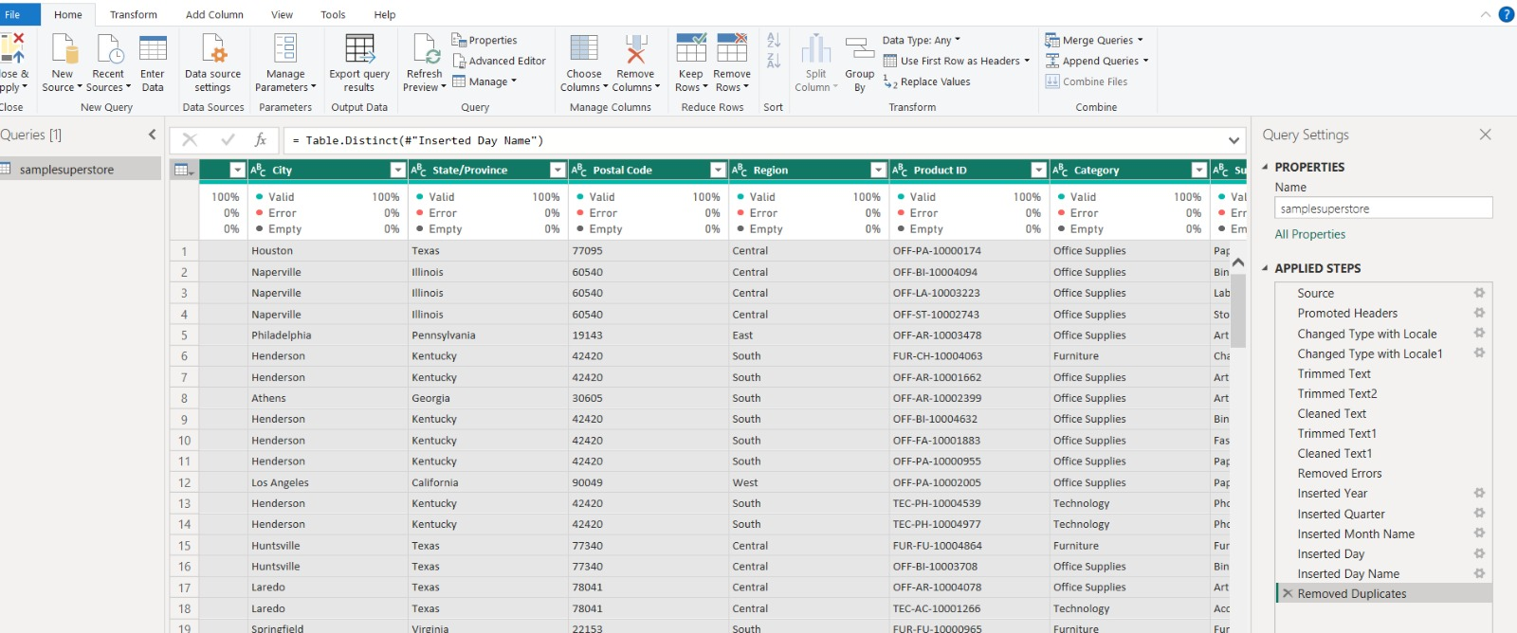
List of all applied steps, ending with Removed Duplicates.

7. Close and Apply
Once the data looked correct, Close & Apply was used to load the cleaned table into the Power BI model.
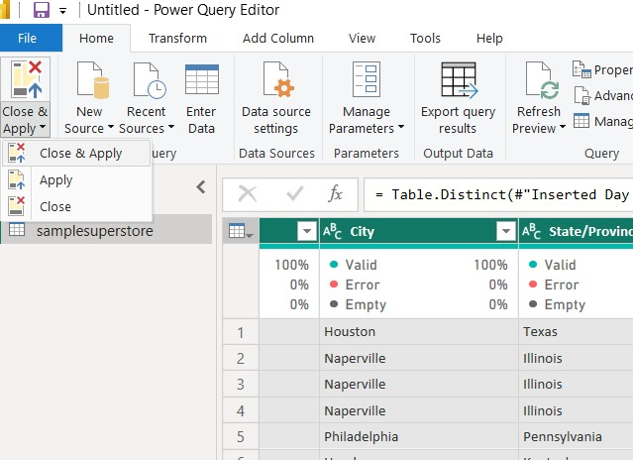
Close & Apply option in Power Query Editor.

8. Checking the Final Data
Data view was used to check the cleaned rows, including the new date columns.
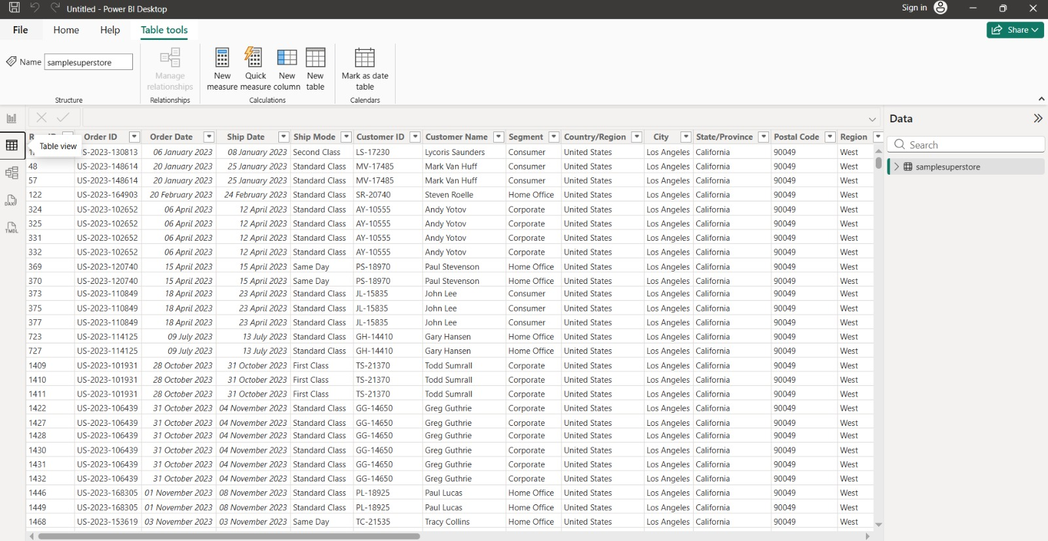
Cleaned data shown in Data view.
Model view was used to confirm the table and all its fields loaded correctly.
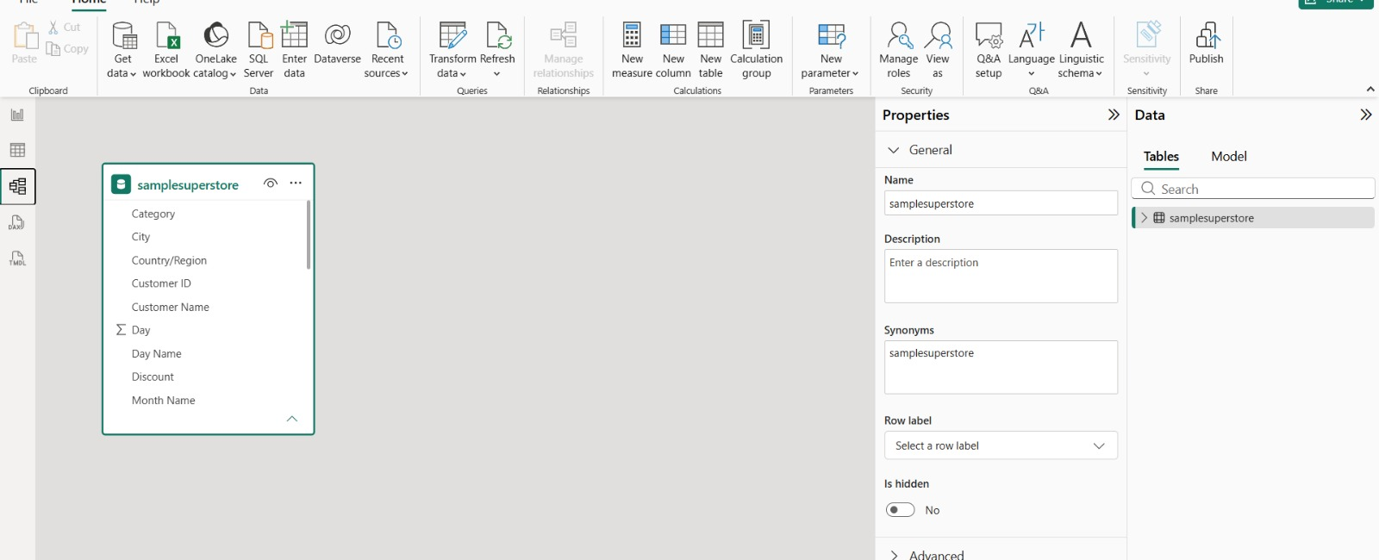
Table and fields shown in Model view.

9. Saving the File
The file was saved as a .pbix file so it can be reopened later to build the dashboard.
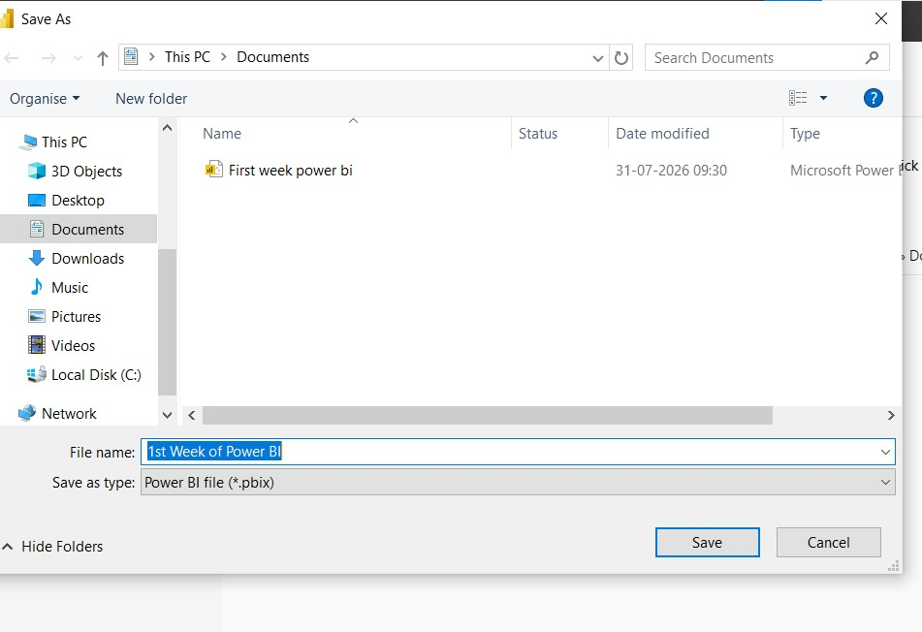
Saving the file as a .pbix Power BI file.

Summary
- Imported the Superstore CSV file into Power BI.
- Checked and fixed data types, especially dates.
- Checked for missing values and removed duplicate rows.
- Cleaned text in Category, Sub-Category and Segment.
- Added Year, Quarter, Month, Day and Day of Week columns.
- Loaded the clean data using Close & Apply and checked it in Data and Model views.
- Saved the file as .pbix

