**ProQuest Test Automation**

**Eclipse:**

1. Download the latest version of eclipse for Java enterprise developer.
2. Create a Java Project
3. Under the src folder start creating the package and classes.
4. Copy and paste the log4j.xml file inside the project.
5. Create a folder for screenshot, driver, Jar files.

**GIT Hub:**

1. Create a Repository in GIT Hub and copy the link

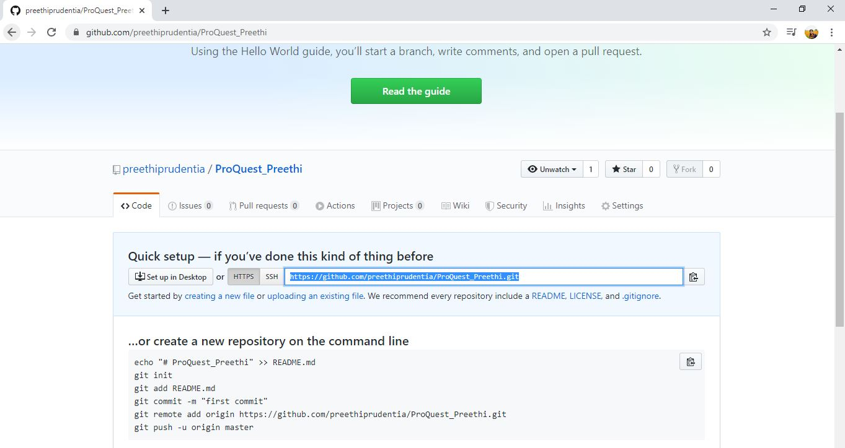

1. In Eclipse share the project under TEAM and configure the same
2. Commit the project to GIT Hub

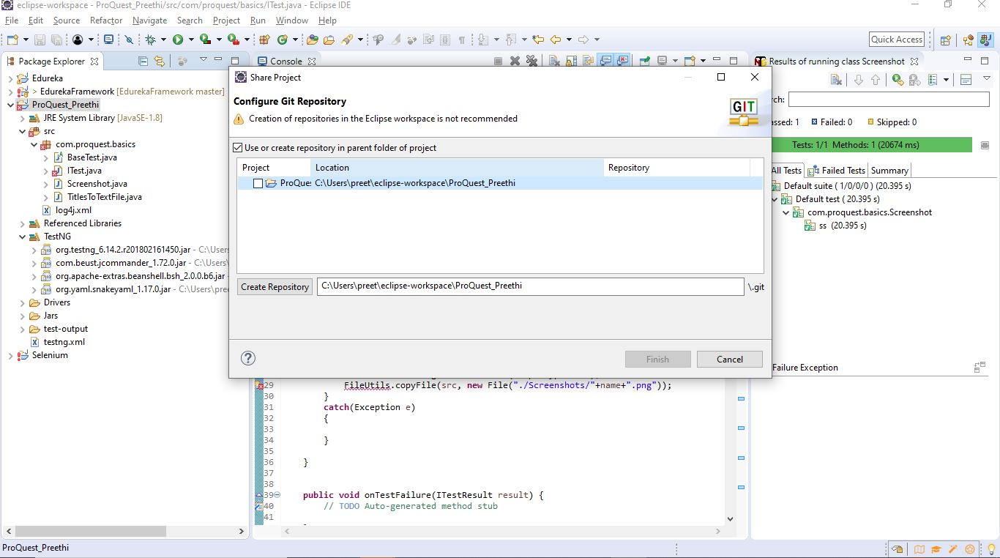

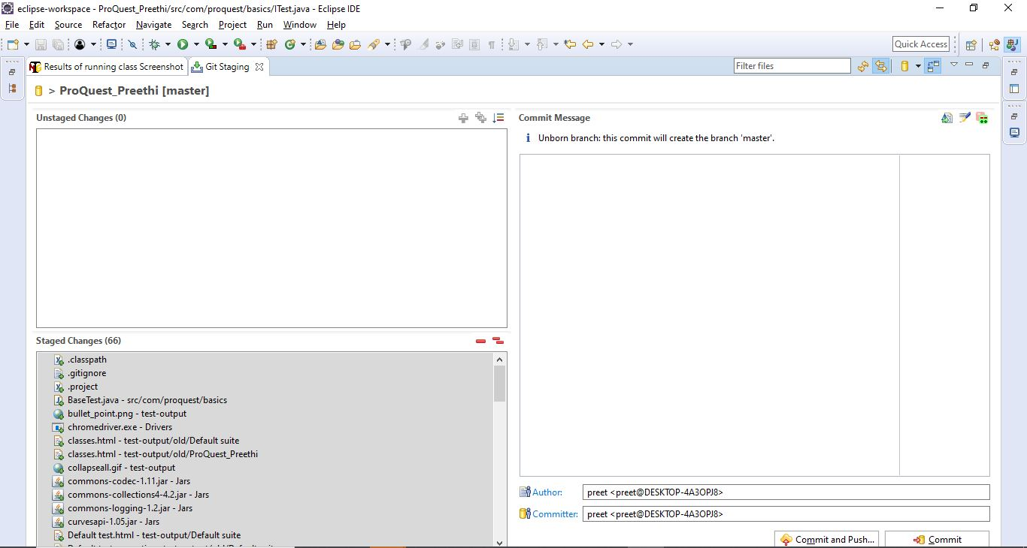

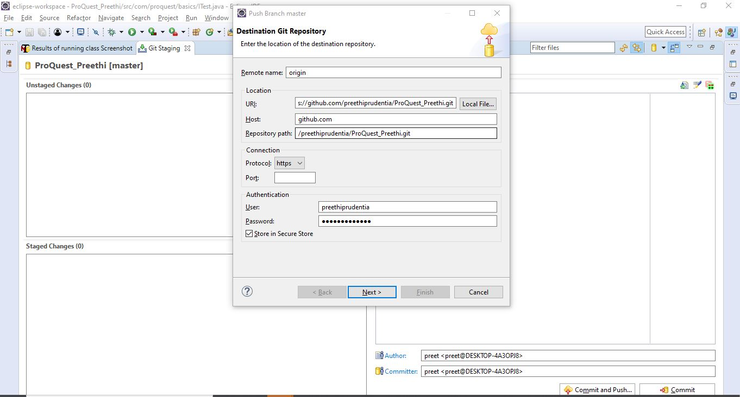

**Download Jar:**

1. Download Selenium standalone server and paste it in the JAR folder.
2. Build path the server so that we get the Referenced Libraries

**Download Driver:**

1. Download the browser driver(I have used Chrome Driver) and paste the same in Driver Folder

**Download Apache Poi:**

1. Download the Apache Poi and extract the same

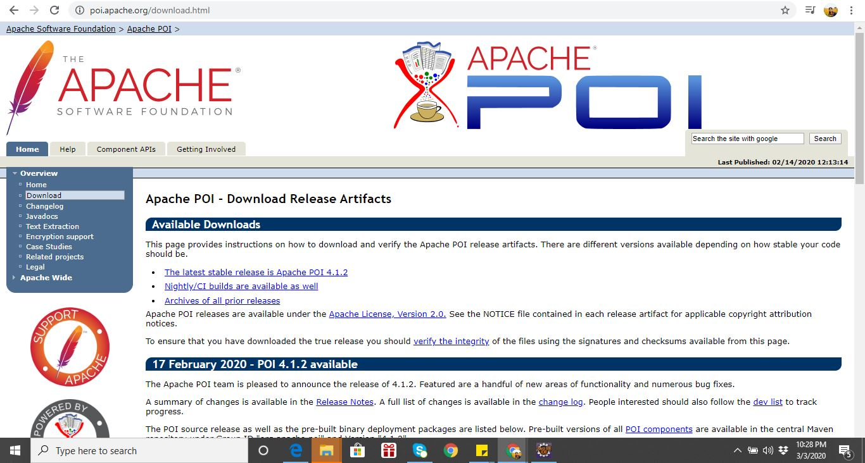

1. Copy and paste the files in JAR folder
2. Build path all the files so that we get all the files In Referenced Libraries

**Download TestNG:**

1. Download TestNG through the Eclipse Marketplace which is under Help menu.
2. Convert the project to TestNG Project.

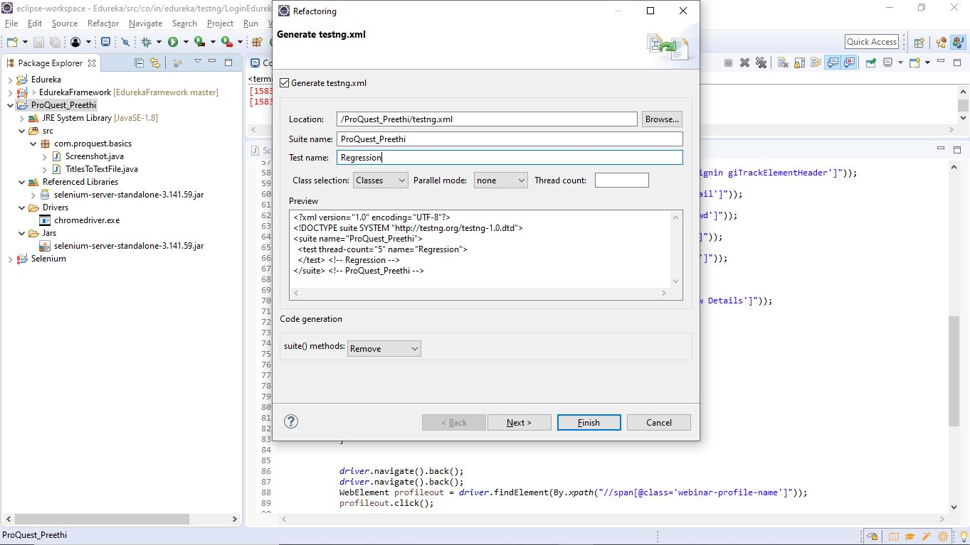

1. Under Project Property, add TestNG Library

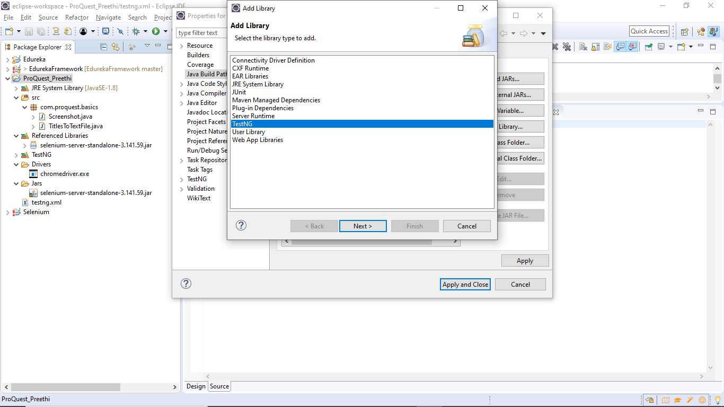

**Implement ITestListener**

ITestListener is an interface which helps to take screenshot.

Implement the interface on which condition the screenshot should be taken.

**Execution:**

Navigate to [www.google.com](https://urldefense.proofpoint.com/v2/url?u=https-3A__nam02.safelinks.protection.outlook.com_-3Furl-3Dhttp-253A-252F-252Fwww.google.com-252F-26data-3D02-257C01-257CSteve.Bush-2540proquest.com-257Cd495d476d6a24434fac108d6cf0fcd38-257Cc598e59c2e194342a52ba055a26296c6-257C0-257C0-257C636924064106137542-26sdata-3Dq3Rxs6JlUjeWEO3tIPnRPQPaBjr1gV0wljjtUdG17Do-253D-26reserved-3D0&d=DwMFaQ&c=WMhnfwkfN4LR6wX29ZSgFCZf_hw4vy5MAv7iZJNaAD4&r=YKBMNY-idOXF-xowvFlitL4pZa7MROnGGmn9L5OkE7s&m=UCtl_A1gCWimQIJy4jdYHenw3b0uOU63qQTt2zb3xXA&s=-M5avqCMQRr836IETL3e1joDs4UlOekAd-p1s4xXUY8&e=) and search for ‘ProQuest’.  Write the titles of all results on the first page to a text file on the operating system.

1. Navigate to ProQuest_Preethi -> src ->com.proquest.basics -> TitlesToTextFile.java
2. Run as ‘TestNG Test’

Open the ProQuest website from the results, search for ‘QA’ in the top nav, and take a screenshot.

1. Navigate to ProQuest_Preethi -> testing.xml
2. Run as ‘TestNG Suite’