Analysis

## 1. Top 5 states for order quantity between 2007 and 2008 for the product, 800 (Road-550-W Yellow, 44), together with a gain/loss percentage of 2008 when compared to 2007

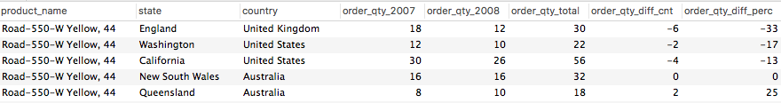

*Reference SQL query: Query 1*

Findings & Business Decisions  
*[Your findings and business decisions/suggestions]*

## 2.

*/\**

*List the top 10 customers in terms of purchases and group by year*

*\*/*

**SELECT c**.**customer_skey**, **c**.**last_name**,**c**.**first_name**, **c**.**gender**, *sum*(f.**extended_amount**) **as** total_amt,d.**the_year**

**FROM** fact_sales F, dim_customer **C**, dim_date D

**WHERE** F.**customer_skey**=**C**.**customer_skey AND** F.**date_skey**=D.**date_skey**

**GROUP BY** D.**the_year**, d.**the_month**

**ORDER BY d.the_year desc,** total_amt **desc**

limit 10;

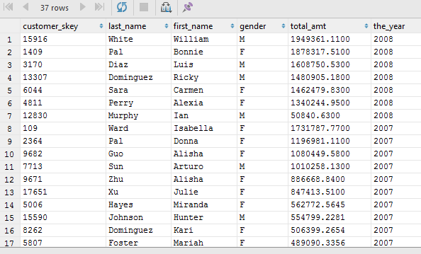

*/\**

*which gender purchased the highest -group by year*

*\*/*

**SELECT c**.**gender**, *sum*(f.**extended_amount**) **as** total_amt,d.**the_year**

**FROM** fact_sales F, dim_customer **C**, dim_date D

**WHERE** F.**customer_skey**=**C**.**customer_skey AND** F.**date_skey**=D.**date_skey**

**GROUP BY c**.**gender**, D.**the_year**

**ORDER BY** d.**the_year desc**, total_amt **desc** ;

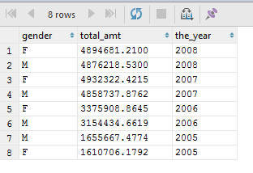

Clearly evident that Females are more valuable than males when it comes to purchases.

*/\**

*What is the sum of sales distribution in a month every year? ANy pattern ?*

*\*/*

**SELECT** d.**the_month**, d.**the_year**, *sum*(f.**extended_amount**) total_amt

**FROM** fact_sales f, dim_customer **c**, dim_product p, dim_date d

**WHERE** f.**customer_skey**=**c**.**customer_skey AND** f.**product_skey**=p.**product_skey AND** f.**date_skey**= d.**date_skey**

**GROUP BY** d.**the_month**, d.**the_year**

**ORDER BY** d.**the_year desc**, total_amt **desc**;

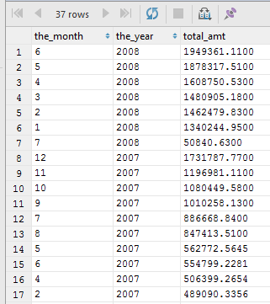

*/\**

*Which color of the products is the most sought after and which gender seeks it - any yearly pattern*

*\*/*

**SELECT distinct** p.**color**, **c**.**gender**, d.**the_year**, *sum*(f.**extended_amount**) amt

**FROM** fact_sales f, dim_customer **c**, dim_product p, dim_date d

**WHERE** f.**customer_skey**=**c**.**customer_skey AND** f.**product_skey**=p.**product_skey AND** f.**date_skey**= d.**date_skey**

**GROUP BY** p.**color**, d.**the_year**

**ORDER BY** d.**the_year desc**, **c**.**gender**, amt **desc**;

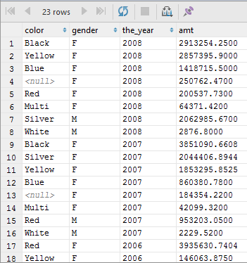

*/\**

*which state has the most ordering customers in terms of order value greater than a sum value of $1000 in the USA per each year*

*\*/*

**select** e.*\**

**FROM**

(

**SELECT c**.**home_address_state**, **c**.**home_address_country**, *sum*(f.**extended_amount**) **as** total_amt, d.**the_year**

**FROM** fact_sales f, dim_customer **c**, dim_product p, dim_date d

**WHERE** f.**customer_skey**=**c**.**customer_skey AND** f.**product_skey**=p.**product_skey AND** f.**date_skey**= d.**date_skey**

**AND c**.**home_address_country LIKE 'United States'**

**GROUP BY c**.**home_address_state**, d.**the_year**

**ORDER BY** d.the_year **DESC**, total_amt **DESC**

) e

**where** e.total_amt > 1000.0000;

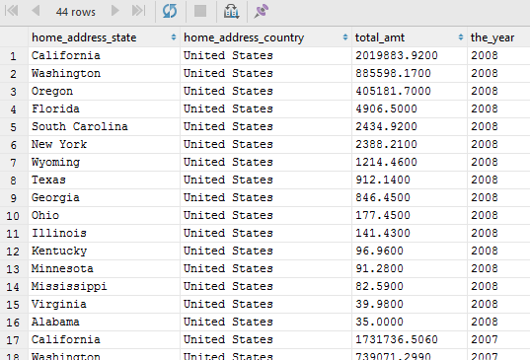

Clearly California, followed by Washington is the winner.

*/\**

*The Categories and Sub categories which are being sold every year*

*\*/*

**SELECT** f.**product_skey**, p.**product_id**, p.**model_name**, p.**product_category**, p.**product_subcategory**, *sum*(f.**extended_amount**) total_amt, d.**the_year**

**FROM** fact_sales f, dim_customer **c**, dim_product p, dim_date d

**WHERE** f.**customer_skey**=**c**.**customer_skey AND** f.**product_skey**=p.**product_skey AND** f.**date_skey**= d.**date_skey**

**GROUP BY** p.**product_subcategory** , d.**the_year**

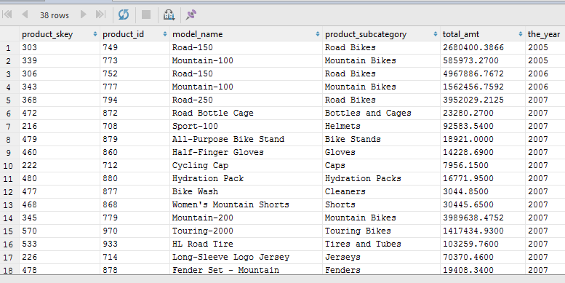 **ORDER BY** D.**the_year**;

The most sought after products are Bikes.