**Name : PREETHI SETHURAGUNATHAN CWID:A20387943**

Analysis

## 1.Quarter Sales Results of a Product- Half-Finger Glove sold in British Columbia, Canada between the Year 2007 and 2008

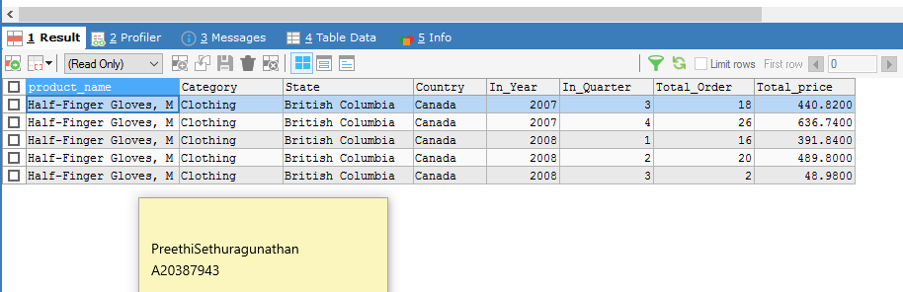

Reference SQL Query analysis1.sql

*/*Analysis of a particular product's selling range by its Quarter results in the city British Columbia, Canada.*/*

*SELECT p.product_name, p.product_category AS Category, c.home_address_state AS State , c.home_address_country AS Country,*

*d.the_year AS In_Year,d.the_quarter AS In_Quarter, SUM(f.order_qty) AS Total_Order, SUM(f.unit_price) AS Total_price*

*FROM fact_sales f, dim_product p, dim_customer c, dim_date d*

*WHERE f.product_skey = p.product_skey*

*AND f.customer_skey = c.customer_skey*

*AND f.date_skey = d.date_skey*

*AND p.product_id = 859*

*AND c.home_address_country= 'Canada'*

*GROUP BY p.product_name,p.product_category, c.home_address_state, d.the_year, d.the_quarter, f.unit_price*

*LIMIT 5*

Findings & Business Decisions

|  |  |
| --- | --- |
| Findings | Business Decisions |
| 1)A) from the analysis, we infer that in the year 2007, the 3rd quarters total number of order quantity is increased from 18 to 26 in the next quarter showing that the product is well received by the customers in that region. | 2)A) Based on 1)A findings that it is clear that the product is well doing and to meet the demands, the quantity of products must be increased thus increasing the overall production cost/cost of raw materials procured and time. Appropriate process plan/workflow must be met to meet the situation in the future. |
| 1)B) Similarly, In the year 2008, the 1st and 2nd quarter results are significantly dropped (more than 80%) in the 3rd quarter falling to only 2 orders placed by the customers in that region. | 2)B) Based on 2)B it can be inferred that the product is suddenly experiencing a steep fall curve and to improve the product sale in the future,necessary field analysis should be conducted, addressing questions such as  1.‘were there any supply over demand issue’?  2.’unsustainable market competition’? or 3.’was it an off season for the product?’ etc. |

## 2. Analysis of Region wise overall sales report for the Category-Bike in the year 2005

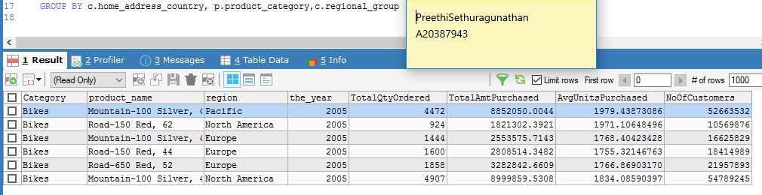

Reference Query: analysis2.sql

SELECT c.home_address_country AS Country, p.product_category AS Category ,p.product_name,c.regional_group AS region,

d.the_year,

SUM(f.order_qty) AS TotalQtyOrdered,

SUM(unit_price) AS TotalAmtPurchased,

AVG(f.unit_price) AS AvgUnitsPurchased,

SUM(c.customer_id) AS NoOfCustomers

FROM fact_sales f,

dim_customer c,

dim_product p,

dim_date d

WHERE f.customer_skey= c.customer_skey

AND f.product_skey= p.product_skey

AND f.date_skey=d.date_skey

AND product_category='Bikes'

GROUP BY c.home_address_country, p.product_category,c.regional_group

Findings & Business Decisions

|  |  |
| --- | --- |
| Findings | Business Decisions |
| 1. In the year 2005 Pacific and North America region have over 50 million customers who purchased mountain bikes in the year 2005 while the same bike has managed to be sold to 16 million customers in the Europe. | Notifying supplier for increase in demand in North America and reviewing supplier with respect to the fall curve in Europe for the same product |
| 2. Europe sells more number of road bikes than North America in the year 2005. | Ordering more road bikes instead of promoting mountain bikes in Europe |

## 3. Analysis to find the top 5 products that are sold in city wise in Australia between the year 2007 and 2008

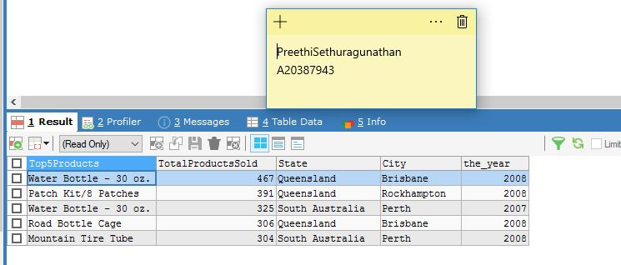

Reference Query: analysis3.sql

SELECT p.product_name AS Top5Products, SUM(f.order_qty) AS TotalProductsSold,

c.home_address_state AS State,

c.home_address_city AS City,d.the_year AS In_Year

FROM fact_sales f, dim_product p, dim_customer c, dim_date d

WHERE f.product_skey = p.product_skey

AND f.customer_skey = c.customer_skey

AND f.date_skey = d.date_skey

AND c.home_address_country='Australia'

GROUP BY p.product_name, p.product_id , d.the_year

ORDER BY SUM(f.order_qty) DESC

LIMIT 5

Findings & Business Decisions:

|  |  |
| --- | --- |
| Findings | Business Decisions |
| 1. Brisbane sell the top product that is sold in highest quantity and Perth sell the fifth top product in Australia | Devising new marketing ideas to maintain the product’s selling range.  Conducting surveys and free trials in other parts to know why they lacked and in what innovative ways the sales can be promoted. |
| 2. In both years 2007 and 2008 same product grossed the top selling but in different cities | Strategic analysis on why the sales dropped in Brisbane in 2008 |

## 4. Analysis to show the Total No of Males and Females from no of customers who ordered specific category region wise in the year 2007

Reference Query: analysis4.sql

SELECT c.regional_group, c.home_address_city,p.product_category,

SUM(f.unit_price) AS AmoutPurchased,

MAX(d.the_year) AS Inyear,

COUNT(CASE WHEN c.gender='M' THEN 1 END) AS NoOfMales,

COUNT(CASE WHEN gender='F' THEN 1 END) AS NoOfFemales,

COUNT(*) AS NumberOfCustomers

FROM fact_sales f,

dim_customer c,

dim_product p,

dim_date d

WHERE f.customer_skey= c.customer_skey

AND f.product_skey= p.product_skey

AND f.date_skey=d.date_skey

AND d.the_year= '2007' AND '2006'

GROUP BY

c.home_address_country, p.product_category,c.gender, d.the_year

Findings & Business Decisions:

|  |  |
| --- | --- |
| Findings | Business Decisions |
| 1. Only female customers bought accessories in the Malabar of Pacific region and only male customers bought the accessories in the Melbourne of pacific region | 1.Devise Business strategies to promote sales of accessories to the male customers in the Malabar and female customers in Melbourne |
| 2. No of Customers buying accessories in North America is higher than the customer buying in Europe | 1.Field Analysis and white board meetings on to promote sales in Europe who have a large customer base but with low sales when compared to north america |

## 5. Analysis of High Priced product that is ordered on the same day by customers in United States

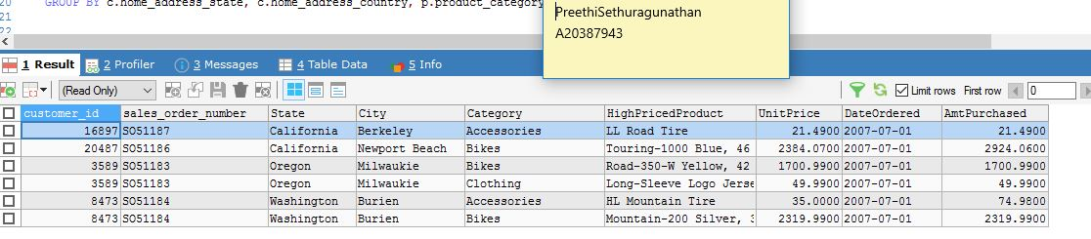

Reference Query: analysis5.sql

SELECT c.customer_id,f.sales_order_number,c.home_address_state AS State,c.home_address_city AS City,

p.product_category AS Category, p.product_name AS HighPricedProduct,

MAX(f.unit_price)AS UnitPrice, d.the_date AS DateOrdered,

SUM(f.unit_price*f.order_qty) AS AmtPurchased

FROM fact_sales f,

dim_customer c,

dim_product p,

dim_date d

WHERE f.customer_skey= c.customer_skey

AND f.product_skey= p.product_skey

AND f.date_skey=d.date_skey

AND c.home_address_country ='United States'

AND c.customer_id IN

(SELECT DISTINCT c.customer_id )

AND f.sales_order_number IN

(SELECT DISTINCT f.sales_order_number)

AND d.the_date='2007-07-01'

GROUP BY c.home_address_state, c.home_address_country, p.product_category

Findings & Business Decisions:

|  |  |
| --- | --- |
| Findings | Business Decisions |
| 1. On July 2007,LL Road tire is the high priced product that sold in BErkely with one quantity and in New Port it is touring -1000  2.customer in Oregon with sale_order_number bought the highest priced products in the bike and accessories category | Research the product’s usability curve to improve more sales and analyzing the lowest selling products and its causes. |
| 1.Bikes and accessories are the top categories that are sold in the city on the same day | Compare with previous year sales and scope for increase in production and sales.  Cautions on ‘not to become supply over demand’ |

Analysis on SCD Attributes

Type : Overwrite

Changing the customer: Shannon Huang’s city

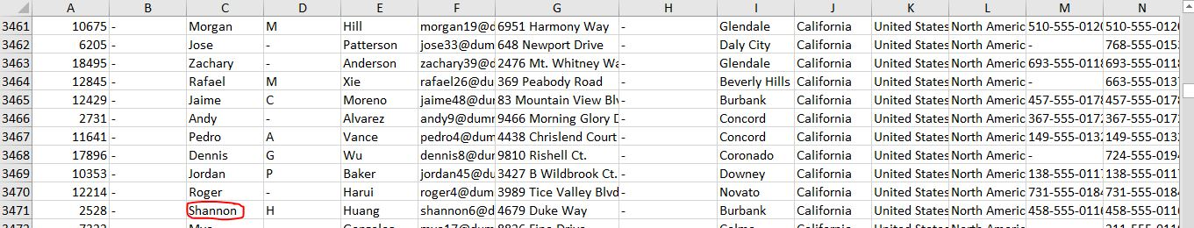

And modified_date

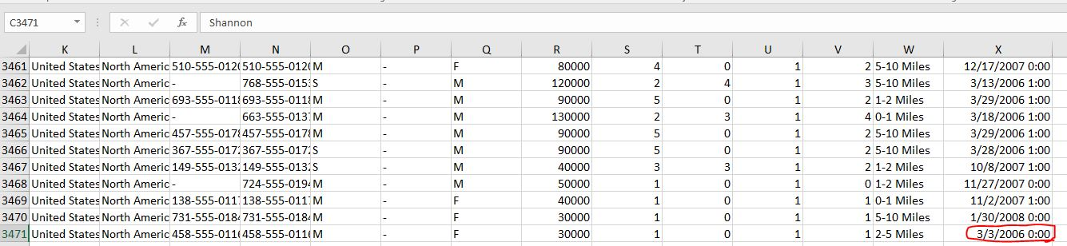

## City changed to ‘Liverpool’ and ‘modified_date’ to 3/13/2007 as shown below



After rerunning the main job below Changes are reflected in the database:

Dim_customer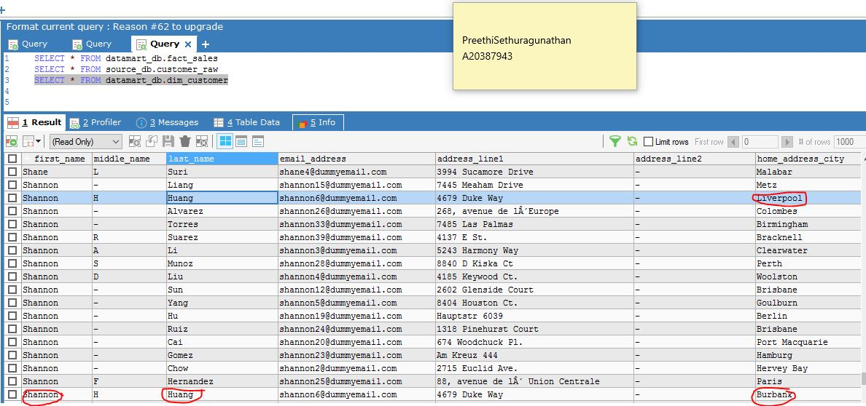

The version is updated with the recent modified date

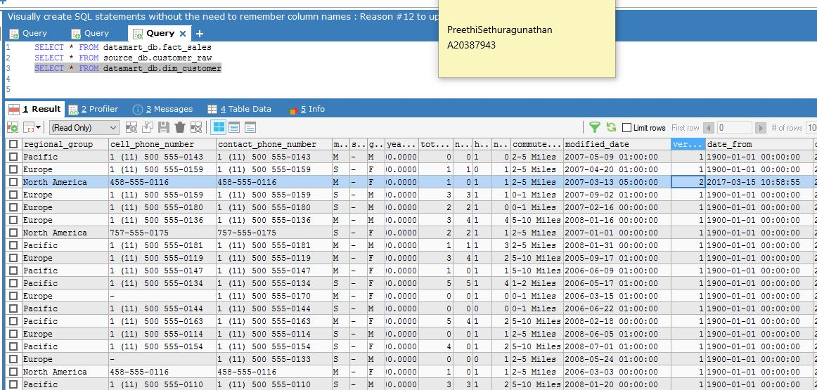

Fact_sales changes

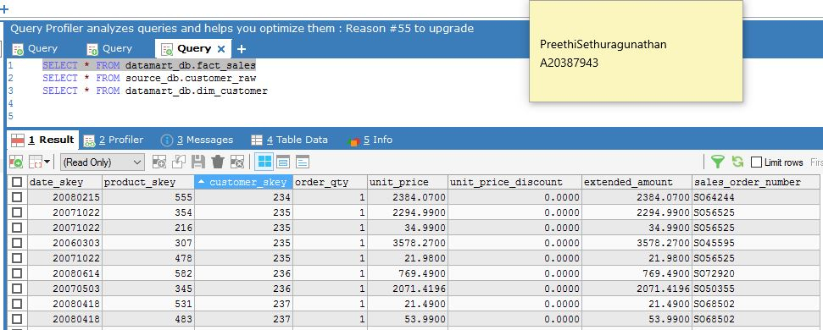

Type: Insert

Added a new row with the existing product id ‘859’ as below

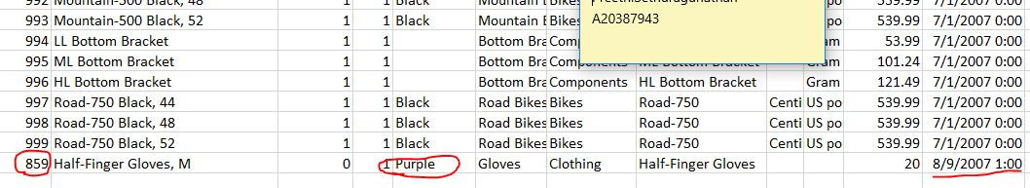

Saved the file and after rerunning the job, below are the changes reflected in db

Changes reflected in the source db are shown below.

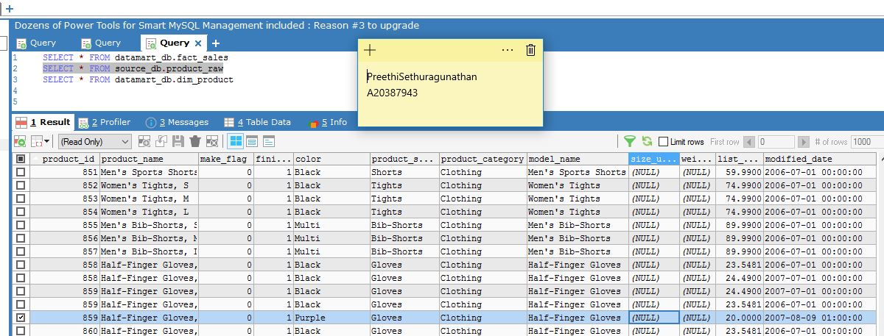

Dim_product

Version is updated and the modified date is recent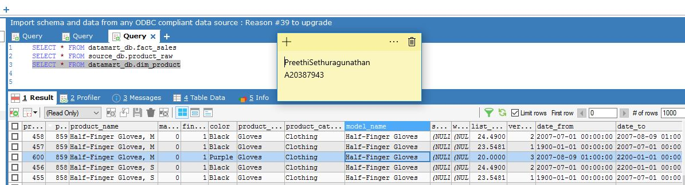

Fact_sales

