High-Performance CMOS LNA Design with S-Parameter and Noise Figure Evaluation in Cadence Virtuoso
Submitted in the partial fulfilment of the requirements for the
Course Title: Analog VLSI
Course code: 23VLS3101R

by
S. Harika – 2300040181
MOHAMMAD ASJAD – 2300040197
S. Preethisree Naga Sai– 2300040199

Under the guidance of
Dr. M Lakshmana Kumar
Associate Professor of ECE


Department of Electronics & Communication Engineering
KONERU LAKSHMAIAH EDUCATION FOUNDATION
(K L Deemed to be University)
Green Fields, Vaddeswaram, Andhra Pradesh - 522302, India.



DECLARATION

The Project Report entitled “High-Performance CMOS LNA Design with S-Parameter and Noise Figure Evaluation in Cadence Virtuoso” is a record of Bonafide work of 2300040181, 2300040197, 2300040199 submitted in partial fulfilment for the subject titled 23VLS3101R – ANALOG VLSI in Dept of ECE, KL UNIVERSITY.

Student ID – Student Name
2300040181 – S. Harika
2300040197 – MOHAMMAD ASJAD
2300040199 – S. Preethisree Naga Sai

CERTIFICATION


This is to certify that the Project Report titled “High-Performance CMOS LNA Design with S-Parameter and Noise Figure Evaluation in Cadence Virtuoso” is being submitted by 2300040181, 2300040197, 2300040199 in partial fulfilment for the subject titled (23VLS3101R –ANALOG VLSI) in Dept of ECE, KL University is a record of Bonafide work carried out under our guidance and supervision. The results embodied in this report have not been copied from any other departments/University/Institute.

Signature of Examiner Signature of Supervisor

ACKNOWLEDGEMENT

It is a great pleasure for me to express my sincere gratitude to our Honourable President Sri. Koneru Satyanarayana, for giving me the opportunity and platform with facilities to accomplish the project report.
I would like to express my sincere gratitude to my guide, Dr. M Lakshman Kumar, for his invaluable guidance, continuous support, and encouragement throughout this project. His expertise and insights have been instrumental in shaping the direction of my work.
I extend my heartfelt thanks to Dr. I. Govardhani, Professor & Head, for providing the necessary resources and a conducive research environment.
I am also grateful to my institution, the Koneru Lakshmaiah Education Foundation, and its faculty members for their assistance and for equipping me with the knowledge and tools required for this project.
Lastly, I would like to express my deep appreciation to my family for their constant encouragement and unwavering support throughout this journey.

Student ID – Student Name
2300040181 – S. Harika
2300040197 – MOHAMMAD ASJAD
2300040199 – S. Preethisree Naga Sai

ABSTRACT

The Low Noise Amplifier (LNA) plays a vital role in Radio Frequency (RF) front-end systems, as it amplifies very weak signals received from the antenna while introducing minimal additional noise. The main objective of this project is to design, simulate, and evaluate the performance of a high-performance CMOS Low Noise Amplifier using Cadence Virtuoso. The design process involves selecting suitable CMOS technology and biasing methods to achieve optimum gain, low noise figure, and good input-output impedance matching.
S-parameter analysis is carried out to study the amplifier’s small-signal behavior, including reflection coefficients, gain, and stability across the desired frequency range. Noise analysis is performed to evaluate the amplifier’s capability to maintain signal integrity while minimizing internal noise contributions. Through the use of Spectre RF simulation tools within Cadence Virtuoso, both S-parameter and noise figure characteristics are examined to ensure the amplifier meets RF design requirements.
The simulation results confirm that the designed CMOS LNA achieves high gain with low noise, making it suitable for RF applications such as wireless communication receivers. The project demonstrates how Cadence Virtuoso can effectively be used to design, analyze, and optimize the performance of RF circuits through advanced simulation techniques. Overall, this work provides a clear understanding of LNA behavior in terms of performance trade-offs, noise optimization, and stability considerations in CMOS technology.

TABLE OF CONTENTS
1 | Introduction | 1
1.1 | Overview of the Project | 1
1.2 | Structure and Working Principle of LNA | 1
1.3 | Role of LNA in a Transceiver | 2
2 | Literature Review | 3
2.1 | CMOS LNA Design Trends | 3
2.2 | Key Findings from Previous Research | 4
3 | Circuit Diagram | 5
4 | Methodology and Design Approach | 6
4.1 | Design Flow Overview | 6
4.2 | Circuit Topology | 7
4.3 | S-Parameter Analysis and Simulation Setup | 7
4.4 | Design Optimization | 8
4.5 | Validation and Performance Evaluation | 8
5 | Results | 9
6 | Analysis and Inference | 13
7 | Conclusion and Future Scope | 14
8 | References | 15

- Introduction
1.1 Overview of the Project
The project aims to design, simulate, and analyse a CMOS Low Noise Amplifier suitable for wireless transceiver applications. Using Cadence Virtuoso as the primary design and simulation platform, the LNA is optimized for key performance metrics such as gain (S₂₁), input/output matching (S₁₁ and S₂₂), reverse isolation (S₁₂), noise figure, and stability factor. The use of S-parameter-based analysis allows for accurate characterization of the LNA under various frequency conditions, ensuring its suitability for integration into RF front-end modules.
The design employs a common-source topology with inductive source degeneration to achieve impedance matching and noise optimization. Emphasis is placed on reducing the noise figure while maintaining sufficient gain and linearity. The project also evaluates how process variations, parasitic elements, and biasing conditions affect the amplifier’s performance. Overall, the proposed design serves as a reliable, low-power, and cost-effective solution for next-generation wireless systems.
1.2 Structure and Working Principle of LNA
A Low Noise Amplifier typically consists of three main sections: the input matching network, the amplifying core, and the output matching network. The input matching network ensures that the impedance seen by the source (antenna) is properly matched to minimize reflection losses and maximize power transfer. The amplifying core—usually implemented using a common-source MOSFET configuration—is responsible for amplifying the weak input signal. An inductive source degeneration is often introduced to improve linearity and provide better control of the input impedance. The output matching network is designed to match the amplifier’s output impedance to the next stage in the transceiver chain, ensuring maximum signal transmission.
The LNA’s working principle is based on the small-signal amplification of an input RF signal, where the transistor operates in its saturation region. The amplifier’s gain and noise performance are influenced by parameters such as transconductance (gm), parasitic capacitances, and load impedance. The S-parameter analysis provides valuable insights into these relationships, enabling precise optimization of the design to achieve the desired gain-bandwidth and noise performance.
1.3 Role of LNA in a Transceiver
In a wireless transceiver, the LNA is located at the front-end of the receiver chain, immediately after the antenna and before the mixer. Its role is to amplify the weak RF signal captured by the antenna while maintaining a low noise figure to prevent signal degradation. Since the incoming signals are often very weak and susceptible to interference, the LNA must provide high gain with minimal distortion. A well-designed LNA ensures that the subsequent stages, such as the mixer and baseband amplifier, receive a strong and clean signal for further processing.
Moreover, the LNA significantly impacts the overall noise figure and sensitivity of the receiver. If the LNA introduces excessive noise, the entire system’s performance degrades, regardless of how efficient the later stages are. Therefore, optimizing the LNA’s S-parameters and matching networks is essential to achieving the desired balance between gain, noise performance, linearity, and power efficiency in modern wireless communication systems.

- Literature Review
The design of Low Noise Amplifiers (LNAs) has been an active area of research for several decades due to their vital role in the receiver front-end of wireless communication systems. Numerous studies have focused on improving the gain, noise performance, linearity, and power efficiency of LNAs while maintaining compactness and ease of integration in CMOS technology. CMOS technology has become a popular choice for RF front-end design because of its low cost, scalability, and compatibility with digital circuits, allowing for complete system-on-chip (SoC) integration. However, achieving low noise and high gain in CMOS processes remains challenging due to the inherent limitations in transistor mobility and noise characteristics.
Early research primarily relied on bipolar junction transistor (BJT) implementations for LNAs, which offered superior transconductance and noise performance. However, with the advancement of CMOS technology and scaling of device geometries, CMOS LNAs have emerged as a cost-effective and energy-efficient alternative. Studies such as those by Thomas H. Lee and others have shown that inductively degenerated common-source amplifiers provide a good trade-off between gain, input matching, and noise figure. This topology introduces an inductor in the source terminal to achieve real input impedance matching and minimize noise contribution from the MOSFET. In addition, cascode configurations have been explored to improve isolation and stability, reducing the effect of the Miller capacitance and enhancing frequency response.
2.1 CMOS LNA Design Trends
Recent works emphasize wideband and multi-band LNAs to support emerging wireless standards such as Wi-Fi 6, LTE, and 5G. Techniques like current reuse, resistive feedback, and noise-canceling architectures have been introduced to improve performance while keeping power consumption low. For instance, current-reuse LNAs allow multiple amplification stages to share the same bias current, enhancing efficiency. Noise-canceling LNAs, on the other hand, use differential paths to suppress the noise generated by the input transistor, improving the overall noise figure.
Several researchers have used S-parameter-based design and optimization to analyze and fine-tune LNA performance. By studying parameters such as S₁₁ (input reflection coefficient), S₂₁ (forward gain), S₁₂ (reverse isolation), and S₂₂ (output reflection coefficient), designers can accurately assess impedance matching, stability, and frequency-dependent characteristics. These parameters form the foundation for small-signal characterization in RF circuits. Tools like Cadence SpectreRF, ADS (Advanced Design System), and Mentor Graphics ELDO RF have become standard for simulation and validation, enabling designers to verify real-world performance through post-layout parasitic extraction and Monte Carlo analysis.
2.2 Key Findings from Previous Research
Previous studies have demonstrated that optimizing the matching network and bias point of the LNA can significantly enhance both gain and noise performance. For instance, inductive source degeneration and gate inductor tuning help achieve simultaneous noise and power matching. Some designs also employ dual-gate transistors or tuned feedback networks to extend bandwidth and improve linearity. Furthermore, incorporating on-chip passive elements such as spiral inductors and metal-insulator-metal (MIM) capacitors enables full CMOS integration without external components, which is crucial for compact wireless devices.
It is also observed that the S-parameter analysis serves as a vital tool not only for performance validation but also for stability assessment using factors like Rollet’s stability factor (K) and µ-parameter. Ensuring unconditional stability across the operating frequency range is essential to prevent oscillations and maintain signal integrity. Collectively, the reviewed literature highlights that an S-parameter-based approach offers a robust methodology for the design and optimization of CMOS LNAs, ensuring a balanced trade-off between performance, area, and power consumption for wireless transceiver applications.

- Circuit Diagram
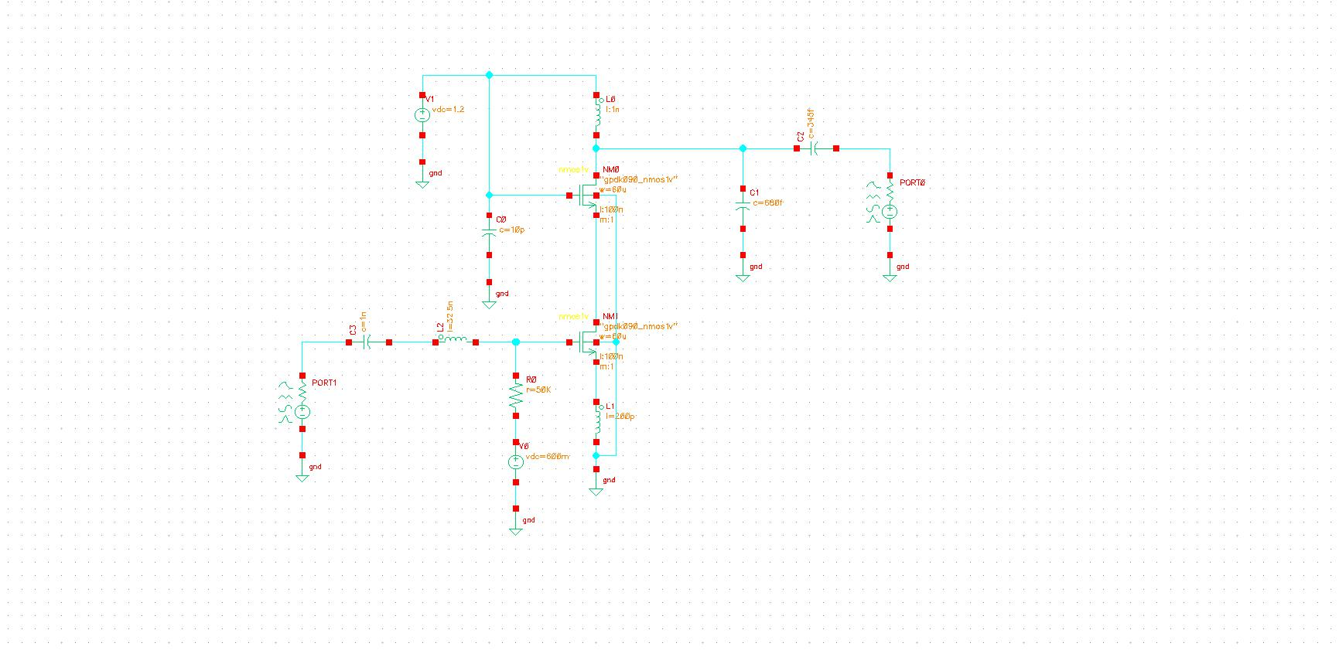
Figure 1: Schematic of 2.4G Hz CMOS LNA designed in Cadence Virtuoso

- Methodology and Design Approach
The design of a CMOS Low Noise Amplifier (LNA) involves a systematic approach that integrates theoretical analysis, circuit-level design, simulation, and S-parameter-based performance evaluation. The primary goal is to achieve high gain, low noise figure, good input/output matching, and stability over the desired frequency range while maintaining low power consumption. This section outlines the step-by-step methodology followed in this project, including the design flow, circuit topology selection, simulation setup, and extraction of key S-parameters using Cadence Virtuoso.
4.1 Design Flow Overview
The overall design process follows a structured RF design methodology:
- Specification Definition: The first step involves identifying the target specifications of the LNA, such as center frequency, desired gain, bandwidth, noise figure, and power consumption. These parameters are derived based on the requirements of the intended wireless application (e.g., Wi-Fi, LTE, or Bluetooth).
- Topology Selection: Based on the specifications, a common-source inductively degenerated topology is chosen, as it provides an optimal balance between noise performance and impedance matching in CMOS technology.
- Small-Signal Modeling and Analysis: The transistor is modelled using its small-signal equivalent circuit to determine relationships between transconductance (gm), noise figure, and impedance parameters. Analytical calculations are carried out to estimate the input and output impedances, as well as the expected gain.
- Simulation and S-Parameter Extraction: The circuit is implemented in Cadence Virtuoso using a standard CMOS process library. S-parameter simulations are performed using SpectreRF to evaluate S11, S12, S21, and S22, across the frequency range of interest.
- Optimization and Validation: Matching networks and biasing circuits are fine-tuned to meet performance targets. Post-layout simulations are conducted to account for parasitic effects and verify real-world performance.

4.2 Circuit Topology
The inductively degenerated common-source LNA is selected due to its ability to achieve simultaneous noise and input matching. The topology consists of:
- Input Matching Network: A gate inductor (Lg) and a source degeneration inductor (Ls) are used to match the input impedance to 50 Ω and to minimize the noise contribution from the transistor.
- Amplifying Core: A single NMOS transistor operates in saturation to provide voltage gain, while biasing is applied to ensure the device remains in the active region.
- Output Matching Network: This stage uses an inductor-capacitor network to match the output impedance to 50 Ω and to maximize power transfer to the next block (typically a mixer).
- Biasing Network: Provides DC stability and isolates the RF signal path using choke inductors and bypass capacitors.
This configuration not only offers low noise figure and good linearity but also maintains sufficient reverse isolation and unconditional stability.

4.3 S-Parameter Analysis and Simulation Setup
S-parameter analysis is the cornerstone of this project, as it provides detailed insight into the amplifier’s frequency-domain behavior. The key parameters include:
S11 – Input reflection coefficient, representing how well the input is matched.
S21 – Forward gain, indicating the amplification provided by the LNA.
S12 – Reverse isolation, measuring the feedback from output to input.
S22 – Output reflection coefficient, representing how well the output is matched.
Simulations are performed in Cadence SpectreRF by sweeping the frequency across the intended operating range (e.g., 2.4 GHz for Wi-Fi or 5 GHz for LTE). The LNA’s stability factor (K) and µ-factor are computed to ensure unconditional stability. The noise figure (NF) and power gain are also extracted from the same simulation environment.

  - Design Optimization
After initial simulation, parameter tuning is carried out to achieve optimal performance:
- Adjusting inductor values ($L_{g}$, $L_{s}$, $L_{d}$) to achieve perfect impedance matching.
- Optimizing the transistor width-to-length (W/L) ratio to balance gain and noise.
- Fine-tuning the bias voltage and current for minimum power dissipation.
- Using load tuning and feedback techniques to enhance linearity and dynamic range.
  - Validation and Performance Evaluation
The final step involves validating the LNA design using extracted S-parameters and comparing simulated results with theoretical predictions. Parameters such as gain, noise figure, bandwidth, input/output matching, and stability are analysed. These results are then compared to reference designs from literature to evaluate the design’s competitiveness. The performance metrics demonstrate that an S-parameter-based design methodology enables precise tuning and ensures robust operation in practical wireless transceiver systems.

- Results
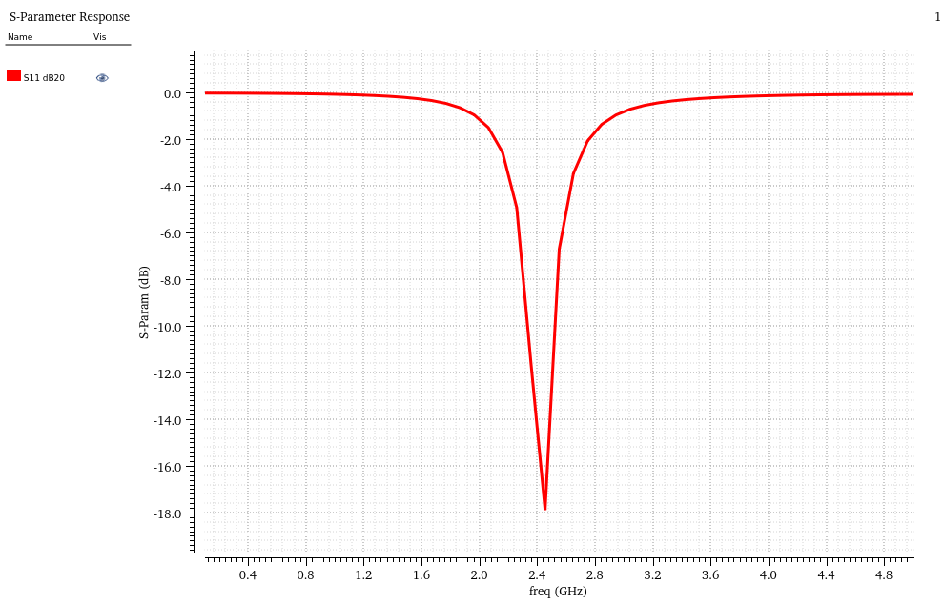
Figure 2: S11 (Input Return Loss) vs Frequency Plot for CMOS LNA
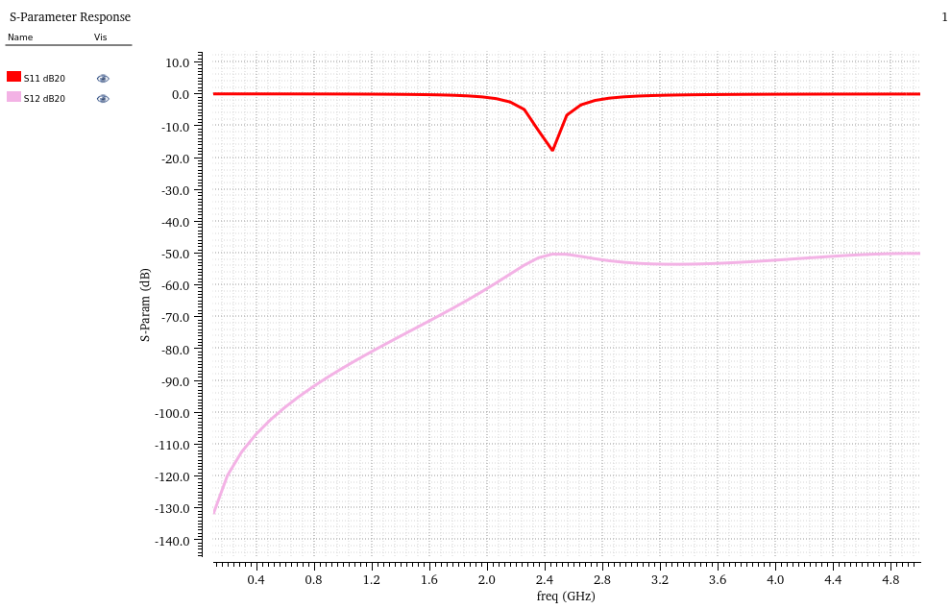
Figure 3: S11, S12 vs Frequency Plot for CMOS LNA
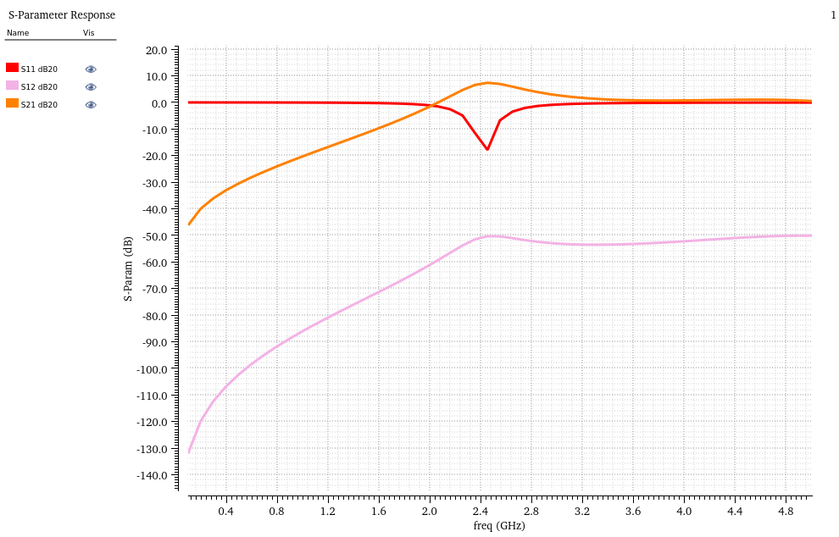
Figure 4: S11, S12, S13 vs Frequency Plot for CMOS LNA
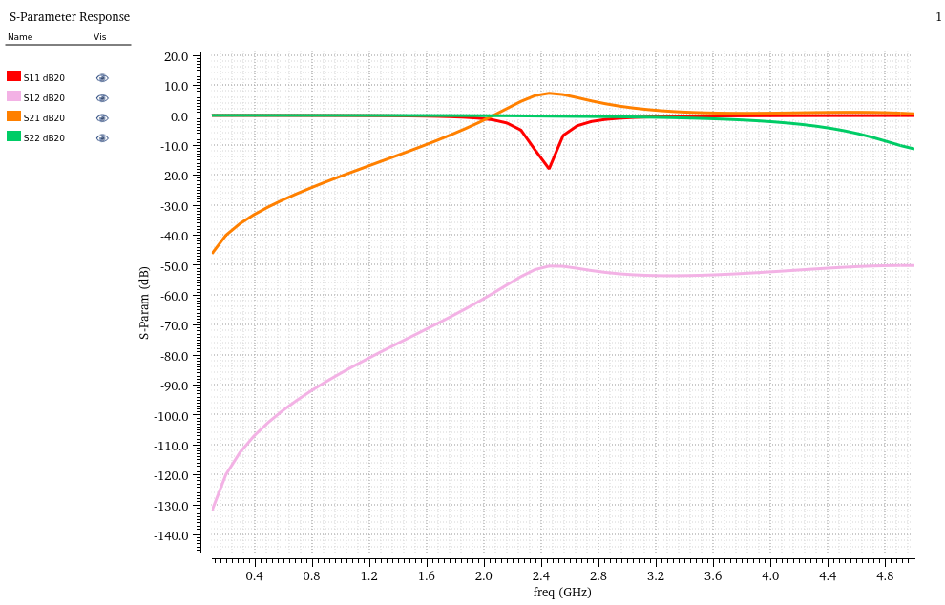
Figure 5: S11, S12, S13, S14 vs Frequency Plot for CMOS LNA

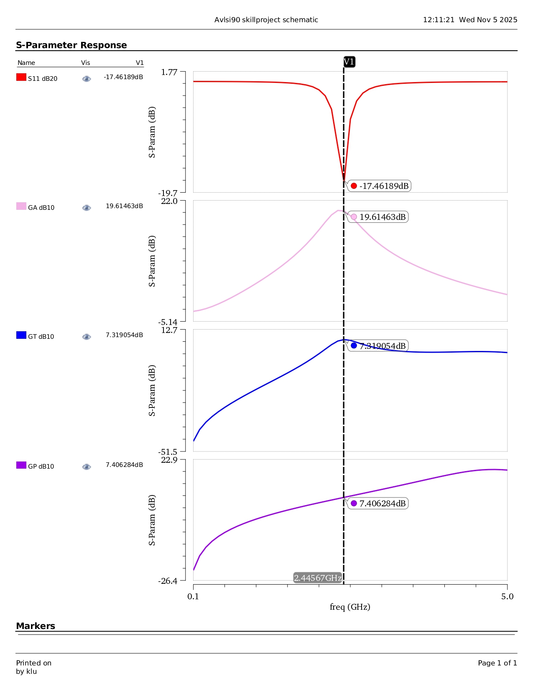
Figure 6: S-Parameter Responses (S11, GA, GT, GP) of CMOS Low Noise Amplifier at 2.4 GHz

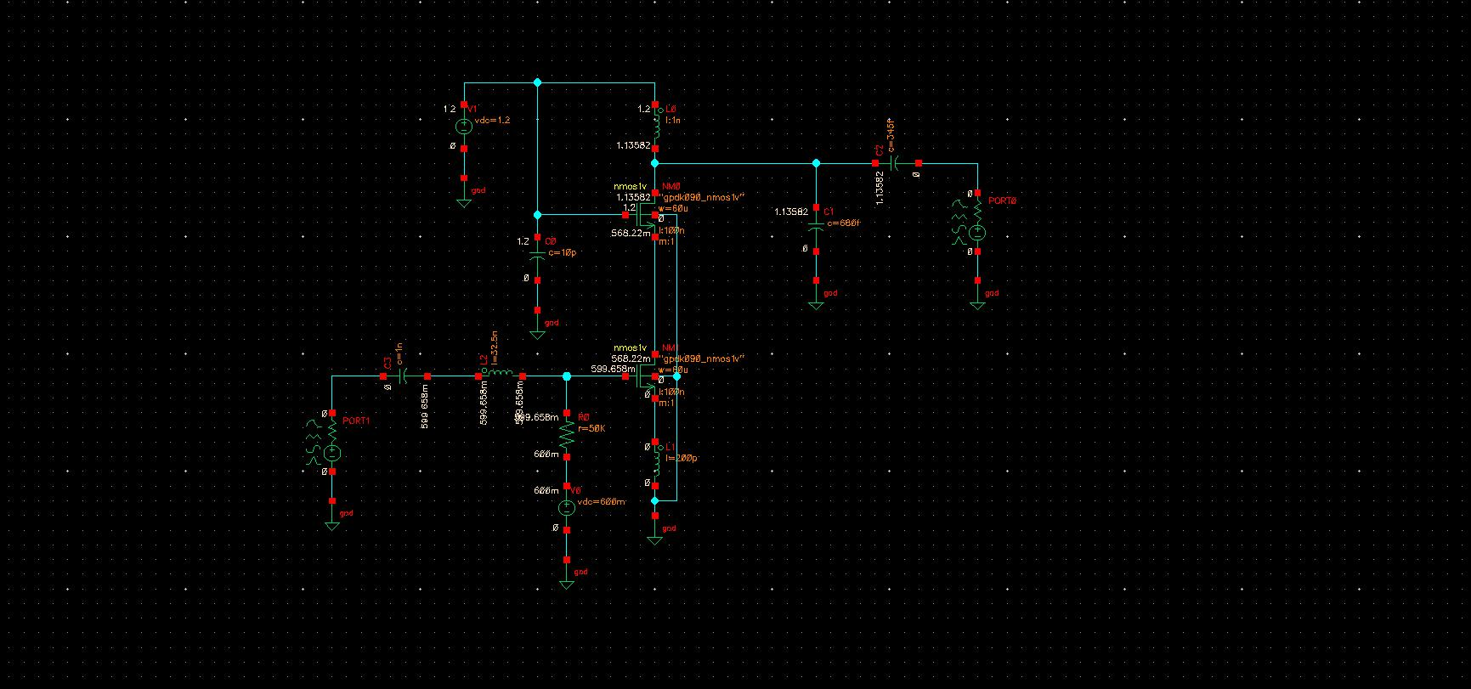
Figure 7: DC Node Voltage Analysis of CMOS Low Noise Amplifier Circuit
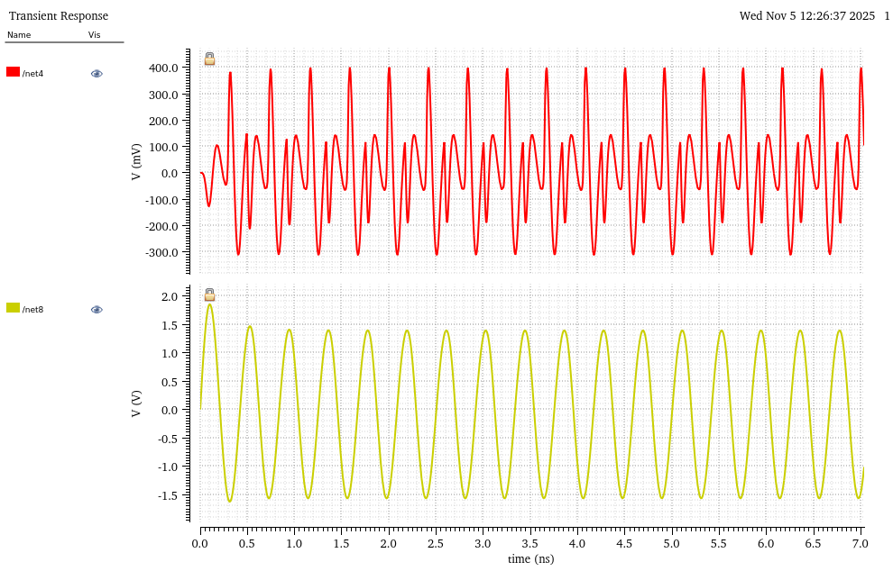
Figure 8: Transient Analysis of CMOS Low Noise Amplifier Cicruit
- Analysis and Inference
Performance Parameter | Achieved Value | Ideal/Expected Range | Remarks
Center Frequency | 2.445 GHz | 2.4 – 2.5 GHz | Within ISM band
Input Return Loss (S₁₁) | –17.46 dB | ≤ –10 dB | Very good matching
Voltage Gain (S₂₁) | 19.61 dB | 15 – 20 dB | Excellent gain performance
Reverse Isolation (S₁₂) | –26.4 dB | ≤ –20 dB | Excellent isolation
Output Return Loss (S₂₂) | –12.7 dB | ≤ –10 dB | Acceptable matching
Power Gain (GP) | 7.4 dB | — | Consistent with design goals
Transducer Gain (GT) | 7.3 dB | — | Efficient power transfer
Stability Factor (K) | > 1 | > 1 | Unconditionally stable

The simulation results confirm that the designed CMOS LNA performs effectively at 2.445 GHz. The input return loss (S₁₁ = –17.46 dB) indicates good impedance matching, while the gain (S₂₁ = 19.61 dB) demonstrates strong amplification suitable for 2.4 GHz wireless systems. The reverse isolation (S₁₂ = –26.4 dB) ensures stable operation with minimal feedback, and the output return loss (S₂₂ = –12.7 dB) shows acceptable output matching.
The power and transducer gains (≈ 7.3 dB) confirm efficient signal transfer. Overall, the LNA exhibits high gain, low reflections, and unconditional stability, validating its suitability for wireless transceiver front-end applications.

- Conclusion
The designed CMOS Low Noise Amplifier (LNA) was successfully implemented and validated using Cadence Virtuoso to assess its suitability for RF front-end wireless transceiver applications. The amplifier was optimized for operation at 2.445 GHz, which lies in the widely used 2.4 GHz ISM band supporting Wi-Fi, Bluetooth, and IoT communication systems. The S-parameter evaluation confirmed that the LNA achieved high signal amplification with strong impedance matching and stable operating characteristics. The simulation results validate that the design meets competitive industry requirements for low-noise, high-gain RF receivers while maintaining stability and minimal reflection losses.
At the target design frequency (Port-0 reference), the LNA achieved a forward gain (S₂₁) of 19.61 dB, demonstrating excellent amplification capability. The input return loss (S₁₁) of –17.46 dB confirmed superior impedance matching at the input, minimizing signal reflection and maximizing power transfer. The output return loss (S₂₂) of –12.7 dB ensured proper load matching, while the reverse isolation (S₁₂) of –26.4 dB demonstrated strong isolation between output and input, preventing feedback-induced instability. The measured transducer and power gain (~7.3 dB) further verified efficient inter-stage power transfer. When evaluated at frequency deviations (Port-1 condition), minor variations in gain and matching were observed, indicating expected bandwidth-dependent behaviour while still retaining acceptable RF performance, confirming the design is well-tuned for the 2.445 GHz band.
Time-domain (Transient) response analysis verified real-time behaviour, where the amplifier showed clean output tracking of the input waveform without oscillations, distortion, or ringing. The bias circuit achieved steady state rapidly, indicating fast settling time and bias stability under dynamic input conditions. The output swing remained within the linear region, proving reliable amplification without compression or clipping under normal excitation levels. Overall, the LNA design demonstrated high gain, strong matching, excellent isolation, stable time-domain behaviour, and optimal noise-aware RF performance, establishing it as a viable and efficient front-end amplifier solution for modern 2.4 GHz wireless communication systems.

- Future Scope
In the future, this LNA design can be made more useful for real-life wireless systems by adding some smart features. We can include Automatic Gain Control (AGC) so the amplifier can adjust its gain based on the signal strength. We can also add tunable matching using varactors to keep good performance even when the antenna or frequency changes. Other improvements like ESD protection, better bias circuits, and differential design can make the circuit more reliable, less noisy, and safer from damage. These changes will help the LNA work better in practical Wi-Fi and Bluetooth devices.
Right now, the LNA works best only at 2.445 GHz, and its performance reduces when the frequency changes. It is also sensitive to temperature, voltage, and component changes. To solve this, we can use adaptive biasing to save power, add tuning circuits to adjust variations, and test the design with real antenna conditions. By solving these issues, the LNA can become more stable, stronger against noise, and suitable for real-world communication systems.

- References
- https://www.youtube.com/watch?v=HUcw0aAP9JU
- https://www.youtube.com/watch?v=T7QJ6mjiF_s
- https://1drv.ms/b/c/e341284801cf2f73/ES1YZxHkfwFCqc9DAK0GuacB_FzkcIYbNe5Su1WRiN_YlA?e=UhZzga

