**Jenkins Master-Slave Architecture:**

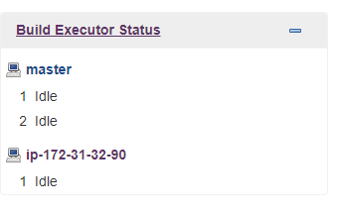

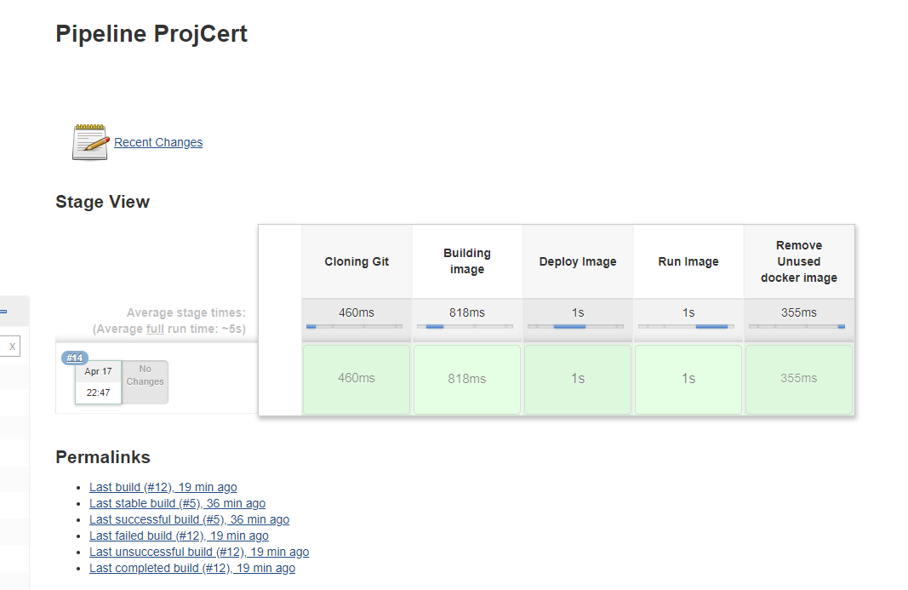

**Pipeline Log:**



**Docker Hub:**

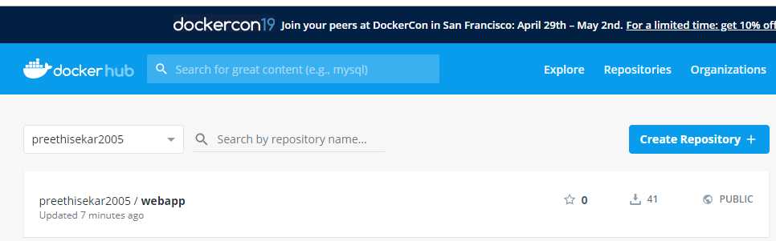

**Website:**

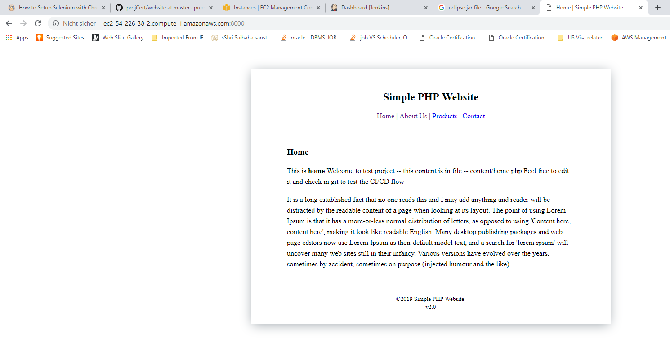

**Eclipse Output:**

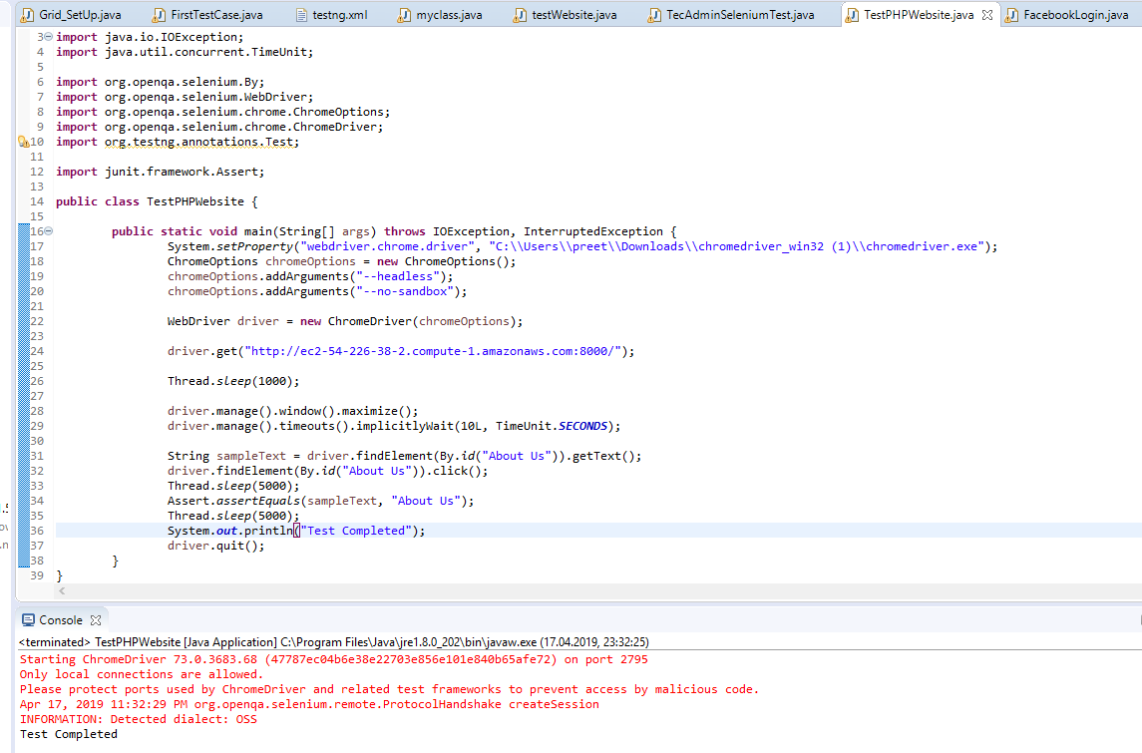

Project Related files present here: <https://github.com/preethivignesh/projCert.git>