Dr. AMBEDKAR INSTITUTE OF TECHNOLOGY
Near Jnana Bharathi Campus, Bengalore-560 056.
(An Autonomous Institution, Aided by Government of Karnataka)



Project Report

on
“POLICE STATION MANAGEMENT SYSTEM”

Submitted By
PREETHAM DP 1DA18CS116
PUNEETH SV 1DA18CS118

Under the Guidance Of

Mrs.Asha
Assoc.Prof, Dept of CSE
Dr. AIT

Department of Computer Science & Engineering
Year 2020-2021

Dr. AMBEDKAR INSTITUTE OF TECHNOLOGY
Near Jnana Bharathi Campus, Bengaluru-560 056.
(An Autonomous Institution, Aided by Government of Karnataka)

CERTIFICATE
This is to certify that the project entitled “Police Station Management System” submitted in the partial fulfillment of the requirement of the 5th semester DBA laboratory curriculum during the year 2020 is a result of bonafied work carried out by-

PREETHAM DP 1DA18CS116
PUNEETH SV 1DA18CS118

Signature of the guides:

________________________
Mrs.Asha
Assoc. Prof, Dept of CSE
Dr. AIT

Internal Examiner _____________

External Examiner _____________
Dr Siddaraju
HOD
Dept. Of CSE Dr.AIT

ACKNOWLEDGEMENT

The satisfaction that accompanies to this project would be incomplete without the mention of the people who made it possible, without whose constant guidance and encouragement would have made our efforts go in vain.

We consider ourselves privileged to express our gratitude and respect towards all those who guided us through the project, “Police Station Management System”.

We would like to express our gratitude to Dr. C Nanjunda Swamy, Principal,Dr. A.I.T., for providing us the congenial environment to work in.

We would like to express our profuse gratitude to Dr. Siddaraju, HOD, Dept. of Computer Science & Engineering, Dr. AIT, for giving us the support, encouragement and providing us the required lab facilities that was necessary for the completion of this project.
As a token of gratitude, we would like to acknowledge our sincere gratefulness to the internal guide Mrs.Asha , Assoc. Prof., Dept. of CSE, Dr.A.I.T., for her unlimited support and encouragement provided throughout the process.

We also express our gratitude and sincere thanks to all the teaching and non-teaching staff of Computer Science & Engineering Department.

Finally, yet importantly, we would like to express our heartfelt thanks to our beloved Parents for their blessings and our Friends for their help and wishes for the successful completion of this project report.

PREETHAM DP 1DA18CS116
PUNEETH SV 1DA18CS118

ABSTRACT

The police station management system is an application that allows all the paper work that are done in the police station to be stored in one single system with great ease. It can help in handling the records easier.
Sometimes if there is a need for some information of a particular criminal then you need to search in huge of files where that information is stored in those files. So that will involve in wastage of time and also effort.
So to overcome these problems, the police station management system can be useful. This will reduce a lot of pen paper work that is involved.
Talking about the features of the Police Station management system, the user can add various information of the criminals and police officers.
For that, the user has to provide convict’s id, name, age, gender, height, weight, crime, conviction etc and police data.
Apart from this, the user can view/check a list of the records and search. The user just has to provide convict id in order to search for a criminal’s record.

CONTENTS

Chapter No. | Title | Page No
Chapter 1 | Introduction | 06
Chapter 2 | Requirement Specification | 07
2.1 | Hardware Requirements | 07
2.2 | Software Requirements | 07
Chapter 3 | Description | 08
3.1 | SQL | 08
3.2 | Oracle | 08
3.3 | ER Diagram | 09
3.4 | Relational Schema | 12
Chapter 4 | Coding | 14
4.1 | Database | 14
4.2 | System Tools | 14
4.3 | Creation Of Tables | 14
4.4 | Insertion Of Tables | 17
4.5 | Queries | 20
Chapter 5 | Conclusion | 22
 | Bibliography | 22

Chapter-1

INTRODUCTION

The police management application can help in storing the records related to the criminals, cases, complaint record, case history and so on. This can allow a person to enter or delete the records if necessary. All these records can be maintained in a single database. Security is maintained so as to ensure that only the authorized users will have access to system. This application will be one of the useful projects that the police can rely on.
This application can help in getting the information of the criminals of many years back. It can also help in minimizing most of the work in police department.

It can store every information regarding police station management as follows:
Criminal record: This application can contain the details related to the criminals in the particular case.
Prisoner record: The details of the prisoner and his case related details can be stored in the database.
Police database management: The details of the police in the particular police station can be maintained through this application.

Chapter-2

Requirement Specification

The hardware and software components of a computer system that are required to install and use software efficiently are specified in the SRS. The minimum system requirements need to be met for the program to run at all times on the system.

2.1 Hardware Requirements:
The hardware requirements specify the necessary hardware which provides us the platform to implement our programs.
- Processor : Intel dual core i5 or above
- RAM : 8GB DDR4 RAM
- Hard drive space : 20GB
- Monitor :15.6’’ LED
- Keyboard : STANDARD

2.2 Software Requirements:
The software requirements specify the pre-installed software needed to run the code being implemented in this project.
- Operating System : Windows 10
- Back end Software : Oracle 10g Express Edition

Chapter-3
DESCRIPTION

A database management system (DBMS) is a collection of programs that enables users to create and maintain a database. The DBMS is a general-purpose software system that facilitates the processes of defining, constructing, manipulating, and sharing database among various users and applications. The database definition or descriptive information is also stored by the DBMS in the form of a database catalog or dictionary; it is called meta-data. Constructing the database is the of storing the data on some storage medium that is controlled by the DBMS. Manipulating a database includes functions such as querying the database to retrieve specific data, updating the database to reflect changes in the mini world, and generating reports from the data. Sharing a database allows multiple users and programs to access the database simultaneously.

3.1 SQL
SQL is a domain specific programming language designed for managing data held in a relational database management system (RDBMS), or for stream processing in a relational data stream management system (RDBMS). It is particularly useful in handling structured data, i.e data incorporating relations among entities and variables. Originally based upon relational algebra and tuple relational calculus, SQL consists of a data definition language, data manipulation language, and a data control language. The scope of SQL includes data insert, query, update and delete, schema creation and modification, and data access control. SQL stores each data item in its own fields. In SQL, the fields relating to a particular person, thing or event are bundled together to form a single complete unit of data called a record. Each record is made up of a number of fields. No two fields in a record can have the same field name.

3.2 ORACLE
An Oracle Database is a collection of data treated as a unit. The purpose of a database is to store and retrieve related information. A database server is the key to solving the problems of information management, In general, a server reliably manages a large amount of data in a multiuser environment so that many users can concurrently access the same data. All this is accomplished while delivering high performance. A database server also prevents unauthorized access and provides efficient solutions for failure recovery.

Oracle Database is the first database designed for enterprise grid computing, the most flexible and cost effective way to manage information and applications. Enterprise grid computing creates large pools of industry standard, modular storage and servers. With this architecture, each new system can be rapidly provisioned from the pool of components. There is no need for peak workloads, because capacity can be easily added or reallocated from the resource pools as needed.

Oracle 10g Express Edition

Oracle Database 10g Express edition(Oracle Database XE) is a free version of the world’s most capable relational database. Oracle Database XE is easy to install, easy to manage, and easy to develop with.
With Oracle Database XE, you use an intuitive, browser-based interface, to:
- Administer the database
- Create tables, views and other database objects
- Import, export, and view table data
- Run queries and SQL scripts
- Generate reports

3.3 ER Diagram
The Entity Relationship Model(ER model) describes interrelated things of interest in a specific domain of knowledge. A basic ER model is composed of entity types(which classify the things of interest)band specifies relationships that can exist between entities(instances of those entity types).

An ER model is usually the result of systematic analysis to define and describe what is important to processes in an area of a business. It does not define the business data schema in graphical form as boxes(entities) that are connected by lines (relationships) which express the associations and dependencies between entities. An ER model can also be expressed in a verbal form.

Entities may be characterized not only by relationships, but also by additional properties(attributes), which include identifiers called "primary keys". Diagrams created to represent attributes as well as entities and relationships may be called entity-attribute relationship diagram rather than Entity-Relationship models.

An ER model is typically implemented as a database. In a simple relational database implementation, each row of a table represents one instance of an entity type, and each field in a table represents an attribute type. In a relational database a relationship between entities is implemented by storing the primary key of one entity as a pointer or "foreign key" in the table of another entity.

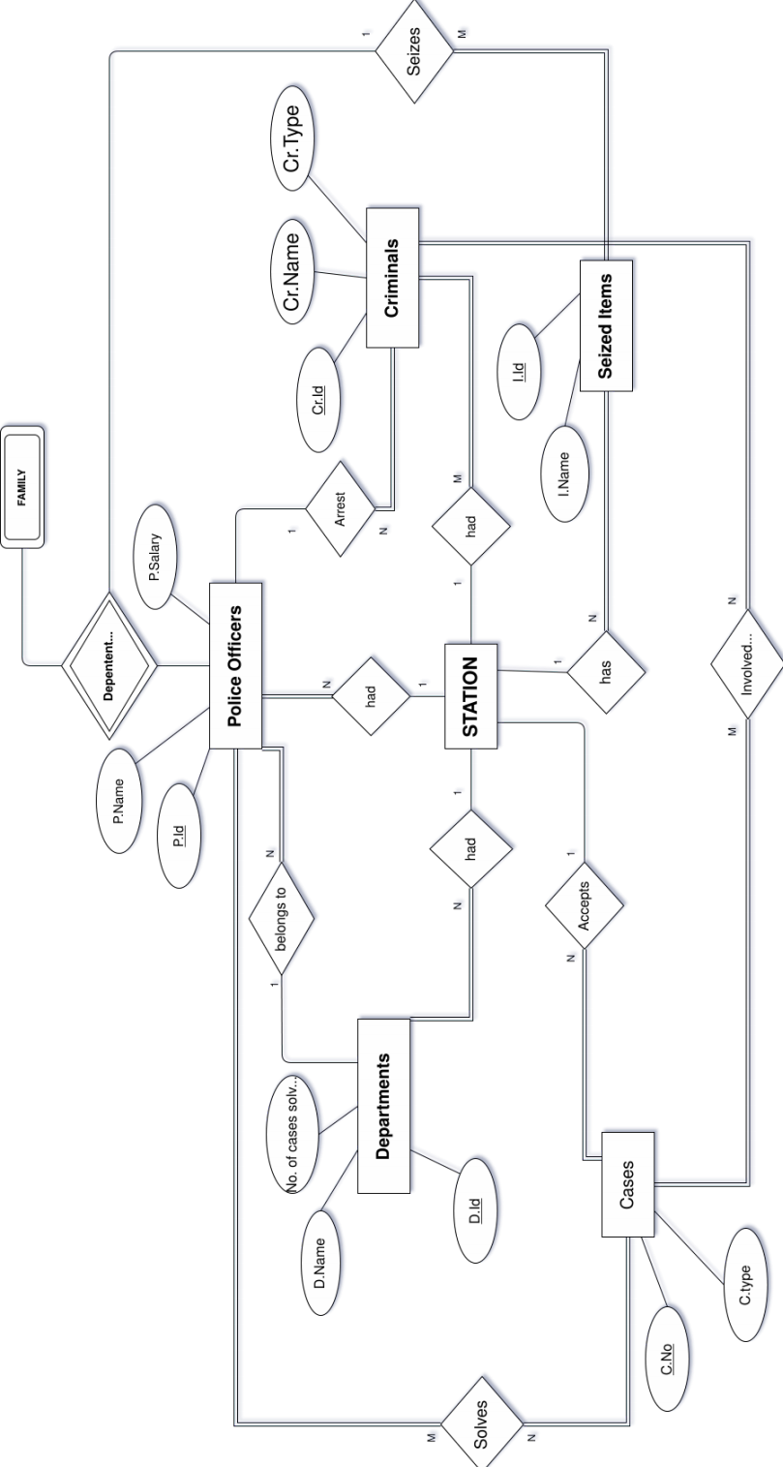
Fig 1

ER Diagram of Police Station Management System

3.4 Relational Schema

A relational database schema is the tables, columns and relationships that make up a relational database. A relational database schema helps you to organize and understand the structure of a database. A relational database schema helps you to organize and understand the structure of a database. This is particularly useful when designing a new database, modifying an existing database to support more functionality ,or building integration between databases. There are two steps to creating a relational database schema: creating the logical schema and creating the physical schema. The logical schema depicts the structure of the database, showing the tables, columns and relationships with other tables in the database and can be created with modeling tools or spreadsheet and drawing software. The physical schema is created by actually generating the tables, columns and relationships in the relational database management software (RDMS).

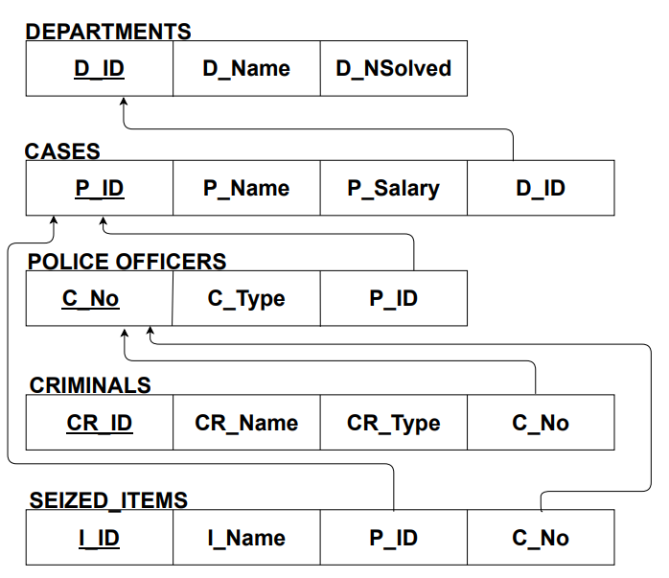

Fig 2

RELATIONAL SCHEMA DIAGRAM FOR THE DATBASE

Chapter-4
CODING

4.1 DATABASE:
DATABASE DESIGN : Databases are the storehouses of data used in the software systems. The data is stored in tables inside the database. Several tables are created for the manipulation of the data for the system. Two essential settings for a database are

- Primary key - the field that is unique for all the record occurrences.

- Foreign key - the field used to set relation between tables. Normalization is a technique to avoid redundancy in the tables.
4.2 SYSTEM TOOLS
The various system tools that have been used in developing back end of the project are being discussed in this chapter.

Back end
The back end is implemented using Oracle 10g Express Edition which is used to design the databases.

4.3 CREATION OF TABLES

- Creating Departments table:
CREATE TABLE DEPARTMENTS (
D_ID NUMBER (10),
D_NAME VARCHAR (30),
D_NSOLVED NUMBER (10),
PRIMARY KEY(D_ID));

DESC DEPARTMENTS;

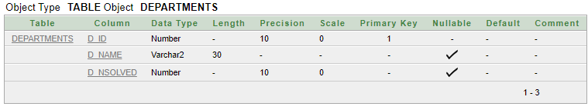

- Creating Police officers table

CREATE TABLE POLICEOFFICERS (
P_ID NUMBER (10),
P_NAME VARCHAR (30),
P_SALARY NUMBER (6),
D_ID NUMBER (10),
PRIMARY KEY(P_ID),
FOREIGN KEY(D_ID) REFERENCES DEPARTMENTS(D_ID));

DESC POLICEOFFICERS;

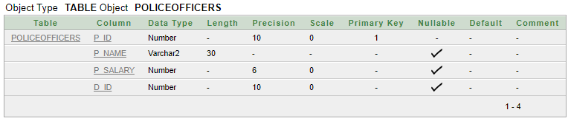

- Creating Cases table:
CREATE TABLE CASES (
C_NO NUMBER (10),
C_TYPE CHAR (20),
P_ID NUMBER (10),
PRIMARY KEY(C_NO),
FOREIGN KEY(P_ID) REFERENCES POLICEOFFICERS(P_ID));

DESC CASES;

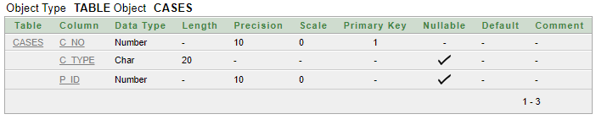

- Creating Criminals table:
CREATE TABLE CRIMINALS (
CR_ID NUMBER (10),
CR_NAME VARCHAR (30),
CR_TYPE VARCHAR (15),
C_NO NUMBER (10),
PRIMARY KEY(CR_ID),
FOREIGN KEY(C_NO) REFERENCES CASES(C_NO));

DESC CRIMINALS;

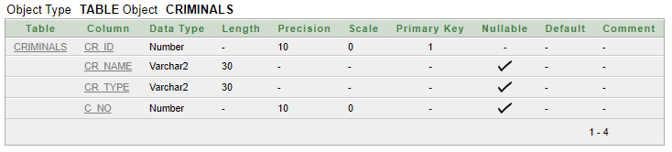

- Creating Seized Items table:
CREATE TABLE SEIZEDITEMS (
I_ID NUMBER (10),
I_NAME VARCHAR (30),
P_ID NUMBER (10),
C_NO NUMBER (10),
PRIMARY KEY(I_ID),
FOREIGN KEY(P_ID) REFERENCES POLICEOFFICERS(P_ID),
FOREIGN KEY(C_NO) REFERENCES CASES(C_NO));

DESC SEIZEDITEMS;

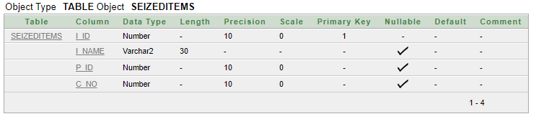

4.4 Insertion Of Tables:
A) Inserting values to Departmrnts table:

INSERT INTO DEPARTMENTS VALUES
(001,'CIVIL',58);
INSERT INTO DEPARTMENTS VALUES (
002,'TRAFFIC',153);
INSERT INTO DEPARTMENTS VALUES (
003,'GUARD',44);
INSERT INTO DEPARTMENTS VALUES (
004,'CRIME INVESTIGATION',287);
INSERT INTO DEPARTMENTS VALUES (
005,'CYBER',178);

SELECT * FROM DEPARTMENTS;
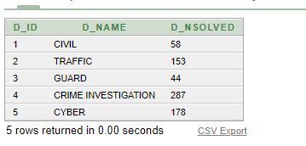

b) Inserting values to Police officers table:

INSERT INTO POLICEOFFICERS VALUES
(3466,'SKANDA AGNI',60000,001);
INSERT INTO POLICEOFFICERS VALUES
(4893,'TEJESWINI',50000,002);
INSERT INTO POLICEOFFICERS VALUES
(2637,'DHEERAJ',70000,003);
INSERT INTO POLICEOFFICERS VALUES
(9373,'RANGANATH',50000,004);

SELECT * FROM POLICEOFFICERS;
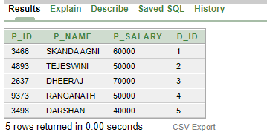
c) Inserting values to Cases table:
INSERT INTO CASES VALUES (
100,'HARASSMENT',3466);
INSERT INTO CASES VALUES (
110,'NO PARKING',4893);
INSERT INTO CASES VALUES (
153,'SECURITY',2637);
INSERT INTO CASES VALUES (
176,'MURDER',9373);
INSERT INTO CASES VALUES (
162,'CYBER CRIME',3498);

SELECT * FROM CASES;
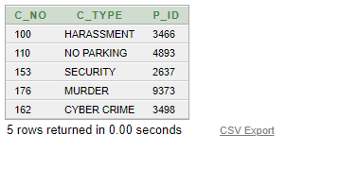

d) Inserting values to Criminals table:
INSERT INTO CRIMINALS VALUES
(420,'SPARSHA','MENTAL HARASSMENT',100);
INSERT INTO CRIMINALS VALUES
(840,'SANJAY','HIT AND RUN',110);
INSERT INTO CRIMINALS VALUES
(230,'VISHAL','THIEF',100);
INSERT INTO CRIMINALS VALUES
(380,'SHYAMANTH','TRESPASSING',153);
INSERT INTO CRIMINALS VALUES
(440,'BHARTHA','MURDER',176);
INSERT INTO CRIMINALS VALUES
(580,'BHUVAN','PHISHING',162);
INSERT INTO CRIMINALS VALUES
(581,'PRAJWAL','ACCIDENT',110);

SELECT * FROM CRIMINALS;

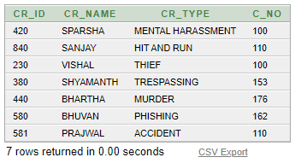

e) Inserting values to Seized Items table:
INSERT INTO SEIZEDITEMS VALUES
(45,'HARD DISK',3466,'100');
INSERT INTO SEIZEDITEMS VALUES
(46,'BIKE',4893,'110');
INSERT INTO SEIZEDITEMS VALUES
(47,'PHONE',2637,'153');
INSERT INTO SEIZEDITEMS VALUES
(48,'KNIFE',9373,'176');
INSERT INTO SEIZEDITEMS VALUES
(49,'LAPTOP',3498,'162');

SELECT * FROM SEIZEDITEMS;
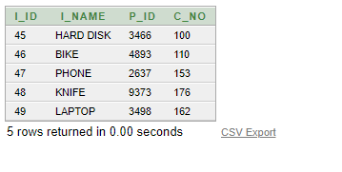

4.5 QUERIES

1) LIST THE ITEMS SEIZED FROM THE PLICEOFFICER =’SKANDA AGNI’
SELECT I_NAME FROM SEIZEDITEMS
WHERE C_NO IN (SELECT C_NO FROM CASES
WHERE P_ID IN (SELECT P_ID FROM POLICEOFFICERS WHERE P_NAME = 'SKANDA AGNI'));

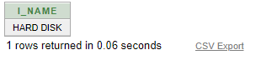

2)List the criminals name solved by the police officers Tejeswini

SELECT CR_NAME FROM CRIMINALS WHERE C_NO IN
(SELECT C_NO FROM CASES WHERE P_ID IN (SELECT P_ID FROM POLICEOFFICERS WHERE P_NAME='TEJESWINI'));

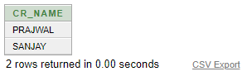

3)List the criminals name in civil department

SELECT CR_NAME FROM CRIMINALS WHERE C_NO=100;
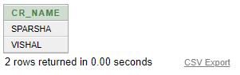

4)List the police officers name from traffic, guard, crime investigation department
SELECT P.P_NAME,D.D_NAME FROM POLICEOFFICERS P,DEPARTMENTS D WHERE P.D_ID = D.D_ID AND D.D_ID BETWEEN 2 AND 5;
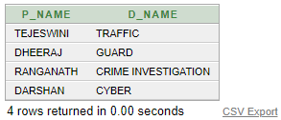

5)List the seized items used by criminals
SELECT I_NAME,C.CR_NAME FROM SEIZEDITEMS S,CRIMINALS C WHERE S.C_NO=C.C_NO;
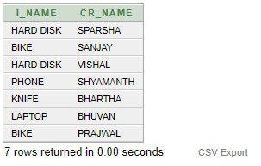

6)Display the average salary of all policemen

SELECT AVG(P_SALARY) AS AVERAGE FROM POLICEOFFICERS;
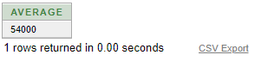

Chapter-5
Conclusion

The Police system management system for computerizing the database. This is capable to provide easy and effective storage of information related criminals and police data. It also include to modify data. With these, the objectives of the system design will be achieved.
In comparison with manual system the benefits under this system are considerable in the saving of man power working hours and effort.

The project can be used to make better management of the database. The user gets timely information system.

BIBLIOGRAPHY:
Few of the books and websites that were instrumental in helping us to complete this project are as mentioned below

Book:
- Fundamental of Database System by Elmasri and Navathe,5th edition,Addison-Wesley,2007

Websites:
www.google.com
www.youtube.com
www.wikipedia.com

