DEFENCE INSTITUTE OF ADVANCED TECHNOLOGY
(DEEMED TO BE UNIVERSITY)


ASSIGNMENT ON

Quadcopter Altitude, Attitude and Position Control Using PID/PD Controllers
NAME | : | PREETI
REGISTRATION NO. | : | 25-06-30
SUBJECT | : | AERIAL ROBOTICS
SUBJECT CODE | : | SR612
COURSE | : | AUTOMATION AND ROBOTICS
DEPARTMENT | : | AEROSPACE ENGINEERING AND AUTONOMOUS SYSTEM
SUBMITTED TO DR. POOJA AGRAWAL

Assignment Report
This report presents the modeling, simulation, and control of a quadcopter using a cascaded PID/PD controller implemented in Python. The work is based on Section IV (PID Controller and Simulation Results) of the paper by Ismat Meslouli et al.

1. Introduction

Control Diagram:

Controller Architecture:
• Altitude loop: PID
• Position x-y loop: PD
• Roll, Pitch, Yaw loops: PID structure with Ki = 0 (effectively PD)

2. Mathematics and Methodology
The translational and rotational equations were adopted from the reference paper.
Altitude dynamics:
z̈ = (cosφ cosθ U1)/m − g
Rotational dynamics:
φ̈ = U2 / Ixx
θ̈ = U3 / Iyy
ψ̈ = U4 / Izz
PID control law:
U(t) = Kp e(t) + Ki ∫e(t)dt + Kd de(t)/dt
Position control law:
ax_des = Kp_pos (x_ref − x) − Kd_pos x_dot
ay_des = Kp_pos (y_ref − y) − Kd_pos y_dot
Small-angle conversion:
θ_ref ≈ ax_des / g
φ_ref ≈ − ay_des / g
Translational model with damping:
ẍ = g θ − k_drag x_dot
ÿ = − g φ − k_drag y_dot
Quadcopter parameters used (from Table I of the paper):
• Mass m: 1.62 kg
• Gravity g: 9.81 m/s²
• Arm length l: 0.25 m
• Ixx: 3.3 × 10⁻³ kg·m²
• Iyy: 3.3 × 10⁻³ kg·m²
• Izz: 3.3 × 10⁻³ kg·m²

Actuator Saturation:
To prevent unrealistic control signals, all controller outputs were limited using np.clip(). Examples include U1 limited to [0, 2mg] and desired roll/pitch limited to ±0.2 rad.

Anti-Windup:
The integral term in the PID controller was limited to a predefined range using np.clip(). This prevents integral windup when the actuator saturates.

Problems Encountered:
Initial simulations produced numerical overflow because the controller outputs were not saturated and the altitude integral term accumulated excessively. After adding saturation and anti-windup, the simulation became stable.

3. Code Flowchart
- Start
- Initialize parameters and PID controllers
- Read user references (x_ref, y_ref, z_ref, ψ_ref)
- For each time step:
  - Compute x-y position errors
  - Compute desired accelerations (PD)
  - Convert accelerations to φ_ref and θ_ref
  - Compute altitude PID output → U1
  - Compute attitude control outputs → U2, U3, U4
  - Apply saturation limits
  - Update nonlinear dynamics
  - Integrate states
  - Store data
- Plot results
- End

4. Code
The complete Python implementation used for this assignment is provided below.
import numpy as np
import matplotlib.pyplot as plt

# 1. QUADCOPTER PARAMETERS (Table I from the paper)
m = 1.62
g = 9.81
l = 0.25

Ixx = 3.3e-3
Iyy = 3.3e-3
Izz = 3.3e-3

# 2. PID CONTROLLER CLASS
class PID:
def __init__(self, kp, ki, kd, integral_limit=10.0, output_limit=None):
self.kp = kp
self.ki = ki
self.kd = kd

self.integral = 0.0
self.prev_error = 0.0

self.integral_limit = integral_limit
self.output_limit = output_limit

def update(self, error, dt):
# Integral term with anti-windup
self.integral += error * dt
self.integral = np.clip(
self.integral, -self.integral_limit, self.integral_limit
)

# Derivative term
derivative = (error - self.prev_error) / dt
self.prev_error = error

# PID equation
output = self.kp * error + self.ki * self.integral + self.kd * derivative

# Saturate controller output
if self.output_limit is not None:
output = np.clip(output, -self.output_limit, self.output_limit)

return output

# 3. PID GAINS
# Altitude controller
pid_yaw = PID(kp=0.02, ki=0.0, kd=0.01, integral_limit=1, output_limit=0.01)

# Attitude controllers
pid_z = PID(kp=3.0, ki=0.5, kd=2.0, integral_limit=20, output_limit=10)

pid_roll = PID(kp=0.05, ki=0.0, kd=0.02, integral_limit=1, output_limit=0.02)

pid_pitch = PID(kp=0.05, ki=0.0, kd=0.02, integral_limit=1, output_limit=0.02)

# Outer-loop position controllers
pid_x = PID(
kp=0.8,
ki=0.0,
kd=0.4,
integral_limit=10,
output_limit=3.0, # max acceleration (m/s^2)
)

pid_y = PID(kp=0.8, ki=0.0, kd=0.4, integral_limit=10, output_limit=3.0)
# 4. SIMULATION SETTINGS
dt = 0.01
T = 120
N = int(T / dt)
time = np.linspace(0, T, N)

# 5. STATE VARIABLES
# Altitude states
z = 0.0 # Position (m)
z_dot = 0.0 # Velocity (m/s)

# Attitude states
phi = 0.0 # Roll angle (rad)
theta = 0.0 # Pitch angle (rad)
psi = 0.0 # Yaw angle (rad)

# Horizontal positions
x = 0.0
y = 0.0

# Horizontal velocities
x_dot = 0.0
y_dot = 0.0

# Angular velocities
phi_dot = 0.0
theta_dot = 0.0
psi_dot = 0.0

# 6. DESIRED REFERENCES
z_ref = float(input("Enter desired altitude: "))
x_ref = float(input("Enter desired x position (m): "))
y_ref = float(input("Enter desired y position (m): "))

psi_ref = float(input("Enter desired yaw (rad): "))

# Safety limits on references
psi_ref = np.clip(psi_ref, -np.pi, np.pi)

# 7. DATA STORAGE FOR PLOTS
z_hist = []
phi_hist = []
theta_hist = []
psi_hist = []
x_hist = []
y_hist = []

# 8. MAIN SIMULATION LOOP
for t in time:
# POSITION CONTROL (x, y)

# Position errors
error_x = x_ref - x
error_y = y_ref - y

# PD gains for position control
Kp_pos = 0.08 # position gain
Kd_pos = 0.60 # velocity damping gain

# Desired accelerations
ax_des = Kp_pos * error_x - Kd_pos * x_dot
ay_des = Kp_pos * error_y - Kd_pos * y_dot

# Limit desired accelerations
ax_des = np.clip(ax_des, -1.0, 1.0)
ay_des = np.clip(ay_des, -1.0, 1.0)

# Convert desired accelerations to roll/pitch
# Small-angle approximation:
# theta ≈ ax/g
# phi ≈ -ay/g
theta_ref = ax_des / g
phi_ref = -ay_des / g

# Limit desired angles
phi_ref = np.clip(phi_ref, -0.2, 0.2)
theta_ref = np.clip(theta_ref, -0.2, 0.2)

#.....
# ALTITUDE CONTROLLER
error_z = z_ref - z
u_z = pid_z.update(error_z, dt)

# Hover thrust + correction
U1 = m * g + u_z

# Thrust saturation
U1 = np.clip(U1, 0.0, 2.0 * m * g)

# ATTITUDE CONTROLLERS
error_phi = phi_ref - phi
error_theta = theta_ref - theta
error_psi = psi_ref - psi

U2 = pid_roll.update(error_phi, dt)
U3 = pid_pitch.update(error_theta, dt)
U4 = pid_yaw.update(error_psi, dt)

# ROTATIONAL DYNAMICS
phi_ddot = U2 / Ixx
theta_ddot = U3 / Iyy
psi_ddot = U4 / Izz

# ALTITUDE DYNAMICS
# Prevent NaNs if angles become invalid
if np.isfinite(phi) and np.isfinite(theta):
z_ddot = np.cos(phi) * np.cos(theta) * U1 / m - g
else:
z_ddot = 0.0

# INTEGRATION
z_dot += z_ddot * dt
z += z_dot * dt

phi_dot += phi_ddot * dt
phi += phi_dot * dt

theta_dot += theta_ddot * dt
theta += theta_dot * dt

psi_dot += psi_ddot * dt
psi += psi_dot * dt

# ANGLE LIMITS
phi = np.clip(phi, -np.pi, np.pi)
theta = np.clip(theta, -np.pi / 2, np.pi / 2)
psi = np.clip(psi, -np.pi, np.pi)

# Simple translational model with damping
k_drag = 0.8

x_ddot = g * theta - k_drag * x_dot
y_ddot = -g * phi - k_drag * y_dot

# Integrate
x_dot += x_ddot * dt
y_dot += y_ddot * dt

x += x_dot * dt
y += y_dot * dt

# SAVE DATA
z_hist.append(z)
phi_hist.append(phi)
theta_hist.append(theta)
psi_hist.append(psi)
x_hist.append(x)
y_hist.append(y)

# 9. PLOTTING RESULTS
plt.figure(figsize=(12, 8))

# Altitude
plt.subplot(3, 2, 1)
plt.plot(time, z_hist, label="z")
plt.axhline(z_ref, color="r", linestyle="--", label="z_ref")
plt.title("Altitude Response")
plt.xlabel("Time (s)")
plt.ylabel("z (m)")
plt.grid()
plt.legend()

# Roll
plt.subplot(3, 2, 2)
plt.plot(time, phi_hist, label="phi")
plt.axhline(phi_ref, color="r", linestyle="--")
plt.title("Roll Response")
plt.xlabel("Time (s)")
plt.ylabel("phi (rad)")
plt.grid()

# Pitch
plt.subplot(3, 2, 3)
plt.plot(time, theta_hist, label="theta")
plt.axhline(theta_ref, color="r", linestyle="--")
plt.title("Pitch Response")
plt.xlabel("Time (s)")
plt.ylabel("theta (rad)")
plt.grid()

# Yaw
plt.subplot(3, 2, 4)
plt.plot(time, psi_hist, label="psi")
plt.axhline(psi_ref, color="r", linestyle="--")
plt.title("Yaw Response")
plt.xlabel("Time (s)")
plt.ylabel("psi (rad)")
plt.grid()

# Position x
plt.subplot(3, 2, 5)
plt.plot(time, x_hist, label="x")
plt.axhline(x_ref, color="r", linestyle="--")
plt.title("Position x Response")
plt.xlabel("Time (s)")
plt.ylabel("x (m)")
plt.grid()

# Position y
plt.subplot(3, 2, 6)
plt.plot(time, y_hist, label="y")
plt.axhline(y_ref, color="r", linestyle="--")
plt.title("Position y Response")
plt.xlabel("Time (s)")
plt.ylabel("y (m)")
plt.grid()

plt.tight_layout()
plt.show()

5. Output
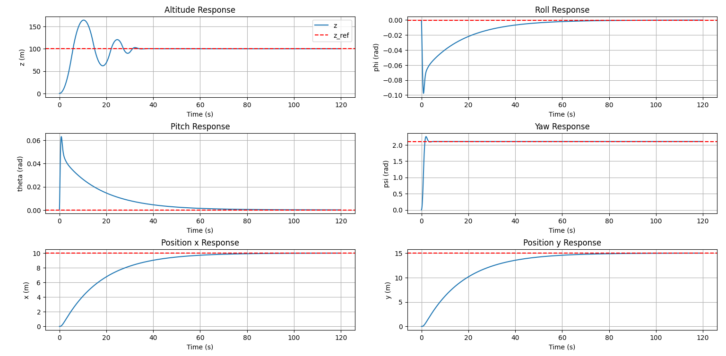

5. References
- Ismat Meslouli, Riad Mesli, Mouad Kahouadji, Amal Choukchou-Braham, and Brahim Cherki, "Quadrotor Design Procedure and PID Control for Outdoor Free Flight," 2017.
- Python libraries used: NumPy and Matplotlib.

