# **1.Complex SQL Query 1 | Derive Points table for ICC tournament**

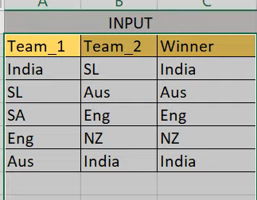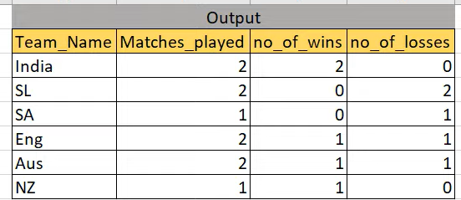

create table icc_world_cup

(

Team_1 Varchar(20),

Team_2 Varchar(20),

Winner Varchar(20)

);

INSERT INTO icc_world_cup values('India','SL','India');

INSERT INTO icc_world_cup values('SL','Aus','Aus');

INSERT INTO icc_world_cup values('SA','Eng','Eng');

INSERT INTO icc_world_cup values('Eng','NZ','NZ');

INSERT INTO icc_world_cup values('Aus','India','India');

select * from icc_world_cup;

**sol-**

select team_name , count(1), sum(win_flag) as no_of_won_matches,

count(1) - sum(win_flag) as no_of_loss_matches

FROM

(

select team_1 as team_name,

case when team_1 = winner then 1 else 0 end as win_flag

from icc_world_cup

group by team_name

union all

select

team_2 as team_name,

case when team_2 = winner then 1 else 0 end as win_flag

from icc_world_cup)

group by team_name