**Hostel Room Allocation**

**System Report**

**NAME: PREETI RACHEL JASPER**

**REG NO: 17BCS0003**

**INTRODUCTION:**

Hostel Room allocation system is a web application which aims at computerization of current procedure of allocating hostel rooms. Currently the process involves students filling up the forms and submitting them in respective hostel offices which involves a lot of paperwork, hence less efficient !

**Types of Users**

1. Student

2. Hostel Manager

3. Admin

**Objective**

● To deal with Hostel Management System in an easy and an

efficient manner.

● Create strong and secrete database that allow for any connection in

a secret way, to prevent any outside or inside attacks.

**Scope of the Project**

● Hostel Management System is designed for Hostel (like schools,

Universities).

● There will be predefined criteria for the Reservation to the hostels.

● He/She checks the attested application forms of the students obtained

from the internet and verify it with the student database.

● If the students are found eligible then they are allotted to the hostel

Room.

**Overview of Project**

Hostel Room Allocation System is a web application which aims at

computerization of current procedure of allocating hostel rooms. Currently the process involves students filling up the forms and submitting them in respective hostel offices which involves a lot of paperwork, hence less efficient.

The Web Application has two main parts:

1) Hostel Administrators

2) Students

The student can select among the allocated hostel to a specified batch and the

Hostel Administrator can assign the room number in the specific hostel that the

student has selected upon the availability.

**User Requirements Definition**

The user requirement for this system is to make the system fast, flexible, less

prone to error, reduce expenses and save the time.

1. Less human error

2. Strength and strain of manual labor can be reduced

3. High security

4. Data redundancy can be avoided to some extent

5. Data consistency

6. Easy to handle

7. Easy data updating

8. Easy record keeping

9. Backup data can be easily generated.

**Functional System Requirement**

This section gives a functional requirement that applicable to the HMS.

These are sub modules in this phase.

● Administrator module.

● User Module

● Application Module

The functionality of each module is as follows:

● Administrator module:

The Administrator can :

1. Allot different students to the different hostels.

2. Vacate the students from the hostels.

3. Edit the details of the students & modify the student records.

● User module:

1. Can submit the application form

2. Can view the notice board

3. Can submit the vacating form.

● Application module:

This section provides a form to the students which can be filled by them,

and a copy of the filled page can be taken in the printed form. This is later

submitted to the Hostel authorities can be verified by them before allotting

them to the respective hostels Rooms.

**Some Performance requirements identified is listed below:**

1. The database shall be able to accommodate around thousand

records to store.

2. The software shall support use of multiple users at a time.

**Safety Requirements**

The database may get crashed at any certain time due to virus or

operating system failure. Therefore, it is required to take the database

**Security Requirements**

Some of the factors that are identified to protect the software from

accidental or malicious access, use, modification, destruction, or

disclosure are described below. Keep specific log or history data sets

1. Assign certain functions to different modules

2. Restrict communications between some areas of the program

3. Check data integrity for critical variables

4. Later version of the software will incorporate encryption

5. techniques in the user/license authentication process.

5. Hardware Requirements

● Processor: Pentium or greater

● RAM: 512MB

● Hard Disk: Depends on how much data is stored in DATABASE (min 1GB)

● Keyboard

● Monitor

6. Software Requirements

● OS: Linux

● Database: SQL

**RESULT:**

**Login Page**

If and only if the user exists in DB and password entered is correct, he/she will be able to

login, otherwise appropriate error message is displayed.

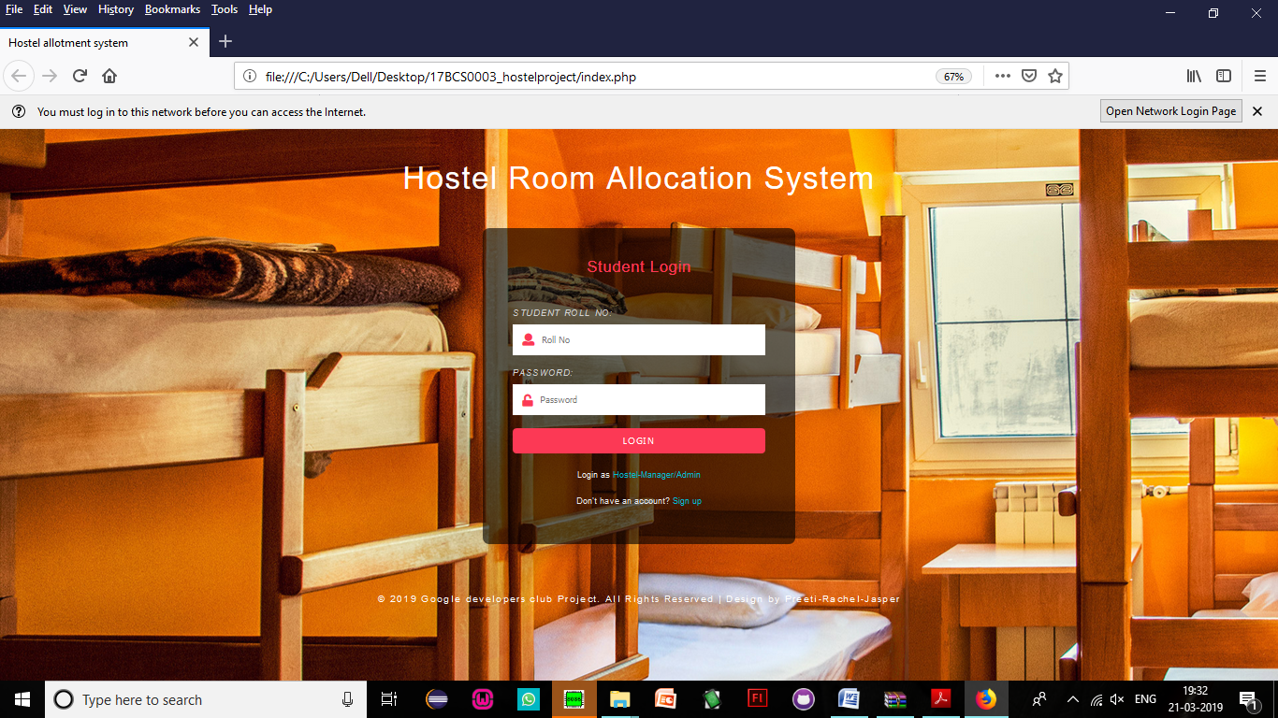

**Sign Up Page**

● Students who are not a part of the portalcan register themselves here.

● Hostel Manager cannot sign up, he/shecan only login. Hostel manager can only

be created by Admin!

● All the necessary error conditions arechecked.(like if a user with the entered roll

number already exists).

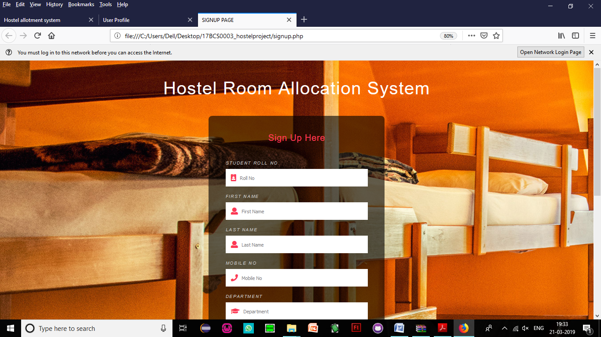

**Application Form**

● Student Should enter password to confirm

● If the student is already allocated room, he won’t be allowed to submit any application forms.

There are 3 different home pages

1. User Homepage

2. Hostel Manager Homepage

3. Admin Homepage

The homepage basically cointains a navigation bar which takes the user to different pages to

perform different activities.

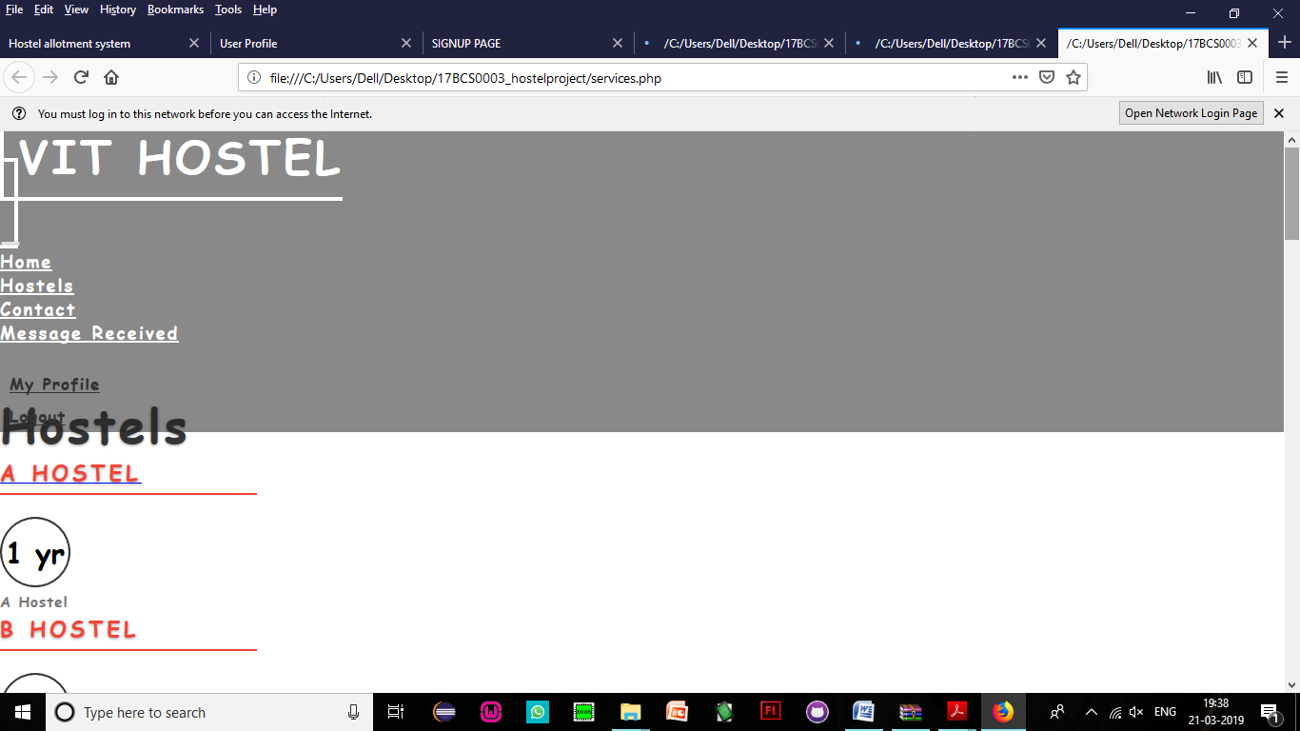

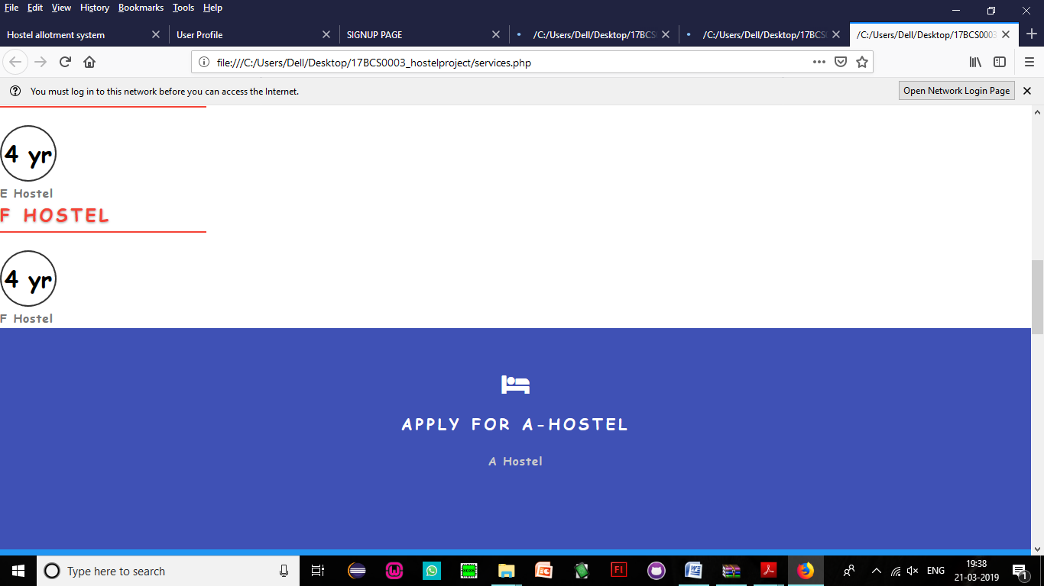

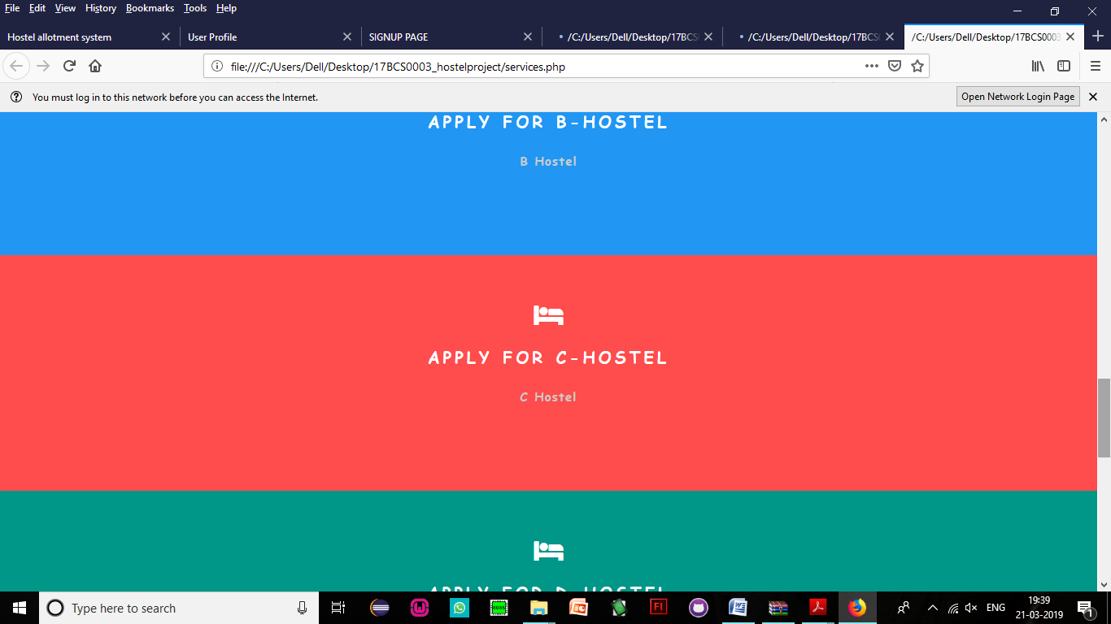

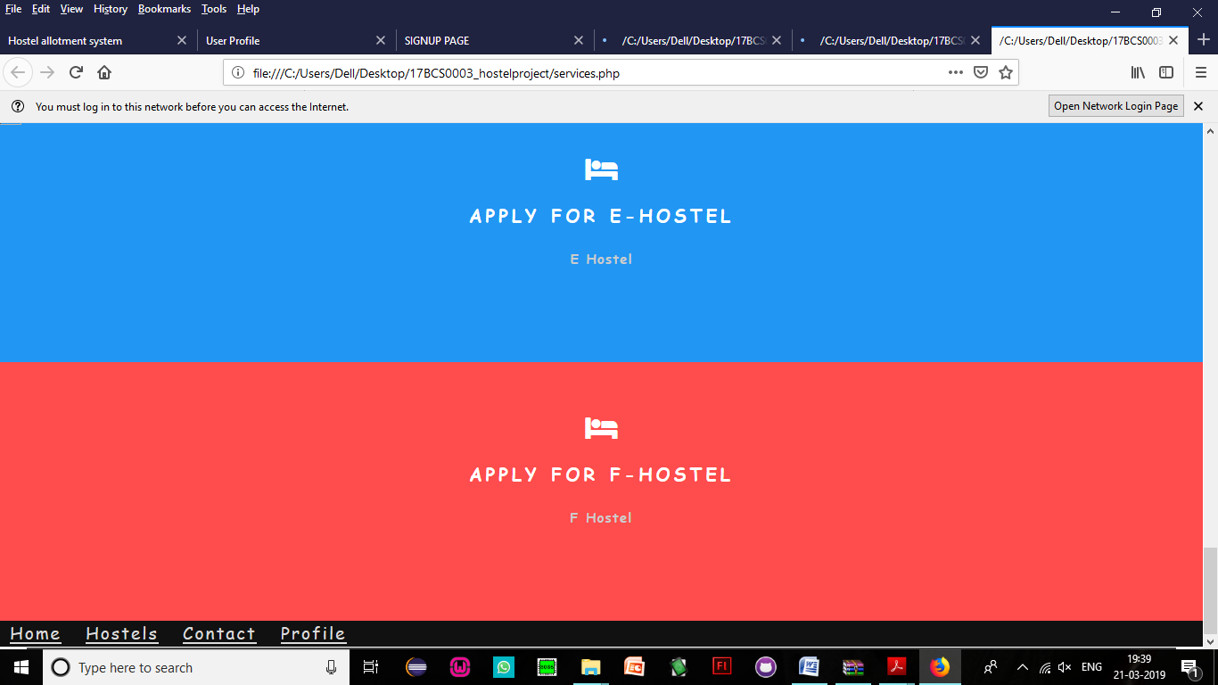

**User interface:**

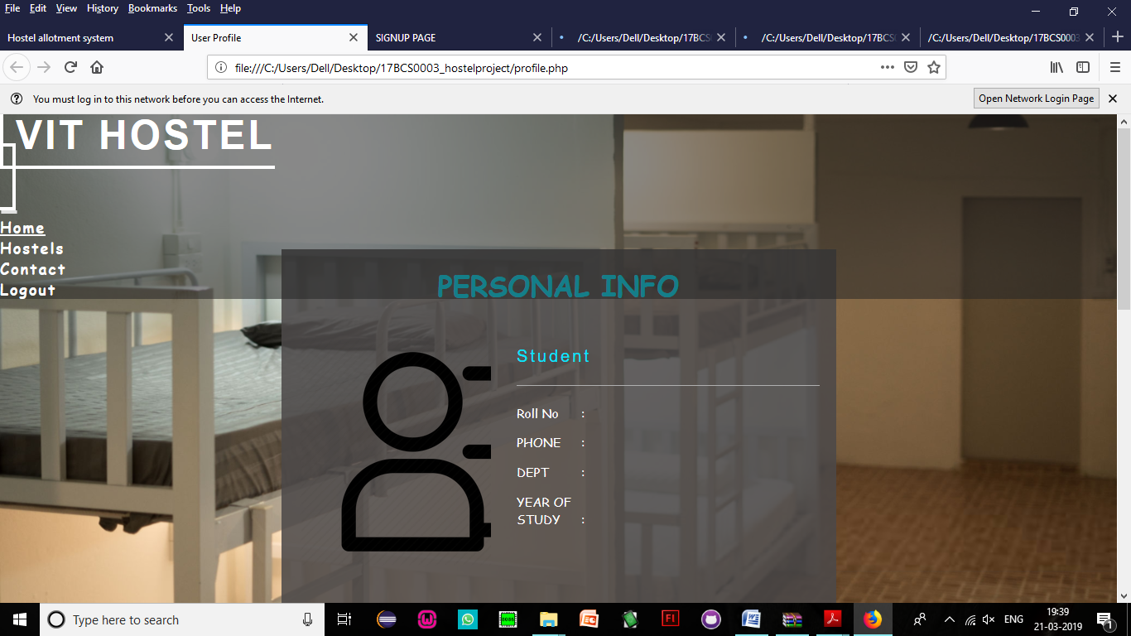

**Allocate:**

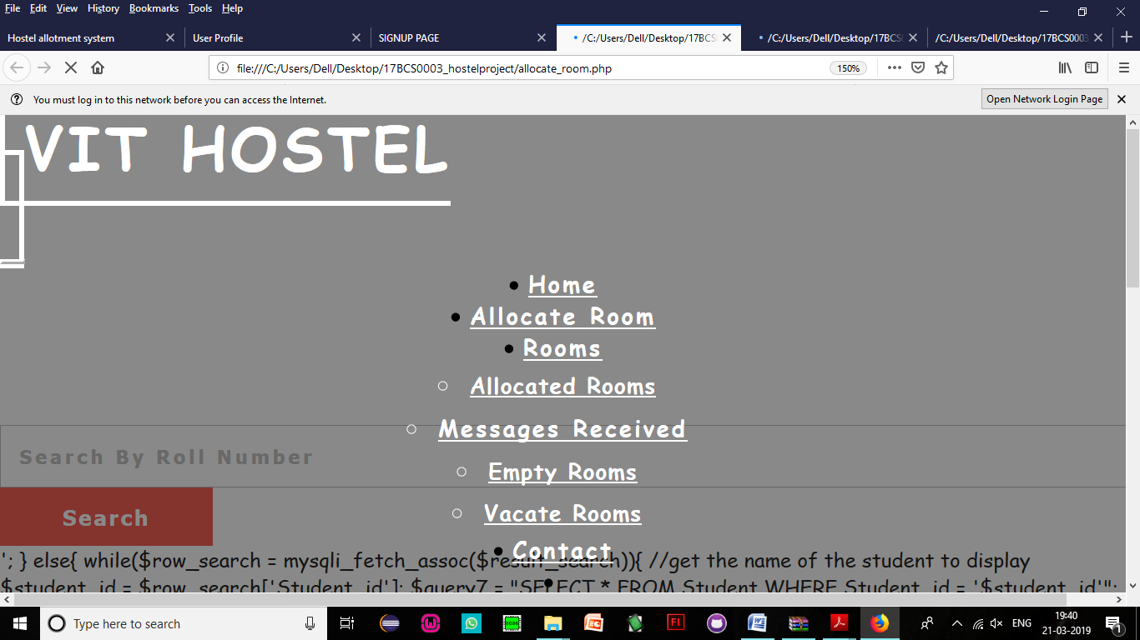

**Application form:**

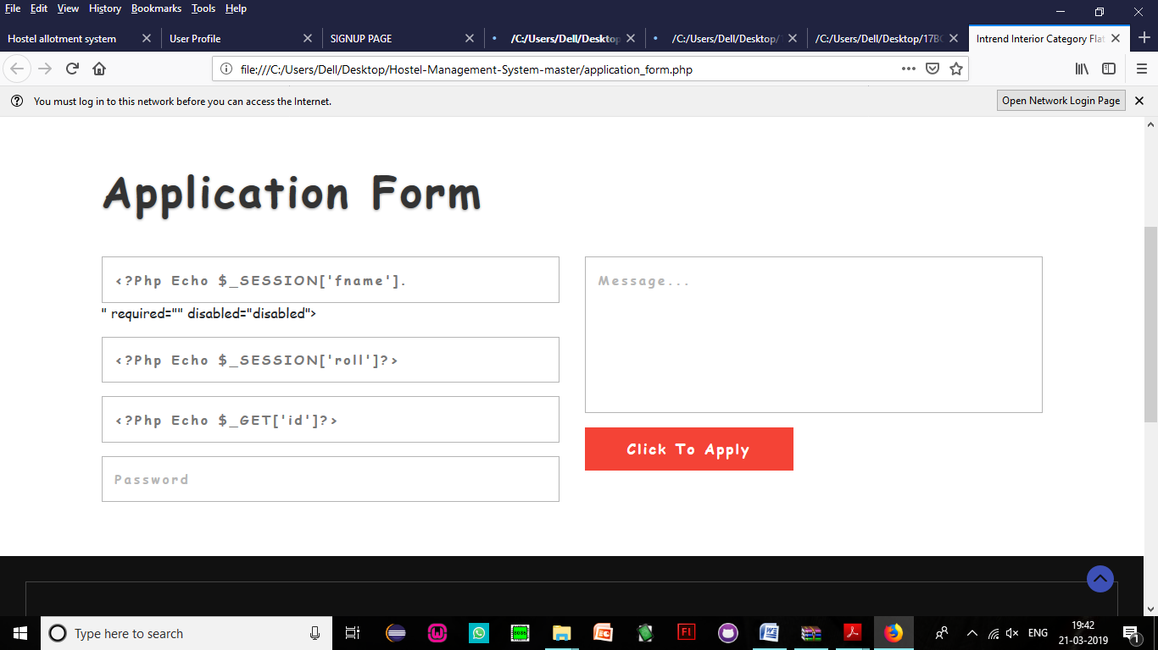

**CONCLUSION:**

Hostel Room allocation system is a web application which aims at computerization of current procedure of allocating hostel rooms. Currently the process involves students filling up the forms and submitting them in respective hostel offices which involves a lot of paperwork, henceless efficient . This website hence helps in maintaining an online database and site for the efficient working of the process for the same.

**THANK YOU!**