GIT ASSIGNMENT SCREENSHOTS

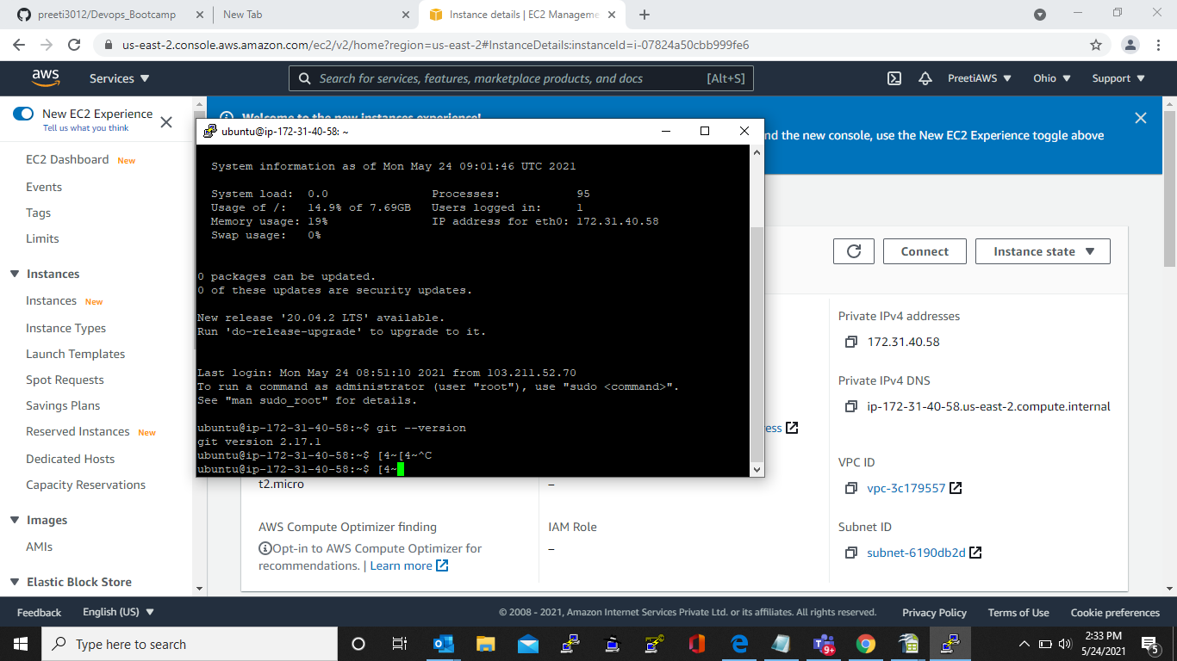
Created By Preeti uppal

Create EC2 Machine on AWS account.

Create Local repository Devleoper A .add 3 files in it and add to staging area and commit it.

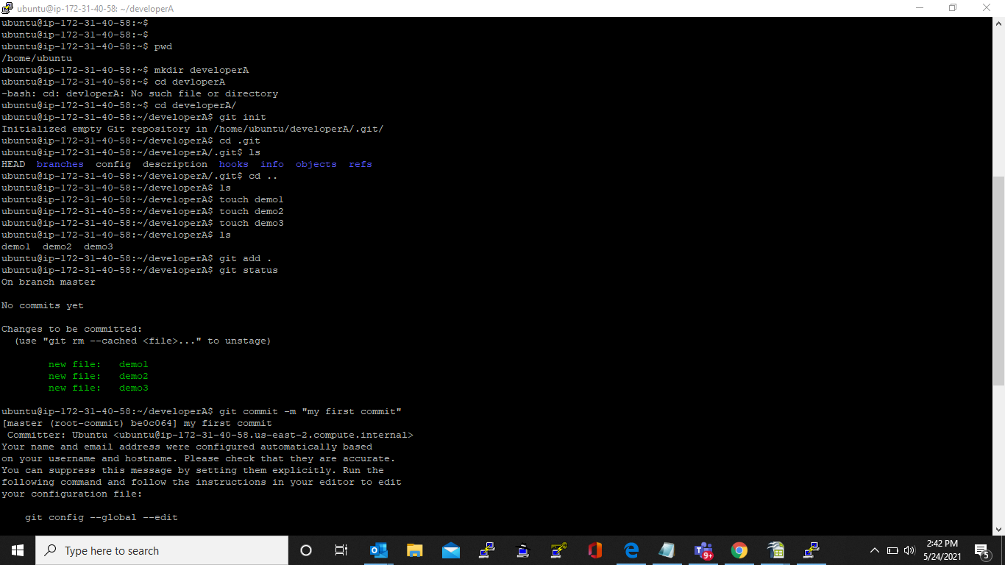

Add the remote repository to the local repository and push the changes to the remote repository from local repository

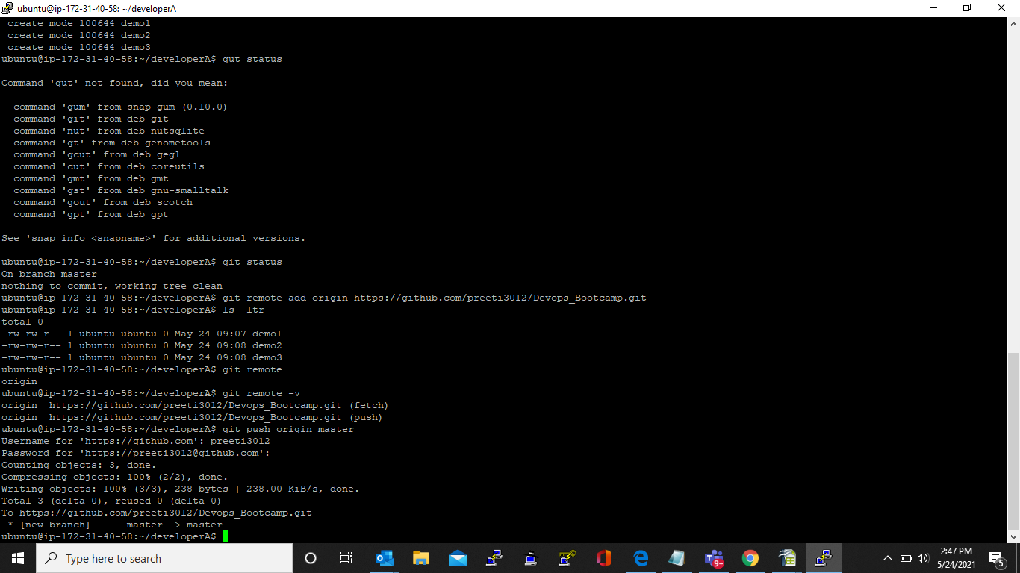

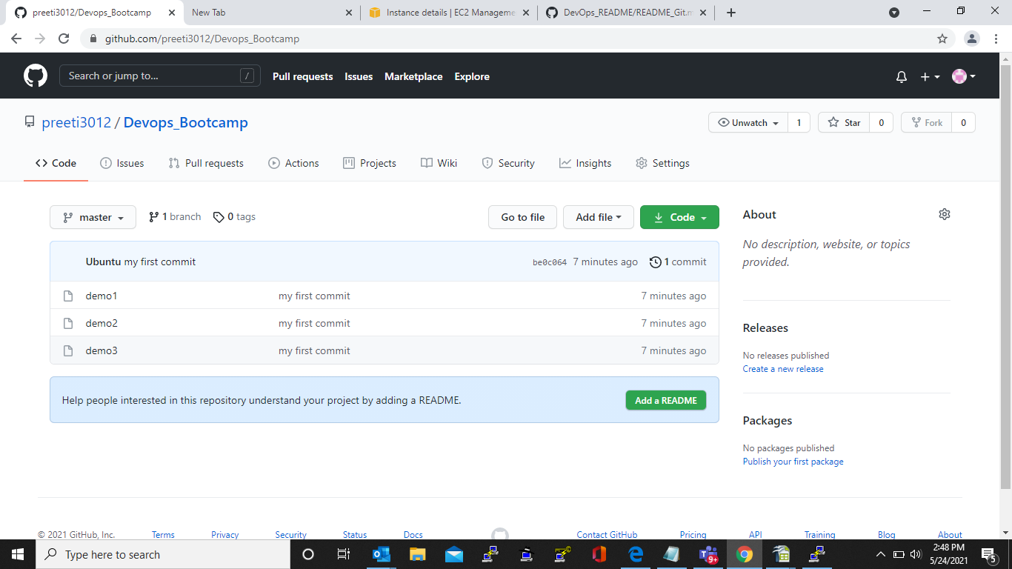
Clone the remote repository to another folder developerB

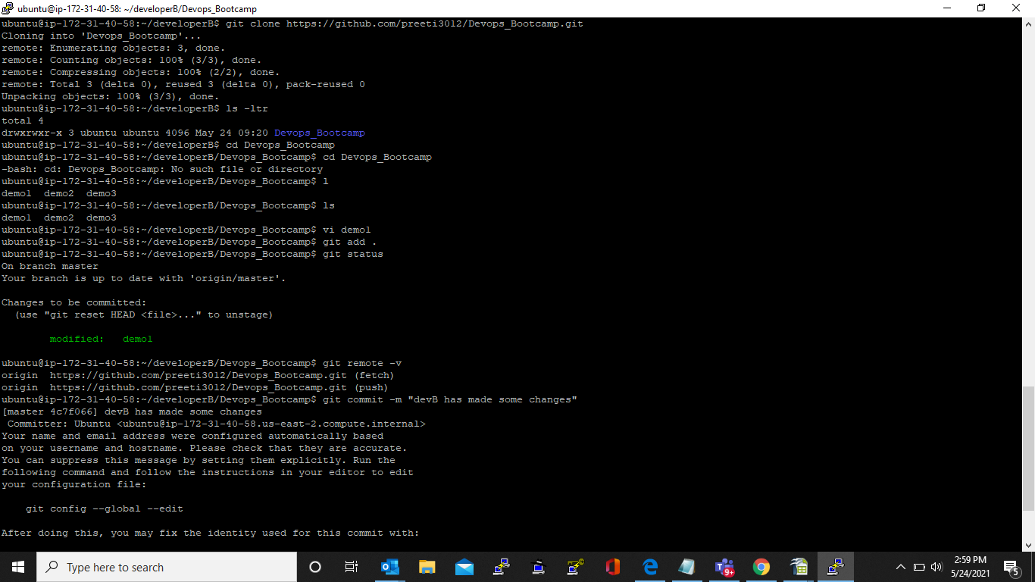

Make and commit the changes via developer B and synchronize the changes in developer A repository

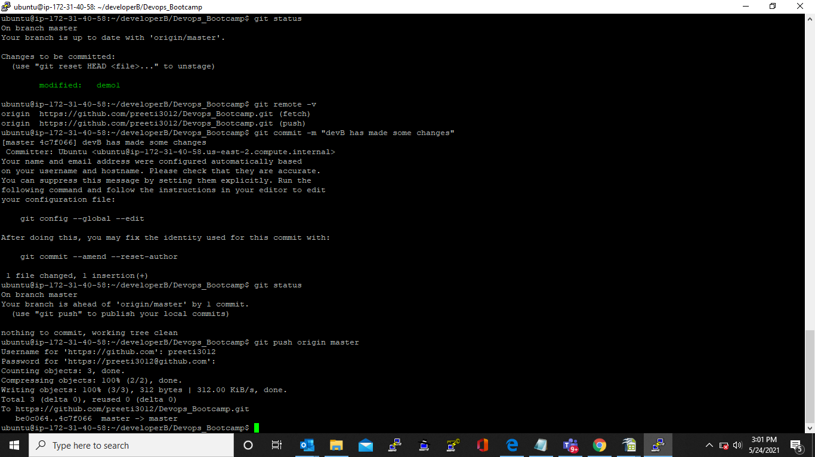

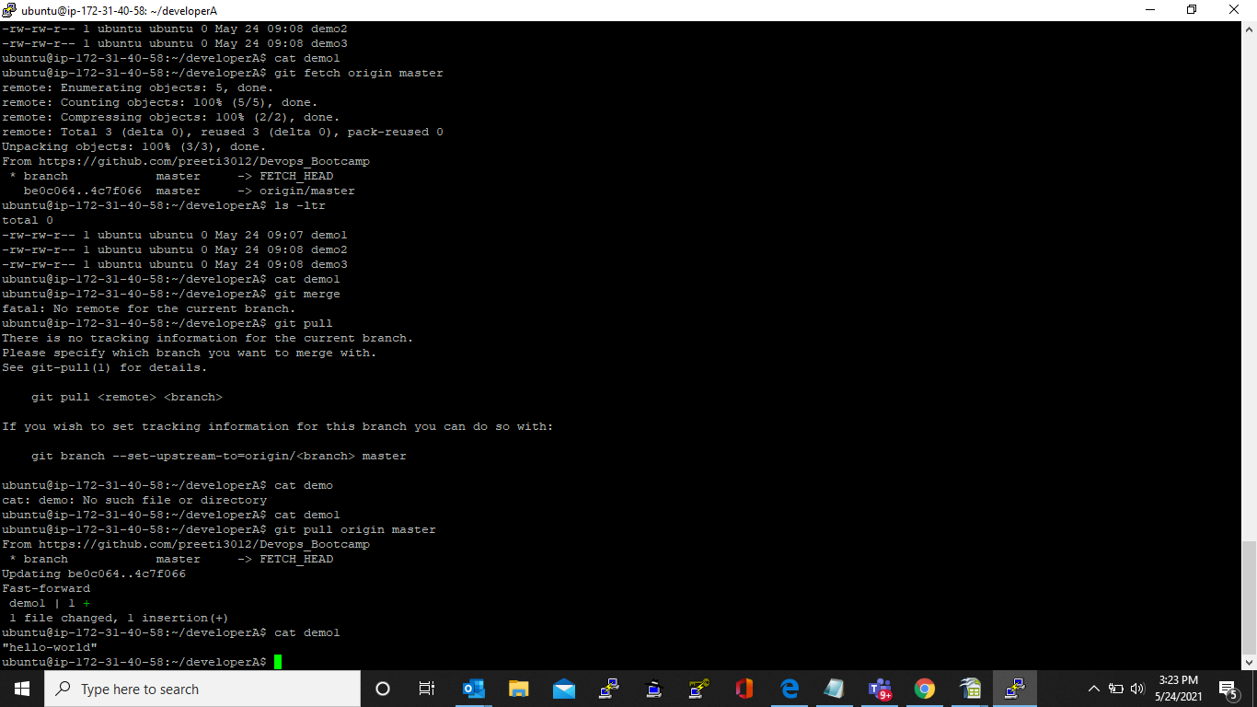

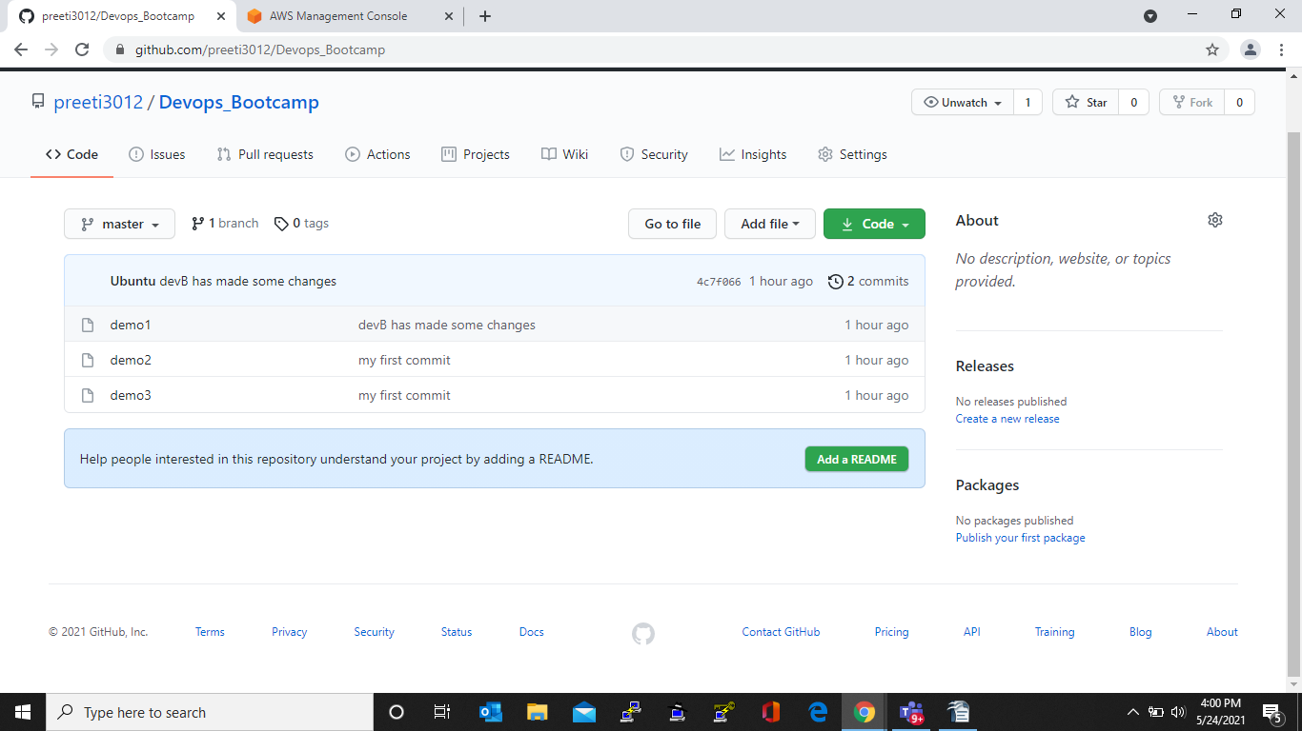

Create feature1 branch and make changes in files and merge the feature with master branch.

Remove feature1 branch and push the code to master in github.

