Ansible master node

Copy pem file on server and add ssh agent.change permission of pem file.
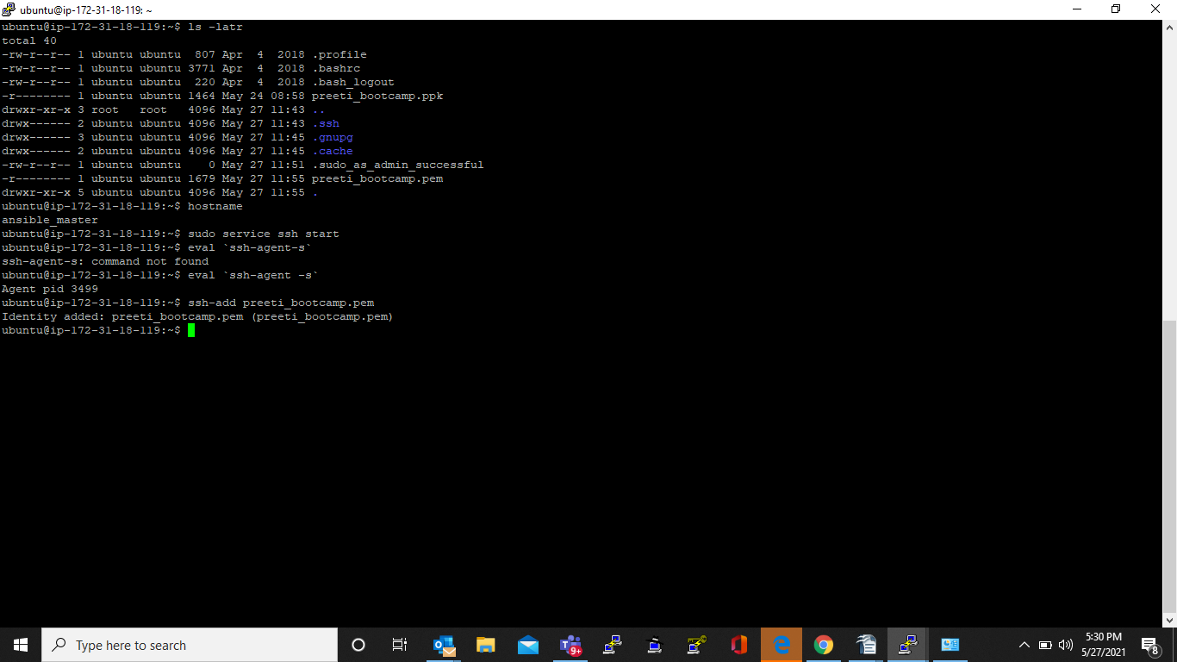

Able to login to client machine using password less ssh

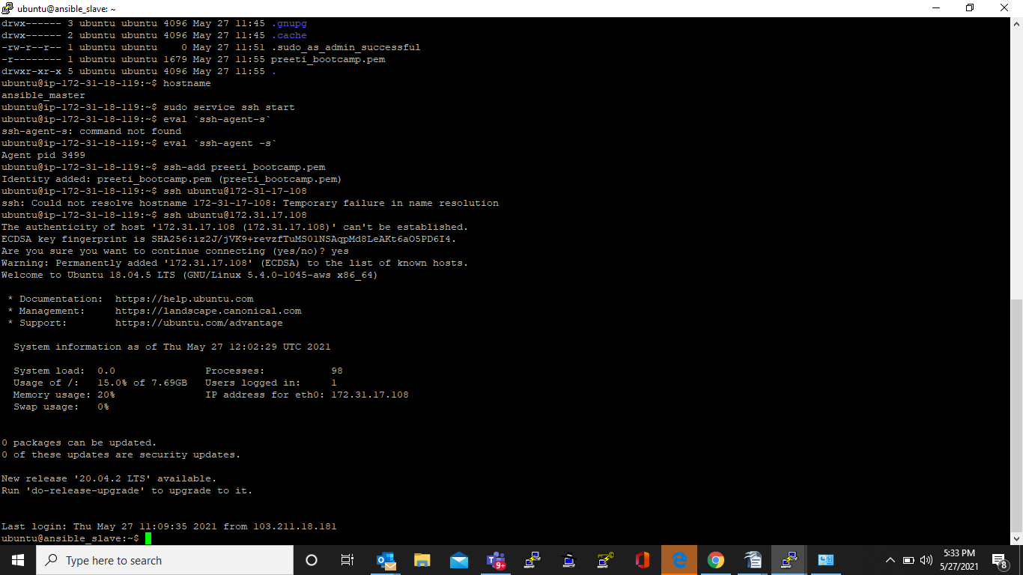
Copy below two line in .bashrc file

eval `ssh-agent -s`
ssh-add preeti_bootcamp.pem

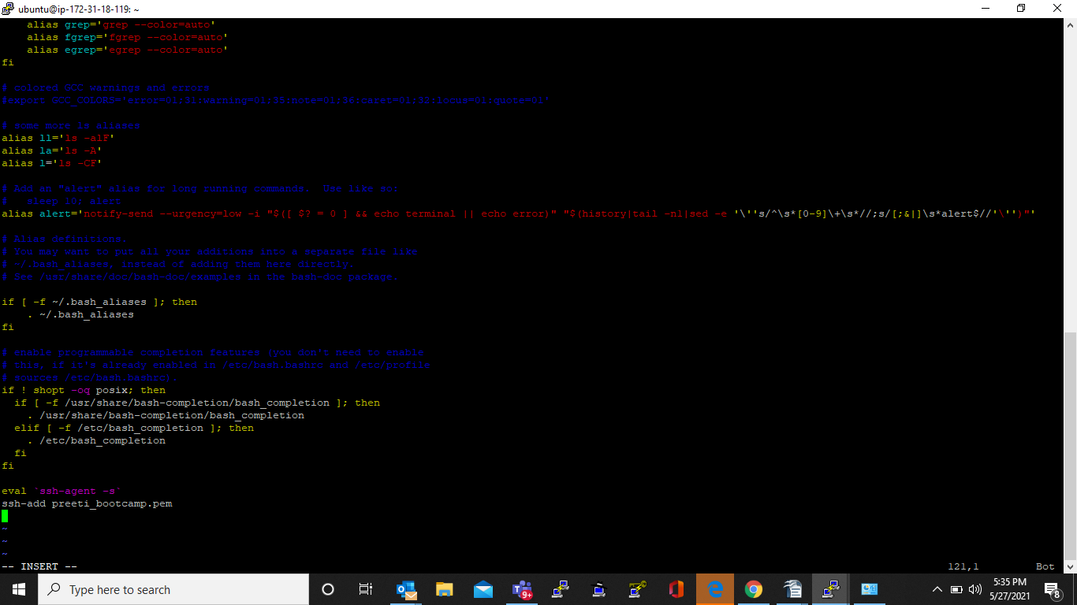

add private IP of ansible slave in /etc/ansible/hosts file on master server.

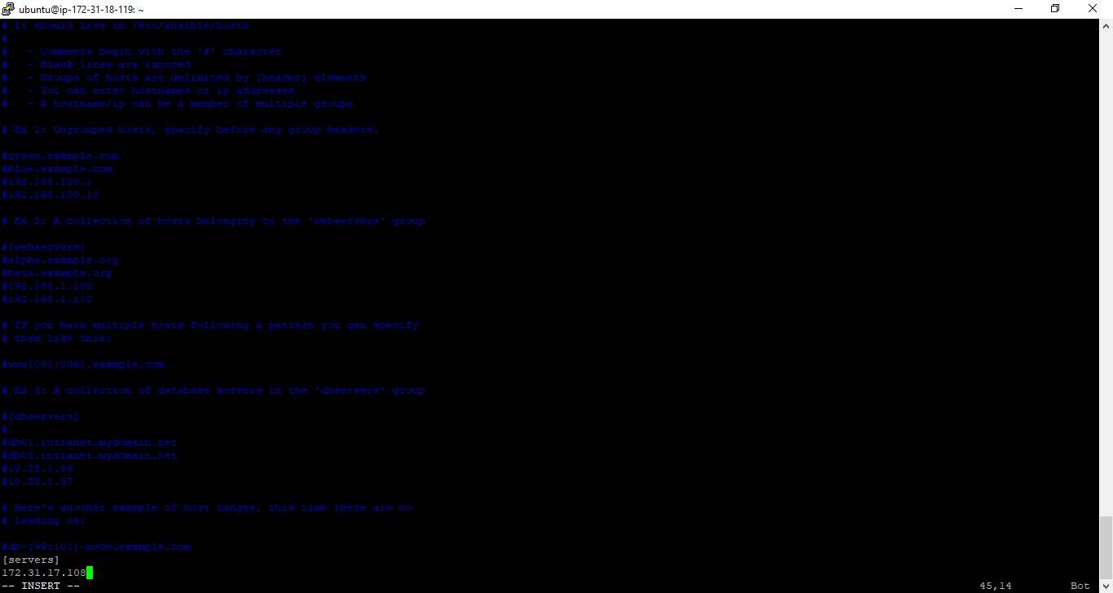

Create playbook to install package aand run application using docker container.

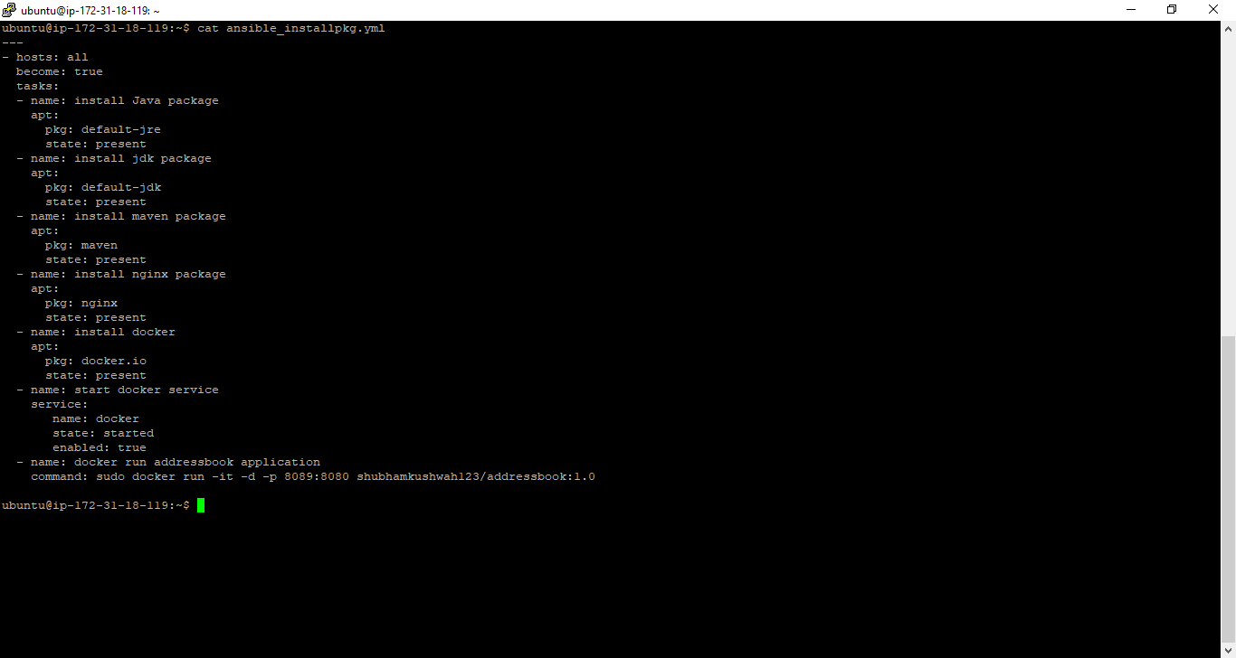

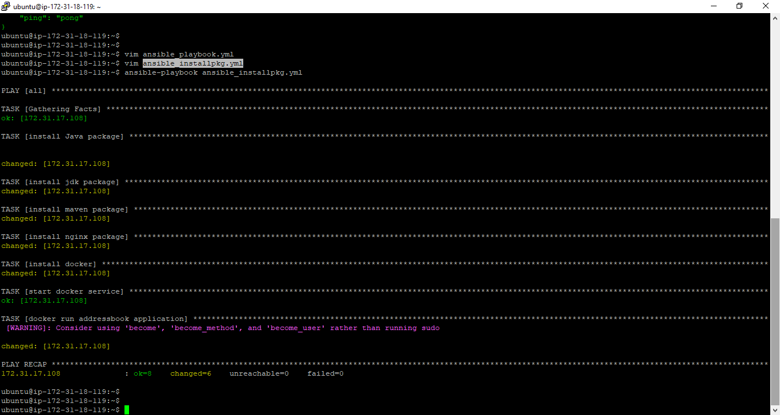

Access application site from Ansible slave Public Ip

