Assessment 1 - Trading Data Cleaning & Feature Engineering
Synthetic BTCUSDT trades with top-3 order book snapshots (trades_orderbook_STUDENT_dirty.csv, 2,035 rows x 18 columns). This document contains the complete Python code and the real output it produced, step by step. Educational material on synthetic data - not financial advice.

How to run
pip install pandas numpy matplotlib
python clean_trading_data.py

Tested with pandas 3.0.2, numpy 2.4.4, matplotlib 3.10.8. The script reads trades_orderbook_STUDENT_dirty.csv and writes trades_orderbook_clean.csv, ohlcv_1min.csv, model_dataset_train.csv, model_dataset_test.csv and charts/*.png.

Results at a glance
Item | Value
Raw rows | 2,035
Duplicates removed (by trade_id) | 35 -> 2,000 unique trades
Repaired exactly (nothing invented) | negative prices 6, x100 prices 8, crossed books 8, missing side 15, missing price 25, missing ask_price_1 8
Dropped as unrecoverable | 70 (2 crossed buys, 12 missing ask_price_1 on sells, 26 missing/zero quantity, 30 missing bid_qty_1)
Clean rows | 1,930
Missing values after cleaning | 0
1-minute candles | 28 (09:00 to 09:27 UTC, no empty minutes)

Cleaning decisions (drop vs fill vs fix)
Problem | Decision | Why
Duplicate rows (35) | Drop, keep first trade_id | Exact copies of the same trade
Mixed timestamps | Parse each format separately into one UTC datetime | Unix values are 10-digit seconds (the task README says milliseconds, but the data is in seconds; this puts every row inside 09:00-09:27 UTC)
side labels (BUY, Sell, blank) | Lower-case; blanks filled from the book | A buy always trades at ask_price_1 and a sell at bid_price_1 (verified on 100% of uncorrupted rows)
symbol variants | Remove / and -, upper-case to BTCUSDT | Same instrument
Price as text ($62,184.2) | Remove $ and commas, convert to float | Needed for maths
Negative prices (6) | abs() | Sign flip; result equals the book price exactly
x100 prices (8) | Divide by 100 | Result equals the book price exactly
Missing price (25) | Fill from the book (buy: ask_1, sell: bid_1) | Exact, same rule
Missing ask_price_1 (20) | Buys: set to price (8). Sells: drop (12) | For sells the spread is random, so it cannot be recovered
Crossed books (10) | Sells: bid_1 = trade price (8 repaired). Buys: drop (2) | For buys the true bid cannot be recovered
Missing / zero quantity (26) | Drop | A trade size cannot be invented, and volume feeds the candles
Missing bid_qty_1 (30) | Drop | Cannot be reconstructed; a global median would use future data (look-ahead bias)
Rows in random order | Sort by timestamp, then trade_id | Required for time series

Code and output, step by step

Setup and helper functions
Code
"""
Assessment 1 - Trading Data Cleaning & Feature Engineering (synthetic BTCUSDT)

Run: python clean_trading_data.py
Needs: pandas, numpy, matplotlib
Reads : trades_orderbook_STUDENT_dirty.csv
Writes: trades_orderbook_clean.csv, ohlcv_1min.csv, model_dataset_*.csv, charts/*.png
"""
import os
import numpy as np
import pandas as pd
import matplotlib
matplotlib.use("Agg") # no GUI needed, just save PNG files
import matplotlib.pyplot as plt

pd.set_option("display.width", 200)
pd.set_option("display.max_columns", 30)

RAW_FILE = "trades_orderbook_STUDENT_dirty.csv"
os.makedirs("charts", exist_ok=True)

def title(text):
print("\n" + "=" * 78 + f"\n{text}\n" + "=" * 78)

# ---------------------------------------------------------------------------
# Helper: parse the three timestamp formats found in the file
# 1) '2026-10-01 09:21:03.172' (standard, with milliseconds)
# 2) '01/10/2026 09:19:56' (DD/MM/YYYY)
# 3) '1790845352' (Unix time - 10 digits = SECONDS, not ms)
# ---------------------------------------------------------------------------
def parse_timestamps(ts):
ts = ts.str.strip()
is_unix = ts.str.fullmatch(r"\d{10}")
is_dmy = ts.str.contains("/", regex=False)
is_iso = ~(is_unix | is_dmy)
out = pd.Series(pd.NaT, index=ts.index, dtype="datetime64[ns]")
out[is_iso] = pd.to_datetime(ts[is_iso], format="%Y-%m-%d %H:%M:%S.%f")
out[is_dmy] = pd.to_datetime(ts[is_dmy], format="%d/%m/%Y %H:%M:%S")
out[is_unix] = pd.to_datetime(ts[is_unix].astype("int64"), unit="s")
return out, {"standard": int(is_iso.sum()), "DD/MM/YYYY": int(is_dmy.sum()),
"unix (seconds)": int(is_unix.sum())}

def to_number(s):
"""'$62,184.2' -> 62184.2 ; '' -> NaN"""
return pd.to_numeric(s.str.replace(r"[$,]", "", regex=True).str.strip()
.replace("", np.nan))

Step 1 - Load and inspect
Load the CSV as plain text first (dtype=str) so nothing is silently converted, then look at the shape, columns and the dtypes pandas would guess.
Code
title("STEP 1: LOAD AND INSPECT")
# dtype=str + keep_default_na=False -> see the data EXACTLY as it is in the file
raw = pd.read_csv(RAW_FILE, dtype=str, keep_default_na=False)
print("shape:", raw.shape)
print(raw.iloc[:5, :8]) # first 8 of the 18 columns, to keep the output readable
print("\nColumns:", list(raw.columns))
print("\nNote: loaded as text on purpose, so hidden problems ($, commas, mixed "
"dates, blanks) stay visible.")
print("\nA normal pandas read (to see what dtypes pandas guesses):")
naive = pd.read_csv(RAW_FILE)
print(naive.dtypes)
print("-> 'price' is read as TEXT (str) instead of a number because of the $ and commas.")

Output
shape: (2035, 18)
trade_id timestamp symbol side price quantity bid_price_1 bid_qty_1
0 100197 1790845352 BTCUSDT sell 62004.9 0.0285 62004.9 0.332
1 101557 2026-10-01 09:21:03.172 BTCUSDT sell 62180.8 0.3711 62180.8 0.309
2 100573 2026-10-01 09:07:37.614 BTCUSDT buy 62090.2 0.0583 62090.1 0.274
3 101717 2026-10-01 09:23:29.337 BTCUSDT sell 62237.0 0.0104 62237.0 2.53
4 100201 2026-10-01 09:02:35.129 BTCUSDT buy 61994.8 0.1156 61994.5 0.965

Columns: ['trade_id', 'timestamp', 'symbol', 'side', 'price', 'quantity', 'bid_price_1', 'bid_qty_1', 'bid_price_2', 'bid_qty_2', 'bid_price_3', 'bid_qty_3', 'ask_price_1', 'ask_qty_1', 'ask_price_2', 'ask_qty_2', 'ask_price_3', 'ask_qty_3']

Note: loaded as text on purpose, so hidden problems ($, commas, mixed dates, blanks) stay visible.

A normal pandas read (to see what dtypes pandas guesses):
trade_id int64
timestamp str
symbol str
side str
price str
quantity float64
bid_price_1 float64
bid_qty_1 float64
bid_price_2 float64
bid_qty_2 float64
bid_price_3 float64
bid_qty_3 float64
ask_price_1 float64
ask_qty_1 float64
ask_price_2 float64
ask_qty_2 float64
ask_price_3 float64
ask_qty_3 float64
dtype: object
-> 'price' is read as TEXT (str) instead of a number because of the $ and commas.

Step 2 - Summarise
Summary statistics and value counts. The price maximum (~6.2 million) and negative minimum already show corrupted prices.
Code
title("STEP 2: SUMMARISE")
print("symbol value_counts:\n", raw["symbol"].value_counts(), sep="")
print("\nside value_counts (blank = missing):\n", raw["side"].replace("", "<blank>").value_counts(), sep="")
tmp = raw.copy()
for c in ["price", "quantity"]:
tmp[c] = to_number(tmp[c])
print("\nprice & quantity statistics (raw, before cleaning):")
print(tmp[["price", "quantity"]].agg(["count", "min", "max", "mean", "median"]).round(4))
print("\n-> The price max (~6.2 million) and min (negative) are not realistic "
"for BTC at ~62,000: outliers.")

Output
symbol value_counts:
symbol
BTCUSDT 1974
btcusdt 24
BTC/USDT 21
BTC-USDT 16
Name: count, dtype: int64

side value_counts (blank = missing):
side
buy 970
sell 930
BUY 63
Sell 57
<blank> 15
Name: count, dtype: int64

price & quantity statistics (raw, before cleaning):
price quantity
count 2.010000e+03 2015.0000
min -6.218370e+04 0.0000
max 6.225050e+06 2.7894
mean 8.621582e+04 0.0806
median 6.211635e+04 0.0488

-> The price max (~6.2 million) and min (negative) are not realistic for BTC at ~62,000: outliers.

Step 3 - Find the problems (Task 1: data-quality report)
Task 1 - report every data-quality issue. All ten planted problems are found and counted here, on the raw file.
Code
title("STEP 3: DATA QUALITY REPORT (raw file)")
num_cols = [c for c in raw.columns if c not in ("trade_id", "timestamp", "symbol", "side")]
chk = raw.copy()
for c in num_cols:
chk[c] = to_number(chk[c])
chk["ts"], ts_formats = parse_timestamps(chk["timestamp"])
chk["side_clean"] = chk["side"].str.strip().str.lower().replace("", np.nan)

issues = {}
issues["1. Duplicate rows (same trade_id)"] = int(chk.duplicated("trade_id").sum())
print("1. Duplicate rows (exact copies):", int(raw.duplicated().sum()),
"| duplicate trade_ids:", issues["1. Duplicate rows (same trade_id)"],
"| unique trade_ids:", raw["trade_id"].nunique())

miss = (raw == "").sum()
miss = miss[miss > 0]
print("\n2. Missing values (blank cells) per column:\n", miss.to_string(), sep="")
issues["2. Missing values (cells)"] = int(miss.sum())

print("\n3. Timestamp formats:", ts_formats)
print(" NOTE: README says Unix *milliseconds*, but the file really contains "
"10-digit Unix *seconds*.")
issues["3. Non-standard timestamps"] = ts_formats["DD/MM/YYYY"] + ts_formats["unix (seconds)"]

print("\n4. side labels:", raw["side"].replace("", "<blank>").value_counts().to_dict())
issues["4. Inconsistent side labels"] = int((~raw["side"].isin(["buy", "sell", ""])).sum())

print("\n5. symbol labels:", raw["symbol"].value_counts().to_dict())
issues["5. Inconsistent symbol names"] = int((raw["symbol"] != "BTCUSDT").sum())

issues["6. Prices stored as text ($ or ,)"] = int(raw["price"].str.contains(r"[$,]").sum())
print("\n6. Prices stored as text with $ and/or commas:", issues["6. Prices stored as text ($ or ,)"])

q1, q3 = chk["price"].quantile([0.25, 0.75])
iqr = q3 - q1
lo, hi = q1 - 1.5 * iqr, q3 + 1.5 * iqr
print(f"\n7. Price outliers - IQR fences: [{lo:.1f}, {hi:.1f}]")
print(" x100 prices (> 1,000,000):", int((chk["price"] > 1_000_000).sum()),
"| negative prices:", int((chk["price"] < 0).sum()),
"| total outside IQR fences:", int(((chk["price"] < lo) | (chk["price"] > hi)).sum()))
issues["7. Outlier / negative prices"] = int(((chk["price"] < lo) | (chk["price"] > hi)).sum())

issues["8. Zero quantities"] = int((chk["quantity"] == 0).sum())
print("\n8. Zero quantities:", issues["8. Zero quantities"])

issues["9. Crossed order books (bid_1 > ask_1)"] = int((chk["bid_price_1"] > chk["ask_price_1"]).sum())
print("\n9. Crossed books (bid_1 > ask_1):", issues["9. Crossed order books (bid_1 > ask_1)"])

issues["10. Rows out of time order"] = int((chk["ts"] < chk["ts"].cummax().shift()).sum())
print("\n10. Rows out of time order:", issues["10. Rows out of time order"],
"of", len(chk), "(file is shuffled)")

print("\n--- Summary of issues found ---")
for k, v in issues.items():
print(f"{k:45s} {v:>6}")

Output
1. Duplicate rows (exact copies): 35 | duplicate trade_ids: 35 | unique trade_ids: 2000

2. Missing values (blank cells) per column:
side 15
price 25
quantity 20
bid_qty_1 30
ask_price_1 20

3. Timestamp formats: {'standard': 1917, 'DD/MM/YYYY': 78, 'unix (seconds)': 40}
NOTE: README says Unix *milliseconds*, but the file really contains 10-digit Unix *seconds*.

4. side labels: {'buy': 970, 'sell': 930, 'BUY': 63, 'Sell': 57, '<blank>': 15}

5. symbol labels: {'BTCUSDT': 1974, 'btcusdt': 24, 'BTC/USDT': 21, 'BTC-USDT': 16}

6. Prices stored as text with $ and/or commas: 50

7. Price outliers - IQR fences: [61845.3, 62367.9]
x100 prices (> 1,000,000): 8 | negative prices: 6 | total outside IQR fences: 14

8. Zero quantities: 6

9. Crossed books (bid_1 > ask_1): 10

10. Rows out of time order: 2024 of 2035 (file is shuffled)

--- Summary of issues found ---
1. Duplicate rows (same trade_id) 35
2. Missing values (cells) 110
3. Non-standard timestamps 118
4. Inconsistent side labels 120
5. Inconsistent symbol names 61
6. Prices stored as text ($ or ,) 50
7. Outlier / negative prices 14
8. Zero quantities 6
9. Crossed order books (bid_1 > ask_1) 10
10. Rows out of time order 2024

Step 4 - Clean (Tasks 2 and 3)
Tasks 2 and 3 - clean, explain every decision, sort by time and de-duplicate by trade_id. Rule used: repair a value only when it can be recovered exactly from the order book; otherwise drop the row rather than invent data.
Code
title("STEP 4: CLEANING (with decision log)")
df = raw.copy()
log = []

def record(step, action, before, after):
log.append((step, action, before, after))
print(f"{step:<42s} rows {before:>5} -> {after:>5} | {action}")

# 4.1 Remove duplicates by trade_id ------------------------------------------
n0 = len(df)
df = df.drop_duplicates(subset="trade_id", keep="first").copy()
record("4.1 duplicates", "dropped repeated trade_ids (exact copies)", n0, len(df))

# 4.2 Standardise symbol and side ---------------------------------------------
df["symbol"] = df["symbol"].str.upper().str.replace(r"[/\-]", "", regex=True)
df["side"] = df["side"].str.strip().str.lower().replace("", np.nan)
print(" symbol ->", df["symbol"].unique().tolist(),
"| side ->", df["side"].value_counts(dropna=False).to_dict())

# 4.3 Convert numeric columns + trade_id --------------------------------------
df["trade_id"] = df["trade_id"].astype("int64")
for c in num_cols:
df[c] = to_number(df[c])

# 4.4 Parse timestamps into one format (UTC) ----------------------------------
df["timestamp"], _ = parse_timestamps(df["timestamp"])
print(" timestamp range:", df["timestamp"].min(), "->", df["timestamp"].max())

# 4.5 Fix negative prices and x100 outliers ------------------------------------
# In the data every real trade price is the best bid (sell) or best ask (buy),
# so the corrupted values can be repaired exactly.
n_neg = int((df["price"] < 0).sum())
df.loc[df["price"] < 0, "price"] = df["price"].abs() # sign error
ref = df["bid_price_1"].fillna(df["ask_price_1"]) # book price for comparison
is_x100 = df["price"] > 10 * ref
n_x100 = int(is_x100.sum())
df.loc[is_x100, "price"] = (df.loc[is_x100, "price"] / 100).round(1) # x100 error
print(f"4.5 negative prices fixed with abs(): {n_neg} | x100 prices divided by 100: {n_x100}")

# Evidence that the repair rule is safe: on every row that is NOT crossed and has both
# side and price, price == ask_1 for buys and price == bid_1 for sells (100% of rows).
ok = df[(df["bid_price_1"] < df["ask_price_1"]) & df["side"].notna() & df["price"].notna()]
buys, sells = ok[ok["side"] == "buy"], ok[ok["side"] == "sell"]
print(f" evidence: buy price == ask_1 on {(buys['price'] == buys['ask_price_1']).mean():.0%} of "
f"{len(buys)} rows | sell price == bid_1 on {(sells['price'] == sells['bid_price_1']).mean():.0%} of {len(sells)} rows")

# 4.6 Crossed order books ------------------------------------------------------
# A buy always executes at ask_1, a sell at bid_1. In a crossed row bid_1 was
# corrupted (pushed above ask_1). If trade price < ask_1 it must be a SELL,
# so the true bid_1 = trade price (exact repair). If price == ask_1 (a BUY) the
# true bid_1 cannot be recovered -> drop the row.
crossed = df["bid_price_1"] > df["ask_price_1"]
fixable = crossed & (df["price"] < df["ask_price_1"])
df.loc[fixable, "bid_price_1"] = df.loc[fixable, "price"]
df.loc[fixable, "side"] = "sell"
n0 = len(df)
still_crossed = df["bid_price_1"] >= df["ask_price_1"]
df = df[~still_crossed].copy()
print(f"4.6 crossed books: {int(crossed.sum())} found | repaired (sell rows): "
f"{int(fixable.sum())} | dropped (buy rows, unrecoverable): {n0 - len(df)}")
log.append(("4.6 crossed books", f"repaired {int(fixable.sum())}, dropped {n0 - len(df)}", n0, len(df)))

# 4.7 Missing side: infer from where the price sits in the book -----------------
n0 = int(df["side"].isna().sum())
df.loc[df["side"].isna() & (df["price"] == df["ask_price_1"]), "side"] = "buy"
df.loc[df["side"].isna() & (df["price"] == df["bid_price_1"]), "side"] = "sell"
print(f"4.7 missing side: {n0} found | still missing after inference: {int(df['side'].isna().sum())}")

# 4.8 Missing price: price = ask_1 for buys, bid_1 for sells ---------------------
n0 = int(df["price"].isna().sum())
df.loc[df["price"].isna() & (df["side"] == "buy"), "price"] = df["ask_price_1"]
df.loc[df["price"].isna() & (df["side"] == "sell"), "price"] = df["bid_price_1"]
print(f"4.8 missing price: {n0} found | still missing: {int(df['price'].isna().sum())}")

# 4.9 Missing ask_price_1: for a buy, ask_1 == price (exact). For a sell it is
# NOT recoverable (the spread is random) -> drop.
n0 = int(df["ask_price_1"].isna().sum())
buy_fix = df["ask_price_1"].isna() & (df["side"] == "buy")
df.loc[buy_fix, "ask_price_1"] = df.loc[buy_fix, "price"]
n_before = len(df)
df = df[df["ask_price_1"].notna()].copy()
record("4.9 missing ask_price_1", f"{n0} found: {int(buy_fix.sum())} repaired (buys), "
f"{n_before - len(df)} dropped (sells)", n_before, len(df))

# 4.10 Missing / zero quantity: trade size cannot be invented -> drop -------------
n_before = len(df)
bad_qty = df["quantity"].isna() | (df["quantity"] <= 0)
df = df[~bad_qty].copy()
record("4.10 missing/zero quantity", f"dropped {int(bad_qty.sum())} trades with no valid size", n_before, len(df))

# 4.11 Missing bid_qty_1: cannot be reconstructed, and filling with a global
# median would use future data (look-ahead) -> drop ---------------------------
n_before = len(df)
df = df[df["bid_qty_1"].notna()].copy()
record("4.11 missing bid_qty_1", f"dropped {n_before - len(df)} rows", n_before, len(df))

# 4.12 Sort by time (tie-break with trade_id) ------------------------------------
df = df.sort_values(["timestamp", "trade_id"]).reset_index(drop=True)

# 4.13 Final validation -----------------------------------------------------------
assert df["trade_id"].is_unique
assert df.isna().sum().sum() == 0
assert (df["price"] > 0).all() and (df["quantity"] > 0).all()
assert (df["bid_price_1"] < df["ask_price_1"]).all()
assert df["timestamp"].is_monotonic_increasing
assert df["price"].between(60_000, 64_000).all()
assert set(df["side"].unique()) == {"buy", "sell"} and set(df["symbol"].unique()) == {"BTCUSDT"}
price_matches_book = np.where(df["side"] == "buy", df["price"] == df["ask_price_1"],
df["price"] == df["bid_price_1"])
assert price_matches_book.all()
print("\n4.13 validation passed: no NaN, no duplicates, no crossed books, prices 60k-64k, "
"price equals best bid/ask on every row, sorted by time.")
print(f"\nFINAL: {len(df)} clean rows kept out of {len(raw)} raw rows "
f"({len(raw) - len(df)} removed: 35 duplicates + {2000 - len(df)} unrecoverable)")

print("\nCleaning log:")
print(pd.DataFrame(log, columns=["step", "action", "rows_before", "rows_after"]).to_string(index=False))
print("\nMissing values after cleaning:", int(df.isna().sum().sum()))
print(df.dtypes)
df.to_csv("trades_orderbook_clean.csv", index=False)

Output
4.1 duplicates rows 2035 -> 2000 | dropped repeated trade_ids (exact copies)
symbol -> ['BTCUSDT'] | side -> {'buy': 1012, 'sell': 973, nan: 15}
timestamp range: 2026-10-01 09:00:01.923000 -> 2026-10-01 09:27:03.984000
4.5 negative prices fixed with abs(): 6 | x100 prices divided by 100: 8
evidence: buy price == ask_1 on 100% of 990 rows | sell price == bid_1 on 100% of 941 rows
4.6 crossed books: 10 found | repaired (sell rows): 8 | dropped (buy rows, unrecoverable): 2
4.7 missing side: 14 found | still missing after inference: 0
4.8 missing price: 25 found | still missing: 0
4.9 missing ask_price_1 rows 1998 -> 1986 | 20 found: 8 repaired (buys), 12 dropped (sells)
4.10 missing/zero quantity rows 1986 -> 1960 | dropped 26 trades with no valid size
4.11 missing bid_qty_1 rows 1960 -> 1930 | dropped 30 rows

4.13 validation passed: no NaN, no duplicates, no crossed books, prices 60k-64k, price equals best bid/ask on every row, sorted by time.

FINAL: 1930 clean rows kept out of 2035 raw rows (105 removed: 35 duplicates + 70 unrecoverable)

Cleaning log:
step action rows_before rows_after
4.1 duplicates dropped repeated trade_ids (exact copies) 2035 2000
4.6 crossed books repaired 8, dropped 2 2000 1998
4.9 missing ask_price_1 20 found: 8 repaired (buys), 12 dropped (sells) 1998 1986
4.10 missing/zero quantity dropped 26 trades with no valid size 1986 1960
4.11 missing bid_qty_1 dropped 30 rows 1960 1930

Missing values after cleaning: 0
trade_id int64
timestamp datetime64[ns]
symbol str
side str
price float64
quantity float64
bid_price_1 float64
bid_qty_1 float64
bid_price_2 float64
bid_qty_2 float64
bid_price_3 float64
bid_qty_3 float64
ask_price_1 float64
ask_qty_1 float64
ask_price_2 float64
ask_qty_2 float64
ask_price_3 float64
ask_qty_3 float64
dtype: object

Step 5 - Handle outliers
Outlier re-check after cleaning, using a rolling median and the IQR method.
Code
title("STEP 5: OUTLIER RE-CHECK ON CLEANED DATA")
roll_med = df["price"].rolling(21, center=True, min_periods=1).median()
dev = (df["price"] - roll_med).abs() / roll_med
q1, q3 = df["price"].quantile([0.25, 0.75])
iqr = q3 - q1
print(f"Rolling-median check: max deviation from 21-trade rolling median = {dev.max():.4%}")
print(f"IQR fences [{q1 - 1.5 * iqr:.1f}, {q3 + 1.5 * iqr:.1f}] -> price outliers left: "
f"{int(((df['price'] < q1 - 1.5 * iqr) | (df['price'] > q3 + 1.5 * iqr)).sum())}")
print("price describe after cleaning:\n", df["price"].describe().round(2).to_string(), sep="")

Output
Rolling-median check: max deviation from 21-trade rolling median = 0.0359%
IQR fences [61848.4, 62365.4] -> price outliers left: 0
price describe after cleaning:
count 1930.00
mean 62108.78
std 80.30
min 61954.10
25% 62042.30
50% 62116.05
75% 62171.55
max 62253.90

Step 6 - Engineer features (Task 4)
Task 4 - add spread, mid_price and order_imbalance, plus returns, rolling volatility, moving averages and RSI. Every feature uses only past/current data (no look-ahead).
Code
# All features use only past/current data -> no look-ahead bias.
# ===========================================================================
title("STEP 6: FEATURE ENGINEERING")
df["spread"] = df["ask_price_1"] - df["bid_price_1"]
df["mid_price"] = (df["ask_price_1"] + df["bid_price_1"]) / 2
df["order_imbalance"] = (df["bid_qty_1"] - df["ask_qty_1"]) / (df["bid_qty_1"] + df["ask_qty_1"])
df["return"] = df["mid_price"].pct_change()
df["log_return"] = np.log(df["mid_price"]).diff()
df["volatility_50"] = df["log_return"].rolling(50).std()
df["ma_20"] = df["mid_price"].rolling(20).mean()
df["ma_50"] = df["mid_price"].rolling(50).mean()
delta = df["mid_price"].diff()
gain = delta.clip(lower=0).rolling(14).mean()
loss = (-delta.clip(upper=0)).rolling(14).mean()
df["rsi_14"] = 100 - 100 / (1 + gain / loss)
df["ma_ratio"] = df["ma_20"] / df["ma_50"] - 1

feat_cols = ["spread", "mid_price", "order_imbalance", "return", "volatility_50", "ma_20", "ma_50", "rsi_14"]
print(df[["timestamp", "side", "price", "spread", "mid_price", "order_imbalance"]].head(8)
.round({"price": 1, "spread": 2, "mid_price": 2, "order_imbalance": 4}))
print("\nFeature summary:\n", df[feat_cols].describe().T.round(5), sep="")
print("\norder_imbalance is inside [-1, 1]:", bool(df["order_imbalance"].between(-1, 1).all()),
"| spread > 0 everywhere:", bool((df["spread"] > 0).all()))
print("(first ~50 rows have NaN for rolling features - that is expected, not an error)")

Output
timestamp side price spread mid_price order_imbalance
0 2026-10-01 09:00:01.923 sell 61994.6 0.1 61994.65 0.2482
1 2026-10-01 09:00:05.700 buy 61991.3 0.5 61991.05 -0.0275
2 2026-10-01 09:00:05.923 buy 61980.7 0.2 61980.60 -0.6551
3 2026-10-01 09:00:05.993 buy 61981.6 0.3 61981.45 0.3693
4 2026-10-01 09:00:07.155 buy 61979.6 0.1 61979.55 -0.8710
5 2026-10-01 09:00:08.283 sell 61984.5 0.5 61984.75 -0.1356
6 2026-10-01 09:00:10.782 buy 61982.9 0.1 61982.85 -0.0692
7 2026-10-01 09:00:10.846 buy 61985.5 0.2 61985.40 0.1845

Feature summary:
count mean std min 25% 50% 75% max
spread 1930.0 0.17622 0.10044 0.10000 0.10000 0.10000 0.20000 0.50000
mid_price 1930.0 62108.78060 80.30429 61954.05000 62042.36250 62116.15000 62171.53750 62253.95000
order_imbalance 1930.0 -0.03369 0.52648 -0.97964 -0.47932 -0.03991 0.41783 0.98638
return 1929.0 0.00000 0.00007 -0.00024 -0.00004 0.00000 0.00005 0.00021
volatility_50 1880.0 0.00007 0.00001 0.00005 0.00006 0.00007 0.00007 0.00009
ma_20 1911.0 62109.16031 79.81375 61967.66250 62041.16250 62113.72000 62172.30125 62245.17500
ma_50 1881.0 62109.88233 79.12114 61974.15600 62042.31500 62113.73400 62173.72900 62237.04200
rsi_14 1916.0 51.41687 16.74781 6.71141 39.28636 51.82305 63.99464 98.65093

order_imbalance is inside [-1, 1]: True | spread > 0 everywhere: True
(first ~50 rows have NaN for rolling features - that is expected, not an error)

Step 7 - Resample to 1-minute OHLCV (Task 5)
Task 5 - resample the ticks into 1-minute OHLCV candles.
Code
title("STEP 7: 1-MINUTE OHLCV CANDLES")
ohlcv = (df.set_index("timestamp")
.resample("1min")
.agg(open=("price", "first"), high=("price", "max"), low=("price", "min"),
close=("price", "last"), volume=("quantity", "sum"), trades=("trade_id", "count")))
ohlcv["volume"] = ohlcv["volume"].round(4)
print("candles:", len(ohlcv), "| empty minutes:", int(ohlcv["close"].isna().sum()))
print(ohlcv.head(10))
print("...")
print(ohlcv.tail(3))
assert ohlcv["volume"].sum().round(6) == round(df["quantity"].sum(), 6)
assert (ohlcv["high"] >= ohlcv[["open", "close"]].max(axis=1)).all()
assert (ohlcv["low"] <= ohlcv[["open", "close"]].min(axis=1)).all()
assert ohlcv["trades"].sum() == len(df)
print("checks passed: total candle volume == total trade quantity; high/low bound open/close.")
ohlcv.to_csv("ohlcv_1min.csv")

Output
candles: 28 | empty minutes: 0
open high low close volume trades
timestamp
2026-10-01 09:00:00 61994.6 62006.7 61962.9 61972.0 6.5837 74
2026-10-01 09:01:00 61969.0 62030.4 61967.2 62011.2 7.4097 75
2026-10-01 09:02:00 62019.6 62020.4 61976.7 61977.9 6.9189 73
2026-10-01 09:03:00 61978.9 62039.0 61954.1 62032.7 5.5302 81
2026-10-01 09:04:00 62028.7 62062.9 62020.1 62026.1 4.2172 56
2026-10-01 09:05:00 62023.2 62023.2 61968.4 61974.5 5.5902 68
2026-10-01 09:06:00 61976.7 62049.3 61965.1 62049.3 5.4529 74
2026-10-01 09:07:00 62042.3 62096.5 62018.6 62069.0 4.3409 69
2026-10-01 09:08:00 62075.9 62100.8 62066.3 62082.3 5.3212 61
2026-10-01 09:09:00 62086.3 62086.3 62046.0 62057.3 5.7622 79
...
open high low close volume trades
timestamp
2026-10-01 09:25:00 62235.5 62239.1 62140.6 62141.4 5.7057 69
2026-10-01 09:26:00 62142.9 62162.4 62119.2 62161.1 8.4520 98
2026-10-01 09:27:00 62160.9 62163.5 62151.7 62151.7 0.4132 5
checks passed: total candle volume == total trade quantity; high/low bound open/close.

Step 8 - Visualise
The five charts requested in the PDF are saved to the charts folder and shown below the output.
Code
title("STEP 8: CHARTS (saved to ./charts)")
plt.figure(figsize=(10, 4)); plt.plot(df["timestamp"], df["price"], lw=0.8)
plt.title("BTCUSDT trade price (cleaned)"); plt.xlabel("time (UTC)"); plt.ylabel("price")
plt.tight_layout(); plt.savefig("charts/1_price_line.png", dpi=120); plt.close()

plt.figure(figsize=(7, 4)); plt.hist(df["quantity"], bins=50)
plt.title("Trade quantity (volume) histogram"); plt.xlabel("quantity (BTC)"); plt.ylabel("count")
plt.tight_layout(); plt.savefig("charts/2_volume_hist.png", dpi=120); plt.close()

plt.figure(figsize=(7, 4)); plt.hist(df["spread"], bins=[0.05, 0.15, 0.25, 0.35, 0.45, 0.55], rwidth=0.8)
plt.title("Bid-ask spread distribution"); plt.xlabel("spread"); plt.ylabel("count")
plt.tight_layout(); plt.savefig("charts/3_spread_dist.png", dpi=120); plt.close()

side_counts = df["side"].value_counts()
plt.figure(figsize=(5, 4)); plt.bar(side_counts.index, side_counts.values, color=["tab:green", "tab:red"])
plt.title("Buy vs sell trades"); plt.ylabel("count")
plt.tight_layout(); plt.savefig("charts/4_buy_vs_sell.png", dpi=120); plt.close()

corr = df[["spread", "mid_price", "order_imbalance", "return", "volatility_50", "rsi_14", "ma_ratio", "quantity"]].corr()
fig, ax = plt.subplots(figsize=(7, 6)); im = ax.imshow(corr, cmap="coolwarm", vmin=-1, vmax=1)
ax.set_xticks(range(len(corr))); ax.set_xticklabels(corr.columns, rotation=45, ha="right")
ax.set_yticks(range(len(corr))); ax.set_yticklabels(corr.columns)
for i in range(len(corr)):
for j in range(len(corr)):
ax.text(j, i, f"{corr.iloc[i, j]:.2f}", ha="center", va="center", fontsize=7)
fig.colorbar(im); ax.set_title("Feature correlation heatmap")
plt.tight_layout(); plt.savefig("charts/5_correlation_heatmap.png", dpi=120); plt.close()

print("Buy vs sell counts:", side_counts.to_dict())
print("Spread value counts:", df["spread"].round(1).value_counts().sort_index().to_dict())
print("Saved: 1_price_line.png, 2_volume_hist.png, 3_spread_dist.png, 4_buy_vs_sell.png, 5_correlation_heatmap.png")

Output
Buy vs sell counts: {'buy': 985, 'sell': 945}
Spread value counts: {0.1: 996, 0.2: 571, 0.3: 276, 0.5: 87}
Saved: 1_price_line.png, 2_volume_hist.png, 3_spread_dist.png, 4_buy_vs_sell.png, 5_correlation_heatmap.png

Charts
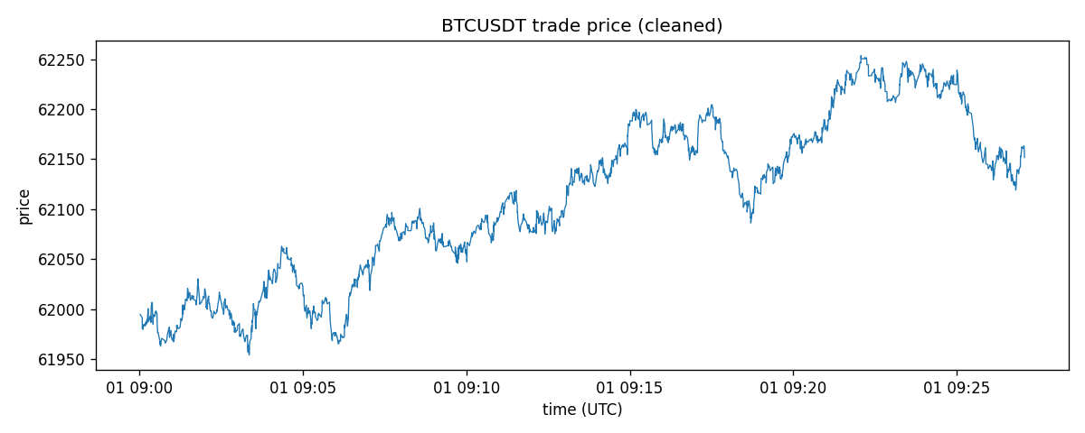
Price line chart
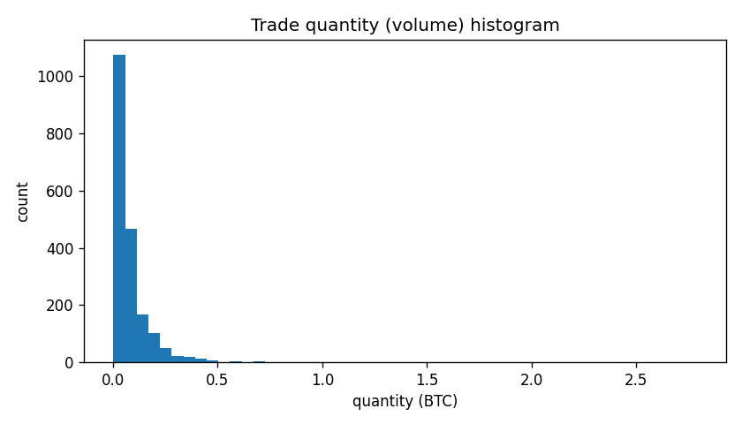
Volume histogram
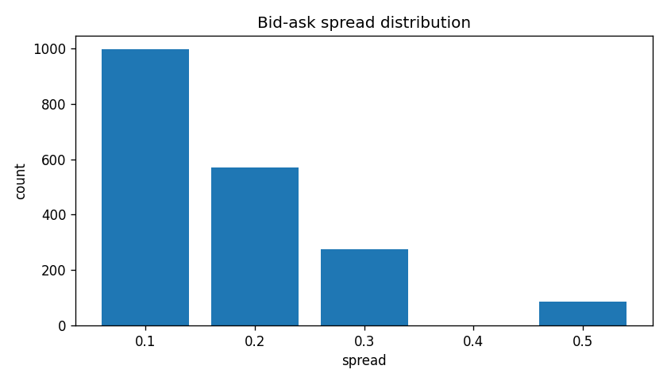
Spread distribution
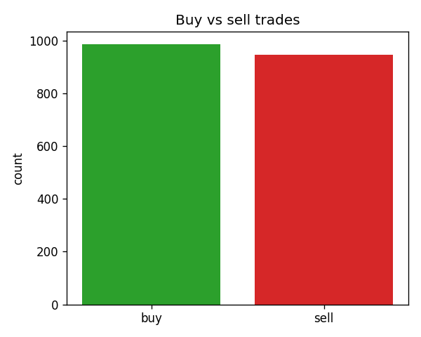
Buy vs sell counts
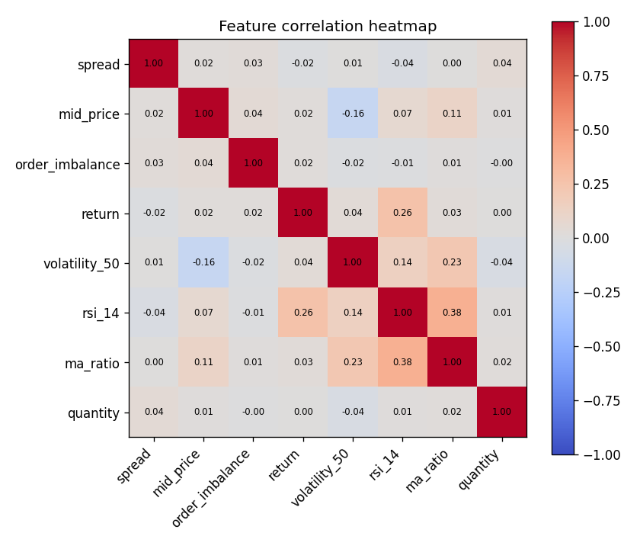
Correlation heatmap

Step 9 - Prepare for a model
Target (price up in 5 minutes), time-based 70/30 split, scaling fitted on the training part only, and the simple order_imbalance > 0.3 rule with a basic backtest.
Code
title("STEP 9: MODEL PREPARATION")
HORIZON = pd.Timedelta(minutes=5)
t = df["timestamp"].to_numpy()
idx_future = np.searchsorted(t, (df["timestamp"] + HORIZON).to_numpy(), side="left")
has_future = idx_future < len(df)
df["future_mid"] = np.where(has_future, df["mid_price"].to_numpy()[np.minimum(idx_future, len(df) - 1)], np.nan)
df["target_up_5min"] = np.where(has_future, (df["future_mid"] > df["mid_price"]).astype(int), np.nan)

model_df = df.dropna(subset=["target_up_5min", "volatility_50", "rsi_14", "ma_50"]).copy()
model_df["target_up_5min"] = model_df["target_up_5min"].astype(int)
print("rows with a full 5-minute future and complete features:", len(model_df))
print("target balance (1 = price up in 5 min):", model_df["target_up_5min"].value_counts().to_dict())

model_feats = ["spread", "order_imbalance", "return", "volatility_50", "rsi_14", "ma_ratio"]
cut = int(len(model_df) * 0.70) # split by TIME, never shuffle
train, test = model_df.iloc[:cut].copy(), model_df.iloc[cut:].copy()
print(f"train: {len(train)} rows {train['timestamp'].min()} -> {train['timestamp'].max()}")
print(f"test : {len(test)} rows {test['timestamp'].min()} -> {test['timestamp'].max()}")
assert train["timestamp"].max() <= test["timestamp"].min()

mu, sd = train[model_feats].mean(), train[model_feats].std() # scaler fitted on TRAIN only
train[model_feats] = (train[model_feats] - mu) / sd
test[model_feats] = (test[model_feats] - mu) / sd
print("scaled train means (should be ~0):", train[model_feats].mean().round(3).to_dict())
train.to_csv("model_dataset_train.csv", index=False)
test.to_csv("model_dataset_test.csv", index=False)

# --- Simple rule + backtest (3Commas demo idea): buy when order_imbalance > 0.3
raw_test = model_df.iloc[cut:]
sig = raw_test["order_imbalance"] > 0.3
ret = raw_test["future_mid"] / raw_test["mid_price"] - 1
print("\nRule: BUY when order_imbalance > 0.3, exit after 5 minutes (no fees, synthetic data)")
print("signals in test set:", int(sig.sum()), "of", len(raw_test))
print("win rate of signals :", round(float((ret[sig] > 0).mean()), 4))
print("avg 5-min return :", f"{ret[sig].mean():.6%}")
print("baseline win rate (all test ticks):", round(float((ret > 0).mean()), 4))
print("Educational only: synthetic data, no fees/slippage, not financial advice.")
print("\nDONE - files written: trades_orderbook_clean.csv, ohlcv_1min.csv, "
"model_dataset_train.csv, model_dataset_test.csv, charts/*.png")

Output
rows with a full 5-minute future and complete features: 1524
target balance (1 = price up in 5 min): {1: 1212, 0: 312}
train: 1066 rows 2026-10-01 09:00:34.922000 -> 2026-10-01 09:15:31.631000
test : 458 rows 2026-10-01 09:15:32.329000 -> 2026-10-01 09:22:03.860000
scaled train means (should be ~0): {'spread': -0.0, 'order_imbalance': 0.0, 'return': 0.0, 'volatility_50': -0.0, 'rsi_14': -0.0, 'ma_ratio': 0.0}

Rule: BUY when order_imbalance > 0.3, exit after 5 minutes (no fees, synthetic data)
signals in test set: 155 of 458
win rate of signals : 0.7548
avg 5-min return : 0.057194%
baseline win rate (all test ticks): 0.7511
Educational only: synthetic data, no fees/slippage, not financial advice.

DONE - files written: trades_orderbook_clean.csv, ohlcv_1min.csv, model_dataset_train.csv, model_dataset_test.csv, charts/*.png

Notes and limitations
- Why 1,930 rows and not 2,000: 35 rows are duplicates and 70 more rows have a value that cannot be recovered from the file. Everything that could be recovered exactly was repaired instead of dropped.
- Unix timestamps are in seconds, not milliseconds as the task README states.
- Candles are built from the cleaned trades, so the 1-minute volumes exclude the 70 dropped trades.
- Backtest: the order_imbalance > 0.3 rule has a win rate (75.5%) almost identical to the baseline of all test ticks (75.1%), so it has no real edge. The synthetic price trends upward, so most 5-minute targets are 'up'. No fees or slippage are included.
- Rolling features (volatility, moving averages, RSI) are NaN for the first rows by design; they are dropped before the model dataset is built.

