REPORT

BY:- PREETI CHAUHAN
REGISTRATION NO :- 25BCE10546
TOPIC:- BURNOUT TRACKER USING PYHTON.
DATE OF MAKING THE REPORT:- 23th NOVEMBER 2025

INTRODUCTION
Burnout is a state of emotional,mental and physical exhaustion caused by long-term stress.
Students often experience burnout due to academic pressure,deadlines , and personal responsibilities.Most people fail to recognize early signs of burnout until it becomes severe.
This project aims to build a simple,rule-based burnout tracking system using Python-based burnout tracking system that helps users monitor their emotional state over a week and visualize changes through a graph.

PROBLEM STATEMENT

There is no simple digital tool for students to quickly track burnout levels and observe weekly emotional patterns without using advanced apps.

This project solves that by providing a lightweight console-based burnout evaluation system
SCREENSHOTS OF THE OUTPUTS:-
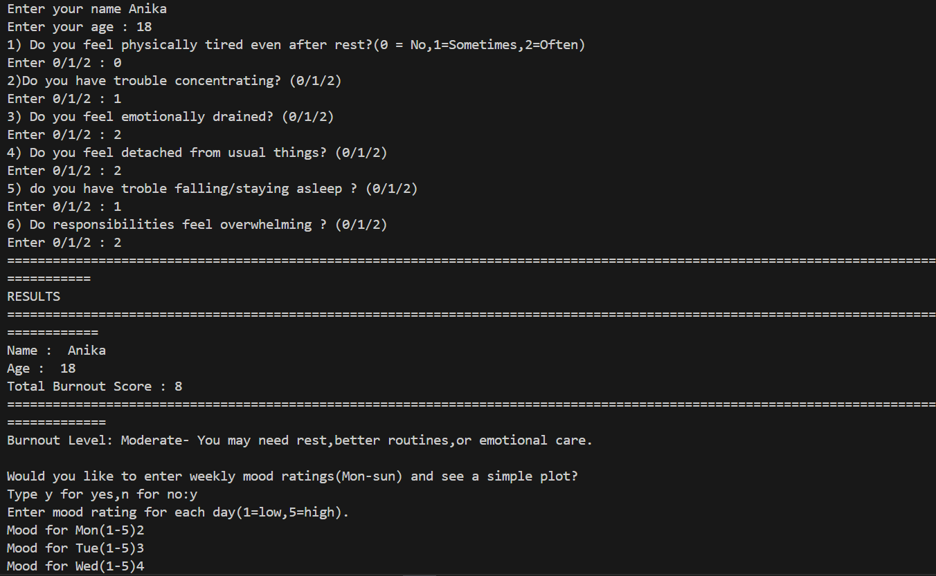

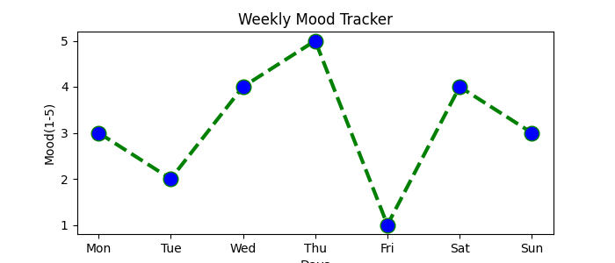

CHALLENGES FACED:-
The following challenges were faced while doing this project:-
- Thinking of a real life problem that can be solved by making a code.
- After thinking of the idea, I had to arrange it in a systematic way so that it looks clean.

CONCLUSION
The “Rule-Based Burnout Tracker “ is a simple yet effective Python tool for tracking emotional well-being . It demonstrates how basic programming concepts like loops,lists and conditional statements can be used to solve real-life problems.
The project also introduces the use of Matlotlib for data visualisation,making the output more insightful.

