Data Owner Registraion table:

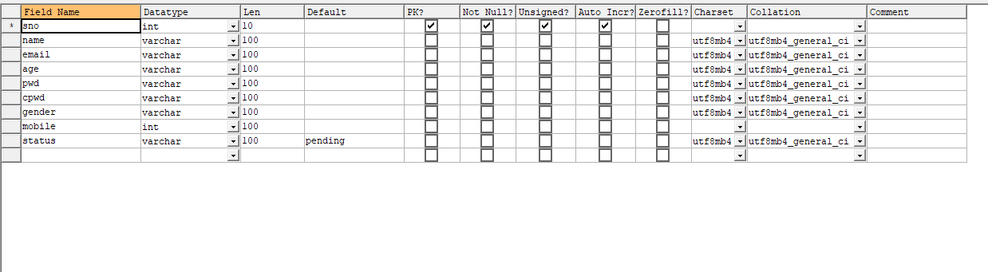

Request table:

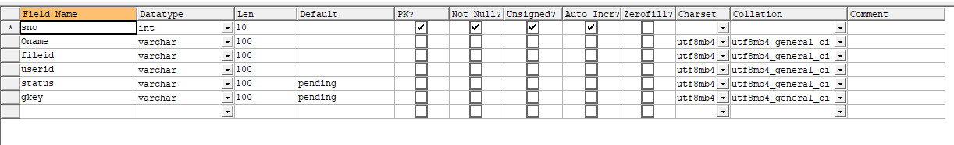

Files Upload:

