Hello Guys, I’m Preeti Here I’m going to demonstrate my final Capstone Project for Web design for everybody.

* So basically its is Portfolio site that describes my work to other people.
* I have completed this site from scratch.

Content of Report

* Snapshot of Site.
* Site URL (Git-hub is used for hosting web pages)
* Responsive web-design. (Desktop View vs Mobile View)
* W3 validation with No Error.
* IS the Site is well Design 🡪 Visit the site
* Extras through Bootstrap 4.
* Image are Responsive
* Presentation

1. Snapshot of my website.

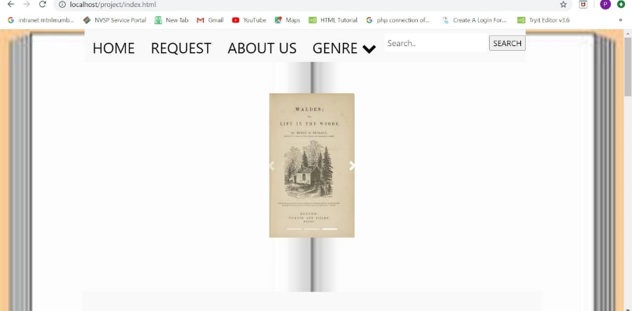 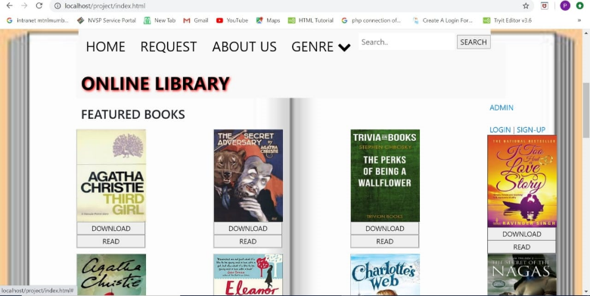

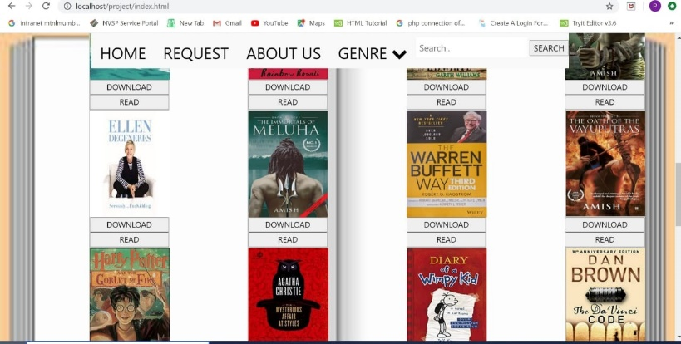 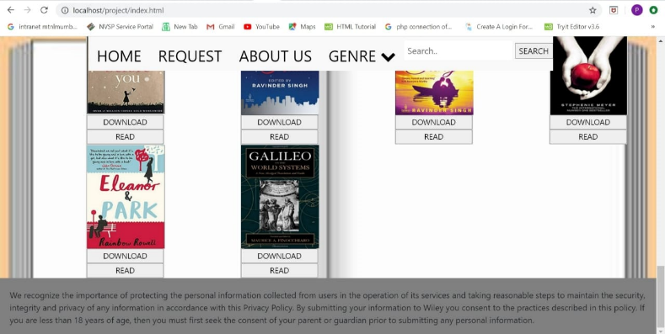

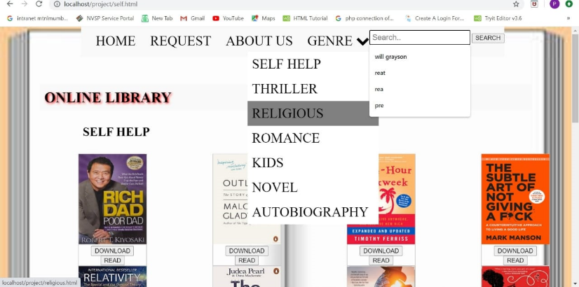 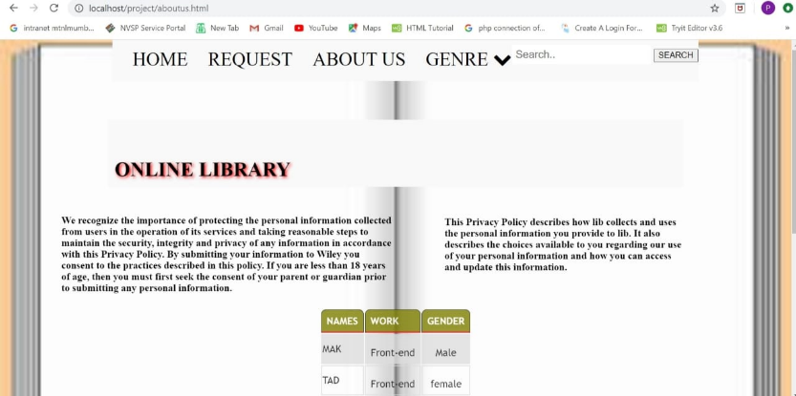

1. Website URL :-

* Here is Website URL.
* GitHub pages helps me out to upload my pages on my own github account.
* I Simply used Git Commands and Git LFS to upload large files on Github pages.
* So here we go the URL of the Site :- https://preetikodwani.github.io/portfolio/

1. Responsive Web-design ( Mobile View VS Desktop View)

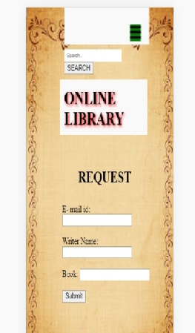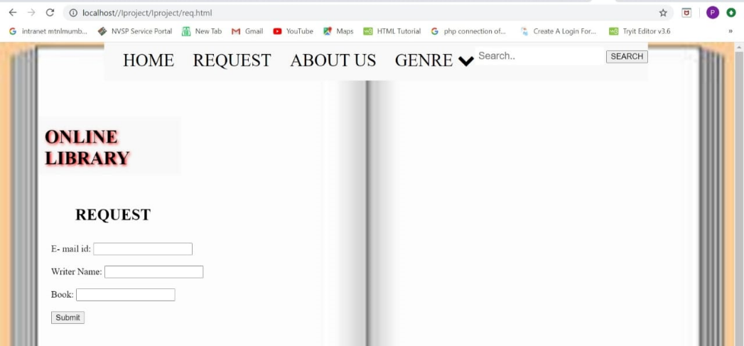

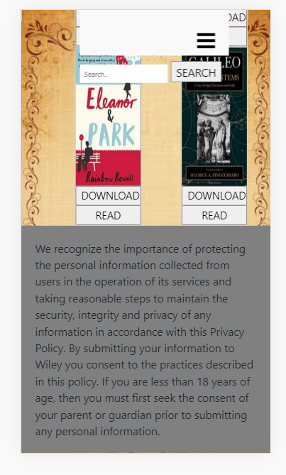

This Two pages shows the Desktop View against the Mobile View. Simply images are stacked on each other due to adding responsive design when there on small screen.

1. W3 validation With no Error :-

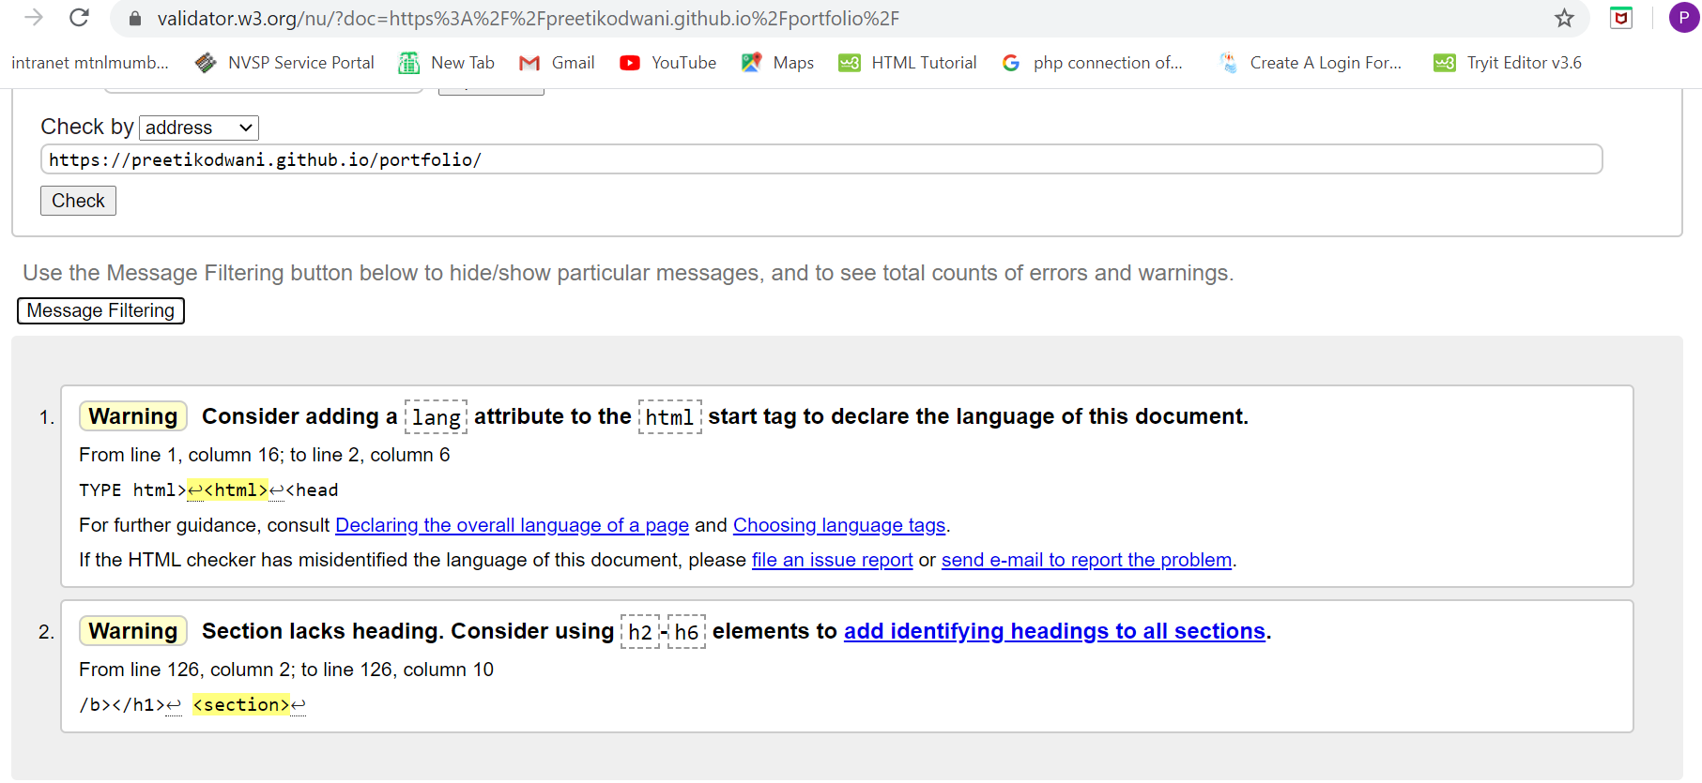

No Error….!!!

Site is validated with no error using <https://validator.w3.org>



1. IS Site is Well Styled..?

You can simply visit the site to see the Styling via CSS3.

https://preetikodwani.github.io/portfolio/index.html

1. Extras Using Bootstrap Four:-
2. Carousel Gallery:-

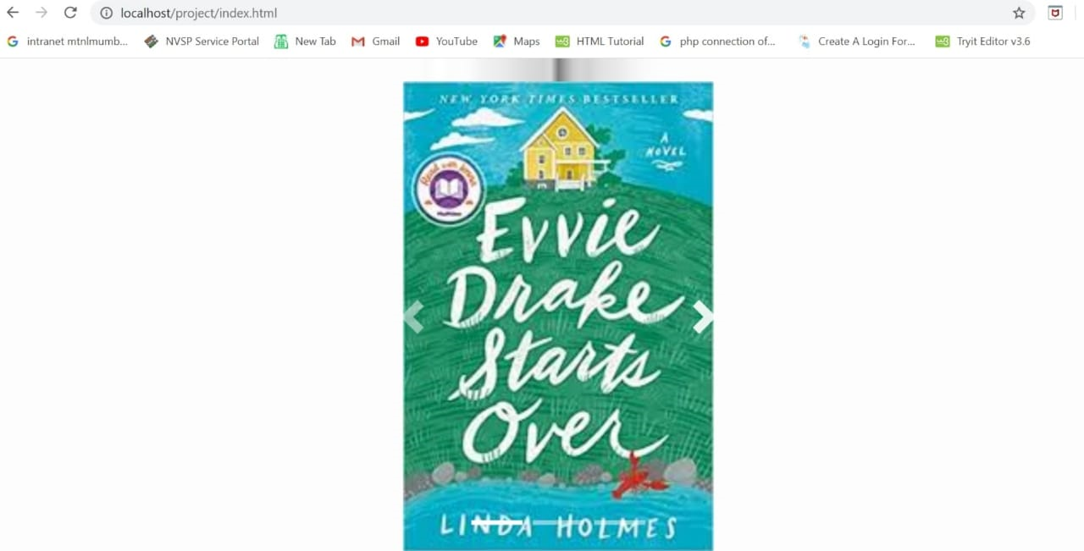

This Figure shows … I have included the carousel gallery where different animation is happening. you can either click on the indicator or transition happen for 3 secs for each image.

Visit site for more visualisation:

1. Sticky Footer :-

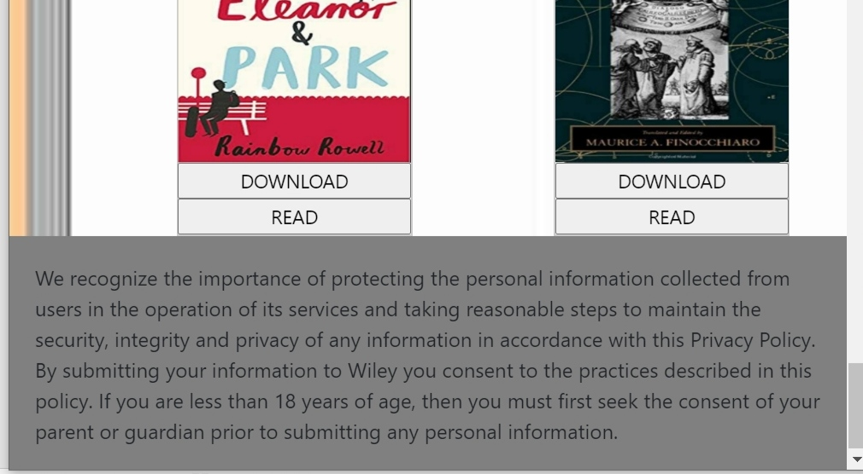

A sticky footer pattern is one where the footer of your page "sticks" to the bottom of the viewport.

1. Bootstrap Tables:

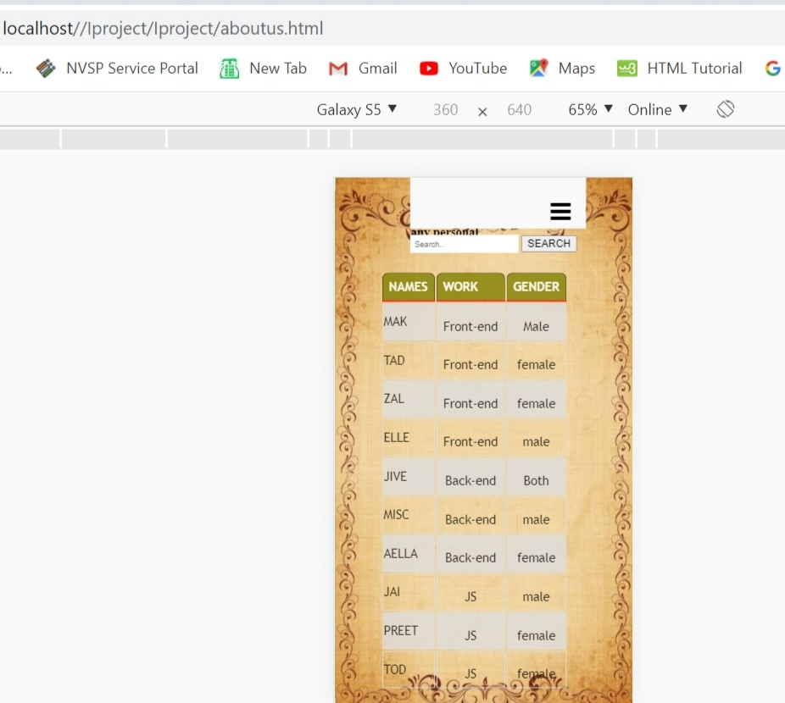

Responsive Tables: -

The. table-responsive class creates a responsive table. The table will then scroll horizontally on small devices (under 768px). When viewing on anything larger than 768px wide, there is no difference.

1. Font Awesome Icon:-

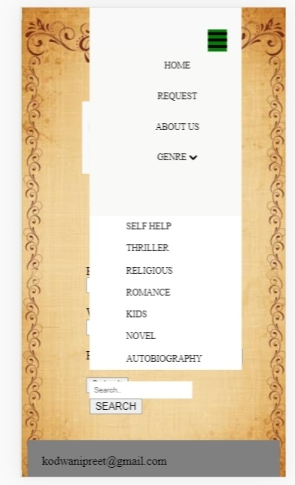

Not enough icons but just two basics ones dropdown and bars.

1. Javascript:

Interaction through javascript and php is done and is running smoothly.

Its shown in video.

1. Images Are Responsive :

This again kind of Mobile View vs desktop view as shown in below figures.

Since bootstrap 4 helps lots in make image responsive apply on both platform.

