//Episode 4:  
>JSX is not mandatory  
>ES6 or etc. is not mandatory

>Typescript is also not mandatory  
  
  
>Any piece of JSX component ,there is only parent element.  
  
// React.Fragment :  
  
It's known as Empty Tag or a react component, we usually use it when we have to wrap children in one parent element , and we don’t want to use ‘div’ , so we use <> </> (empty Tag).  
>this component comes from ‘react’ core library  
<React. Fragment></React. Fragment> === <> </>   
  
Inline CSS:  
  
// 1st way :

Styles values must passed as a key :value pair or js object,that’s, {{}}, double curly brackets means we can write any piece of js in {}, nd {{backgroundColor:"#f0f0f0"}}> has passed as a js object here.

<div className="cardBody"  style={{backgroundColor:"#f0f0f0"}}> </div>

2nd way:  
>create a js variable with an object and passed it directly variable name.

const styling ={

backgroundColor:"#dac6c6",

}

<RestroCard name={restroDetails[1].name} img={restroDetails[1].img} star={restroDetails[1].star}  style={styling}/>

>If there is list of arrays and want to seprate their elemnets by comma or anything use ‘ .join( “, “) ‘ with the list name  
  
  
Config Driven UI:  
It means a website or UI driven/controlled by API data/ data.  
  
  
//props or properties :  
>passing data/properties inside component  
> It’s similar to a normal js function where an argument passed to an function parameter( here it called as props).   
  
  
//spread operator …  
// {} -> it use to extract values  
  
//destructor  
//.map() is best way for functional programming, where there is iteration or looping of component,use .map()  
// if there is any iteration always pass unique ‘key’ .   
  
//try to avoid usage of index as a ‘key ‘, consider/pass something unique id as a key. But passing key is must in any iteration.  
  
>while using map(), always give key to parent element.  
  
// virtual DOM: Representation of DOM.  
Q. Reconciliation:  
//Q. React fiber :new Reconciliation engine

// optional chaining => ‘?.’

// Episode 5:  
  
>to maintain code , we generally structure our folder,  
create utils folder inside ‘src’ folder nd inside utilis create config.js/ contacts.js file where we keep hardcoded data like URL or any variables etc.

>Every component in React ,maintain its state.  
>local state variable are similar to normal js variable, however these state variable has superpowers unlike normal js variable.  
>so in react instead of normal js variable , we use state variable.

HOOK: It’s a normal js utility function .

every hook has specific function for a particular hook.  
e.g of hooks are , useState, useEffect etc.  
  
useState :  
>It’s a hook given by React, use to create super powerful local state variable inside functional component.  
>Never use useState() outside functional component.  
>Never create state variable/ use useState() inside ‘if condition’, or ‘for loop’ or inside a new function.  
>this hook returns an array, whereas 1st item of array is variable name, and 2nd item is a function which update the variable.  
  
Imp:\*  
>Never create component inside a component

Import and Export are done by two types:  
1>Default Import and Export  
2>Named Import and Export

Note\*  
>React is fast bcoz it doing efficient DOM Manipulation , bcoz it has virtual DOM.  
>React use Reconciliation Algorithm also known as React fiber  
>React 16 came with new Algo called React Fiber.It’s a new way to find difference between old DOM nd new Dom and update the Dom accordingly.  
  
Imp\*  
>Whenever state variable update/change, React Re-render the component.

Q. what is state variable, why do we use it?  
Q. what is React Hooks?  
Q. what is useState?  
Q. events like, onchange, onclick etc.?  
Q. Data binding in React?  
Q. e.target.value?  
Q. Diff Algo, Reconciliation, React Fiber?  
  
Dom:  
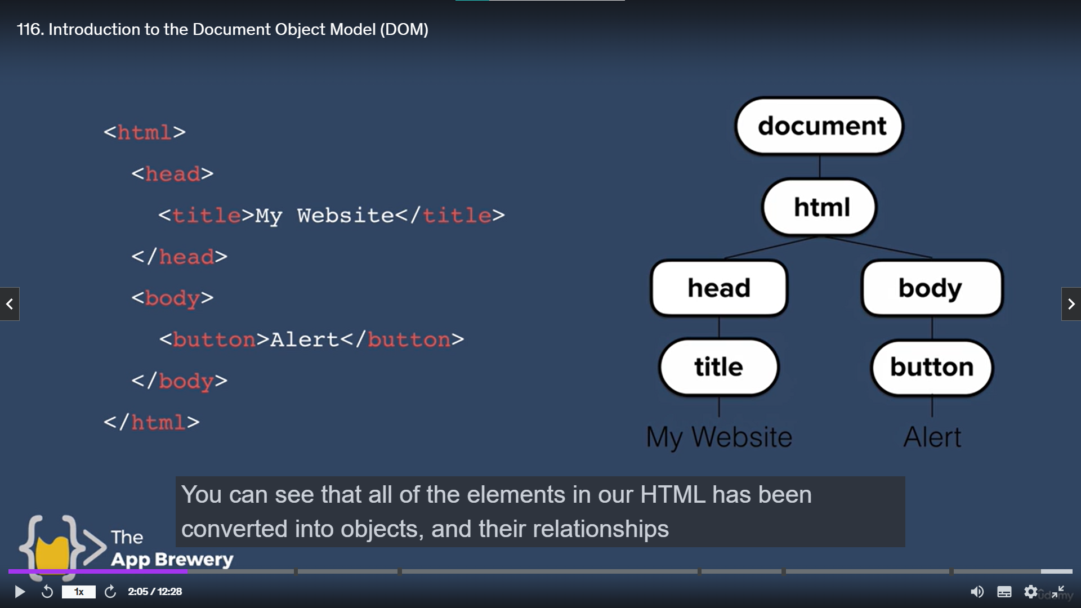  
  
Dom introduce to solve fly changes of web pages while loading it.  
It's basically catalogue of a web page, which represent into individual object which can we select and manipulate.  
  
>when a page load , browser turns each of elements and it’s associated data into Tree structure with a whole bunch of objects, which can be selected and manipulated as per requirement.  
>Dom represent in tree structure.  
>All html elements converted into object and their relationship to each other element mapped out in the tree diagram .  
“Document”=>it’s a objects, which contain entire html element as a objects.  
whereas, each object has some properties and methods, which can be used to manipulate Dom object /html element.  
