Ep:12  
  
Redux:it manages data layer, also known for managing state.  
>It has high/huge learning curve.(take time to learn/understand )  
>It has complex configuration  
>No need of it in small applications, better use in large scale application.  
>Note: React and Redux are different.

>easier to debug using chrome extension(devreduxtool)  
  
Redux toolkit(rtk): solution of Redux drawbacks or issues  
i.e  
>redux store configuration is too complicated, but it’s easy with redux toolkit

>redux need lot of external package to make something work, redux toolkit has resolved this prblm.  
>Redux require too much boilerplate, it has been resolved in Redux toolkit.  
  
Redux store:it’s like a big objects of some piece of section  
>All comp. of an application can access redux store.  
>Big object kept in single global central space.

>we can have multiple context but in Redux we have only single redux store to keep all type of data which is separated into different slices(small portion of store)   
>we can’t modify store directly through a component.  
  
//install these packages for redux:  
npm I @reactjs/toolkit =>it’s a core of redux

npm I react-redux => it’s bridge b/w react & redux

//in this way we can update store:  
  
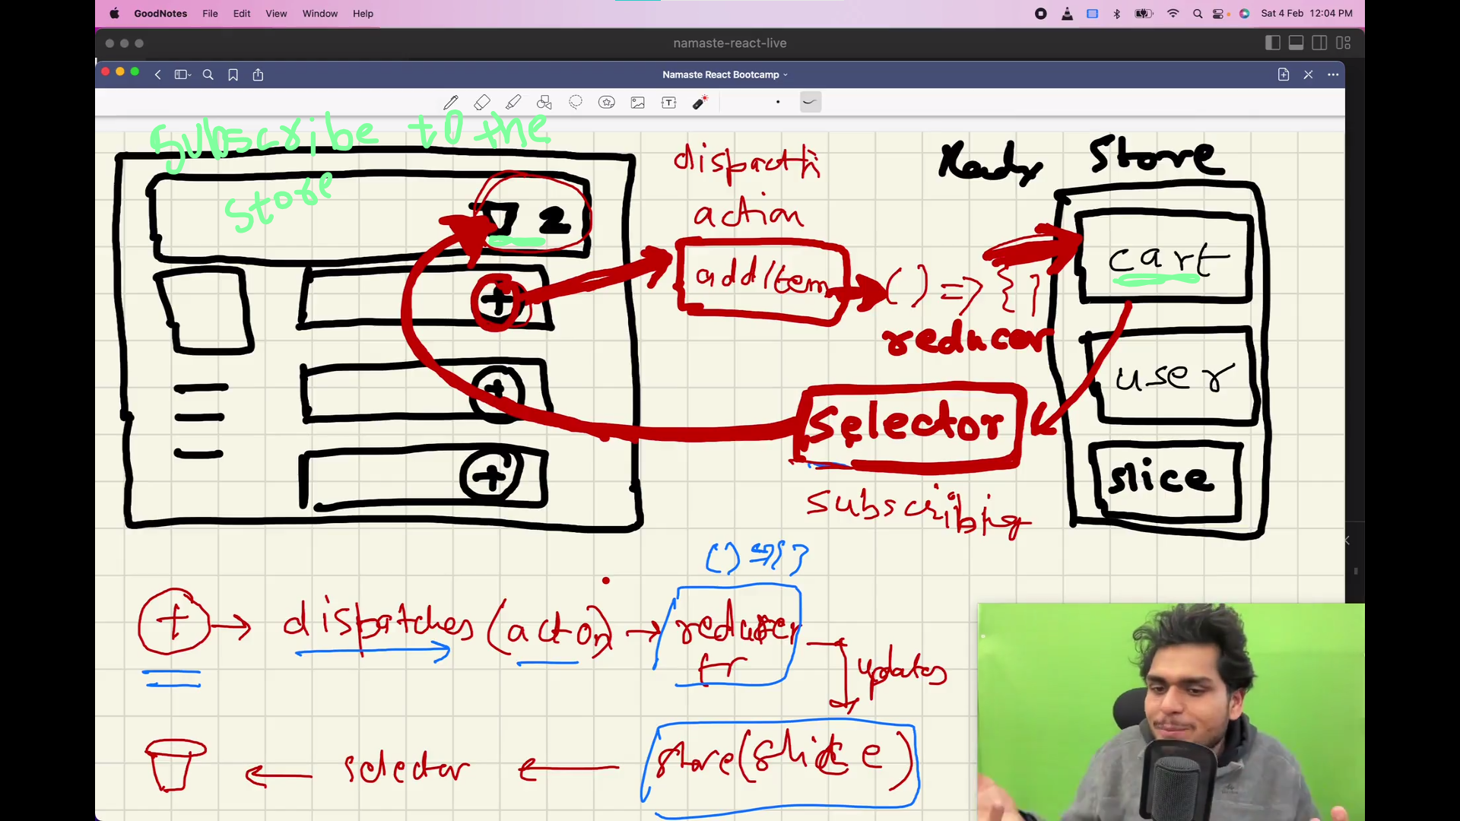  
>if we click on any button or anything ,it dispatch the action, which calls the reducer function (callback function ) which modifies/update slice of a redux store.  
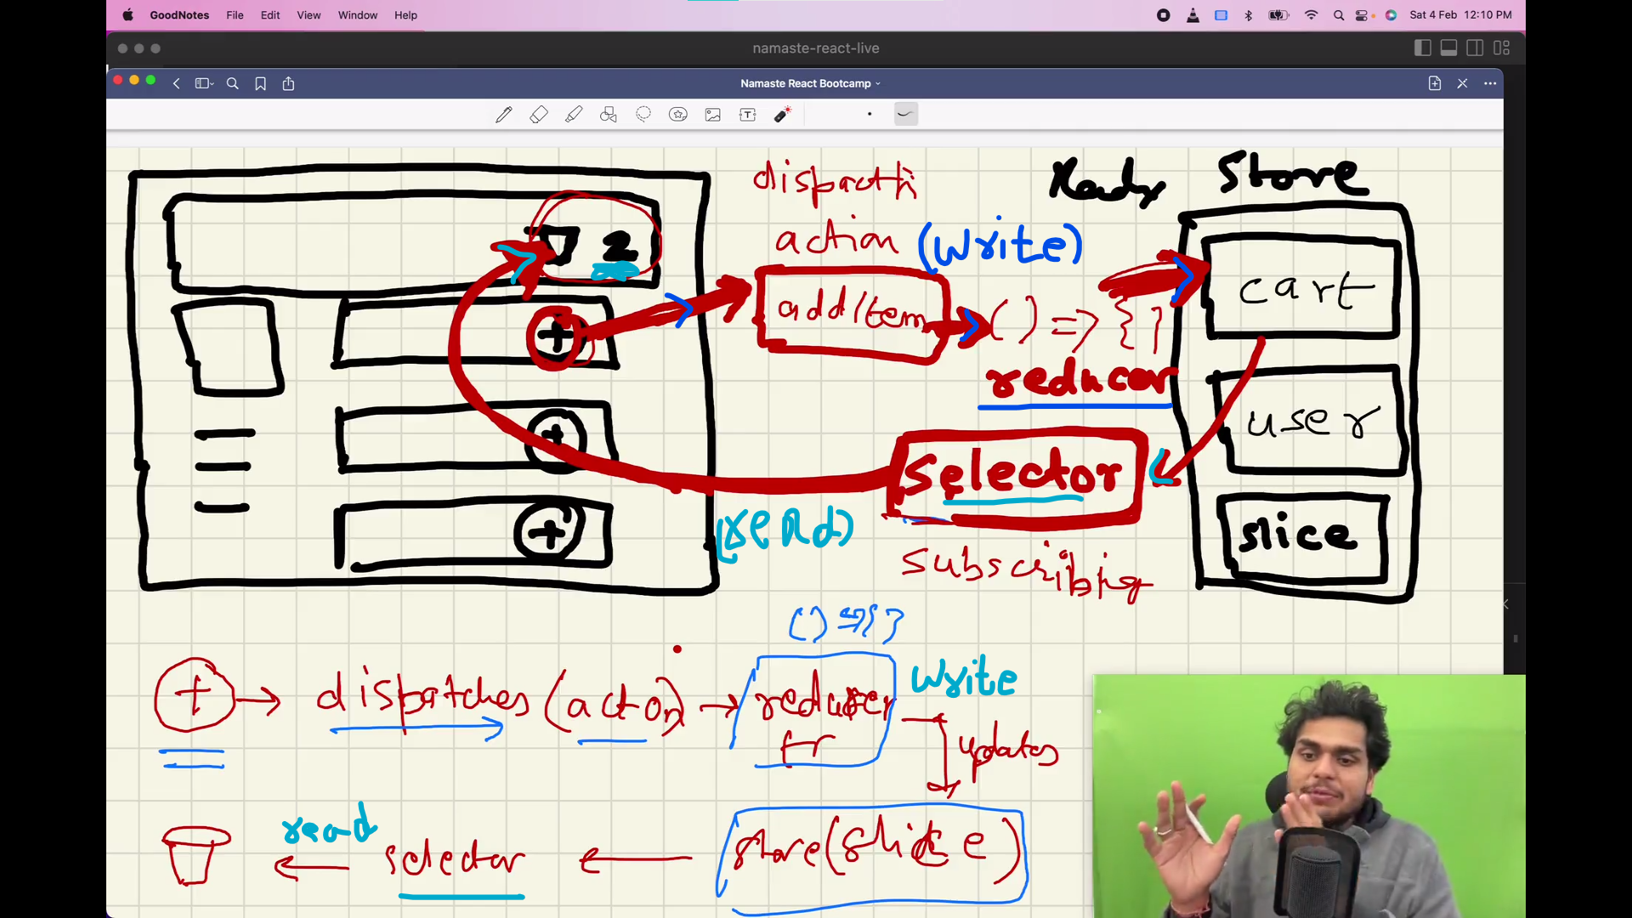  
>for writing into the store we use reducer function

>for Reading data from the store we use selector  
Selector: it’s a hook ,by using useSelector we can read data from redux store. And it’s also known as subscribing .  
like here cart component/item is subscribed to slice cart of redux store so whenever store update the UI of cart item/comp. also get updated.  
  
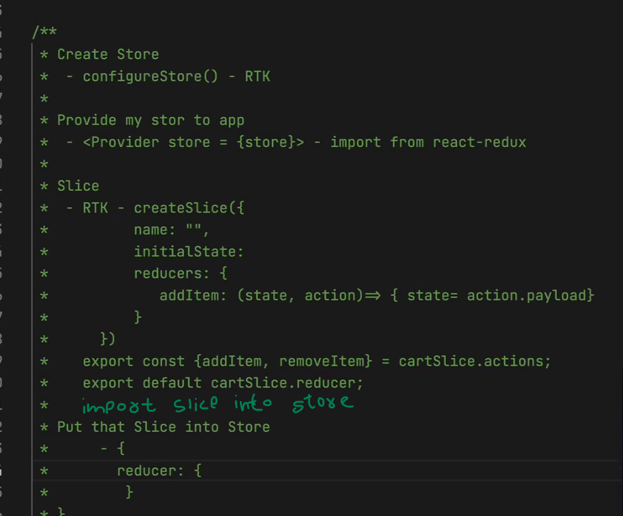

<Provider store={}>

=>it’s a component

useSelector():

>To subscribe to the store.  
>This is the place where we tell that what we are subscribing to.  
  
Note:  
Anything related hooks or component using inside application components, which directly effect the UI is come from ‘react-redux’.  
  
>reducer doesn’t return anything

//Q. zustand, middlewear, RTk query, thunk, redux devtool, web vitals, sprint mechanism,web performance, attack,  
  
//Q. array ,string ,map,set, debounce, throatling, memorizing,useMemo,