SOFTWARE REQUIREMENTS SPECIFICATION
DvantaQA360 — Web-Based Automated Testing & Performance Platform
An Integrated Manual, AI-Driven, and Local-AI (Ollama) Functional Testing
and Performance Benchmarking SaaS Platform
Document Version: 1.0
Status: Draft for Review
Prepared For: DvantaQA Project Stakeholders

Table of Contents
Table of Contents 2
1. Introduction 4
1.1 Purpose 4
1.2 Scope 4
1.3 Intended Audience 4
1.4 Definitions, Acronyms, and Abbreviations 4
1.5 Document Conventions 5
1.6 References 5
2. Overall Description 6
2.1 Product Perspective 6
2.2 Product Functions — Summary 6
2.3 User Classes and Characteristics 6
2.4 Operating Environment 7
2.5 Design and Implementation Constraints 7
2.6 Assumptions and Dependencies 7
3. System Features (Functional Requirements) 8
3.1 Home Page & Authentication 8
3.2 Dashboard 8
3.3 Manual Testing Module 8
3.4 AI-Powered Testing Module 9
3.5 Local AI (Ollama) Fallback Module 9
3.6 Live Test Execution & Self-Fix 10
3.7 Test Reporting Module 10
3.8 Performance Testing Module 10
3.9 Live Performance Logs & Dashboard Graphs 11
3.10 Performance Reporting & Summary 11
3.11 Grafana Integration (Optional) 11
4. External Interface Requirements 13
4.1 User Interfaces 13
4.2 Hardware Interfaces 13
4.3 Software Interfaces 13
4.4 Communication Interfaces 13
5. Data Model 14
5.1 Entity Notes 14
6. Non-Functional Requirements 15
6.1 Performance 15
6.2 Security 15
6.3 Reliability & Availability 15
6.4 Usability 15
6.5 Scalability 15
6.6 Maintainability 15
Appendix A — Manual Test Case JSON Schema 16
Appendix B — Supported Test Step Actions 16
Appendix C — Glossary 17

1. Introduction

1.1 Purpose
This Software Requirements Specification (SRS) defines the functional and non-functional requirements for the DvantaQA360 platform — a web-based application that allows a user to register, log in, and test the functionality and performance of their own website directly from a browser dashboard, without needing to install or run any command-line tooling. The document is intended to guide the frontend team (Next.js/TypeScript), backend team (Spring Boot/MySQL), and the underlying test-execution engine team through a single, unambiguous specification, so the product can be developed, reviewed, and shipped as production-ready software.

1.2 Scope
The platform wraps an existing automated testing and performance engine (internally referred to as the DvantaQA360 engine) inside a full multi-user web product. In scope for this specification:
- User registration, login, and session management.
- A central Dashboard from which a user manages their own projects, tests, and reports.
- A Manual Testing module, where the user uploads or pastes JSON-based test cases, which are validated for correct syntax before being accepted.
- An AI-Powered Testing module, where the user supplies a website URL (and optionally specific sub-URLs), the platform crawls the site, builds a page inventory, and — using a Gemini/OpenAI API key supplied and verified at run time — generates test cases automatically.
- A Local-AI fallback (Ollama) module for users who have neither manual test cases nor a paid AI key, so the platform can still generate and run tests end-to-end at no external cost.
- A Live Test Execution view that opens in a new dashboard tab and shows the real browser running the test steps, with an option for the user to attempt a self-fix when a step fails.
- An automatic Test Report, generated after every run and stored in the user's Reports section for viewing and downloading.
- A Performance Testing module where the user sets load parameters (virtual users and duration) and watches live performance logs on the dashboard.
- A Performance Report with a dynamic, graph-based Summary section covering recent activity, pass/fail/error counts, and performance trends.
- Optional Grafana/Prometheus integration: when a user connects their own Grafana instance, its metrics are fetched in parallel with the platform's own performance run and shown side by side.
Out of scope: payment/billing, mobile native apps, and test types other than web UI functional testing and HTTP-level load/performance testing.

1.3 Intended Audience
- Frontend developers building the Next.js/TypeScript dashboard and UI.
- Backend developers building the Spring Boot/MySQL API, auth, and orchestration layer.
- QA/DevOps engineers integrating the Playwright + k6 execution engine.
- Project stakeholders and reviewers who need a plain, production-ready reference document.

1.4 Definitions, Acronyms, and Abbreviations
Term | Meaning
SRS | Software Requirements Specification (this document).
Manual Mode | Testing mode where the user supplies their own test cases as JSON.
AI Mode | Testing mode where the platform crawls the site and an AI provider (Gemini/OpenAI) generates test cases.
Ollama Mode | Fallback AI mode using a locally hosted open-source model when the user has no manual tests and no external AI key.
VU | Virtual User — a simulated concurrent user during a performance run.
P50 / P95 / P99 | 50th / 95th / 99th percentile response-time latency metrics.
RPS | Requests Per Second.
Self-Fix | An assisted step where, if a test step fails, the user can trigger an automatic suggestion/repair of the failing selector or step before re-running.
Agentless Mode | Performance reporting mode used automatically when the user has not connected Grafana — metrics come from the load engine only.
JWT | JSON Web Token, used for authenticated sessions.

1.5 Document Conventions
Functional requirements are numbered per module using the pattern FR-<MODULE>-<n> (e.g., FR-AUTH-1). Each requirement is independently testable. Priority levels used throughout: Must Have, Should Have, Could Have (MoSCoW).

1.6 References
- DvantaQA360 engine README and Architecture notes (internal engine: Playwright + k6 + Chart.js + optional Grafana/Prometheus + Gemini/OpenAI/Ollama).
- Existing manual-test-cases.json schema and supported step actions (Appendix A and B).

2. Overall Description

2.1 Product Perspective
DvantaQA360 is a new, self-contained SaaS product. It is composed of four cooperating layers: a Next.js/TypeScript frontend, a Spring Boot/MySQL backend that owns authentication, data, and orchestration, a Node.js/Playwright/k6 execution engine that actually drives the browser and load tests, and optional external services (an AI provider or a user's own Grafana instance) that the user may connect. The high-level architecture is shown below.
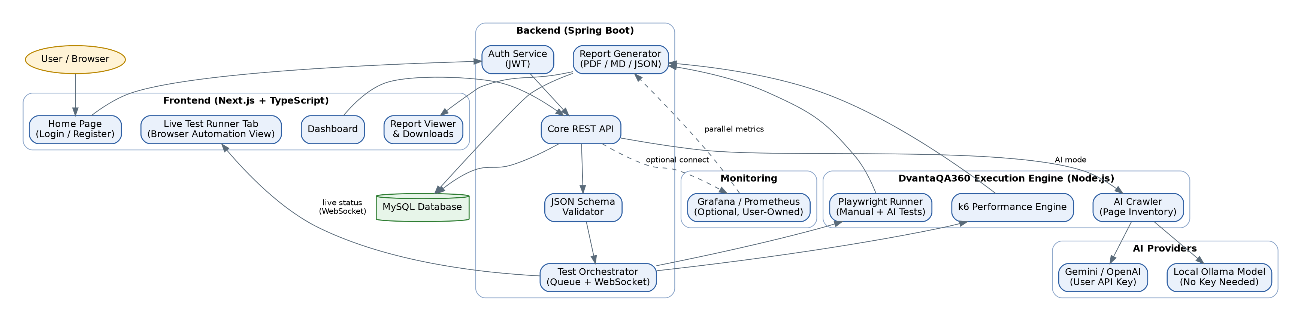
Figure 2.1 — High-level system architecture.

2.2 Product Functions — Summary
- Account registration and login.
- Project/website registration on the dashboard.
- Manual test case upload with live JSON syntax validation.
- AI-driven crawl-and-generate test case creation (Gemini / OpenAI key).
- Local Ollama-based test case generation when no key and no manual tests exist.
- Live, in-browser test execution in a dedicated dashboard tab, with optional self-fix.
- Automatic test report generation, storage, viewing, and downloading.
- Configurable performance (load) runs with live log streaming.
- Dynamic, graph-based performance summary and history.
- Optional parallel Grafana/Prometheus metrics when the user connects their own instance.

2.3 User Classes and Characteristics
User Class | Description
New User | Has no account yet; lands on the Home Page and must register.
Registered User (Manual Tester) | Has their own written test cases in JSON and just wants to run and monitor them.
Registered User (AI Tester) | Has an AI provider key (Gemini/OpenAI) and wants tests auto-generated from their live site.
Registered User (No Key / No Manual Tests) | Has neither; relies on the built-in local Ollama model to generate and run tests end-to-end for free.
Registered User with Grafana | Already monitors their own infrastructure with Grafana/Prometheus and wants that data alongside the platform's own performance run.
Administrator (future) | Manages users and platform-level settings; not required for the initial production release but the data model should not block adding this role later.

2.4 Operating Environment
- Frontend: Next.js + TypeScript, served over HTTPS, responsive for desktop and tablet.
- Backend: Spring Boot (Java), exposing a REST + WebSocket API.
- Database: MySQL for all persistent data (users, projects, test suites, runs, reports).
- Execution engine: Node.js with Playwright (Chromium) and k6, invoked and supervised by the backend, one isolated run per user/project at a time.
- Deployment target: Linux server / container; browser automation runs headless in production.

2.5 Design and Implementation Constraints
- Each user's test run must execute in isolation (its own browser context and its own k6 process) so concurrent users never see each other's data or logs.
- AI provider keys (Gemini/OpenAI) are supplied by the user at run time, verified before use, and must not be permanently stored in plain text.
- Grafana connection details are optional, user-owned, and the platform must degrade gracefully to Agentless Mode when absent.
- Manual test case JSON must be validated against a fixed schema before it is accepted; invalid JSON must never reach the execution engine.

2.6 Assumptions and Dependencies
- The target website under test is reachable over the public internet or a network accessible to the execution engine.
- If the user chooses AI Mode, they either provide a valid Gemini/OpenAI key or accept the platform's local Ollama model as a substitute.
- If the user wants CPU/Memory-level infrastructure metrics, they must connect their own Grafana/Prometheus; otherwise, only load-engine metrics (RPS, latency, error rate) are available.

3. System Features (Functional Requirements)

3.1 Home Page & Authentication
The Home Page is the first screen every visitor sees. It presents the product briefly and offers two actions: Register (for first-time users) and Login (for returning users).
FR-AUTH-1: The system shall display a Home Page with clearly separated Login and Register actions.
FR-AUTH-2: The system shall allow a new user to register with name, email, and password; the email must be unique.
FR-AUTH-3: The system shall allow a registered user to log in with email and password and receive a signed session token (JWT).
FR-AUTH-4: The system shall redirect an authenticated user straight to the Dashboard; an unauthenticated user attempting to open the Dashboard shall be redirected back to the Home Page.
FR-AUTH-5: The system shall allow the user to log out, invalidating the current session token.
Priority: Must Have.

3.2 Dashboard
The Dashboard is the user's control center after login. From here the user can register a website/project to test, choose Manual, AI, or Ollama testing mode, start a performance run, and reach their Reports section.
FR-DASH-1: The system shall let the user add a project by entering the target website URL and a display name.
FR-DASH-2: The system shall present the choice between Manual Testing and AI-Powered Testing for each project.
FR-DASH-3: The system shall show, at a glance, the user's most recent test runs, most recent performance runs, and a shortcut to Reports.
FR-DASH-4: The system shall show whether a Grafana connection is configured for the current project, and allow the user to add or update it at any time.
Priority: Must Have.

3.3 Manual Testing Module
This module supports users who already maintain their own test cases as JSON, following the format already used by the underlying engine (see Appendix A).
FR-MAN-1: The system shall allow the user to upload a JSON file, or paste JSON directly, containing an array of test cases.
FR-MAN-2: The system shall validate the JSON syntax and schema (required fields: id, feature, priority, steps[], expectedResult; each step must use a supported action — see Appendix B) at the moment of upload, before accepting it.
FR-MAN-3: If validation fails, the system shall reject the file, keep the user on the same screen, and show the exact error (e.g., malformed JSON, missing field, unsupported action) with the offending line/test case identified wherever possible.
FR-MAN-4: If validation succeeds, the system shall enable the Run Test action and store the validated test suite against the project.
FR-MAN-5: The system shall let the user edit and re-validate a previously uploaded test suite without creating a duplicate project.
Priority: Must Have.

3.4 AI-Powered Testing Module
This module is for users who do not want to hand-write test cases and instead want the platform to discover their site and generate tests automatically, using their own Gemini or OpenAI key.
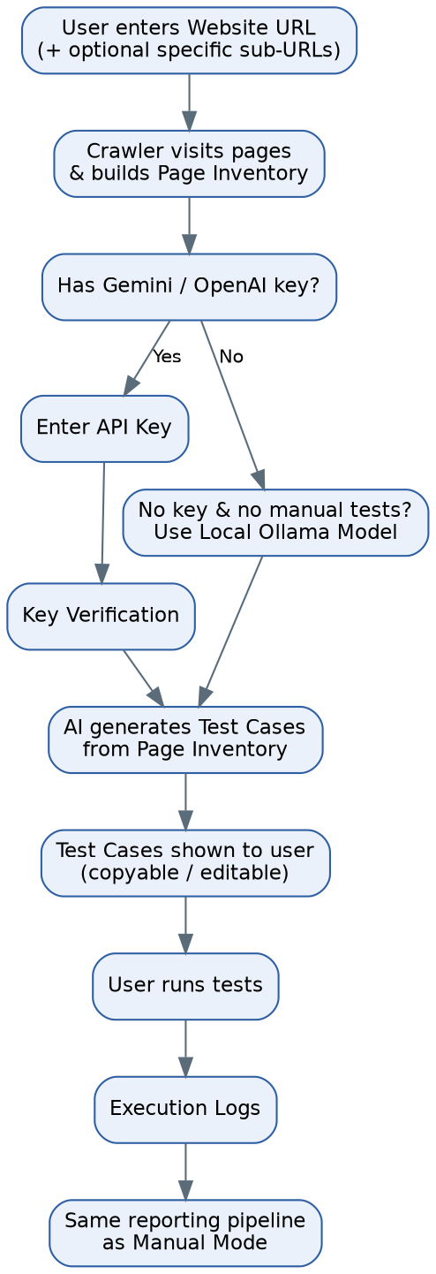
Figure 3.1 — AI mode flow: crawl → key verification → generation → execution.
FR-AI-1: The system shall provide an AI Testing section where the user enters their website URL.
FR-AI-2: The system shall allow the user to optionally restrict the crawl to specific sub-URLs instead of the whole site.
FR-AI-3: The system shall crawl the given URL(s), discover interactive elements/pages, and build a page inventory.
FR-AI-4: The system shall prompt the user for a Gemini or OpenAI API key before generation, and shall verify the key with a lightweight call before proceeding.
FR-AI-5: If the key fails verification, the system shall show a clear error and let the user re-enter the key or switch to Ollama Mode (section 3.5).
FR-AI-6: Once verified, the system shall generate test cases from the page inventory using the selected AI provider, and display them to the user.
FR-AI-7: The system shall let the user copy the generated test cases in one action.
FR-AI-8: The system shall let the user run the generated test cases immediately, following the same execution flow as Manual Mode (section 3.6).
Priority: Should Have.

3.5 Local AI (Ollama) Fallback Module
For a user who has neither a manual test suite nor a Gemini/OpenAI key, the platform must still be able to produce a working test suite. This module uses a locally hosted open-source model (Ollama) to perform the same crawl-to-test-case job as section 3.4, at no cost to the user and with no external key required.
FR-OLLAMA-1: The system shall detect when a project has no manual test suite and no AI key provided, and offer Ollama Mode as the default path.
FR-OLLAMA-2: The system shall run the same crawl and page-inventory step as AI Mode, then generate test cases using the local Ollama model instead of an external API.
FR-OLLAMA-3: The system shall present Ollama-generated test cases for review, copy, and execution using the same UI as AI Mode.
FR-OLLAMA-4: The system shall clearly label Ollama-generated results as such, so the user always knows which engine produced a given test suite.
Priority: Should Have.

3.6 Live Test Execution & Self-Fix
Whichever mode produced the test cases (Manual, AI, or Ollama), execution behaves the same way: it opens in a new tab on the dashboard and drives a real browser through each step.
FR-EXEC-1: The system shall open a new dashboard tab that shows the live, in-progress browser test run for the selected test suite.
FR-EXEC-2: The system shall execute each test step in order (goto, click, fill, select, check/uncheck, expectVisible, expectText, wait, setViewport, reload, goBack) exactly as defined by the test case.
FR-EXEC-3: If a step fails, the system shall pause on that step and clearly flag the failure to the user, without silently continuing.
FR-EXEC-4: The system shall offer a Self-Fix action on a failed step, which attempts an automatic repair suggestion (for example, a corrected selector) that the user can accept and re-run.
FR-EXEC-5: The system shall allow the user to skip a failed step and continue the remaining suite if they choose not to self-fix.
FR-EXEC-6: Upon completion (pass, fail, or partially fixed), the system shall automatically generate a Test Report and place it in the user's Reports section without requiring a manual export step.
Priority: Must Have.

3.7 Test Reporting Module
FR-REP-1: The system shall list every generated test report under the user's Reports section, newest first.
FR-REP-2: The system shall let the user open a report in-browser to see pass/fail status per test case, screenshots on failure, and the overall summary.
FR-REP-3: The system shall let the user download a report (PDF and/or JSON) for offline sharing.
Priority: Must Have.

3.8 Performance Testing Module
After functional testing, the user can load-test the same website by specifying how many virtual users and for how long.
FR-PERF-1: The system shall let the user start a performance run by entering the number of virtual users (VUs) and the run duration.
FR-PERF-2: The system shall validate the entered values (VUs and duration must be positive, within a configured safe maximum) before starting the run.
FR-PERF-3: The system shall start the load engine against the target project URL once inputs are valid.
FR-PERF-4: The system shall prevent a second performance run from starting on the same project while one is already active.
Priority: Must Have.

3.9 Live Performance Logs & Dashboard Graphs
FR-PLOG-1: The system shall stream live performance logs to the Dashboard's Performance Logs area while a run is in progress.
FR-PLOG-2: The system shall let the user copy the current logs in one action at any time.
FR-PLOG-3: The system shall let the user generate a Performance Report directly from the logs, either during or after the run.
FR-PLOG-4: The Dashboard shall render dynamic graphs (updated as new data arrives) showing request throughput, error counts, and overall performance score for the active or most recent run.
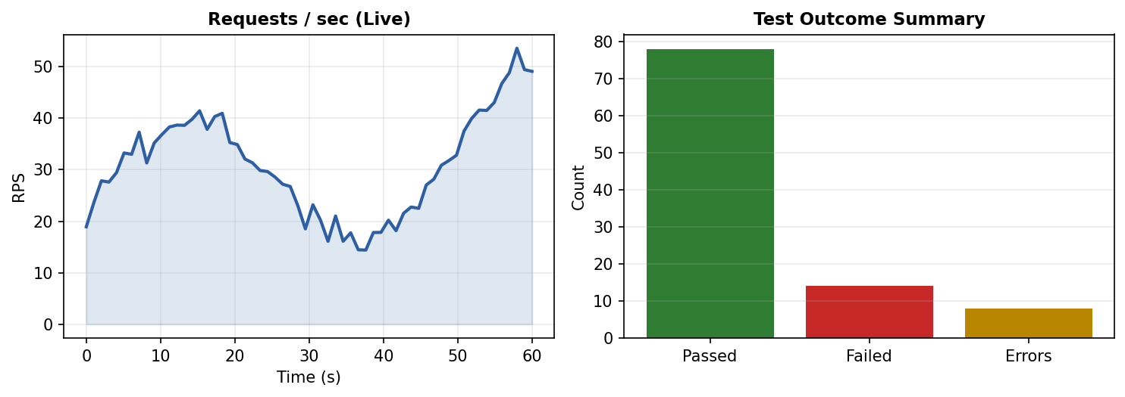
Figure 3.2 — Illustrative dashboard graphs: live throughput and test outcome summary.
Priority: Must Have.

3.10 Performance Reporting & Summary
FR-PREP-1: The Performance Report shall include a Summary section listing the user's recent activity: which projects were tested, when, and with what settings.
FR-PREP-2: The Summary section shall show, with graphs, the count of errors, count of passed checks, and an overall performance indicator for each recent run.
FR-PREP-3: The system shall let the user download the Performance Report (PDF and/or JSON) in addition to viewing it on-screen.
FR-PREP-4: The system shall retain historical performance runs per project so the Summary can show trends over time, not just the latest run.
Priority: Must Have.

3.11 Grafana Integration (Optional)
FR-GRAF-1: The system shall allow a user who already runs Grafana/Prometheus for their own site to enter their Grafana URL and access token against a project.
FR-GRAF-2: When a Grafana connection is configured, the system shall fetch CPU/Memory/Network metrics for the duration of the performance run and display them in parallel with the platform's own load-engine metrics.
FR-GRAF-3: When no Grafana connection is configured, the system shall run in Agentless Mode: load-engine metrics (RPS, latency percentiles, error rate) are shown normally, and hardware metrics are shown as Not Available rather than causing an error.
Priority: Could Have.

4. External Interface Requirements

4.1 User Interfaces
The end-to-end user journey across all major screens is shown below. Solid arrows are the primary path; dashed arrows are optional branches (self-fix, Grafana).
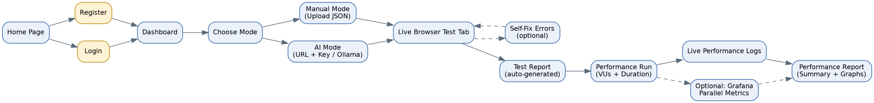
Figure 4.1 — End-to-end user flow from Home Page to Performance Report.
- Home Page: product intro, Login and Register actions.
- Dashboard: project list, mode selector (Manual / AI / Ollama), quick links to Reports and Performance.
- Manual Upload screen: JSON upload/paste box with instant validation feedback.
- AI Setup screen: URL + optional sub-URL input, key entry and verification, generated test case list with Copy.
- Live Test Tab: real-time browser view, step-by-step status, Self-Fix control on failure.
- Reports screen: list of test reports and performance reports, with View and Download.
- Performance screen: VU/duration inputs, live logs panel, dynamic graphs, optional Grafana panel.

4.2 Hardware Interfaces
No special end-user hardware is required beyond a standard desktop/laptop or tablet capable of running a modern web browser. On the server side, the execution engine requires enough CPU/RAM headroom to run a headless Chromium instance and a k6 load process per active test run.

4.3 Software Interfaces
Interface | Purpose
Gemini API / OpenAI API | Used in AI Mode to generate test cases from the page inventory; requires a user-supplied key, verified before use.
Local Ollama Runtime | Used in Ollama Mode as a no-key fallback for test case generation.
Grafana HTTP API / Prometheus | Optional; used to pull CPU/Memory/Network metrics from the user's own monitoring stack during a performance run.
MySQL | Primary data store for users, projects, test suites, runs, and reports.
Playwright (Chromium) | Drives the actual browser during functional test execution.
k6 | Generates the HTTP load during performance runs.

4.4 Communication Interfaces
- All frontend-backend traffic over HTTPS.
- A WebSocket (or equivalent push) channel between backend and frontend for live test execution status and live performance logs, so the Dashboard updates in real time without polling.

5. Data Model
The core entities needed to support every module above are shown in the entity-relationship diagram below. Each user owns one or more Projects; each Project can have one Test Suite (Manual, AI, or Ollama-sourced) and any number of Performance Runs; every Test Run and Performance Run produces a Report.
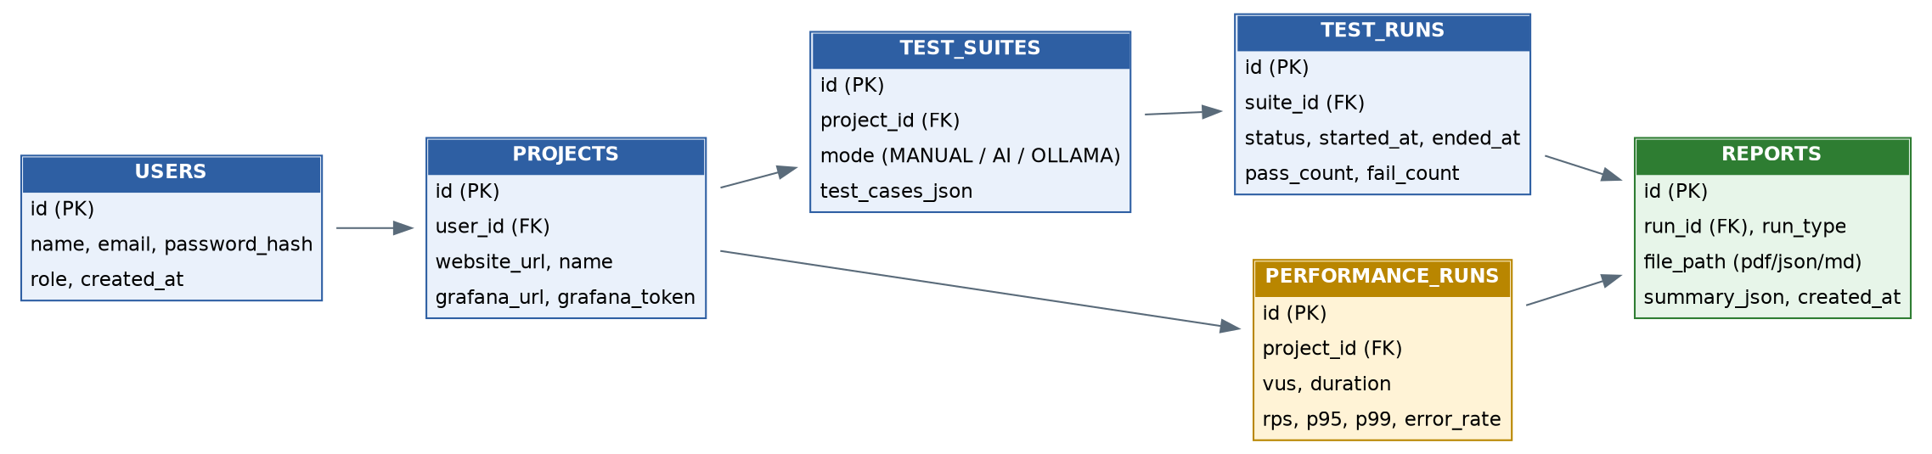
Figure 5.1 — Core entity-relationship diagram.

5.1 Entity Notes
- USERS: authentication and role.
- PROJECTS: one row per website the user is testing; optionally holds the user's own Grafana URL/token.
- TEST_SUITES: the validated test case JSON, tagged with its origin mode (MANUAL / AI / OLLAMA).
- TEST_RUNS: one row per execution of a test suite, with pass/fail counts and status.
- PERFORMANCE_RUNS: one row per load test, storing VUs, duration, and resulting RPS/latency/error metrics.
- REPORTS: generated artifacts (PDF/JSON/Markdown) linked back to either a Test Run or a Performance Run, plus a machine-readable summary used to render the dashboard graphs.

6. Non-Functional Requirements

6.1 Performance
- The Dashboard shall reflect live test and performance status with no more than a 2-second perceptible delay.
- The platform shall support multiple users running independent test/performance sessions concurrently without cross-contamination of logs or results.

6.2 Security
- Passwords shall be stored using a strong one-way hash; JWTs shall be short-lived and refreshed securely.
- AI provider keys and Grafana tokens shall be transmitted over HTTPS and encrypted at rest; they shall never be written to logs or included in downloadable reports.
- A user shall only ever be able to view or download their own projects, test suites, and reports.

6.3 Reliability & Availability
- If the AI provider is unreachable or the key fails verification, the system shall fail gracefully with a clear message and offer Ollama Mode instead of crashing the flow.
- If Grafana is unreachable during a performance run, the run shall continue in Agentless Mode rather than aborting.

6.4 Usability
- JSON validation errors must be specific enough (which field, which test case) that a non-developer QA user can fix the file without external help.
- The Manual, AI, and Ollama flows shall converge on the same execution, reporting, and performance screens, so the user only has to learn one dashboard regardless of which mode they use.

6.5 Scalability
- The execution engine shall be invokable as an isolated, queueable job per run, so additional concurrent users can be handled by adding worker capacity without redesigning the API.

6.6 Maintainability
- Manual, AI, and Ollama test-generation paths shall share the same downstream execution, validation, and reporting code, so a fix or improvement to reporting benefits all three modes at once.

Appendix A — Manual Test Case JSON Schema
A manual test suite is a JSON array of test case objects. Each object requires: id, feature, priority, steps (an array of step objects), and expectedResult. Example:
[
{
"id": "TC-AUTH-001",
"feature": "Valid user logs in successfully",
"priority": "CRITICAL",
"steps": [
{ "action": "goto", "target": "/login" },
{ "action": "fill", "target": "input[type=\"email\"]", "value": "demo@demo.com" },
{ "action": "fill", "target": "input[type=\"password\"]", "value": "demo" },
{ "action": "click", "target": "button[type=\"submit\"]" },
{ "action": "wait", "ms": 1000 },
{ "action": "expectVisible", "target": "body" }
],
"expectedResult": "User is authenticated and redirected to the dashboard"
}
]
This is exactly the schema the validator in section 3.3 (FR-MAN-2) checks at upload time — before any test case reaches the execution engine.

Appendix B — Supported Test Step Actions
Action | Parameters | Description
goto | target: "/path" | Navigate to a route (resolved against the project's base URL).
click | target: "selector" | Click an element, with auto-retry.
fill | target, value | Type text into an input field.
select | target, value | Choose a dropdown option.
check / uncheck | target: "selector" | Toggle a checkbox.
expectVisible | target: "selector" | Assert an element is visible.
expectText | target, value | Assert an element contains given text.
wait | ms: 1000 | Explicit pause in milliseconds.
setViewport | width, height | Resize viewport (e.g., for mobile testing).
reload | — | Reload the current page.
goBack | — | Navigate the browser back.

Appendix C — Glossary
Term | Meaning
Test Suite | A named, validated collection of test cases attached to one project.
Test Run | One execution of a test suite, producing pass/fail results and a report.
Performance Run | One load test execution with a defined VU count and duration.
Self-Fix | User-triggered attempt to automatically repair a failed test step.
Page Inventory | The structured list of pages/elements discovered by the crawler, used as input to AI/Ollama test generation.

