**Onload View**

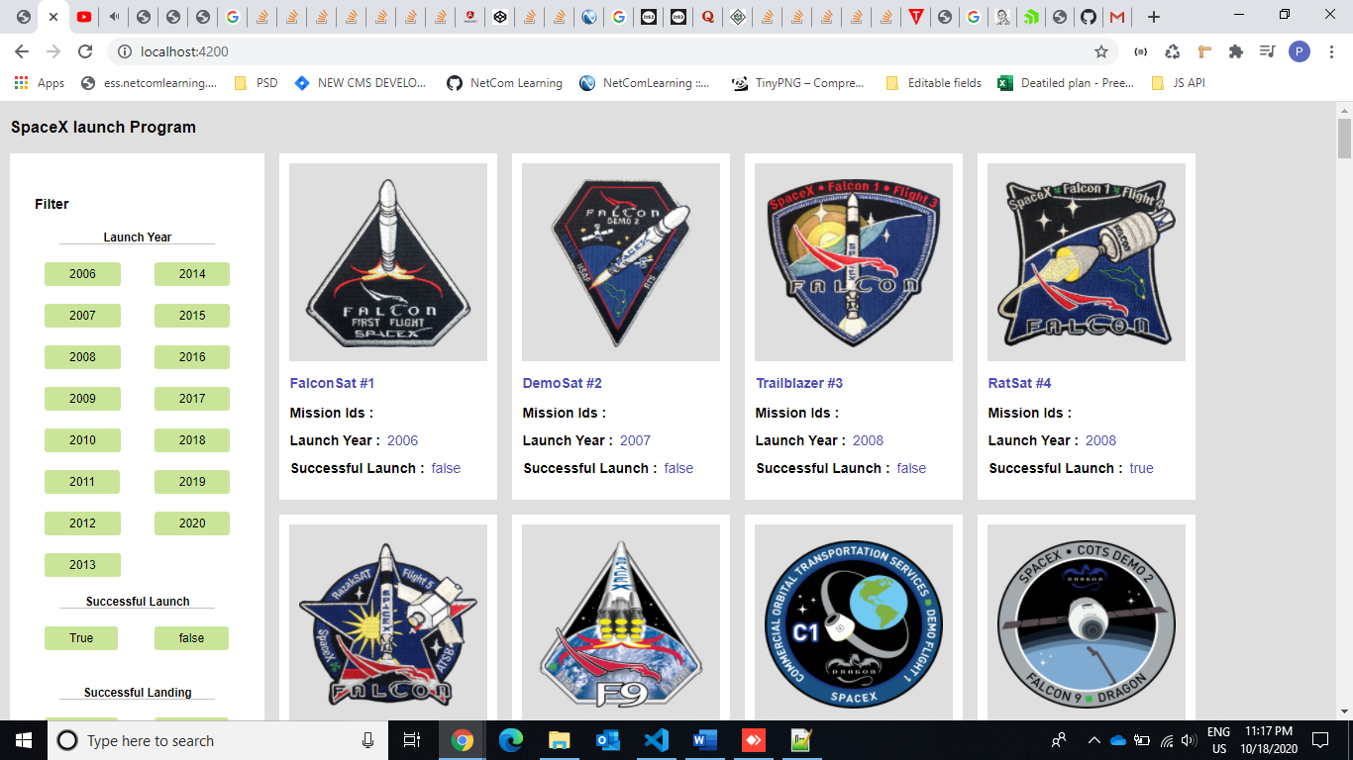

**Successful launch - True**

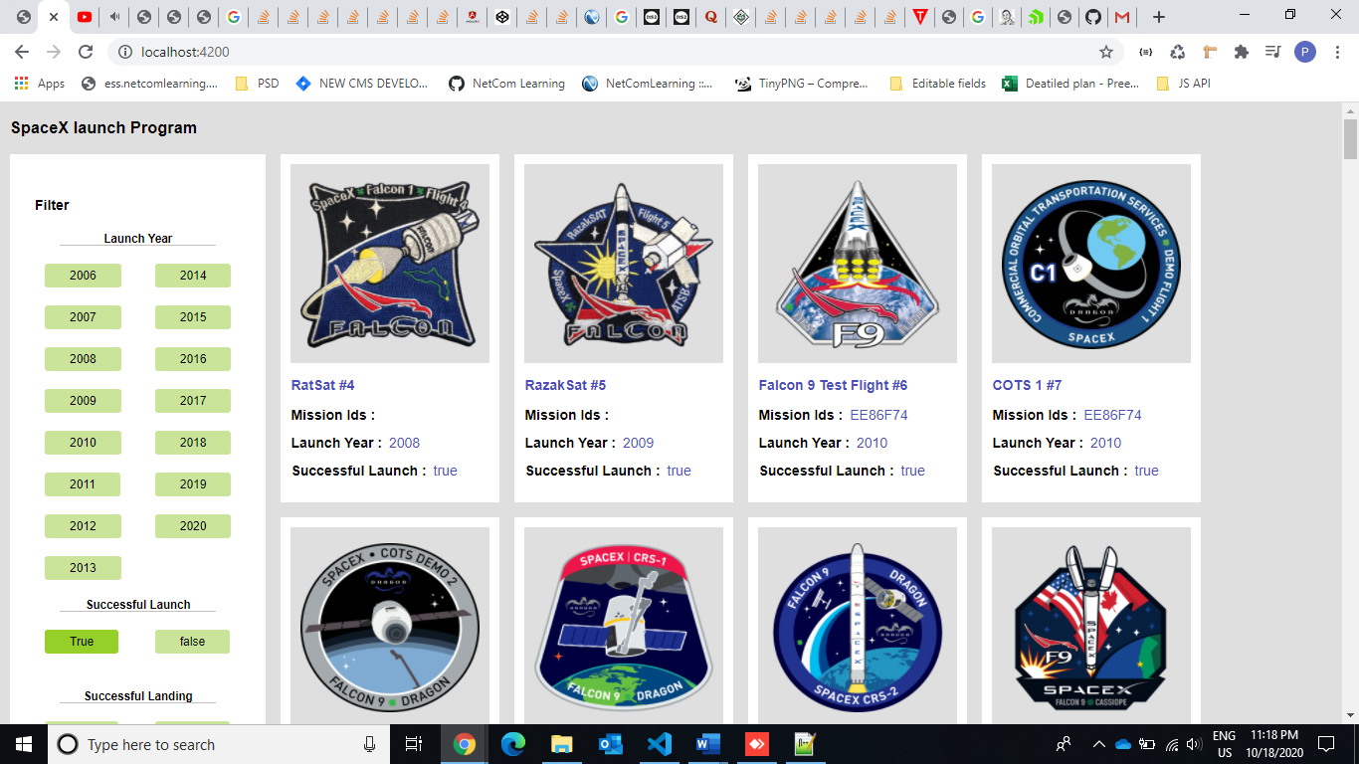

**Successful launch – False**

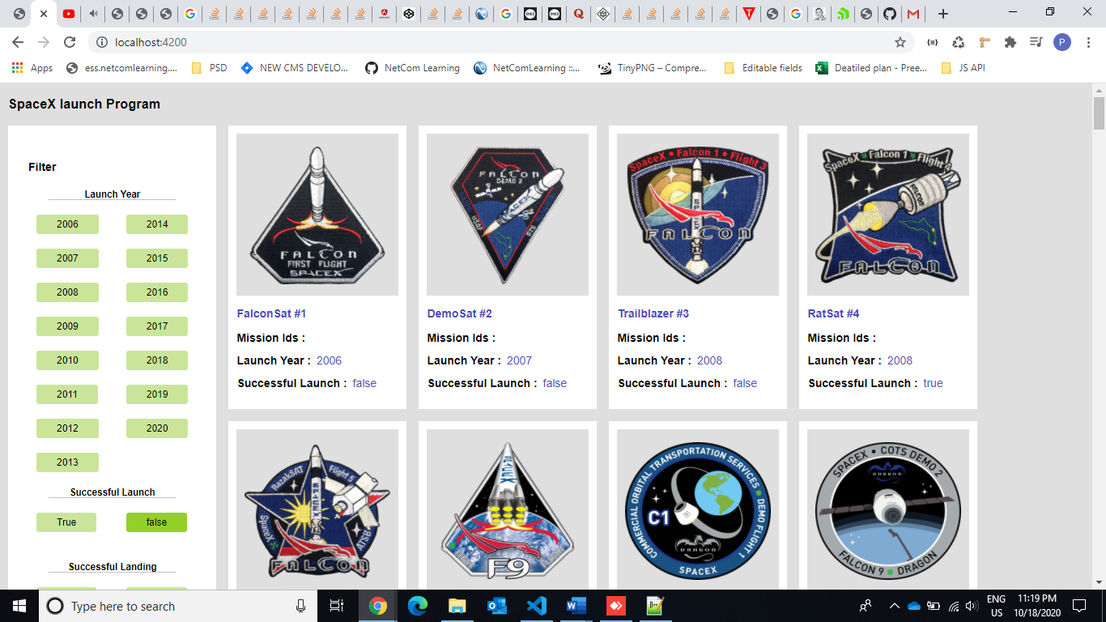

**Successful launch ( True) and Successful Landing (True)**

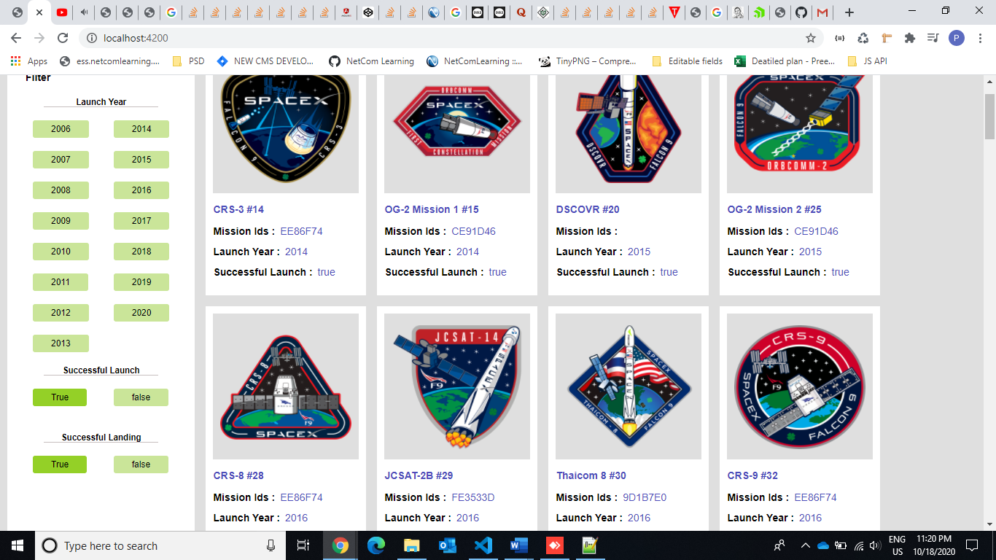

**Successful launch ( True) and Successful Landing (False)**

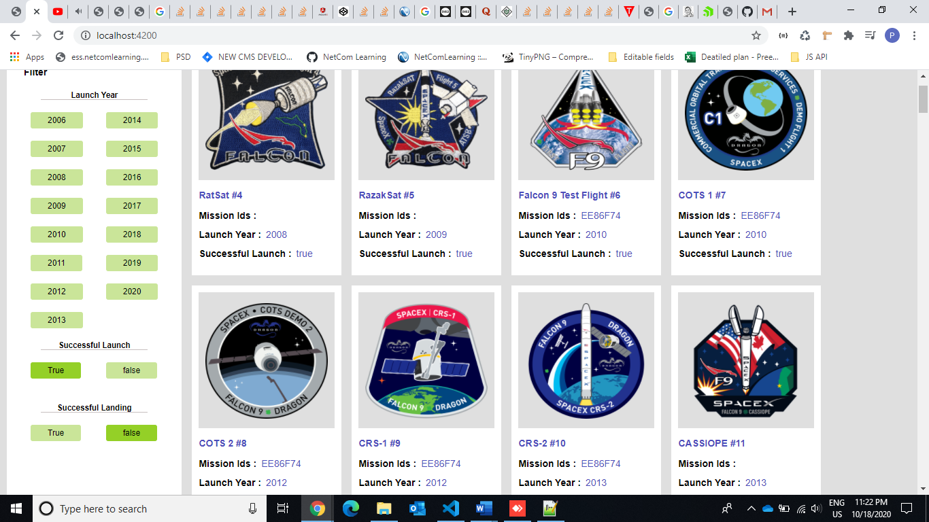

**Successful launch ( True), Successful Landing (False) and Launch Year- 2014**

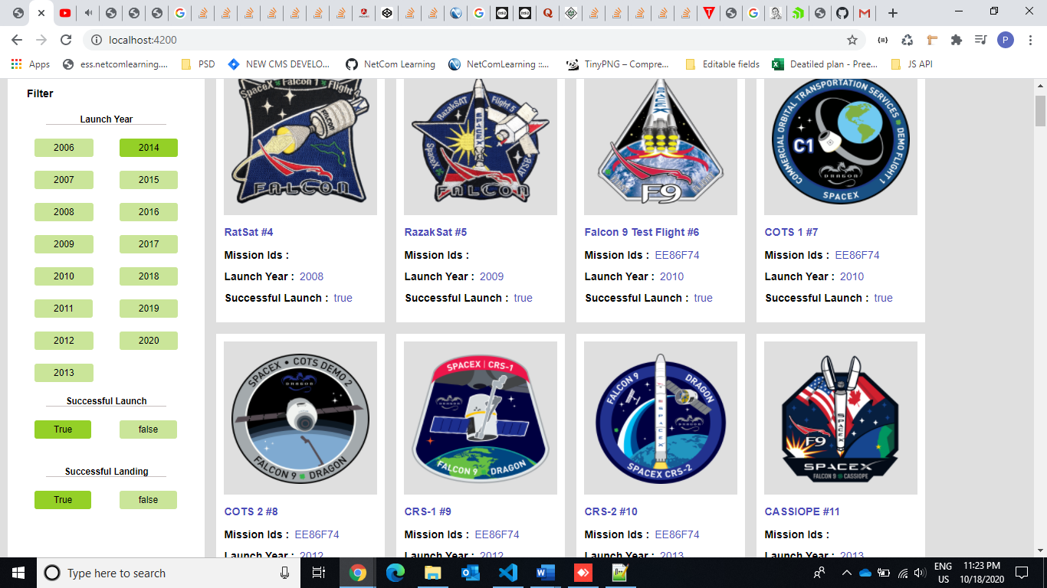

**When No Data found in JSON**

