

**CA2 - KOBITON**

**Name :Preeti Pandey**

**UID : 19BIT033**

**Class : SYIT**

**Subject : Software Methodologies and Management**

**JAI HIND COLLEGE**

**UNDER THE GUIDANCE OF PROF DIKSHA WAKODE**

**Introduction**

**Kobiton is a mobile testing platform that accelerates delivery and testing of mobile apps by offering manual and automated testing on real devices, in the cloud or on-premise.**

**It is a powerful mobile device platform that offers real mobile devices for both testers and developers.**

**Simple to use, easy to access from anywhere, and highly flexible, Kobiton minimizes costs while increasing productivity, so businesses can get apps to market sooner.Kobiton supports running automated tests with Selenium WebDriver (for web applications) and Appium (for native and mobile web applications).**

## Manual Testinghttps://docs.kobiton.com/basic/knowledge-base/

* **Full control of mobile devices:** **Test on physical devices remotely with support for multi-touch gestures, orientation and GPS simulations, camera and speaker control, and device connection management.**
* **Automatically record all test sessions**:**Kobiton captures all the actions you perform on the app in a device log so you can quickly review performance benchmarks in real time.**
* **Enhanced remote control experience:** **Optimize rendering rate and device selection based on your connection quality and location.**

## Automation Testing

* **No change to your automation scripts:** **Execute automation tests on Kobiton devices by updating the device settings to your required configuration**.
* **Test sessions history:** **Kobiton preserves all automation executions, including commands, logs, screenshots and metadata.**
* **Automate from A-Z:** **Kobiton automatically cleans your test apps and data after the session ends.**

## Device Managementhttps://docs.kobiton.com/basic/knowledge-base/

* **Easy setup:** **Download the Kobiton Desktop App and start plugging in your devices.**
* **Easy device enrollment:** **Register your own devices to the Kobiton cloud and make the device available to your teams across different locations.**
* **Maximize device coverage** : **Use your own devices and Kobiton cloud devices together to increase device coverage for your testing and to save on**

**Testing**

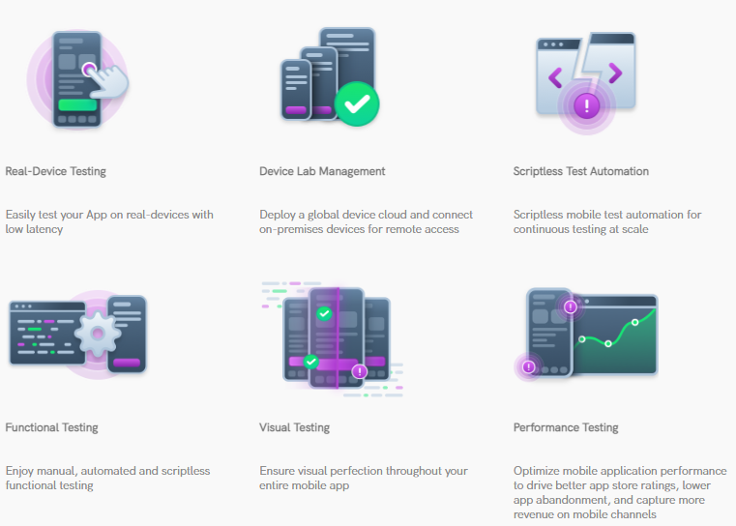

# Manual testing

**Test**

* **Web,**
* **Native or hybrid apps with Kobiton devices by following these steps:**

# Getting started with manual testing

**Step 1:** **From** **Devices** **tab of** **Kobiton Portal**, **hover over the device you** **want to test and click** **Launch device**.

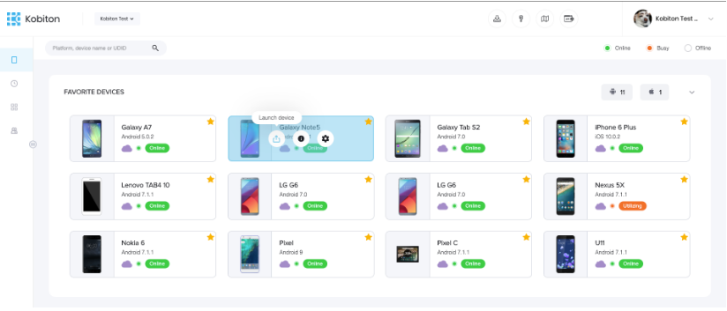

**Step 2**:**When the device launches, click on** **Install Apps** **to be presented with a popup in which you can choose to upload and install your iOS or Android binary file (IPA/APK).**

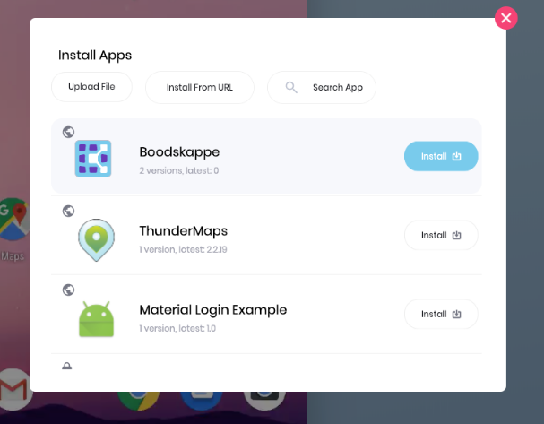

**Step 3:** **Use the** **Sessions** **tab of** **Kobiton Portal** **to view the logs for your manual test session.**

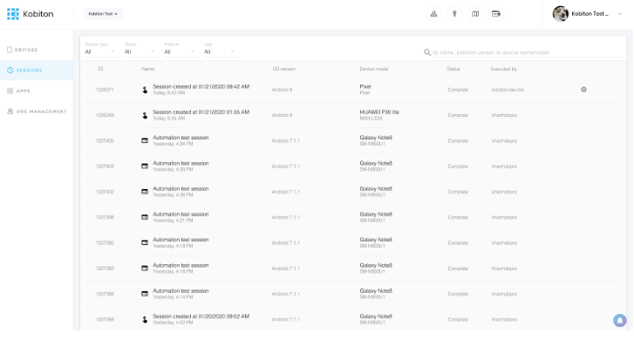

# Installing application on the launched device

**Step 1:  From Devices tab of Kobiton Portal, hover over the device you want to test and click Launch device.**

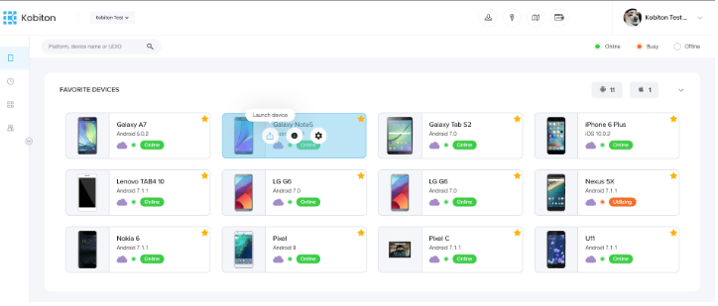

**During a Manual Test session with Kobiton, first click on Install Apps. You can choose to install your iOS or Android apps on the launched device in one of the following ways:**

* **Click on Upload File to browse the location of the file and supply it.**
* **Click on Install from URL to install the app from a third-party URL.**
* **Search and install your apps which have been uploaded to the App Repository.**

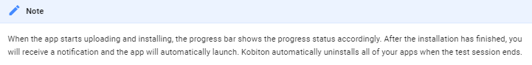

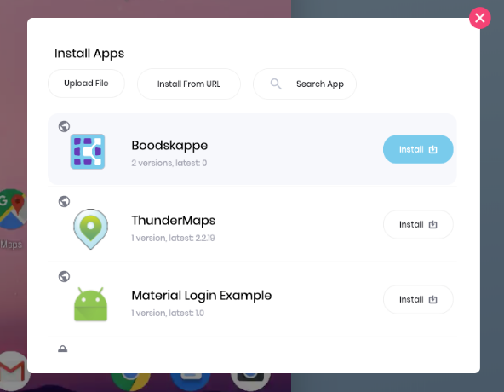

# Manual Test setup

**You can add manual test session details to help you organize your testing. While all settings are optional and Kobiton will automatically name your session, you may want to adjust it to your preferences.**

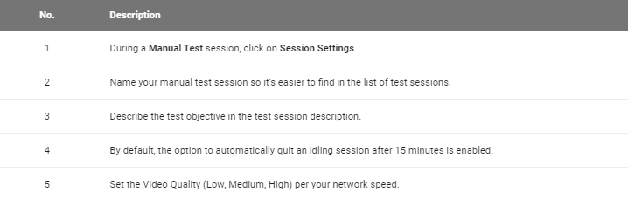

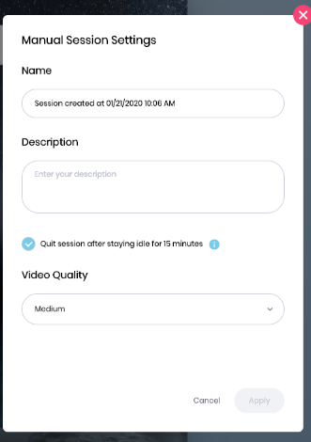

**Kobiton's Features**

* **Automated or manual tests on real devices**
* **Rich test logs**
* **Public, Private or Hybrid cloud support**
* **Support for all major CI/CD tools and processes**

**Company uses Kobiton**



## Kobiton Alternatives & Comparisons

**Sauce Labs**

**Cloud-based automated testing platform enables developers and QEs to perform functional, JavaScript unit, and manual tests with Selenium or Appium on web and mobile apps. Videos and screenshots for easy debugging. Secure and CI-ready.**

**BrowserStack**

**Live, Web-Based Browser Testing Instant access to all real mobile and desktop browsers. Say goodbye to your lab of devices and virtual machines.**

**BitBar**

**Testdroid provides a set of products for Android and iOS app/game testing on real devices. With different testing solutions, you can efficiently develop and test your mobile apps/games in agile way and achieve your business goals.**

**AWS Device Farm**

**Run tests across a large selection of physical devices in parallel from various manufacturers with varying hardware, OS versions and form factors.**

**Appium**

**Appium is an open source test automation framework for use with native, hybrid, and mobile web apps. It drives iOS and Android apps using the WebDriver protocol. Appium is sponsored by Sauce Labs and a thriving community of open source developers.**

**Advantages**

* **Kobiton allows the testers to carry out parallel testing.**
* **It enables performing the manual as well as automated tests on real mobile devices.**
* **Kobiton supports Selenium WebDriver, Appium, and Katalon Studio.**
* **Kobiton allows you to record videos.**
* **It also enables you to capture the screenshots as well as user interactions.**
* **Kobitons enables integration with tools like GitHub, Jenkins, TeamCity, and more.**

# Limitations and issues

### **Automation Testing**https://docs.kobiton.com/faq/known-limitations-and-issues/

* **On iOS devices, timeout error occurs due to the use of "/session//execute_async" (JsonWire protocol) command.**

### **Manual Testing**https://docs.kobiton.com/faq/known-limitations-and-issues/

#### **iOS Devices**https://docs.kobiton.com/faq/known-limitations-and-issues/

* **iPhone 4, 4S, 5, 5C**
* **iPad 2, 3, 4, mini 1**
* **iPod Touch 5**
* **Currently, Kobiton supports the removal of data history, cache data, account information and recent-viewed applications on Safari and Firefox only**
* **User’s activities will be limited to some extent. For example, the user is unable to set a passcode, change Wi-Fi settings, Kobiton is not responsible for protecting user's own iCloud accounts**
* **Long-press gesture used as Home button is inactive on iOS 10.0.x - 10.2.x**
* **Double-press gesture used as Home button is inactive on iOS 10.3 or later versions**

#### **Android**https://docs.kobiton.com/faq/known-limitations-and-issues/

* **The user is unable to change Screen Settings that might potentially affect Kobiton's devices**

#### **IE 11 and Edge browser**https://docs.kobiton.com/faq/known-limitations-and-issues/

* **At this stage, we do not support streaming video on IE 11 and Edge browsers. It will be the main cause of increasing response time up to 11 seconds for streaming video on browsers thereof. This feature, however, works well on Chrome, Firefox and Safari.**

#### **Network Traffic Capturing**https://docs.kobiton.com/faq/known-limitations-and-issues/

* **Network Traffic Capturing (HAR) is unavailable on Android version 4.x & 5.x.**
* **A reboot is required to recover the device's network settings in case the device is disconnected/unplugged from host machine**
* **If the device is unplugged during the initialization process, the device will be disconnected from the internet. A reboot or re-plug is required to connect to the internet.**
* **High-quality native apps such as YouTube, Google Maps, Facebook etc. cannot be accessed while network capturing is on. In regard to Android 7.x and higher, the following solution will help with internet access while network capturing is on**<https://developer.android.com/training/articles/security-config.html>

### **Others**https://docs.kobiton.com/faq/known-limitations-and-issues/

**Recent application and application data, generated during a single test session, will remain unchanged at the end of each session (both manual and automation testing).**

**Frequent Questions**

### **Which OS version does Kobiton support?**https://docs.kobiton.com/faq/general-questions/#do-you-track-any-user-behavioral-data-from-the-kobiton-portal

**Kobiton supports iOS versions 9.0 to 13.3.1 and Android versions 4.2.2 to 10.**

### **Do you store my app, tests and other files on your servers? For how long?**https://docs.kobiton.com/faq/general-questions/#do-you-track-any-user-behavioral-data-from-the-kobiton-portal

**Kobiton automatically uninstalls tested apps after the test session. Kobiton retains test history, including session name, description, screenshots, and logs until you can cancel your account. You can delete the test session at any time.**

### **What are the available devices?**https://docs.kobiton.com/faq/general-questions/#do-you-track-any-user-behavioral-data-from-the-kobiton-portal

**Kobiton has a large (and growing) selection of iOS and Android devices, including both older and the latest models.**

### **How can I select a device for testing? Can I retest on the same device?**https://docs.kobiton.com/faq/general-questions/#do-you-track-any-user-behavioral-data-from-the-kobiton-portal

**Access all available devices via the Device Menu. You can retest on the same exact device within your organization. However, Kobiton assigns cloud devices based on your desired configuration, making it difficult to guarantee the ability to test on the same device in future test sessions.**

### **Does Kobiton have an API that allows me to integrate my testing with my CI/CD workflow?**https://docs.kobiton.com/faq/general-questions/#do-you-track-any-user-behavioral-data-from-the-kobiton-portal

**Yes, please visit our**[**API documentation**](https://api.kobiton.com/docs)**.**

**Where are Kobiton’s headquarters?**

**Kobiton’s headquarters are in 1776 Peachtree St NW, Ste 200N, Atlanta, Georgia, 30309, United States**

**What is Kobiton’s official website?**

**Kobiton’s official website is www.kobiton.com**

**What is Kobiton’s industry?**

* **Kobiton is in the industry of: Software Development & Design, Software**

**What companies has Kobiton acquired?**

* **Kobiton has acquired the companies: Mobile Labs**

**Who are Kobiton’s main competitors?**

* **Kobiton's main competitors are: pCloudy, Experitest, Testlio, Sauce Labs**

**Who is Kobiton's CEO?**

**Kevin Lee** **is the CEO of Kobiton, a mobile device cloud platform start-up based in Atlanta, GA**



**Who is Kobiton's Co-Founder ?**

**VU LAM**

* 

**What is Kobiton's tech stack?**

**The technologies that are used by Kobiton are: Google Global Site Tag, WordPress, Google Font API, jQuery**

**Kobiton Datasheet :**

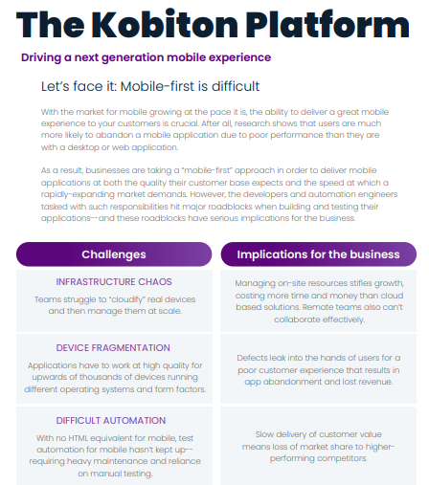

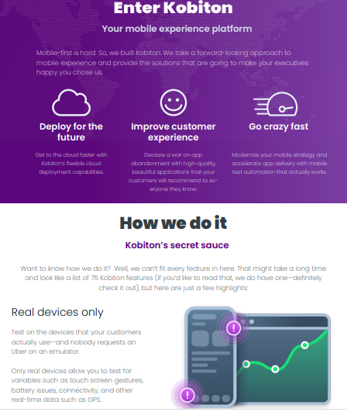

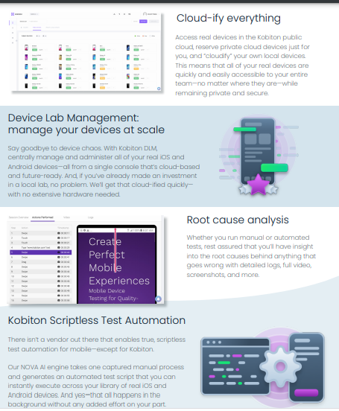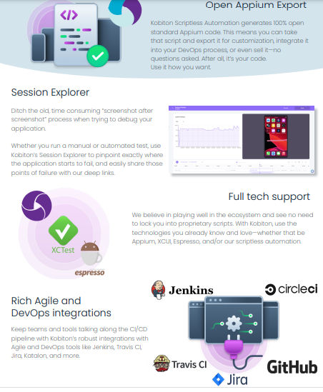

**RESEARCH**

## Kobiton Survey Shows Covid-19’s Impact on Software QA Teams

Some teams have experienced process breakdowns or missed sprint deadlines, but overall QA has been resilient in the face of the pandemic.

**ATLANTA, Aug. 06, 2020 (GLOBE NEWSWIRE) --**[**Kobiton**](https://www.globenewswire.com/Tracker?data=Rgb2kAGjX1Ba_u3Cyx1YXpTFWXwsluzNjaDpX1-U6E9STUoFzXOBxid22Z4vIFJCz5UdYDEUyC0qXerjc4aRug==)**, a provider of software testing solutions, has completed a survey on the effects of Covid-19 on software QA teams and processes. A key takeaway from the survey, completed by 80 QA professionals, is that most teams haven’t experienced much disruption as yet related to the pandemic, though some are beginning to see problems, causing them to reconsider their operational strategies.**

**Covid-19 has undoubtedly created challenges for QA teams, ranging from issues with team collaboration and communication to alignment with other DevOps teams. 40% of QA professionals responding to Kobiton’s survey reported minor disruptions to their QA processes, and 33% said they’d experienced minor delays in their product release cycles. Meanwhile, 10% said they’re beginning to see real problems in their QA processes, and another 10% said they are worried about problems looming on the horizon.**

**But overall, QA teams seem to be holding up rather well, with 38% of survey respondents reporting zero disruptions to their processes, and 34% saying they had no release cycle delays and weren’t too worried about future release cycle disruptions. Nevertheless, Covid-19 is causing QA teams to consider major operational shifts to combat the crisis. For example, 21% of survey respondents said that providing systems for remote mobile device access would be their top priority, followed by more automated test cases (15%), central reporting (13%) and new collaboration processes (also 13%).**

**QA teams are also prioritizing the need to support distributed teams due to Covid-19. 55% of survey respondents said their top priority along these lines would be investing in culture as they embrace what it means to be a remote team. The second biggest priority would be investing in systems that enable remote testing teams (50%), followed by strategies to maintain efficiency and effectiveness in remote environments (45%).**

**“Covid has upended conventional business processes in every industry, company and department. But so far at least, QA teams appear to be holding up,” said Kevin Lee, CEO of Kobiton. “This can best be attributed to strong company cultures and quick reactions to the crisis in the form of reprioritized objectives and a higher tolerance for bugs in the interest of speed. While the uncertainty and challenges surrounding Covid continue to plague organizations of all shapes and sizes, the most agile and resilient software development teams will emerge stronger, faster and better.”**

**Kobiton’s complete *Covid 9: Global Impact on Mobile QA* survey results**

# Kobiton acquires Mobile Labs for faster app delivery and AI across real devices



**A huge opportunity to improve the testing experience for our customers even further, especially with the maturity of AI and machine learning,” said Dan McFall, CEO of Mobile Labs. “The combined Mobile Labs and Kobiton platform will deliver on that vision on-premises, in the cloud or as a hybrid solution for the most demanding organizations in the world.”**

**Kobiton aims to catch cross-platform issues before checking in code and tests on real devices directly within a developer’s IDE with support for manual testing, automated testing, and a scriptless automation solution. Users can integrate continuous testing right in their DevOps CI/CD processes.**

**Meanwhile, Mobile Labs’ GigaFox solution features scheduling, collaboration, user management, security, mobile DevOps, and continuous automated testing for mobility teams spread across the globe, and can connect cloud devices to an industry-leading number of third-party tools such as XCode, Android Studio, and many commercial test automation tools.**

**“Mobile Labs perfectly helps Kobiton deliver on our vision of what a mobile experience platform should be,” said Kevin Lee, the CEO of Kobiton. “Leveraging our flexible deployment model along with our leading AI testing technology, coupled with Mobile Labs’ industry leading on-premises device deployment, leads to the most comprehensive mobile testing solution on the market today.”**

**References**

* [**http://www.globenewswire.com/news-release/2020/08/06/2074258/0/en/Kobiton-Survey-Shows-Covid-19-s-Impact-on-Software-QA-Teams.html**](http://www.globenewswire.com/news-release/2020/08/06/2074258/0/en/Kobiton-Survey-Shows-Covid-19-s-Impact-on-Software-QA-Teams.html)
* **https://kobiton.com/**