***DBMS***

***RESORT MONITORING AND RESERVATION SYSTEM.***

***NAME: PRINCY PATIL***

***UID: 19BIT035***

***NAME: PREETI PANDEY***

***UID: 19BIT033***

***NAME: MITALI PILANKAR***

***UID: 19BIT037***

TABLE OF CONTENTS

|  |  |  |
| --- | --- | --- |
| SR NO | TITLE |  |
| 1 | ***System Description*** |  |
| 2 | ***Data dictionaries*** |  |
| 3 | ***ER(Entity Relationship) diagram*** |  |
| 4 | ***Select statement queries*** |  |
| 5 | ***Count and group function queries*** |  |
| 6 | ***Subqueries*** |  |
| 7 | ***Joins*** |  |
| 8 | ***Update queries*** |  |
| 9 | ***Delete queries*** |  |
| 10 | ***References*** |  |

***System Description***

***RESORT MONITORING AND RESERVATION SYSTEM.***

This project is an enhanced resort management system that consists of all the features and functions required for effectively managing a resorts. The system allows to check for room reservations, advance bookings, current bookings, free rooms, status of the restaurant . The system also sends room status notification and when the room was last cleaned or about when last maintenance check was performed on it to the manager or concerned staff. This system can be used to effectively manage large resorts with ease. This system is very user-friendly. User with basic computer knowledge can use this system Databases in Resort management are very dynamic and scalable.

The system has the following table:

1. **Customer table:**

In this table detail of customer are display for the resort reservation.

1. **Reservation table**:

In this table detail of reservation are display.

1. **Room table:**

The table store the detail of customer who book the room.

1. **Cancellation table**:

The table contents the cancellation detail of the customer.

1. **Payment table:**

This table define the payment of the reservation.

***Data dictionaries***

***Customer table***

1. Cust_id: Customer id id a primary key which uniquely define the customer table.
2. Cust_fname: cust_fname refer to customer first name. the data type of cust_fname is varchar(20).
3. Cust_lname: cust_lname refer to customer last name. The data type of cust_lname is varchar(20).
4. Cust_age: the cust_age refer to customer age .the data type of cust_age id varchar(2).
5. Cust_contact: cust_contact refer to customer contact number. The data type of cust_contact is number(10).
6. Cust_address: cust_address refer to customer address. The data type of cust_address is varchar(30).
7. Cust_adharNo: cust_adharNo refer to customer adhar card number. The data type of cust_adharNo is varchar(12).
8. Cust_country: cust_country refer to country where customer live. The data type of cust_country is varchar(20).
9. Cust_email: cust_email refer to customer unique email id. The data type of cust_email is varchar(20).
10. Cust_zipcode: cust_zipcode refer to customer zipcode. The data type of cust_zipcode is varchar(6).
11. Payment_id: payment_id refer to payment id number which is uniquely define. The data type of payment_id is varchar(20) and it has not null constraint.
12. Reservation_id: reservation_id refer to reservation id number which is uniquely define. The data type of reservation_id is varchar(20) and it has not null constraint.

***Reservation table***

1. Reservation_id: reservation_id refer to reservation id number which is uniquely define. The data type of reservation_id is varchar(20) and it has not null constraint.
2. ArrivalDate: arrivalDate refer to the customer who will arrive at that date. The data type of arrivelDate Is date.
3. departureDate: departureDate refer to the customer who will departure from the resort at that date. The data of the departureDate is date.
4. Cust_id: Customer id id a primary key which uniquely define the customer table.
5. Payment_id: payment_id refer to payment id number which is uniquely define. The data type of payment_id is varchar(20) and it has not null constraint.
6. Cancel_id: cancel_id refer to cancellation of the reservation of the resort. The data type of the cancel_id id varchar(20).
7. Totaldays: totaldays refer to how many days the customer would live in resort. The data type of totaldays is number(2).
8. Room_no: room_no refer to the number of room where customer would live. The data type of room_no is varchar(5).

***Room table***

1. Room_no: room_no refer to the number of room where customer would live. The data type of room_no is varchar(5).
2. Room_type: room_type refer to the the type of room like general delux and full delux. The data type of room_type is varchar(10).
3. Room_charges: Room_charges refer to the charge of the room. Thr data type of the Room_charges is int.
4. Availability: Availability refer to available room in the resort. The4 data type of the is varchar(10).

***Cancellation table***

1. Cancel_id: cancel_id refer to cancellation of the reservation of the resort. The data type of the cancel_id id varchar(20).
2. Cust_id: Customer id id a primary key which uniquely define the customer table.

***Payment table***

1. Payment_id: payment_id refer to payment id number which is uniquely define. The data type of payment_id is varchar(20) and it has not null constraint.
2. Othercharge: othercharge refer to the other charges. Thr data type of othercharges id int.
3. Amount: amount refer to total amount of the resort. The data type of amount is int.

***ER(Entity Relationship) diagram***

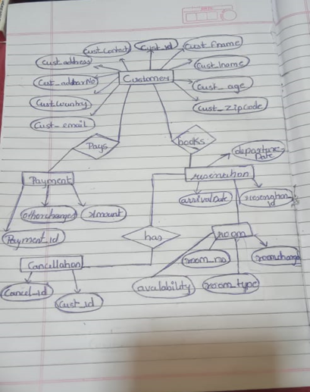

***Select statement queries***

1. select min(room_charges) as min_chargeof_room from room;

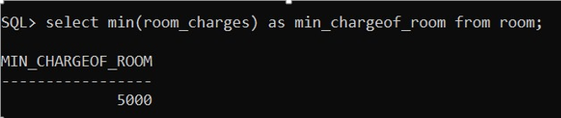

1. select max(room_charges) as max_chargeof_room from room;

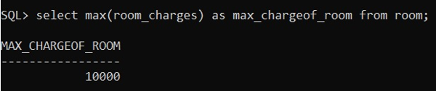

1. select cust_fname from customer where cust_fname like’P%';

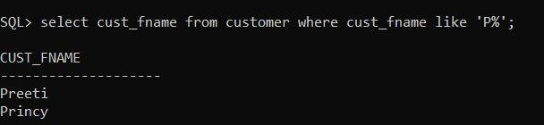

1. select room_no ,room_type , room_charges from room where room_no =' RM402' ;

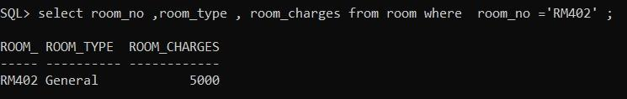

1. select count(reservation_id) as number_of_reservations from reservation;

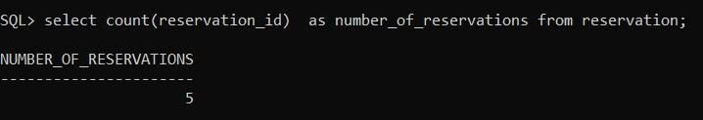

1. select other_charges from payment where payment_id ='P2003';

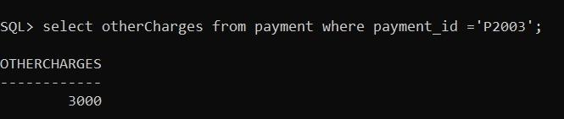

1. select room_type from room;

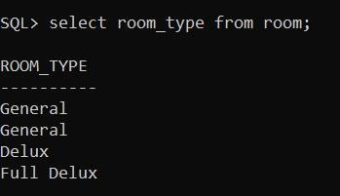

1. select room_type from room where room_no IN('RM405' ,'RM402','RM401');

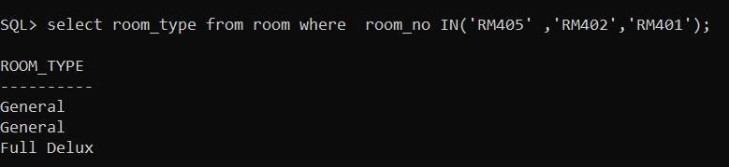

1. select room_no,AVAILABILITY from room;

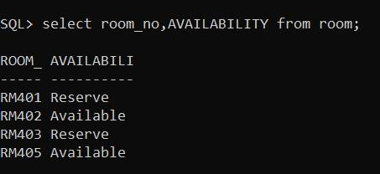

1. select cust_id, substr(cust_fname,1,4) as full_name from customer;

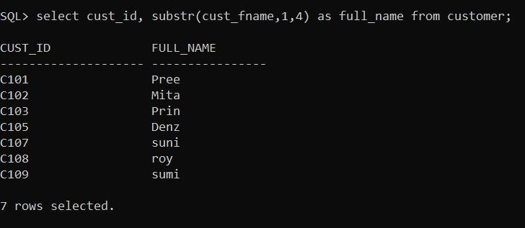

***Count and group function queries***

1. select cust_country,count(cust_country) from customer group by cust_country;

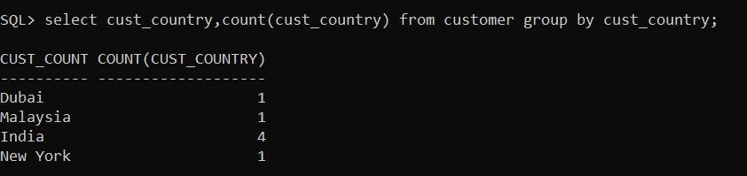

1. select AVAILABILITY,count(AVAILABILITY) from room group by AVAILABILITY;

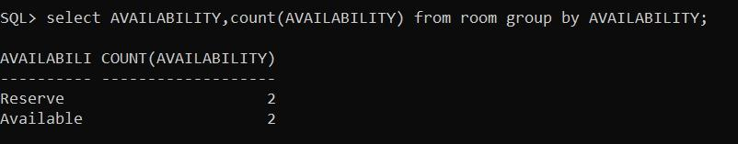

1. select avg(room_charges) from room;

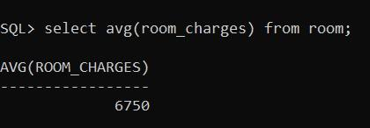

***Subqueries***

1. Show all room no of rooms which are 'available' and whose room_charges<8000

select room_no from room

where room_no IN (select room_no from room

where availability = 'Available') and room_charges < 8000;

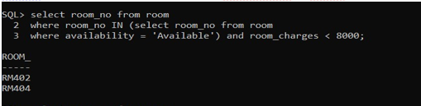

2. Show all room no of rooms which are 'available' and whose room_type = 'Deluxe'

select room_no from room

where room_no IN (select room_no from room

where availability = 'Available') and room_type = 'Delux';

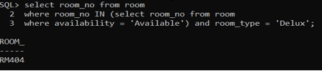

3. Show name of customer staying in room_no = 'RM420'

select cust_fname from customer

where cust_id IN (select cust_id from reservation

where room_no IN (select room_no from room

where room_no like 'RM401')

);

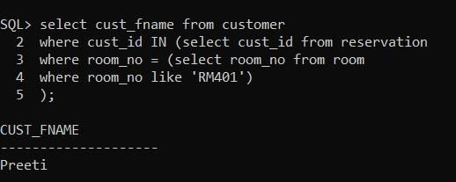

1. select cust_fname from customer

WHERE cust_id IN(select cust_id

from reservation WHERE room_no IN

(select room_no from room WHERE room_type ='General'));

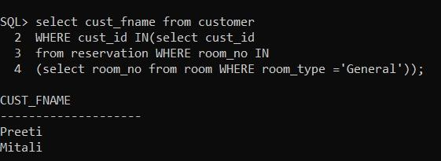

5. Show other charges of customer whose cust_fname = 'Preeti'

select othercharges from payment

where payment_id = (select payment_id

from reservation where cust_id = (select cust_id from customer

where cust_fname = 'Preeti'));



***Joins***

1. Arrival date of each customer.

SELECT customer.cust_id, customer.cust_fname, reservation.arrivalDate

FROM customer

INNER JOIN reservation ON customer.cust_id LIKE reservation.cust_id;

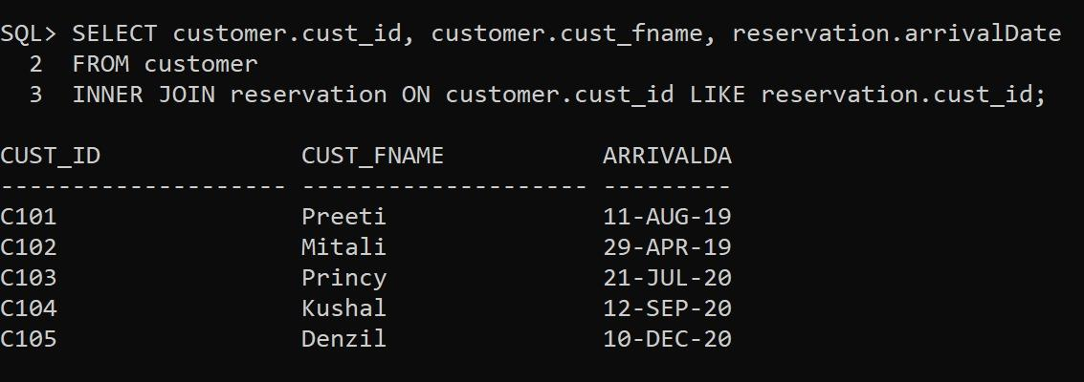

2. Name of customer whose total days are greater than equal to 2.

SELECT customer.cust_id, customer.cust_fname, reservation.totalDays

FROM customer INNER JOIN reservation

ON customer.cust_id LIKE reservation.cust_id and reservation.totalDays >= 2;

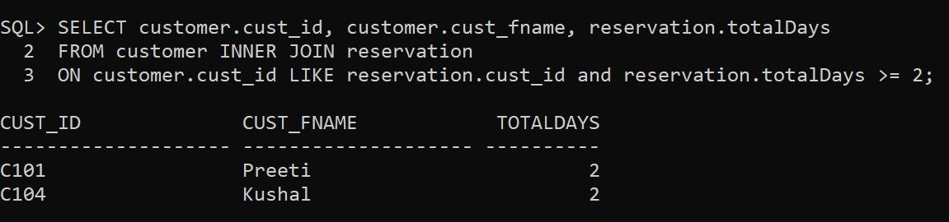

3. Name of customer whose checkout is 22-Jul-2020

SELECT customer.cust_fname, reservation.departureDate

FROM customer INNER JOIN reservation

ON customer.cust_id LIKE reservation.cust_id and

reservation.departureDate = '22-Jul-2020';

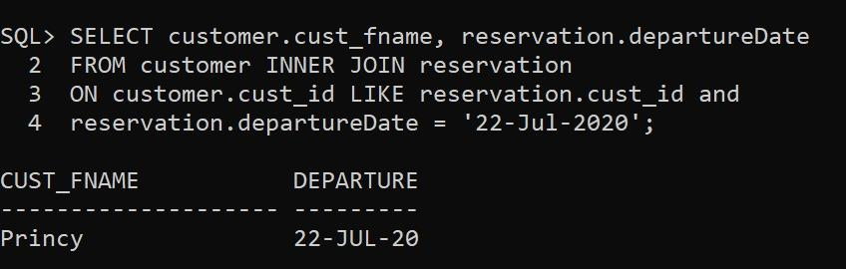

4.Name of customer who have cancelled the reservation.

SELECT customer.cust_id, customer.cust_fname, reservation.cancellation as Reservation

FROM customer INNER JOIN reservation

ON customer.cust_id LIKE reservation.cust_id and

reservation.cancellation = 'Cancel';

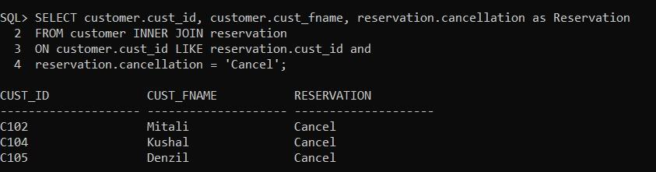

5. Name of customer whose total days are equal to 1.

SELECT customer.cust_id, customer.cust_fname, reservation.totalDays

FROM customer INNER JOIN reservation

ON customer.cust_id LIKE reservation.cust_id and reservation.totalDays = 1;

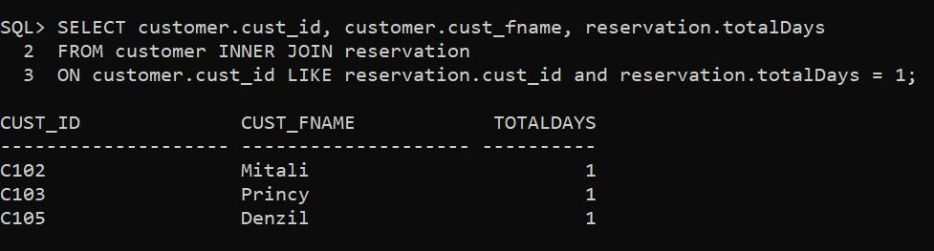

***Update queries***

1. update customer

set cust_address='Raigad'

where cust_id='C102';

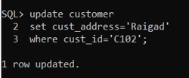

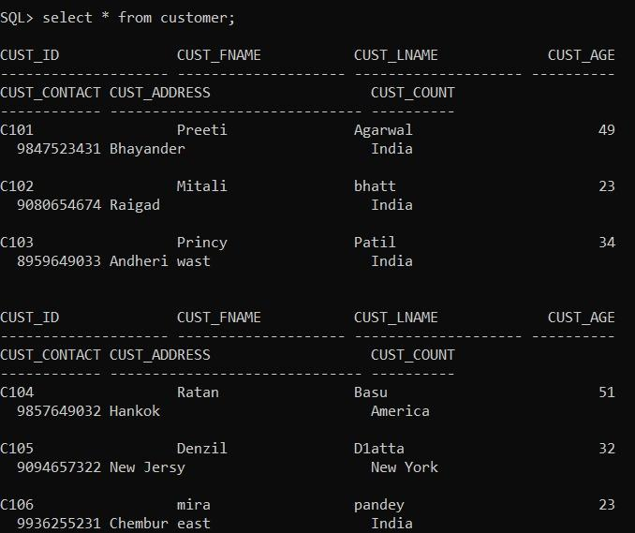

1. update customer

set cust_fname='Ratan'

where cust_id='C104';

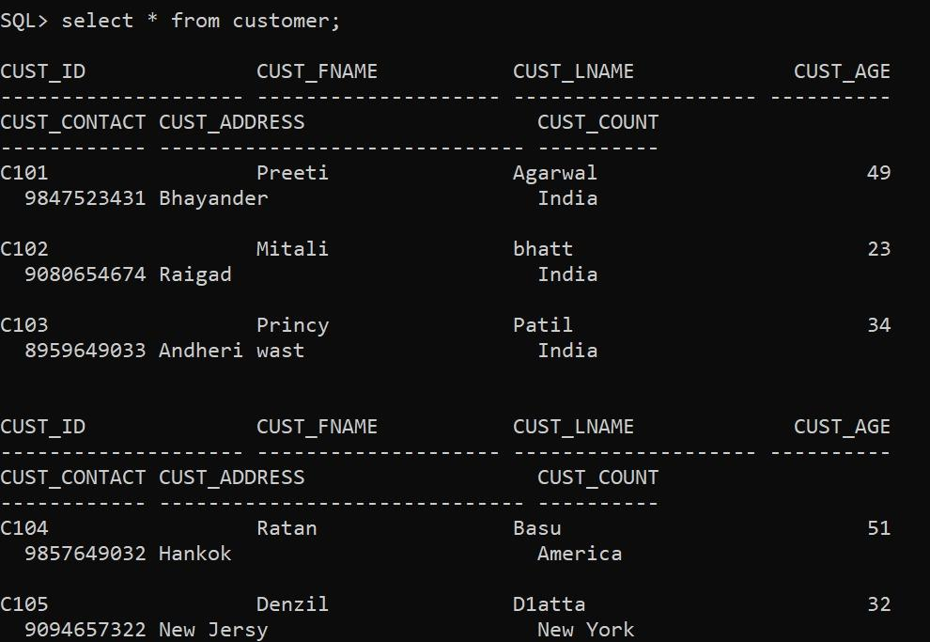

1. update reservation

set departureDate=' 14-mar-2020'

where room_no =' RM401';

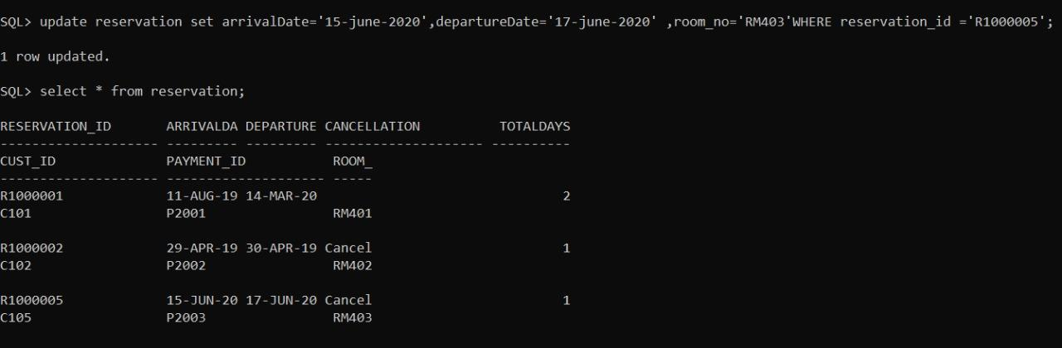

1. update reservation

set arrivalDate='15-june-2020',departure_Date='17-june-2020' ,room_no=' RM403'

WHERE reservation_id ='R1000005';



1. update payment

set amount=amount+3000,otherCharges=otherCharges*2000

WHERE payment_id='P2002';

BEFORE UPDATE:

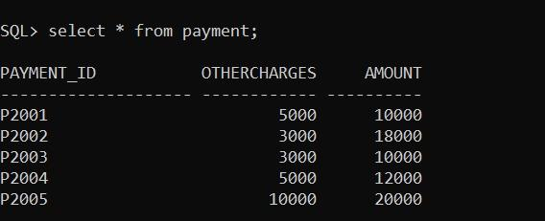

AFTER UPADTE:

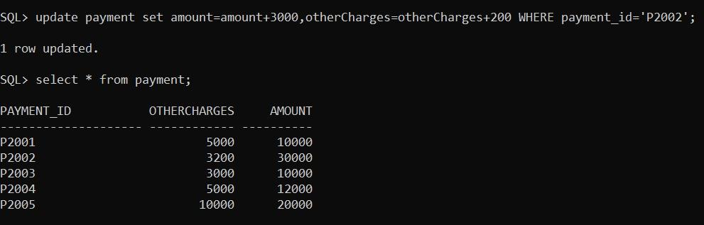

***Delete queries***

1. delete from customer where cust_id='C106';

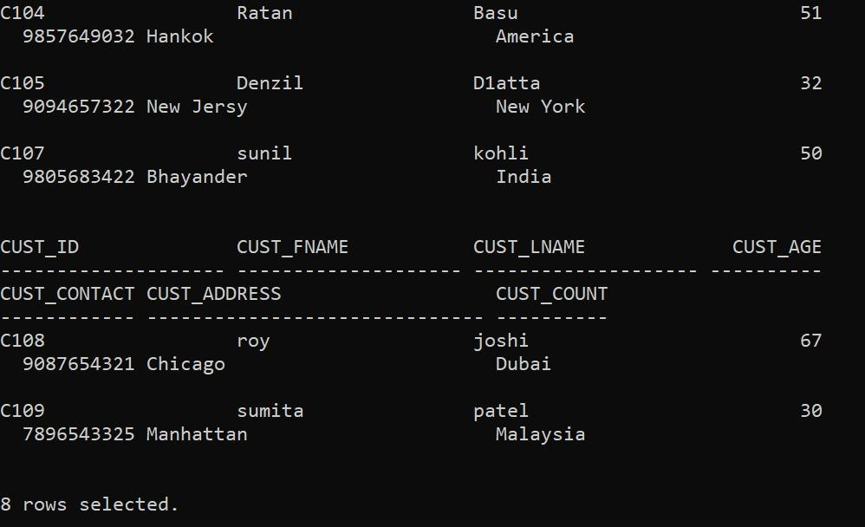



1. delete from reservation where arrivalDate between ' 20-july-2020' and '22-july-20 delete from reservation where arrivalDate between ' 20-july-2020' and '22-july-2020';

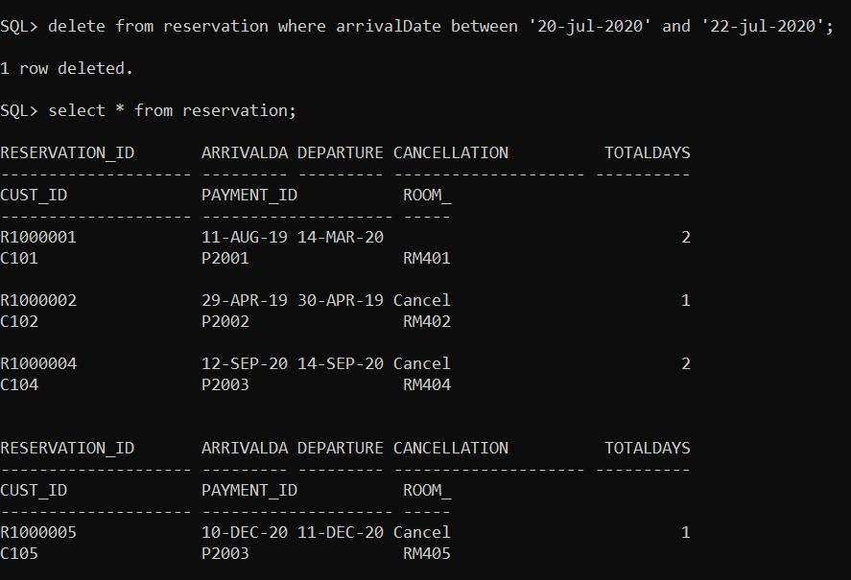

1. delete from reservation where reservation_id='R1000004';

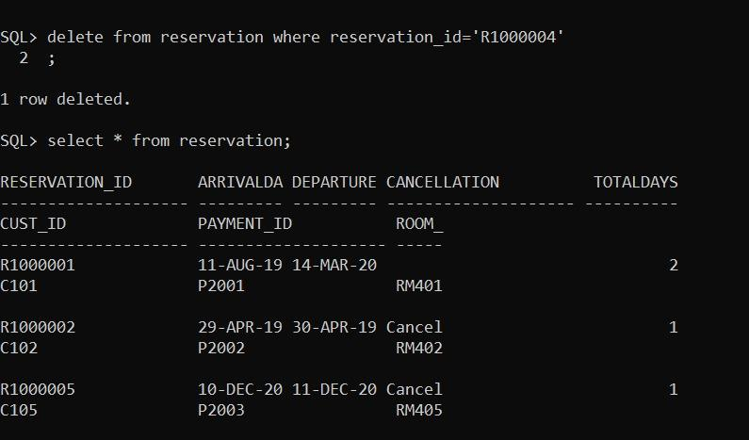

1. delete from payment where amount >20000;

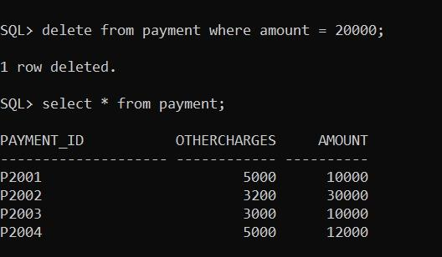

1. delete from customer where cust_lname like '___';

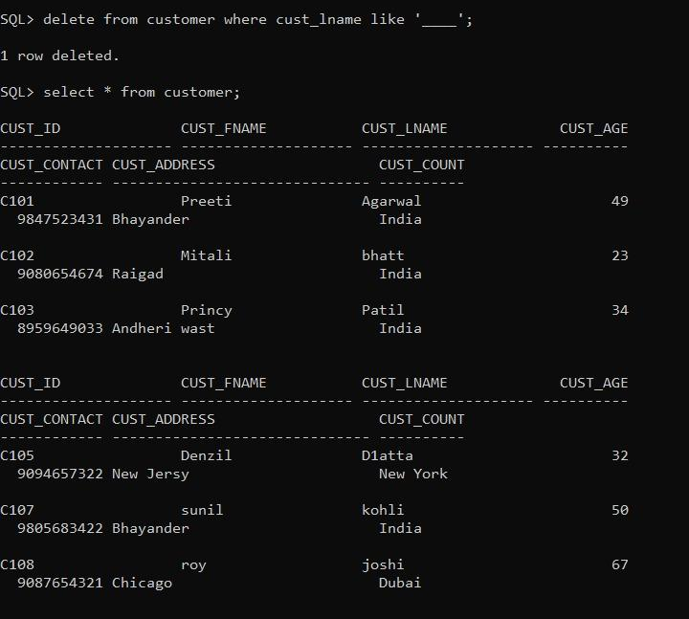

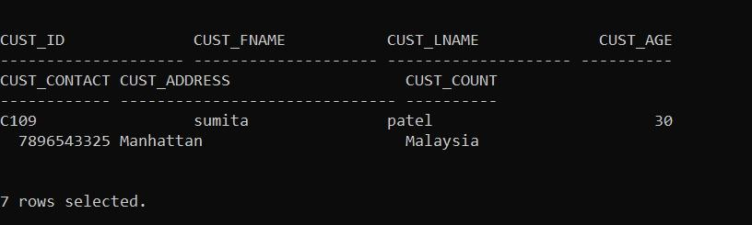

1. delete from room where room_no = 'RM404';

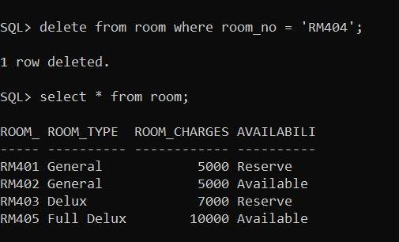

***References***

https://nevonprojects.com/enhanced-resort-management-system/