Documentation of project

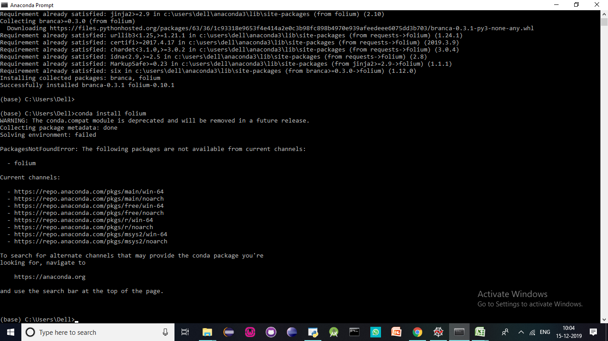

Installing folium for geomap plotting