**Virtual Classroom System**

(REPORT)

**TEAM - DEFAULT**

**TEAM MEMBERS**

(BSC 2ND YEAR, COMPUTER SCIENCE)

*PREETI RACHEL JASPER*

**PROJECT GUIDE**

*MRS. MANJULA R*

Introduction

**The Idea:**

Developing a virtual classroom system to promote a greater count of students to splurge into the field of Education. It integrates the benefits of a physical classroom with the convenience of a ‘no-physical-bar’ virtual learning environment, minus the commuting hazards and expenses. It will usher in the immense flexibility and sophistication in the existing learning platform structures, with the perfect blend of synchronous and asynchronous interaction. It provides a means of collaborative learning for the students.

There are basically 4 types of users:

Student

Faculty

College Management (Dean, HODs, Principal)

Administrator

Purpose

**VCS** (Virtual Classroom System) aims to promote a greater count of students to splurge into the field ofEducation. It integrates the benefits of a physical classroom with the convenience of a ‘no-physical-bar’ virtual learning environment, minus the commuting hazards and expenses. It will usher in the immense flexibility and sophistication in the existing learning platform structures, with the perfect blend of synchronous and asynchronous interaction. It provides a means of collaborative learning for the students.

**Highlighting the main features of VCS** :

Attend Lectures as per student's convenience.

Appear for Exams, view Progress Reports and participate in extra curricular activities online. Faculties can evaluate test sheets, schedule tests and perform related activities online.

Providing easy-to-access web based service which can give management an effective means of managing all resources..

**SOURCE CODE:**

**INDEX:**

<!DOCTYPE HTML>

<HTML>

<head>

<meta charset="UTF-8">

<meta http-equiv="Content-type" content="text/html;charset=UTF-8">

<title>VES</title>

<link rel="stylesheet" type="text/css" href="css/Index.css">

</head>

<BODY>

<div id="top">

</div>

<div>

<h2><span><a href = "Home Page.html" id = "Logo"><img src="img/Logo.png" id = "Logo"></a></span></h2>

</div>

<nav>

<ul id="mmenu">

<li><a href="Home Page.html" class = "home">HOME</a></li>

<li><a href="About.html">ABOUT</a>

<ul>

<li><a href="New Student.html">K OS AT A GLANCE</a></li>

<li><a href="Current Student.html">ACHIEVEMENTS</a></li>

<li><a href="Alumni.html">PLACEMENT</a></li>

<li><a href="Alumni.html">PHOTO GALLERY</a></li>

<li><a href="Alumni.html">FACILITIES</a></li>

<li><a href="Alumni.html">CONTACT US</a></li>

</ul>

</li>

<li><a href= "#" >PROGRAMMES</a>

<ul>

<li><a href="Music.html">GRADUATE</a>

<!--<ul>

<li><a href="Music.html">BTECH</a></li>

</ul>-->

</li>

<li><a href="Videos.html">POST GRADUATE</a></li>

</ul>

</li>

<li><a href= "#" >ACADEMICS</a>

<ul>

<li><a href="Music.html">DEPARTMENTS</a></li>

<li><a href="Videos.html">CURRICULUM / SYLLABI</a></li>

<li><a href="Calendar.html">ACADEMIC CALENDAR</a></li>

</ul>

</li>

<li><a href="#">STUDENTS</a>

<ul>

<li><a href="New Student.html">CURRICULUM / SYLLABI</a></li>

<li><a href="Current Student.html">TIME TABLE</a></li>

<li><a href="Alumni.html">LIST OF HOLIDAYS</a></li>

<li><a href="Alumni.html">STUDENT NOTICEBOARD</a></li>

<li><a href="Alumni.html">RESULTS</a></li>

<li><a href="Alumni.html">ATTENDANCE RULES</a></li>

<li><a href="Alumni.html">GRIEVANCE FORM</a></li>

</ul>

</li>

<!--<li><a href="#">STAFF</a></li>-->

</ul>

</nav>

<center>

<button id="GetS">

<span><a href="Home Page.html">GET STARTED</a></span>

</button>

</center>

<!--<div id="lside">left</div>-->

<!--<div id="center">center</div>-->

<!--<div id="rside">GHello</div>-->

<!--<div id="bottom">Hello</div>-->

</BODY>

</HTML>

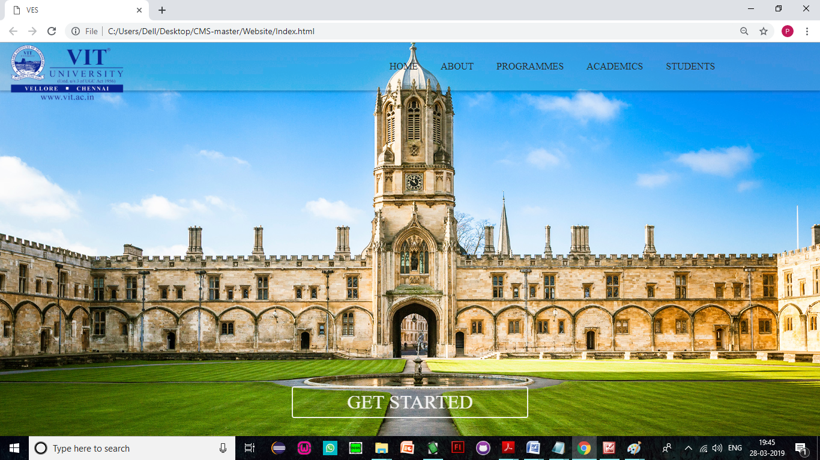

**HOME:**

<!DOCTYPE HTML>

<HTML>

<head>

<meta charset="UTF-8">

<meta http-equiv="Content-type" content="text/html;charset=UTF-8">

<meta name="viewport" content="width=device-width, initial-scale=1">

<title>VIRTUAL EDUCATION SYSTEM</title>

<link rel="stylesheet" type="text/css" href="css/Main.css">

<link rel="stylesheet" type="text/css" href="css/Home Page.css">

</head>

<BODY>

<div id="holder">

<div id="top">

</div>

<div>

<h2><span><a href = "Home Page.html" id = "Logo"><img src="img/Logo.png" id = "Logo"></a></span></h2>

</div>

<div id="login"><a href="https://kos-dev-ed.my.salesforce.com">STAFF LOGIN</a></div>

<nav>

<ul id="mmenu">

<li><a href="Home Page.html">HOME</a></li>

<li><a href="#">ABOUT</a>

<ul>

<li><a href="At A Glance.html">VIT AT A GLANCE</a></li>

<li><a href="Achievements.html">ACHIEVEMENTS</a></li>

<li><a href="Placement.html">PLACEMENT</a></li>

<li><a href="Photo Gallery.html">PHOTO GALLERY</a></li>

<li><a href="Facilities.html">FACILITIES</a></li>

<li><a href="Contact.html">CONTACT US</a></li>

</ul>

</li>

<li><a href= "#" >PROGRAMMES</a>

<ul>

<li><a href="Graduate.html">GRADUATE</a>

<!--<ul>

<li><a href="Music.html">BTECH</a></li>

<li><a href="Videos.html">MED</a></li>

</ul>-->

</li>

<li><a href="Post Graduate.html">POST GRADUATE</a></li>

</ul>

</li>

<li><!--<span class="current">--><a href= "#" >ACADEMICS</a><!--</span>-->

<ul>

<li><a href="Departments.html">DEPARTMENTS</a></li>

<li><a href="Curriculum.html">CURRICULUM / SYLLABI</a></li>

<li><a href="Academic Calendar.html">ACADEMIC CALENDAR</a></li>

</ul>

</li>

<li><a href="#">STUDENTS</a>

<ul>

<li><a href="Curriculum.html">CURRICULUM / SYLLABI</a></li>

<li><a href="Time Table.html">TIME TABLE</a></li>

<li><a href="Holidays.html">LIST OF HOLIDAYS</a></li>

<li><a href="Noticeboard.html">STUDENT NOTICEBOARD</a></li>

<li><a href="Results.html">RESULTS</a></li>

<li><a href="Attendance Rules.html">ATTENDANCE RULES</a></li>

<li><a href="Grievance.html">GRIEVANCE FORM</a></li>

</ul>

</li>

<!--<li><a href="#">STAFF</a></li>-->

</ul>

</nav>

<div id="rside">

<div id="mtird">

<p>

ADMISSIONS OPEN NOW ! <br> <br>

<font color = '#FFBD00'>_________ </font><br><br>

BBA Counselling in progress : New Students Jam Up The Corridors ! <br><br>

<font color = '#FFBD00'>_________ </font><br><br>

FEE SUBMISSION : Last Date for Fee Submission has been extended to 5th August, 2019 (Friday). <br><br>

<font color = '#FFBD00'>_________ </font><br><br>

New Session starts from 1st August, 2019 (Monday).<br><br>

<font color = '#FFBD00'>_________ </font><br><br>

</p>

</div>

<div id="ltird">

<left>

<a href="New Students.html">NEW STUDENTS »</a>

<br><br>

<a href="Hiring.html">WE ARE HIRING »</a>

</left>

</div>

</div>

<div id="center">

<div id="scrdiv">

<br><br><br><br><br><br>

<div id="headiv">

<left>

<span id="heading"><b>&nbsp;Best online university in the business</b></span>

<hr><br>

vit univeristy of virtual interactive eductation, vellore was established in the year 1969. VIT College has a material designed campus spread all over the globe.

<br><br>

VIT College offers Under Graduate and Post Graduate level full time Professional programs approved by AICTE in affiliation with VIT UNIVERSITY, Vellore.

<br><br>

<br><br><br>

</left>

<div id="left">

<span id="inheading"><b>SIDEBAR</b></span>

<hr>

<br>

<!--<img src="img/L.jpg" height="100px" width="100px" id="roleimg" >

<br>

<span id="rott1">Preeti Rachel</span>

<br>-->

<span id="rott2">CEO</span>

<br>

<br>

<hr>

<br>

<br>

<!--<img src="img/PRJ.jpg" height="100px" width="100px" id="roleimg" >

<br>

<span id="rott1">jasper lal</span>

<br>-->

<span id="rott2">CHAIRPERSON</span>

<br>

<br>

<hr>

<br>

<br>

<!--<img src="img/K.jpg" height="100px" width="100px" id="roleimg" >

<br>

<span id="rott1">mathew jasper</span>

<br>-->

<span id="rott2">DIRECTOR</span>

<br>

<br>

<hr>

<br>

<br>

<!--<img src="img/K.jpg" height="100px" width="100px" id="roleimg" >

<br>

<span id="rott1">rachel jasper</span>

<br>-->

<span id="rott2">PRINCIPAL</span>

<br>

<br>

<hr>

<br>

<br>

<hr>

<br>

<br>

<div id="rdm">some random text</div>

</div>

<div id="highlt">

<span id="inheading"><b>NOTABLE ACHIEVEMENTS</b></span>

<hr>

<br>

<br>

<div id="highltin">

» Students have brought laurels to the college by winning a total of 13 Gold Medals.

<br><hr><br>

» ECE department got a sponsored project titled “Hybrid Satellite Terrestrial Communication: Algorithm Design & Performance Analysis” for an amount of Rs.36.92 Lakh from Department of Science & Technology (DST), Govt. of India, New Delhi.

<br><hr><br>

» 'All Terrain Vehicle' & Thunder Bolt developed by the Students was displayed at Auto Expo 2010 & 2014 respectively and awarded by the University.

<br><hr><br>

» Civil Department got a consultancy from CPWD, Central Govt. for an amount of Rs.60,000/- to make a Structural Design for Erection of Temporary Earth retain structure using soldier piles/H-beams.

<br><hr><br>

» Placement of more than 85% eligible Students in 2015-16.

<br><br>

<hr>

<br><br><br>

</div>

</div>

<div id="newdiv">

<br><br>

<span id="inheading"><b>NOTABLE APPROVALS FROM ONLINE SCHOOL BOARDS</b></span>

<hr><br>

<div id="highltin">

<span id="rott3">Approved by: AICTE</span>

<br>

<hr>

<br>

<span id="rott3">Accreditated by: NAAC</span>

<br>

<hr>

<br>

<span id="rott3">Affiliated to: VIT GROUP OF INSTITUTIONS, Vellore</span>

<br>

<hr>

<br>

<span id="rott3">ISO 9001:2008 Certified</span>

<br>

<hr>

<br>

<span id="rott3">EN ISO 14001:2004 Certified</span>

<br>

<hr>

<br>

</div>

</div>

<br><br><br>

<hr>

</div>

</div>

<div id="bottom"></div>

</div>

</div>

</BODY>

</HTML>

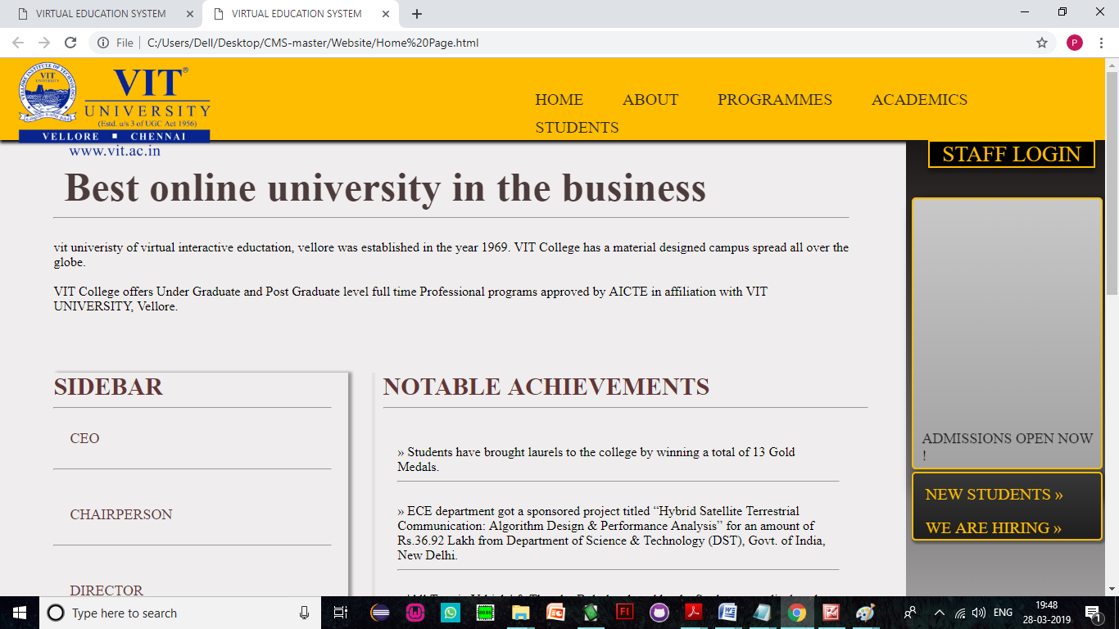

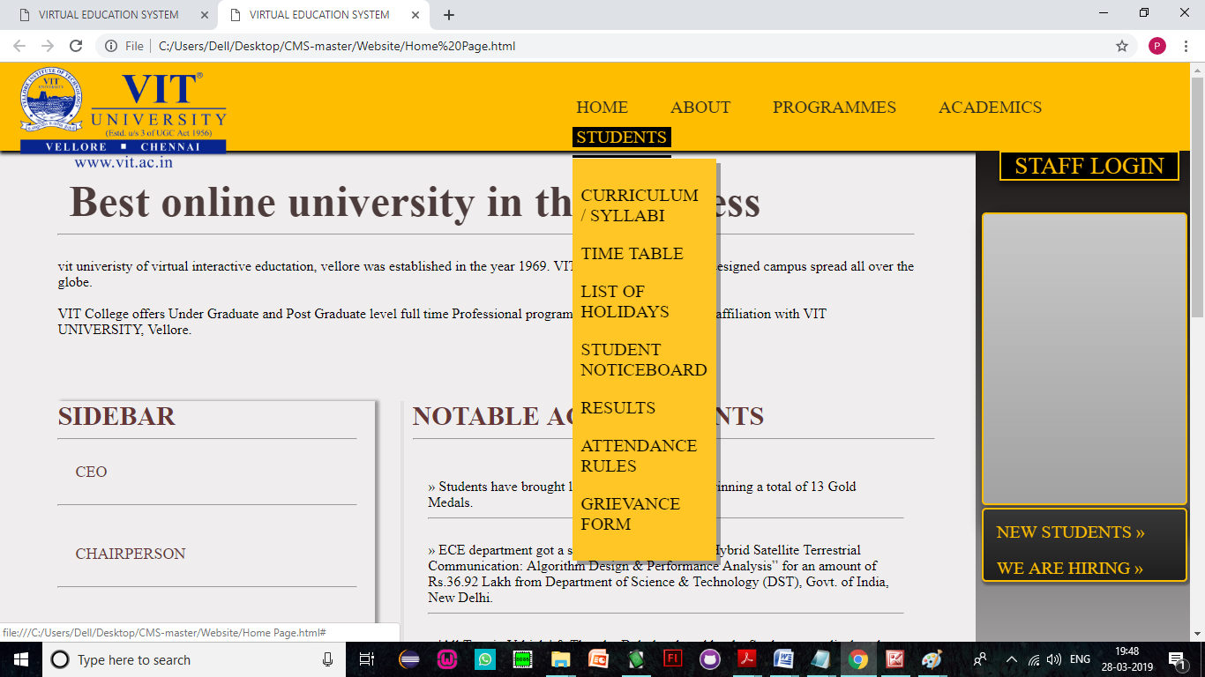

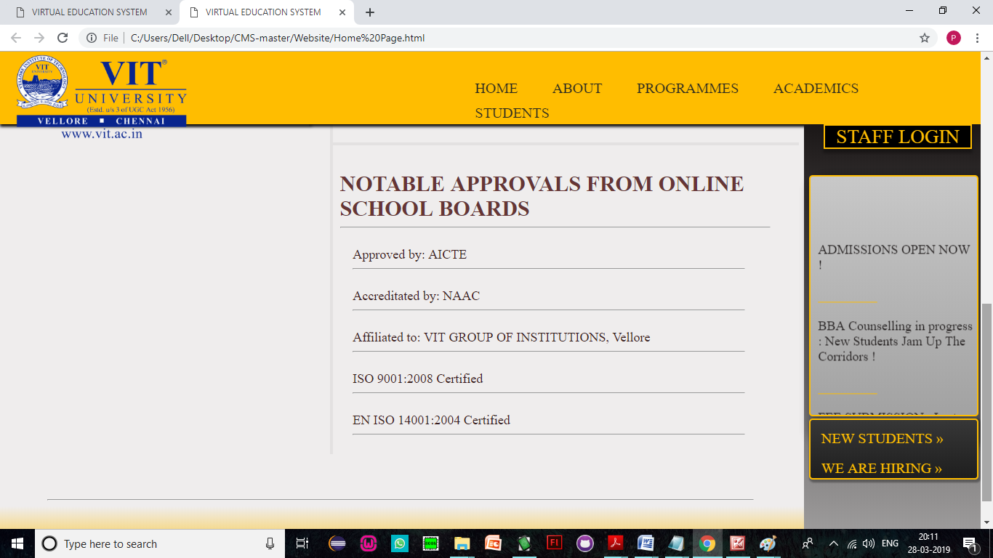

**REGISTRATION**

<!DOCTYPE HTML>

<HTML>

<head>

<meta charset="UTF-8">

<meta http-equiv="Content-type" content="text/html;charset=UTF-8">

<meta name="viewport" content="width=device-width, initial-scale=1">

<title>VES</title>

<link rel="stylesheet" type="text/css" href="css/Main.css">

<link rel="stylesheet" type="text/css" href="css/Home Page.css">

<link rel="stylesheet" type="text/css" href="css/Registration Forms.css">

</head>

<BODY>

<div id="holder">

<div id="top">

</div>

<div>

<h2><span><a href = "Home Page.html" id = "Logo"><img src="img/Logo.png" id = "Logo"></a></span></h2>

</div>

<div id="login">STAFF LOGIN</a></div>

<nav>

<ul id="mmenu">

<li><a href="Home Page.html">HOME</a></li>

<li><a href="#">ABOUT</a>

<ul>

<li><a href="At A Glance.html">VIT AT A GLANCE</a></li>

<li><a href="Achievements.html">ACHIEVEMENTS</a></li>

<li><a href="Placement.html">PLACEMENT</a></li>

<li><a href="Photo Gallery.html">PHOTO GALLERY</a></li>

<li><a href="Facilities.html">FACILITIES</a></li>

<li><a href="Contact.html">CONTACT US</a></li>

</ul>

</li>

<li><a href= "#" >PROGRAMMES</a>

<ul>

<li><a href="Graduate.html">GRADUATE</a>

<!--<ul>

<li><a href="Music.html">BTECH</a></li>

<li><a href="Videos.html">MED</a></li>

</ul>-->

</li>

<li><a href="Post Graduate.html">POST GRADUATE</a></li>

</ul>

</li>

<li><span class="current"><a href= "#" >ACADEMICS</a></span>

<ul>

<li><a href="Departments.html">DEPARTMENTS</a></li>

<li><a href="Curriculum.html">CURRICULUM / SYLLABI</a></li>

<li><a href="Academic Calendar.html">ACADEMIC CALENDAR</a></li>

</ul>

</li>

<li><a href="#">STUDENTS</a>

<ul>

<li><a href="Curriculum.html">CURRICULUM / SYLLABI</a></li>

<li><a href="Time Table.html">TIME TABLE</a></li>

<li><a href="Holidays.html">LIST OF HOLIDAYS</a></li>

<li><a href="Noticeboard.html">STUDENT NOTICEBOARD</a></li>

<li><a href="Results.html">RESULTS</a></li>

<li><a href="Attendance Rules.html">ATTENDANCE RULES</a></li>

<li><a href="Grievance.html">GRIEVANCE FORM</a></li>

</ul>

</li>

<!--<li><a href="#">STAFF</a></li>-->

</ul>

</nav>

<div id="rside">

<div id="mtird">

<p>

ADMISSIONS OPEN NOW ! <br> <br>

<font color = '#FFBD00'>_________ </font><br><br>

BBA Counselling in progress : New Students Jam Up The Corridors ! <br><br>

<font color = '#FFBD00'>_________ </font><br><br>

FEE SUBMISSION : Last Date for Fee Submission has been extended to 5th August, 2016 (Friday). <br><br>

<font color = '#FFBD00'>_________ </font><br><br>

New Session starts from 1st August, 2016 (Monday).<br><br>

<font color = '#FFBD00'>_________ </font><br><br>

</p>

</div>

<div id="ltird">

<left>

<a href="New Students.html">NEW STUDENTS »</a>

<br><br>

<a href="Hiring.html">WE ARE HIRING »</a>

</left>

</div>

</div>

<div id="center">

<div id="scrdiv">

<br><br><br><br><br><br>

<div id="headiv">

<!--<left>

<span id="heading"><b>&nbsp;BEST ONLINE UNIVERSITY</b></span>

<hr><br>

VIT College offers Under Graduate and Post Graduate level full time Professional programs approved by AICTE in affiliation with VIT UNIVERSITY, Vellore.

<br><br>

<br><br> vit univeristy of virtual interactive eductation, vellore was established in the year 1969. VIT College has a material designed campus spread all over the globe.

<br><br><br>

</left>-->

<div id="leftdiv">

<span id="inheading"><b>OUR PATRONS</b></span>

<hr>

<br>

<img src="img/a.jpg" height="80px" width="80px" id="roleimg" >

<br>

<span id="rottnr1">prj</span>

<br>

<span id="rottnr2">CEO</span>

<hr>

<br>

<br>

<img src="img/b.jpg" height="80px" width="80px" id="roleimg" >

<br>

<span id="rottnr1">prj</span>

<br>

<span id="rottnr2">CHAIRPERSON</span>

<hr>

<br>

<br>

<img src="img/t.jpg" height="80px" width="80px" id="roleimg" >

<br>

<span id="rottnr1">[rj</span>

<br>

<span id="rottnr2">DIRECTOR</span>

<hr>

<br>

<br>

<img src="img/l" height="80px" width="80px" id="roleimg" >

<br>

<span id="rottnr1">preeti rachel</span>

<br>

<span id="rottnr2">PRINCIPAL</span>

<br>

<hr>

<br>

<!--<div id="rdm">some random text</div>-->

<!--<hr><br><br>

<center>

<div id="frame">-->

<!--<iframe src="https://visualantidote.ap2.visual.force.com/apex/FormdraftPreview?id=a0d2800000253tuAAA" height="586px" width="100%"></iframe>-->

<!--<script type="text/javascript" id="jsFastForms" src="https://fastforms.visualantidote.com/FormEngine/Scripts/Main.js?d=PzCCLNh%2fNeWWpbCyPuOwcR5owlDtbnQX5%2fM3bSRF24nlY2XqU2GTUFOBD0Em3rHP" height="585px" width="100%"></script>

</div>

</center>-->

<!--<br><br><hr>-->

</div>

<div id="formdiv">

<div id="sturegframe">

<script type="text/javascript" id="jsFastForms" src="https://fastforms.visualantidote.com/FormEngine/Scripts/Main.js?d=PzCCLNh%2fNeWWpbCyPuOwcR5owlDtbnQX5%2fM3bSRF24mxl1Kyu%2fNb2uB6HusAdGVp">

</script>

</div>

<!--<span id="inheading"><b>VIT ACHIEVEMENTS</b></span>

<hr>

<br>

<br>

<div id="highltin">

» Students have brought laurels to the college by winning a total of 13 Gold Medals.

<br><hr><br>

» ECE department got a sponsored project titled “Hybrid Satellite Terrestrial Communication: Algorithm Design & Performance Analysis” for an amount of Rs.36.92 Lakh from Department of Science & Technology (DST), Govt. of India, New Delhi.

<br><hr><br>

» 'All Terrain Vehicle' & Thunder Bolt developed by the Students was displayed at Auto Expo 2010 & 2014 respectively and awarded by the University.

<br><hr><br>

» Civil Department got a consultancy from CPWD, Central Govt. for an amount of Rs.60,000/- to make a Structural Design for Erection of Temporary Earth retain structure using soldier piles/H-beams.

<br><hr><br>

» Placement of more than 85% eligible Students in 2015-16.

<br><br>

<hr>

<br><br><br>

</div>-->

</div>

<!--<div id="newdiv">

<br><br>

<span id="inheading"><b>HEADING 'N' - Change Text</b></span>

<hr><br>

<div id="highltin">

<span id="rott3">Approved by: AICTE</span>

<br>

<hr>

<br>

<span id="rott3">Accreditated by: NAAC</span>

<br>

<hr>

<br>

<span id="rott3">Affiliated to: VIT GROUP OF INSTITUTIONS, New Delhi</span>

<br>

<hr>

<br>

<span id="rott3">ISO 9001:2008 Certified</span>

<br>

<hr>

<br>

<span id="rott3">EN ISO 14001:2004 Certified</span>

<br>

<hr>

<br>

</div>

</div>-->

<br><br><br>

<!--<hr>-->

</div>

</div>

<div id="bottom"></div>

</div>

</div>

</BODY>

</HTML>

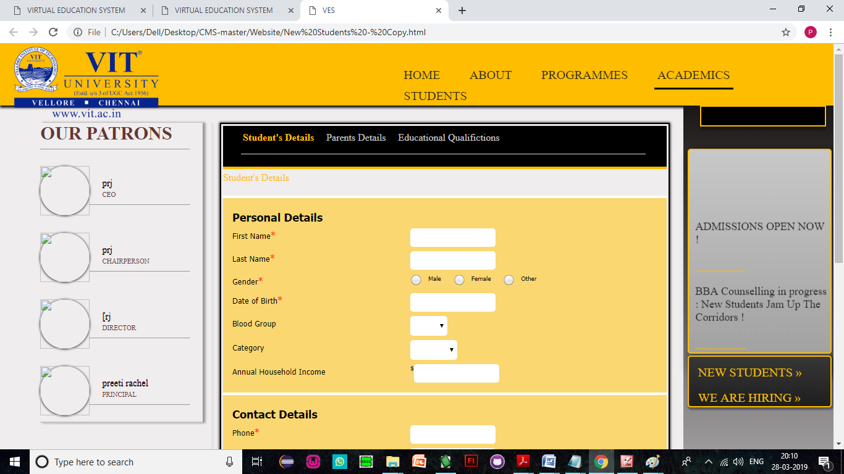

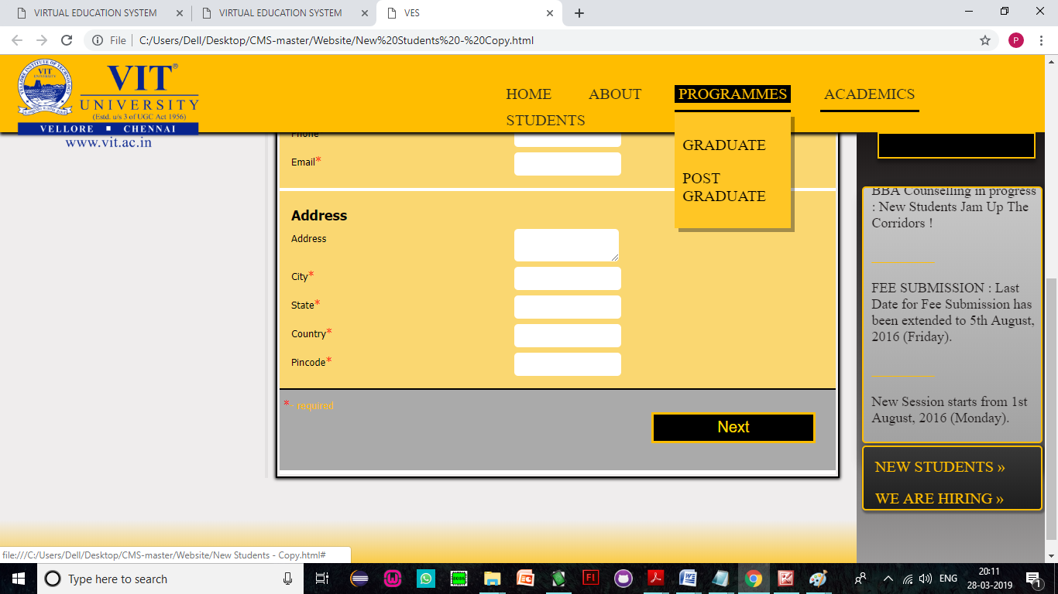

**LOGIN**

<!DOCTYPE HTML>

<HTML>

<head>

<meta charset="UTF-8">

<meta http-equiv="Content-type" content="text/html;charset=UTF-8">

<meta name="viewport" content="width=device-width, initial-scale=1">

<title>VIRTUAL EDUCATION SYSTEM</title>

<link rel="stylesheet" type="text/css" href="css/Main.css">

<link rel="stylesheet" type="text/css" href="css/Home Page.css">

</head>

<BODY>

<div id="holder">

<div id="top">

</div>

<div>

<h2><span><a href = "Home Page.html" id = "Logo"><img src="img/Logo.png" id = "Logo"></a></span></h2>

</div>

<div id="login"><a href="https://kos-dev-ed.my.salesforce.com">STAFF LOGIN</a></div>

<nav>

<ul id="mmenu">

<li><a href="Home Page.html">HOME</a></li>

<li><a href="#">ABOUT</a>

<ul>

<li><a href="At A Glance.html">VIT AT A GLANCE</a></li>

<li><a href="Achievements.html">ACHIEVEMENTS</a></li>

<li><a href="Placement.html">PLACEMENT</a></li>

<li><a href="Photo Gallery.html">PHOTO GALLERY</a></li>

<li><a href="Facilities.html">FACILITIES</a></li>

<li><a href="Contact.html">CONTACT US</a></li>

</ul>

</li>

<li><a href= "#" >PROGRAMMES</a>

<ul>

<li><a href="Graduate.html">GRADUATE</a>

<!--<ul>

<li><a href="Music.html">BTECH</a></li>

<li><a href="Videos.html">MED</a></li>

</ul>-->

</li>

<li><a href="Post Graduate.html">POST GRADUATE</a></li>

</ul>

</li>

<li><!--<span class="current">--><a href= "#" >ACADEMICS</a><!--</span>-->

<ul>

<li><a href="Departments.html">DEPARTMENTS</a></li>

<li><a href="Curriculum.html">CURRICULUM / SYLLABI</a></li>

<li><a href="Academic Calendar.html">ACADEMIC CALENDAR</a></li>

</ul>

</li>

<li><a href="#">STUDENTS</a>

<ul>

<li><a href="Curriculum.html">CURRICULUM / SYLLABI</a></li>

<li><a href="Time Table.html">TIME TABLE</a></li>

<li><a href="Holidays.html">LIST OF HOLIDAYS</a></li>

<li><a href="Noticeboard.html">STUDENT NOTICEBOARD</a></li>

<li><a href="Results.html">RESULTS</a></li>

<li><a href="Attendance Rules.html">ATTENDANCE RULES</a></li>

<li><a href="Grievance.html">GRIEVANCE FORM</a></li>

</ul>

</li>

<!--<li><a href="#">STAFF</a></li>-->

</ul>

</nav>

<div id="rside">

<div id="mtird">

<p>

ADMISSIONS OPEN NOW ! <br> <br>

<font color = '#FFBD00'>_________ </font><br><br>

BBA Counselling in progress : New Students Jam Up The Corridors ! <br><br>

<font color = '#FFBD00'>_________ </font><br><br>

FEE SUBMISSION : Last Date for Fee Submission has been extended to 5th August, 2019 (Friday). <br><br>

<font color = '#FFBD00'>_________ </font><br><br>

New Session starts from 1st August, 2019 (Monday).<br><br>

<font color = '#FFBD00'>_________ </font><br><br>

</p>

</div>

<div id="ltird">

<left>

<a href="New Students.html">NEW STUDENTS »</a>

<br><br>

<a href="Hiring.html">WE ARE HIRING »</a>

</left>

</div>

</div>

<div id="center">

<div id="scrdiv">

<br><br><br><br><br><br>

<div id="headiv">

<left>

<span id="heading"><b>&nbsp;Best online university in the business</b></span>

<hr><br>

vit univeristy of virtual interactive eductation, vellore was established in the year 1969. VIT College has a material designed campus spread all over the globe.

<br><br>

VIT College offers Under Graduate and Post Graduate level full time Professional programs approved by AICTE in affiliation with VIT UNIVERSITY, Vellore.

<br><br>

<br><br><br>

</left>

<div id="left">

<span id="inheading"><b>SIDEBAR</b></span>

<hr>

<br>

<!--<img src="img/YKV.jpg" height="100px" width="100px" id="roleimg" >

<br>

<span id="rott1">Preeti Rachel</span>

<br>-->

<span id="rott2">CEO</span>

<br>

<br>

<hr>

<br>

<br>

<!--<img src="img/Vis.jpg" height="100px" width="100px" id="roleimg" >

<br>

<span id="rott1">jasper lal</span>

<br>-->

<span id="rott2">CHAIRPERSON</span>

<br>

<br>

<hr>

<br>

<br>

<!--<img src="img/Sumit.jpg" height="100px" width="100px" id="roleimg" >

<br>

<span id="rott1">mathew jasper</span>

<br>-->

<span id="rott2">DIRECTOR</span>

<br>

<br>

<hr>

<br>

<br>

<!--<img src="img/Parv.jpg" height="100px" width="100px" id="roleimg" >

<br>

<span id="rott1">rachel jasper</span>

<br>-->

<span id="rott2">PRINCIPAL</span>

<br>

<br>

<hr>

<br>

<br>

<hr>

<br>

<br>

<div id="rdm">some random text</div>

</div>

<div id="highlt">

<span id="inheading"><b>NOTABLE ACHIEVEMENTS</b></span>

<hr>

<br>

<br>

<div id="highltin">

» Students have brought laurels to the college by winning a total of 13 Gold Medals.

<br><hr><br>

» ECE department got a sponsored project titled “Hybrid Satellite Terrestrial Communication: Algorithm Design & Performance Analysis” for an amount of Rs.36.92 Lakh from Department of Science & Technology (DST), Govt. of India, New Delhi.

<br><hr><br>

» 'All Terrain Vehicle' & Thunder Bolt developed by the Students was displayed at Auto Expo 2010 & 2014 respectively and awarded by the University.

<br><hr><br>

» Civil Department got a consultancy from CPWD, Central Govt. for an amount of Rs.60,000/- to make a Structural Design for Erection of Temporary Earth retain structure using soldier piles/H-beams.

<br><hr><br>

» Placement of more than 85% eligible Students in 2015-16.

<br><br>

<hr>

<br><br><br>

</div>

</div>

<div id="newdiv">

<br><br>

<span id="inheading"><b>NOTABLE APPROVALS FROM ONLINE SCHOOL BOARDS</b></span>

<hr><br>

<div id="highltin">

<span id="rott3">Approved by: AICTE</span>

<br>

<hr>

<br>

<span id="rott3">Accreditated by: NAAC</span>

<br>

<hr>

<br>

<span id="rott3">Affiliated to: VIT GROUP OF INSTITUTIONS, Vellore</span>

<br>

<hr>

<br>

<span id="rott3">ISO 9001:2008 Certified</span>

<br>

<hr>

<br>

<span id="rott3">EN ISO 14001:2004 Certified</span>

<br>

<hr>

<br>

</div>

</div>

<br><br><br>

<hr>

</div>

</div>

<div id="bottom"></div>

</div>

</div>

</BODY>

</HTML>

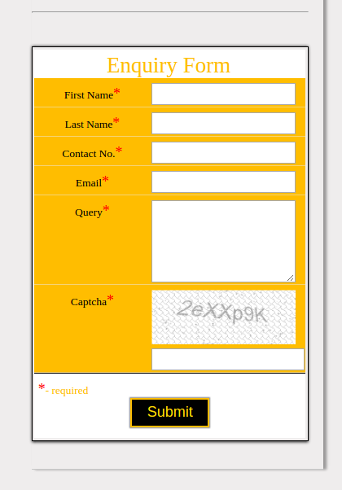

**DEPARTMENTS:**

<!DOCTYPE HTML>

<HTML>

<head>

<meta charset="UTF-8">

<meta http-equiv="Content-type" content="text/html;charset=UTF-8">

<title>VIRTUAL EDUCATION SYSTEM</title>

<link rel="stylesheet" type="text/css" href="css/Index.css">

</head>

<BODY>

<div id="top">

</div>

<div>

<h2><span><a href = "Home Page.html" id = "Logo"><img src="img/Logo.png" id = "Logo"></a></span></h2>

</div>

<nav>

<ul id="mmenu">

<li><a href="Home Page.html" class = "home">HOME</a></li>

<li><a href="About.html">ABOUT</a>

<ul>

<li><a href="New Student.html">VIT AT A GLANCE</a></li>

<li><a href="Current Student.html">ACHIEVEMENTS</a></li>

<li><a href="Alumni.html">PLACEMENT</a></li>

<li><a href="Alumni.html">PHOTO GALLERY</a></li>

<li><a href="Alumni.html">FACILITIES</a></li>

<li><a href="Alumni.html">CONTACT US</a></li>

</ul>

</li>

<li><a href= "#" >PROGRAMMES</a>

<ul>

<li><a href="Music.html">GRADUATE</a>

<!--<ul>

<li><a href="Music.html">BTECH</a></li>

<li><a href="Videos.html">MED</a></li>

</ul>-->

</li>

<li><a href="Videos.html">POST GRADUATE</a></li>

</ul>

</li>

<li><a href= "#" >ACADEMICS</a>

<ul>

<li><a href="Music.html">DEPARTMENTS</a></li>

<li><a href="Videos.html">CURRICULUM / SYLLABI</a></li>

<li><a href="Calendar.html">ACADEMIC CALENDAR</a></li>

</ul>

</li>

<li><a href="#">STUDENTS</a>

<ul>

<li><a href="New Student.html">CURRICULUM / SYLLABI</a></li>

<li><a href="Current Student.html">TIME TABLE</a></li>

<li><a href="Alumni.html">LIST OF HOLIDAYS</a></li>

<li><a href="Alumni.html">STUDENT NOTICEBOARD</a></li>

<li><a href="Alumni.html">RESULTS</a></li>

<li><a href="Alumni.html">ATTENDANCE RULES</a></li>

<li><a href="Alumni.html">GRIEVANCE FORM</a></li>

</ul>

</li>

<!--<li><a href="#">STAFF</a></li>-->

</ul>

</nav>

<center>

<button id="GetS">

<span><a href="Home Page.html">GET STARTED</a></span>

</button>

</center>

<!--<div id="lside">left</div>-->

<!--<div id="center">center</div>-->

<!--<div id="rside">GHello</div>-->

<!--<div id="bottom">Hello</div>-->

</BODY>

</HTML>

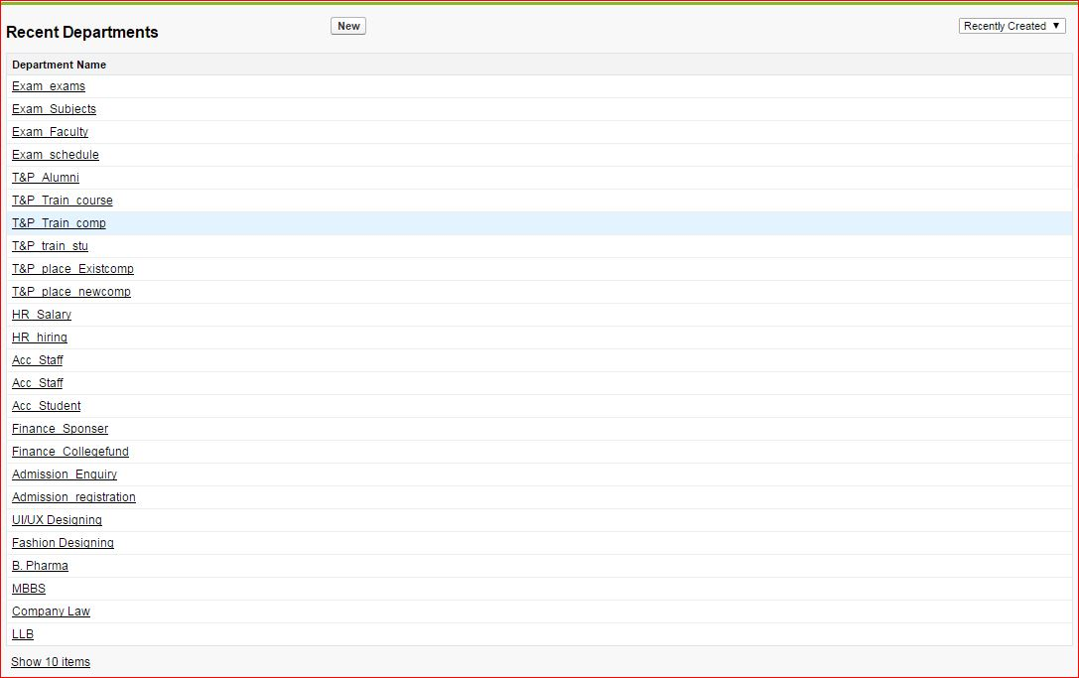

\

**SCREENSHOTS OF WEBSITE:**













**THANK YOU!**