Sales Dashboard in Excel
Task 1 | OutriX Data Analytics Internship
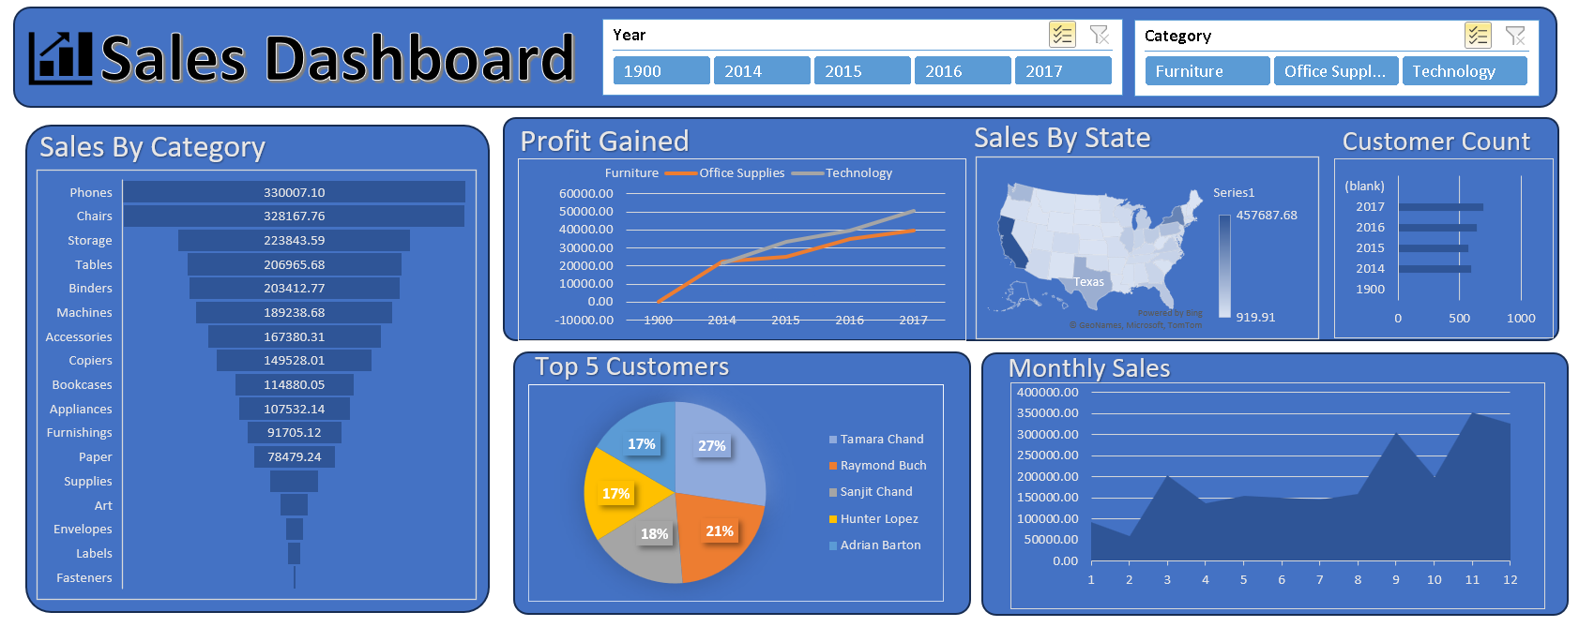

1. Introduction
For this task I took a Superstore-style sales dataset, cleaned it, built pivot tables from it and put everything together in one interactive Excel dashboard. The idea was to turn raw order-level data into something a manager can open and understand in a minute.
The dashboard is built to answer these questions:
- Which products and categories bring in the most sales?
- Which category actually makes a profit, and which one does not?
- Which states are the biggest markets?
- Who are the most profitable customers?
- How do sales change across the months of the year?

2. Dataset
The data is in the sheet named salesdata inside salesdata.xlsx. It has the following columns: Order Date, Year, Month, Customer Name, State, Category, Sub-Category, Product Name, Sales, Quantity and Profit.
Detail | Value
Number of rows | 9,993 orders
Time period | January 2014 to December 2017
Customers | 793
States | 49
Categories / Sub-categories | 3 / 17
Total sales | 2,296,919.70
Total profit | 286,409.85

3. Tools Used
- Microsoft Excel
- Pivot tables and pivot charts
- Slicers (Year and Category)
- Funnel, line, map, bar, pie and area charts

4. How I Built It

Step 1: Cleaning the data
I checked the dataset for missing values and duplicate rows and found none. I made sure Sales, Profit and Quantity were stored as numbers and Order Date as a proper date so that the pivots would group correctly. Year and Month are kept as separate columns because the slicer and the monthly chart use them.

Step 2: Pivot tables
Every chart on the dashboard has its own pivot table on a separate sheet.
Sheet | What it shows
Sales By Category | Total sales for each sub-category
Profit Gained | Profit by year, split by category
Sales By State | Total sales for each state
Customer Count | Number of customers per year
Top5Customer making Profits | Top 5 customers by profit
Monthly Sales | Total sales for each month (1 to 12)

Step 3: Charts
Chart | Used for
Funnel chart | Sales by sub-category, sorted from highest to lowest
Line chart | Profit by year for each category
Filled map | Sales by state
Bar chart | Customer count by year
Pie chart | Share of the top 5 customers by profit
Area chart | Monthly sales trend

Step 4: Slicers
I added two slicers, Year and Category, and connected them to all the pivot tables. Selecting a year or a category updates every chart on the dashboard at the same time.

Step 5: Dashboard layout
All the charts are placed on one Dashboard sheet with the same blue theme. The title sits at the top and the slicers are next to it, so the filters are easy to find.

5. Key Insights

Sales
- Overall: Total sales are about 2.30M. Technology leads with 836K, followed by Furniture (742K) and Office Supplies (719K).
- Sub-categories: Phones (330K) and Chairs (328K) are the two best-selling sub-categories by a big margin. Fasteners (3K) and Labels (12K) sell the least.
- Yearly trend: Sales dipped slightly in 2015 (470K) compared to 2014 (484K), then grew every year and reached 733K in 2017.

Profit
- Best categories: Technology earns the most profit (145K), with Office Supplies close behind (122K).
- Problem area: Furniture brings in 742K in sales but only 18K in profit. That is a margin of about 2.5%, while the other two categories are at roughly 17%.
- Growth: Total profit almost doubled from 49.5K in 2014 to 93.4K in 2017.

States
- Top states: California is the biggest market with 457,688 in sales, followed by New York (310,876) and Texas (170,188).
- Smallest states: North Dakota (920) and West Virginia (1,210) are the smallest.

Customers
- Top 5: Tamara Chand, Raymond Buch, Sanjit Chand, Hunter Lopez and Adrian Barton are the top 5 by profit. Tamara Chand alone makes up 27% of this group.
- Customer growth: The customer count grew from 595 in 2014 to 692 in 2017.

Seasonality
- Slow months: Sales stay low in the first half of the year, and February is the weakest month at 60K.
- Busy months: Sales jump in September (307K), and November (352K) and December (327K) are the strongest months. This looks like a year-end buying season.

6. A Data Issue I Found
One row in the dataset has Year = 1900 even though its Order Date is 30 December 2017. That is why 1900 appears in the Year slicer and why the Profit Gained chart has a tiny point at 1900 (profit of -0.60).
It is a single order worth 3.02 in sales, so it does not change any of the insights above. The correct fix is to change the Year value of that row to 2017 and refresh the pivot tables. I have kept it visible in this version so the issue is documented.

7. Conclusion
The dashboard gives a clear picture of the business in one screen. Sales and profit have grown steadily since 2014, Technology and Office Supplies are the profit drivers, and Furniture needs attention because of its very low margin. California and New York are the key markets, and the last quarter of the year is the peak selling period.
Through this task I learned how to prepare data for pivot tables, connect one slicer to several pivots, pick the right chart for each question and check data quality before trusting a dashboard.

