PROJECT REPORT
Weather Pattern Analysis & Climate Insights Dashboard
Prepared By :Preeti Raj

1. Business Problem & Objective
India's climate varies sharply across regions, and this variation directly affects planning decisions for agriculture, retail demand, disaster management, and infrastructure. Businesses and government bodies need a reliable, data-driven view of city-level weather patterns rather than relying on scattered or anecdotal information.

Objective
- Build an end-to-end analytics pipeline using real historical weather data (no mock data) for 9 major Indian cities.
- Identify temperature, precipitation, and sunshine trends across cities and over time.
- Deliver a business-style interactive dashboard that supports planning and decision-making.
- Translate the findings into actionable, non-technical recommendations.

2. Data Source & Methodology
Historical weather data was collected via the Open-Meteo API for 9 cities — Delhi, Mumbai, Bengaluru, Chennai, Kolkata, Hyderabad, Chandigarh, Jaipur, and Pune — covering a 3-year period (11 Sep 2023 to 11 Sep 2026).

Pipeline
- API Ingestion (Python) — config-driven script fetching all 9 cities' data.
- Data Cleaning (Python) — validation, type conversion, and outlier checks.
- SQL Star Schema (PostgreSQL) — fact_weather, dim_date, dim_city tables with keys and indexes.
- Power BI Data Model — relationships, DAX measures, and a multi-page dashboard.
- Business Insights — city-wise and time-based analysis translated into recommendations.

3. Data Cleaning & Validation
Data quality was verified at every stage before loading into the database:
Metric | Result
Total records | 9,873 rows x 19 columns
Missing values | 0
Duplicate rows | 0
Date coverage | 1,097 days per city (identical range for all 9 cities)
Outliers (temp, precipitation, wind speed) | 0 flagged in sanity checks

4. Database Design
A star schema was implemented in PostgreSQL (database: weather_analytics) to support efficient querying and modeling in Power BI:
- dim_date — 1,097 rows, marked as the official Date Table
- dim_city — 9 rows, one per city
- fact_weather — 9,873 rows, linked to both dimension tables via foreign keys

5. Key DAX Measures
15 DAX measures were built across three categories: core aggregates, city comparisons, and time intelligence. The most business-relevant ones:
Measure | Purpose
Avg Max / Min Temp | Core temperature aggregates across all cities and dates
Avg Temp Range | Daily variation between max and min temperature
Total Precipitation / Total Rain | Cumulative rainfall volume per city
Rainy Days Count | Number of days with recorded precipitation
Avg Sunshine Duration | Average daily sunshine hours (corrected from seconds to hours)
Hottest City / Wettest City | Ranks cities dynamically by temperature and rainfall
Temp Rank by City | Ranks all 9 cities by average max temperature
YoY Temp Change | Year-over-year percentage change in temperature
MoM Precipitation Change | Month-over-month change in rainfall
Rolling 30-Day Avg Temp | Smoothed trend line to reduce daily noise

6. Dashboard Pages & Insights

Page 1 — Overview
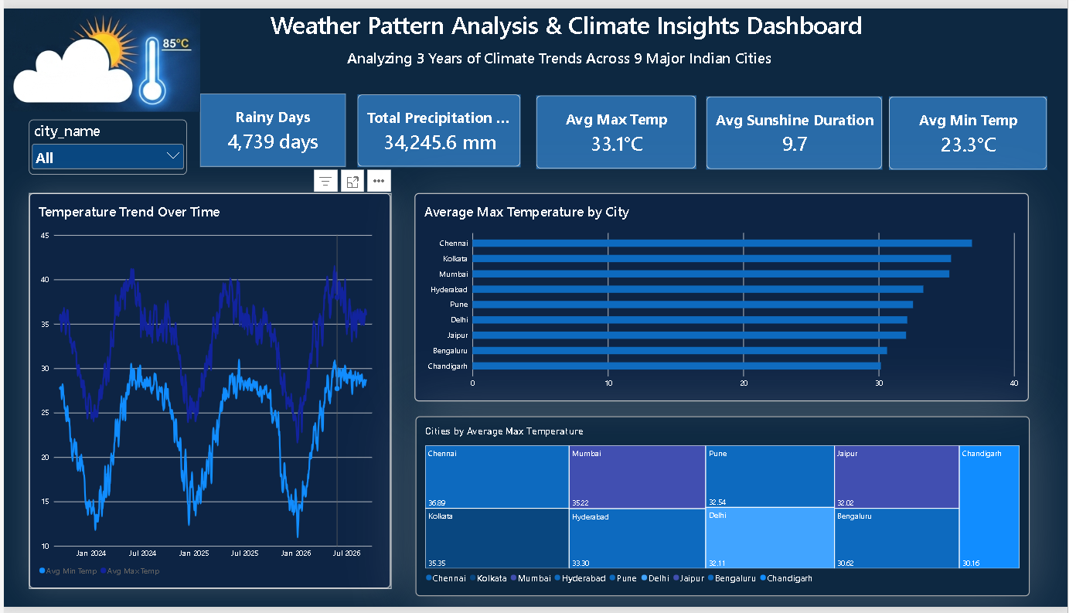
Overview page: KPI cards, temperature trend, and city-wise max temperature comparison.
- Across all 9 cities, the average max temperature is 33.1°C and average min temperature is 23.3°C.
- Chennai is the hottest city (avg max 35.89°C); Chandigarh is the coolest (avg max 30.16°C).
- 4,739 rainy days were recorded in total across all cities over 3 years, with total precipitation of 34,245.6 mm.

Page 2 — City-Wise Weather Comparison
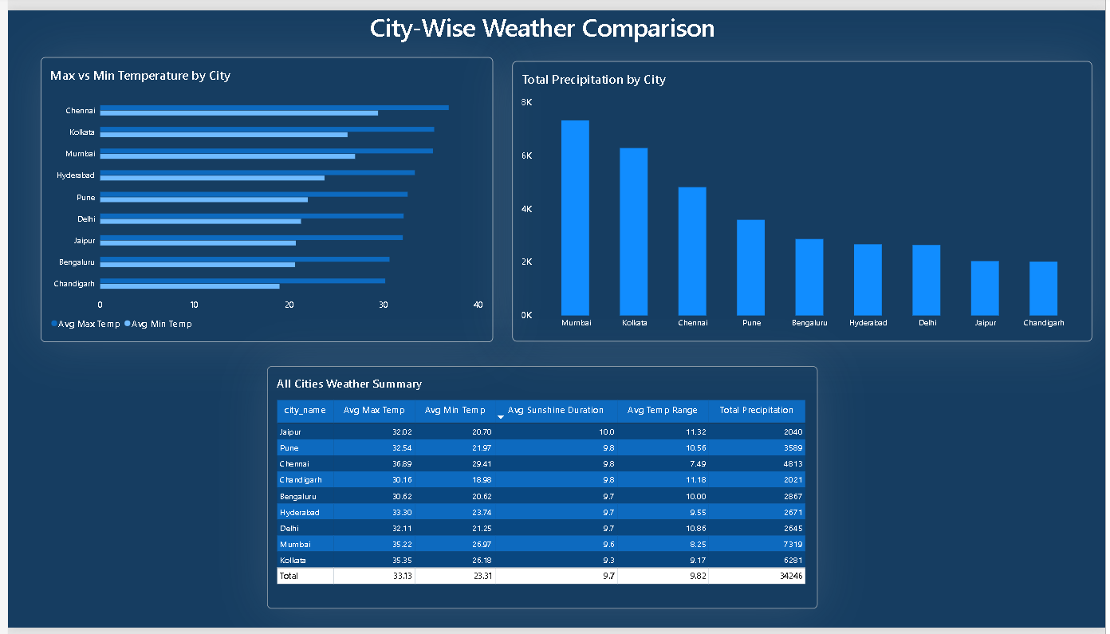
City comparison page: max vs min temperature, total precipitation by city, and a full summary table.
- Mumbai receives the highest total precipitation (~7,319 mm), followed by Kolkata (~6,281 mm).
- Chandigarh receives the lowest precipitation (~2,021 mm) despite having the widest average temperature range (11.18°C).
- Chennai has the smallest average temperature range (7.49°C), indicating a more stable daily climate.

Page 3 — Weather & Precipitation Analysis
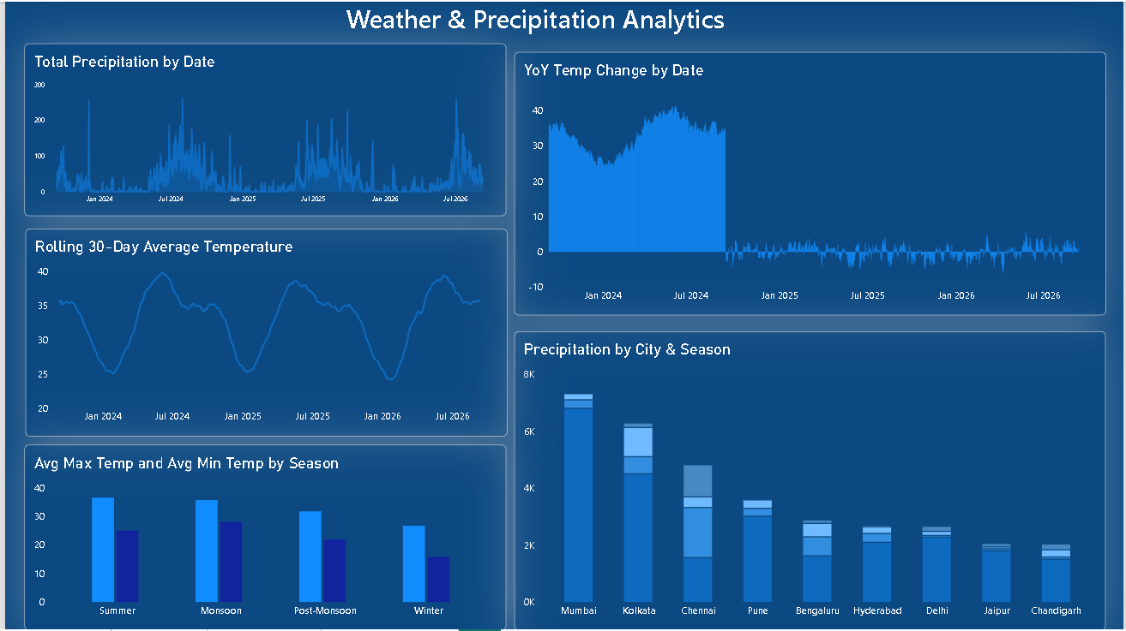

Time trends page: total precipitation by date, rolling 30-day average temperature, and year-over-year temperature change.
- The rolling 30-day average temperature shows a clear seasonal cycle repeating each year, with peaks around April-June and troughs around December-January.
- Precipitation spikes align with the monsoon months (roughly July-September) each year, consistent with the Indian monsoon pattern.
- Note: the YoY Temp Change measure currently shows an unusually large value for the first year of data (since there is no prior year to compare against) before settling into a realistic range — this is flagged for correction in the next iteration.

7. Remaining Work
Two dashboard pages are still in progress and will be added in the next phase of this project:
- Seasonal Analysis — month/season-wise breakdown of temperature and rainfall patterns.
- Extreme Weather / Risk — identification of heatwave days, heavy rainfall events, and city-level risk scoring.

8. Business Recommendations
- Cities with high total precipitation (Mumbai, Kolkata, Chennai) should prioritize drainage and flood-preparedness infrastructure ahead of monsoon months.
- Chandigarh and Jaipur, with wider daily temperature swings, may need more flexible energy demand planning (heating and cooling) than cities like Chennai with stable temperatures.
- The clear seasonal cycle in temperature supports using the rolling 30-day trend for agricultural crop-cycle and retail-demand planning rather than relying on daily readings.

9. Tools & Tech Stack
- Python — API ingestion, data cleaning, validation
- PostgreSQL — star schema data warehouse
- Power BI + DAX — data modeling and dashboard
- Open-Meteo API — real historical weather data source

